**Create IAM User and Group:**

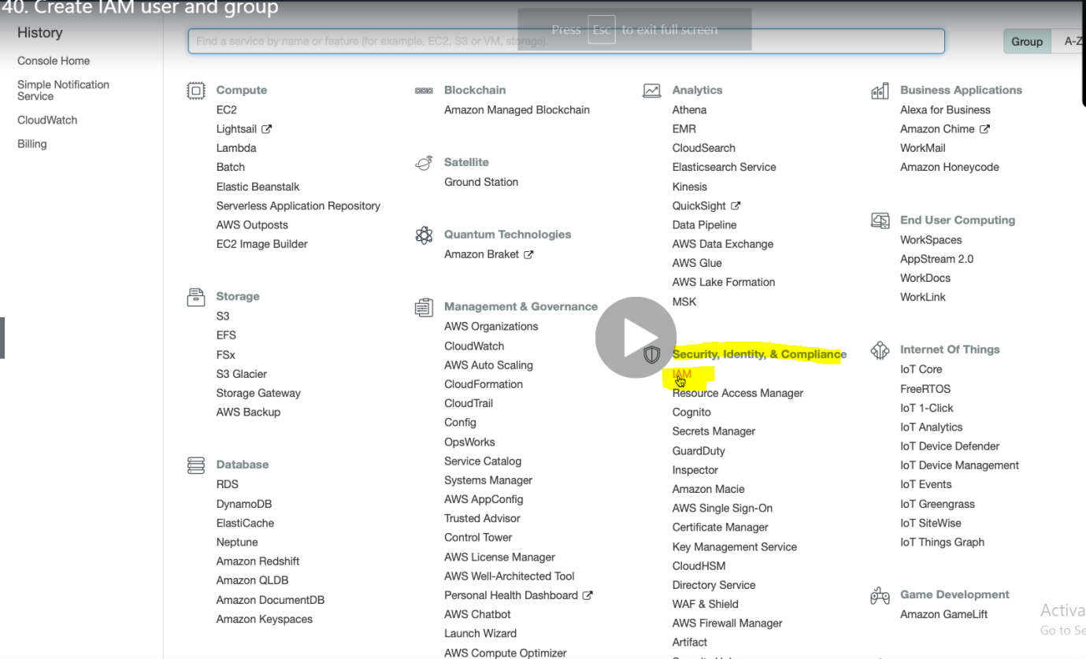

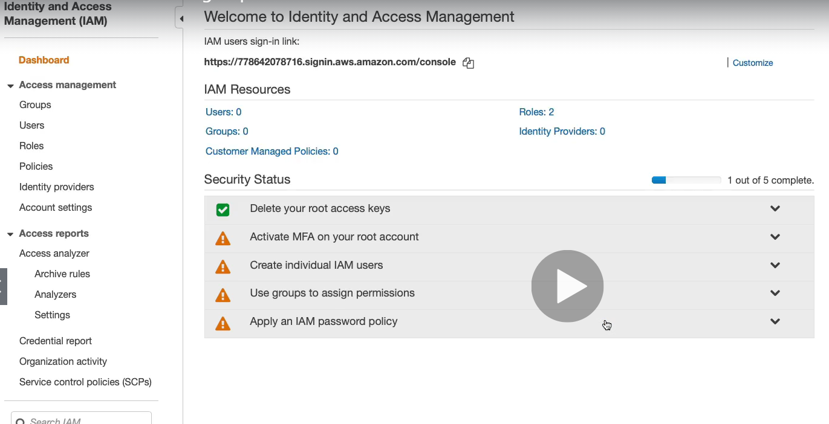

Click customize

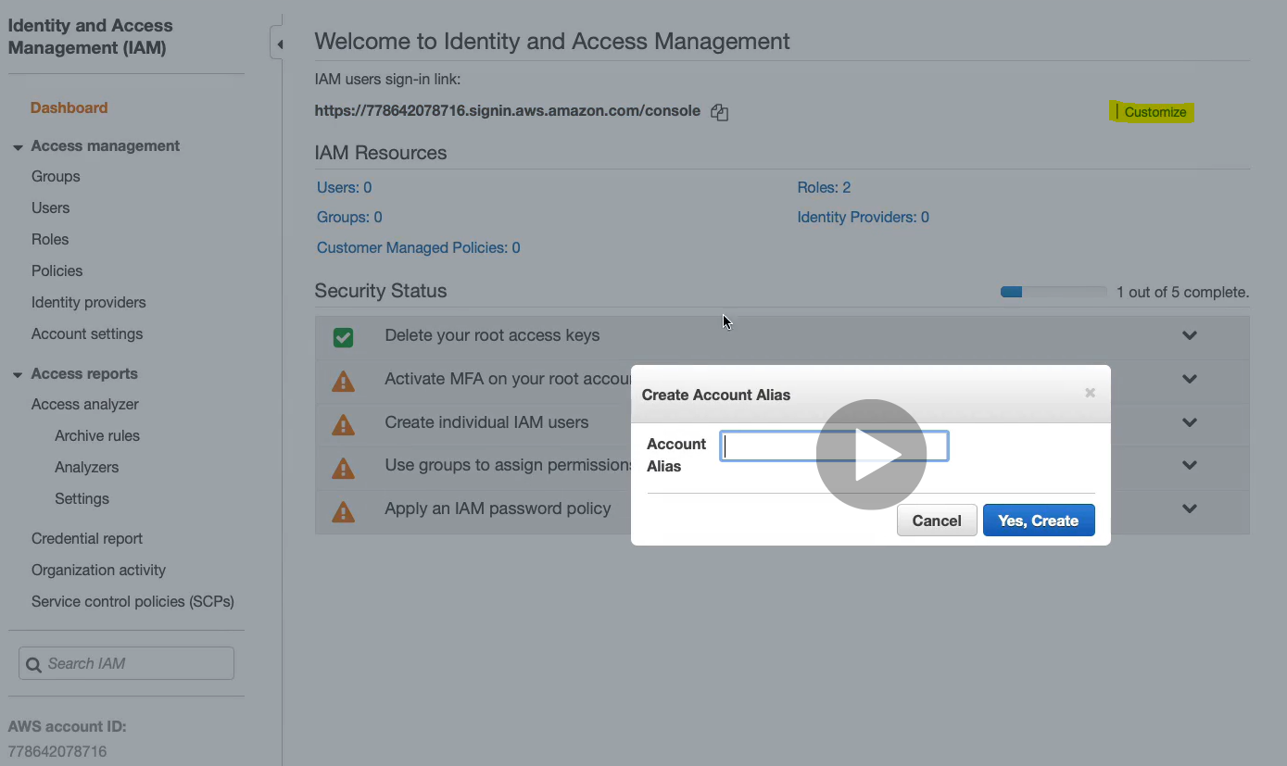

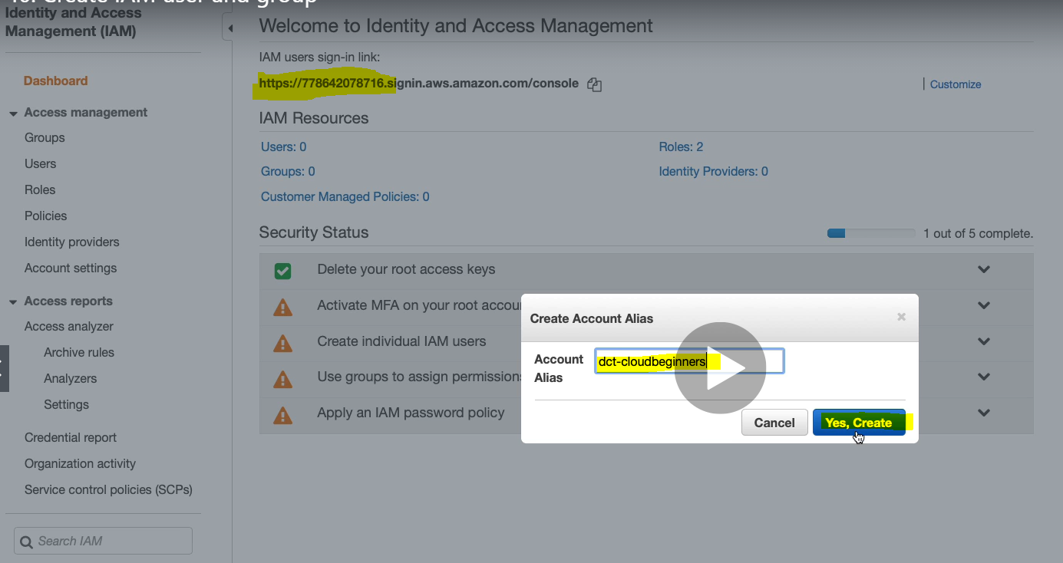

As soon as we provide this name the sign-in link would be changed.

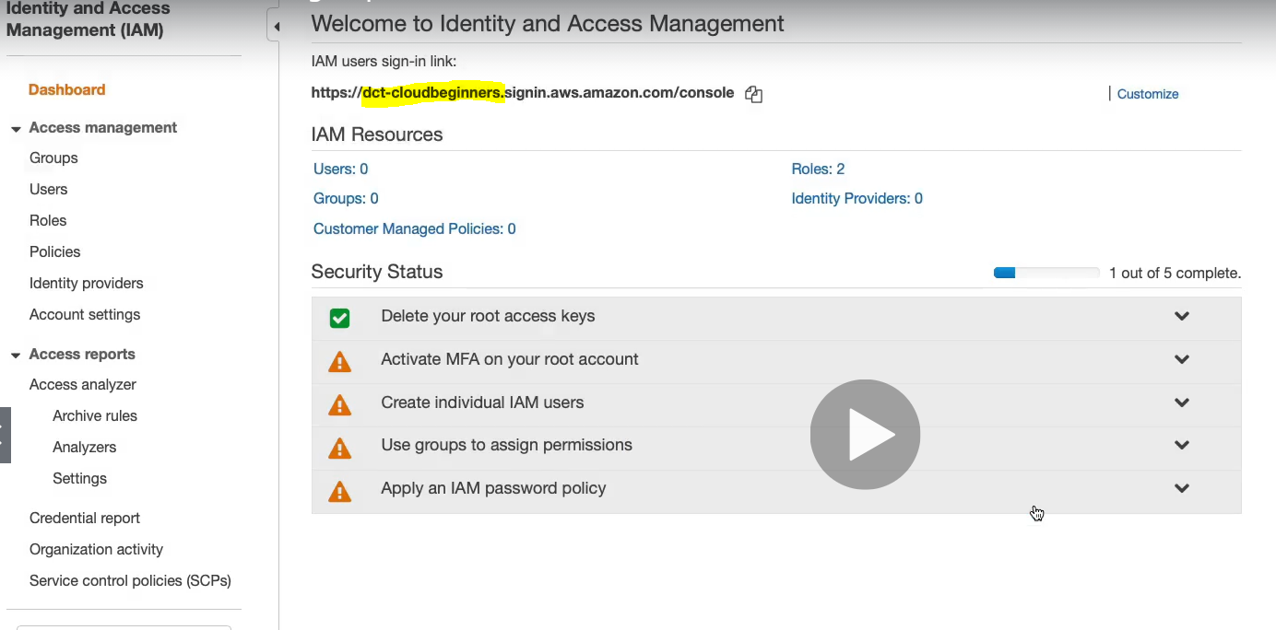

It got changed

Creating a Group:

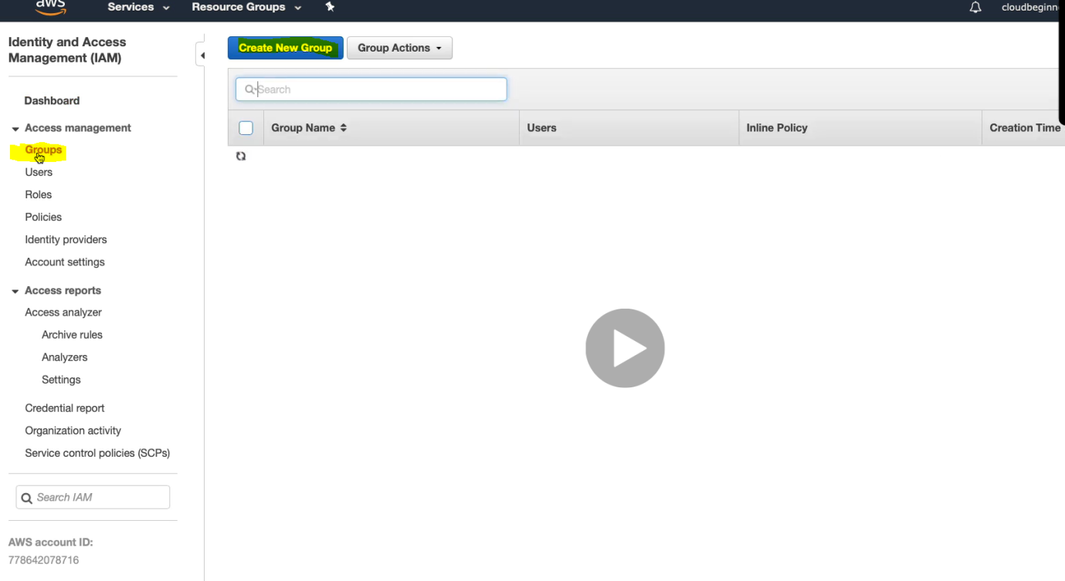

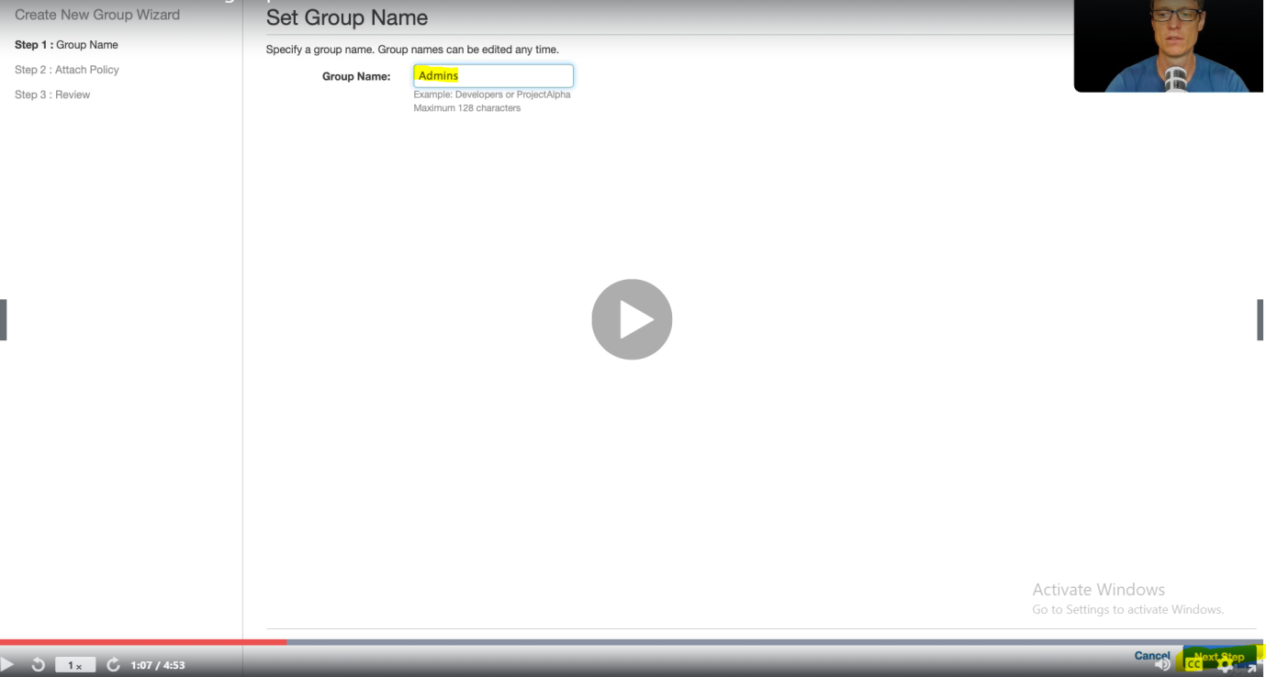

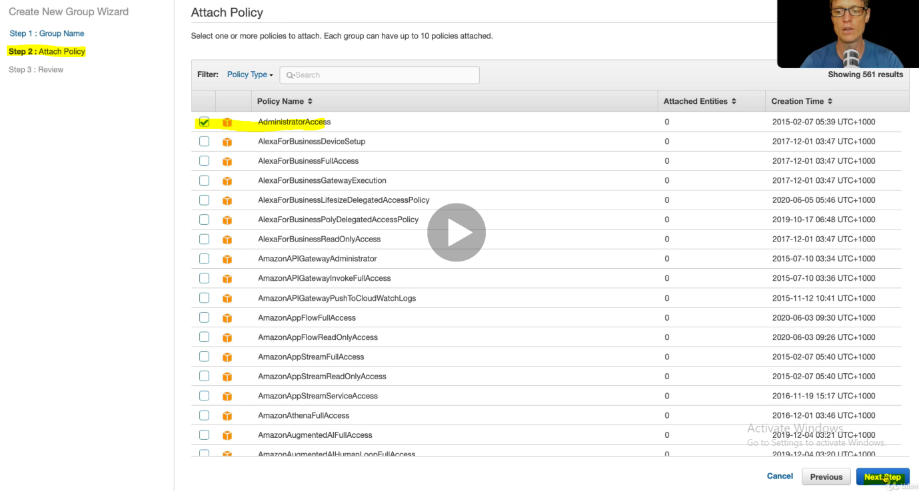

WE have got some predefined policy. Now attach the policy according to your need. > Click Next.

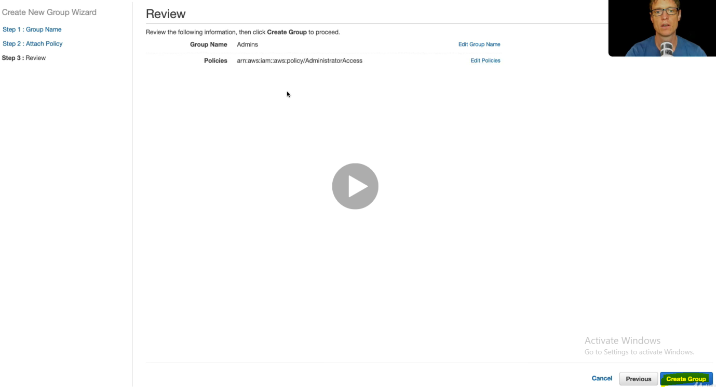

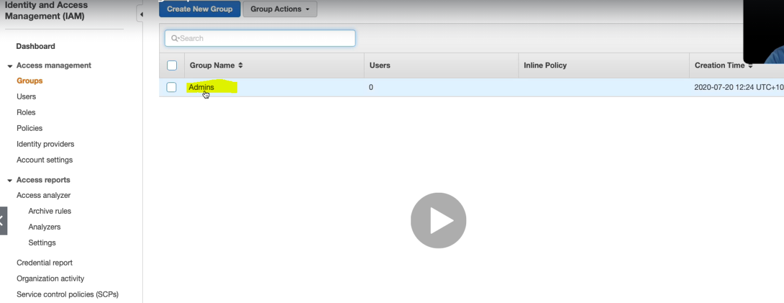

Group Got created.> Click on this Admin

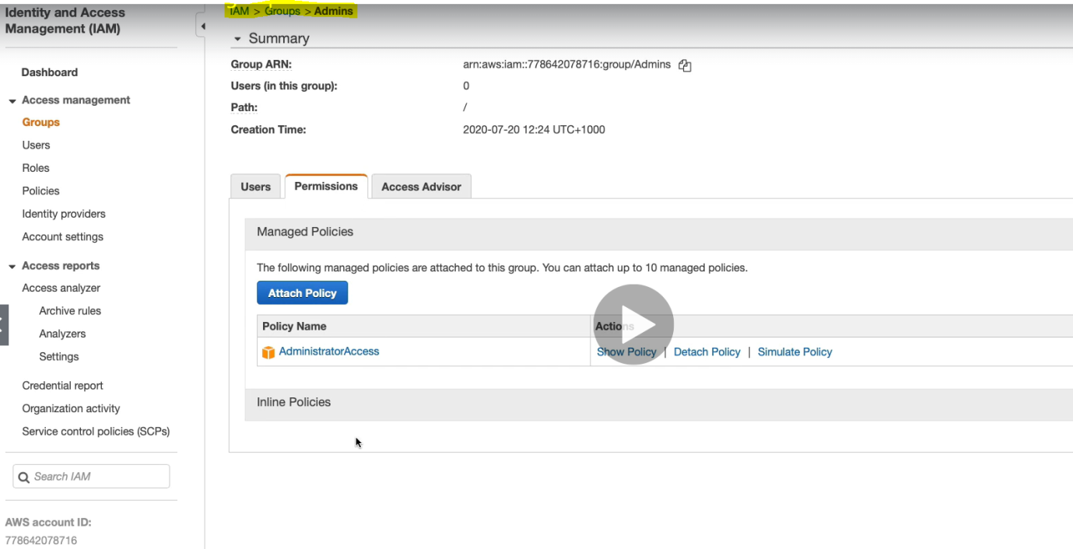

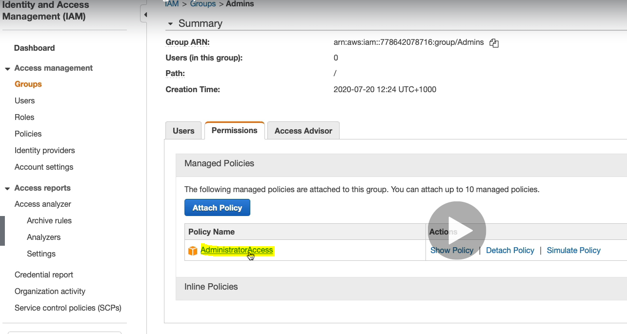

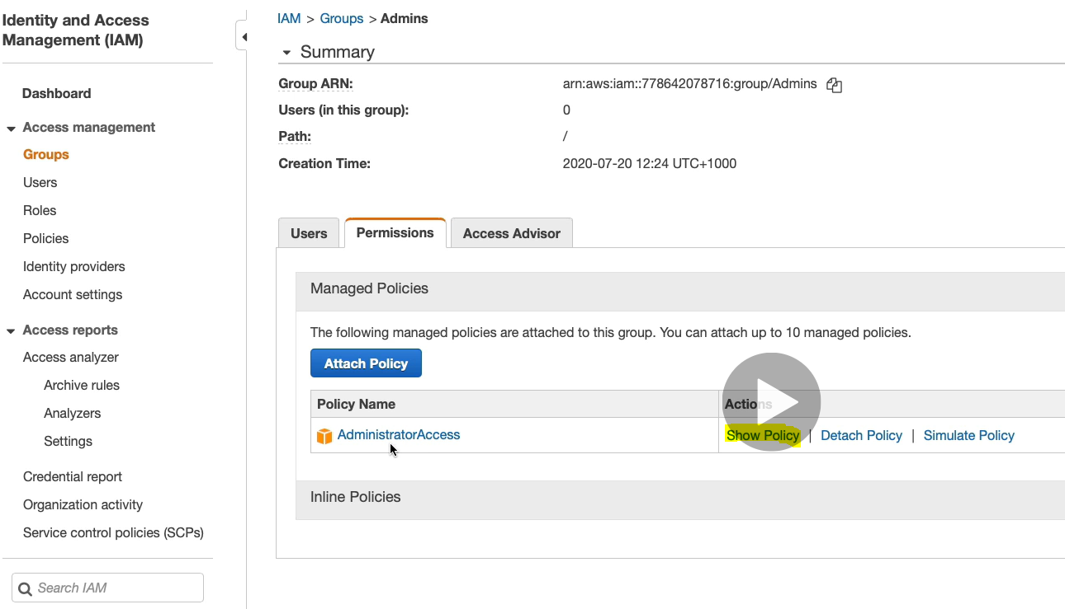

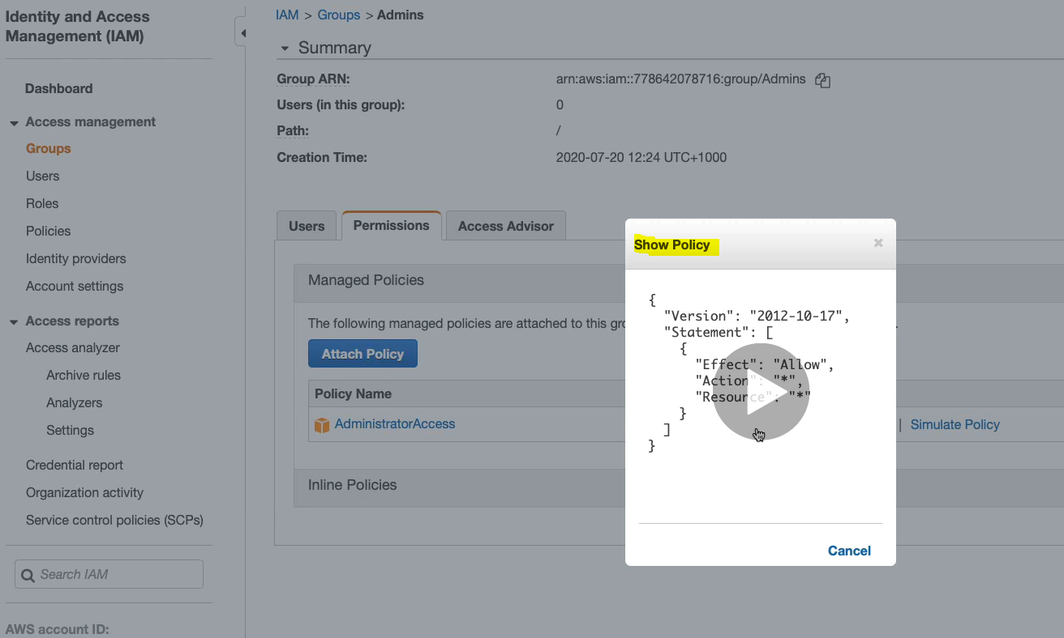

Here it allows for any Action for any Resource.

Now we have to create user in this Admin Group.

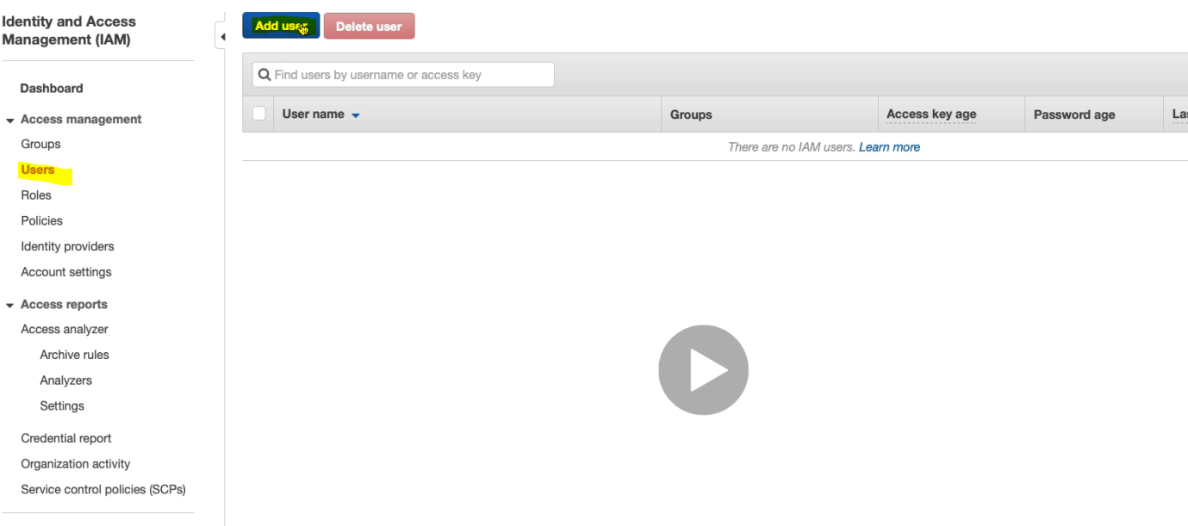

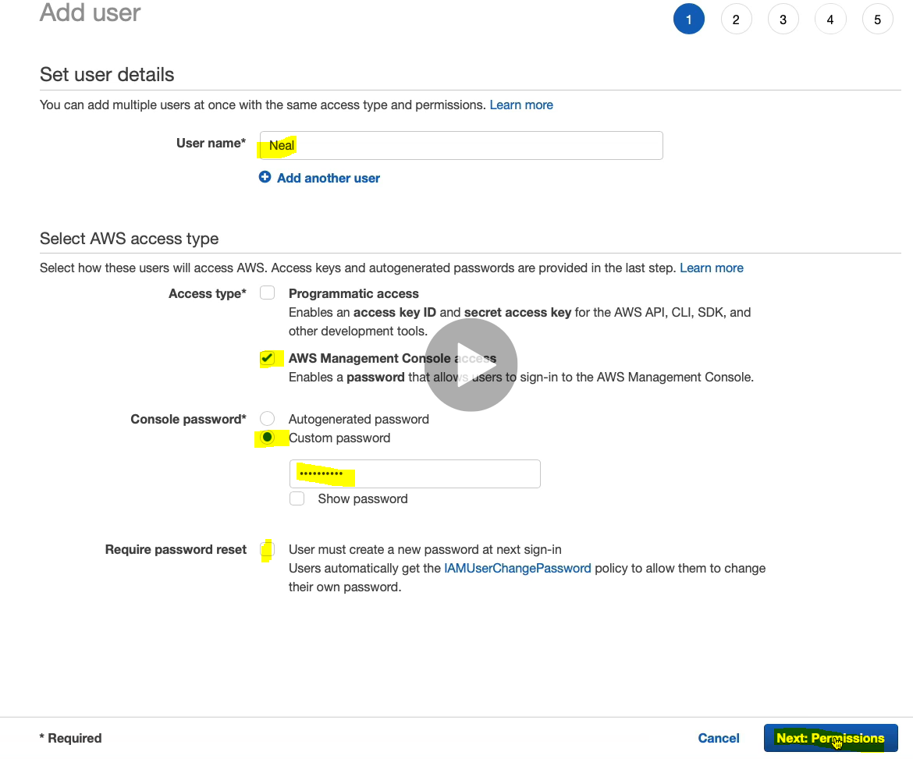

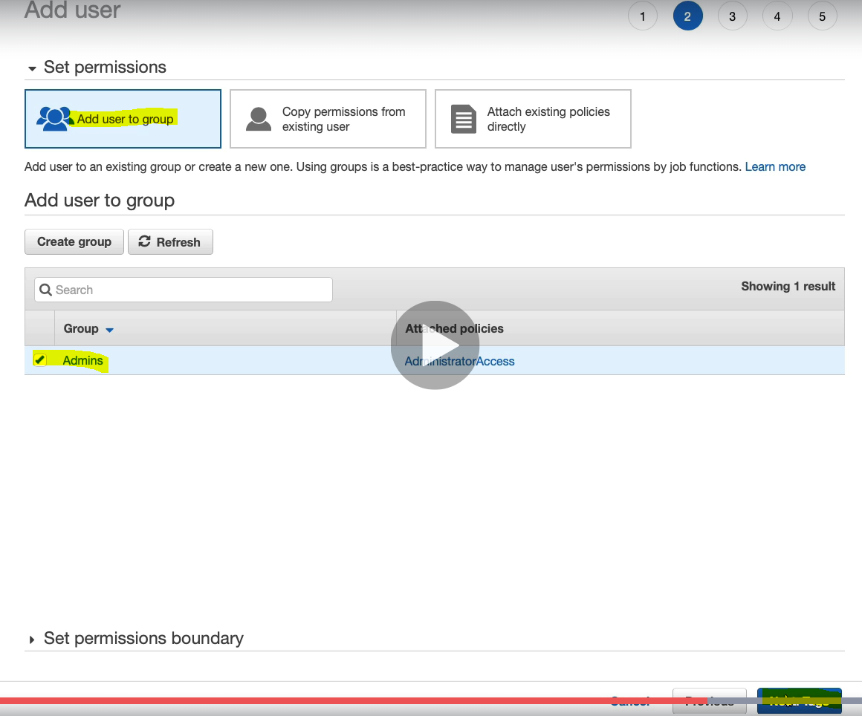

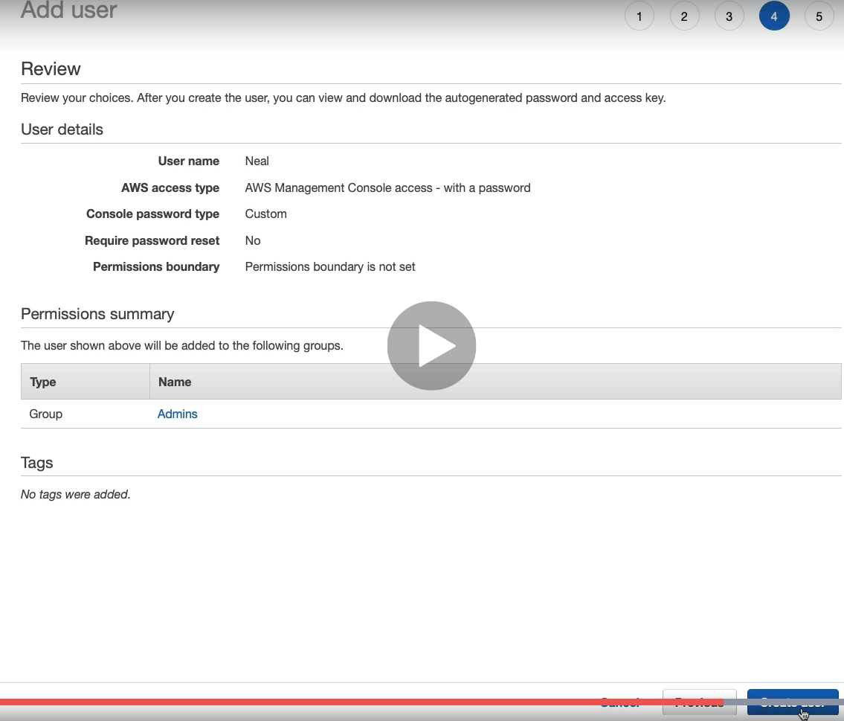

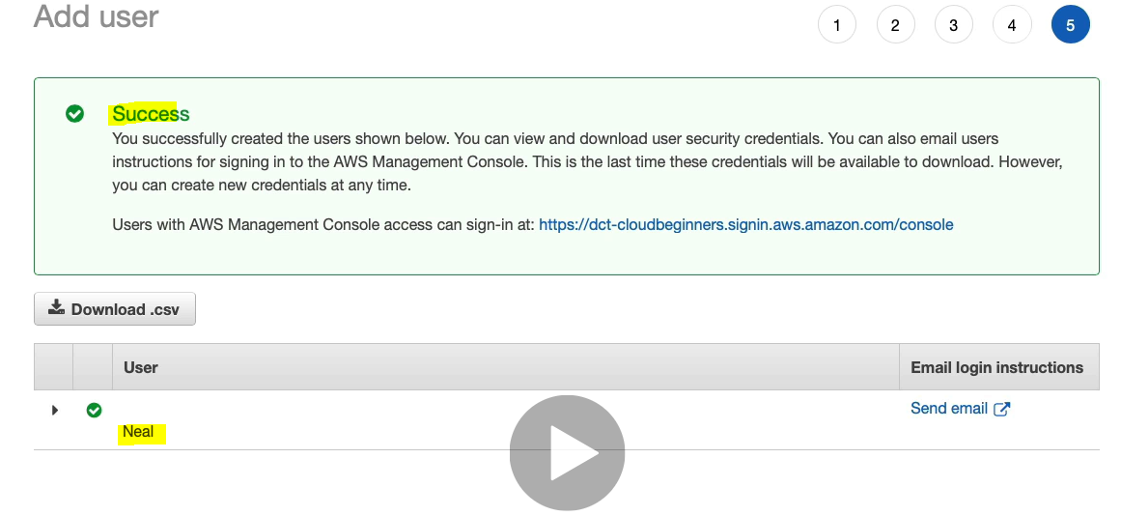

Now we can sign-in with dct-cloudbeginners account instead of 7digit number account provided by AWS by default. Here Neal is a user who is having admin access. So let’s login with account and user (Neal)

Now paste the link into AWS console and we will get dct-cloudbeginners as an account instead of 7digit number

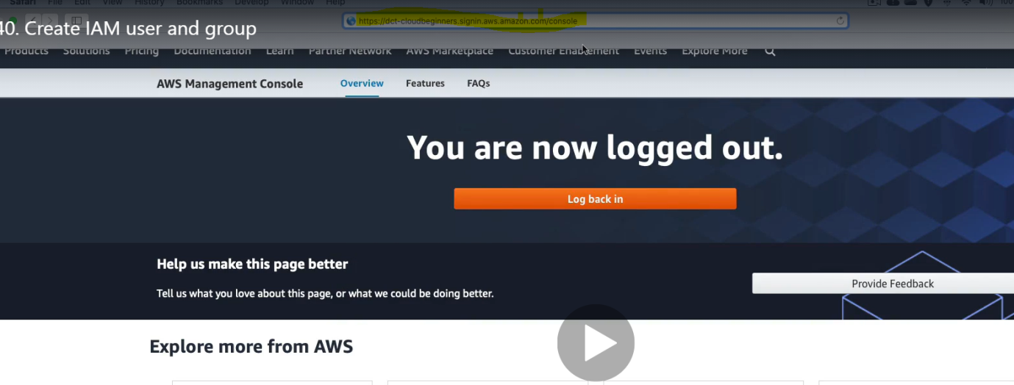

|  |  |
| --- | --- |
|  |  |

As we can see that the 12 digit account number got converted into alias . Now put the Admin User Name (Neal) and password and sign-in

Now we will get the console with lot of access as this user Neal is Admin user.

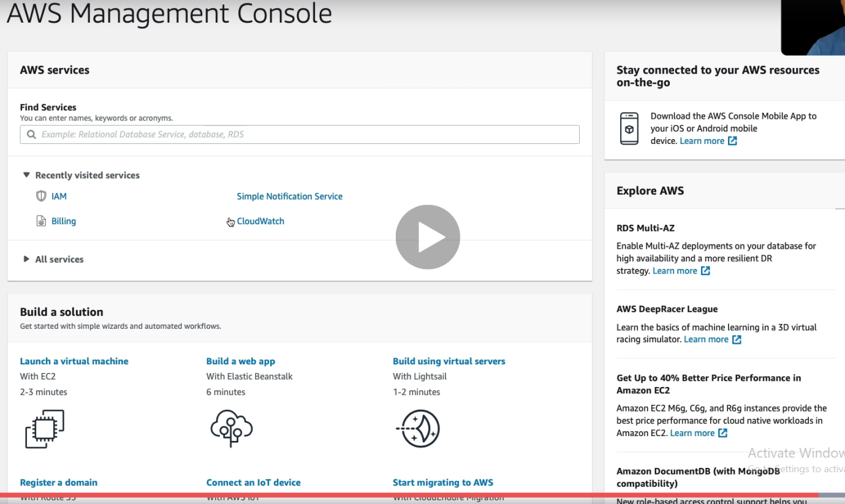

So now instead of root user we have login with IAM user.

**Amazon Virtual Private Network**:

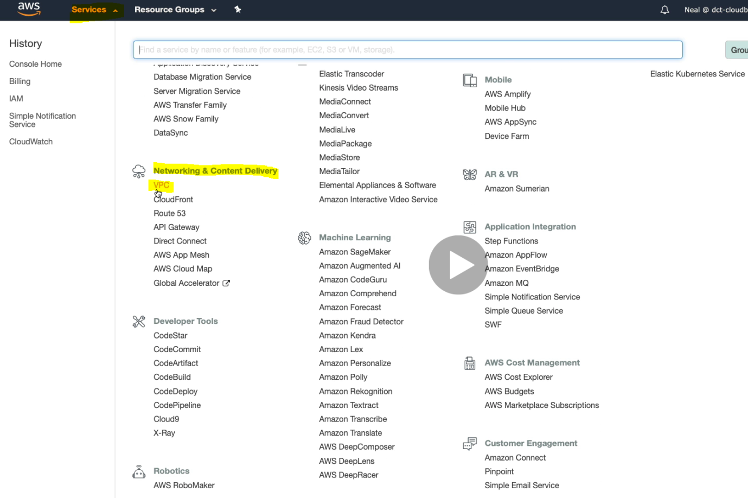

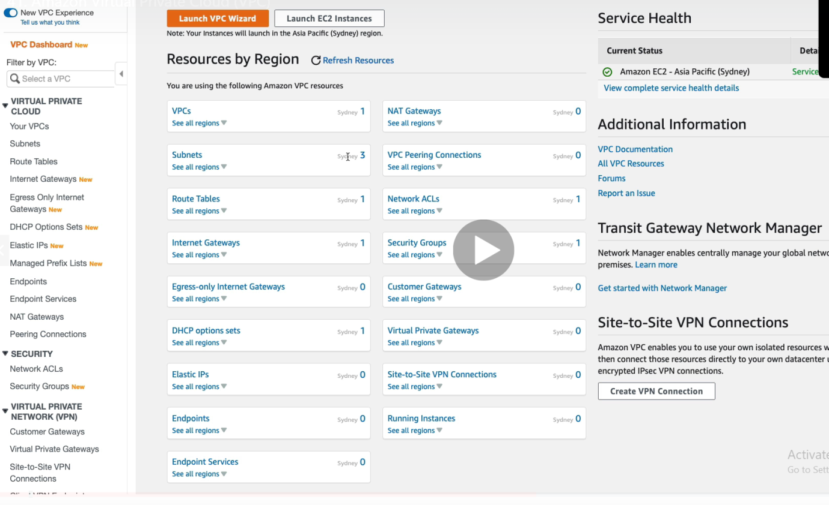

So here we can see the resource information according to their region like (VPCs , Subnets etc). These are the default number of resources based on the Region selected.

Click on “Your VPCs and will get the instance of VPC

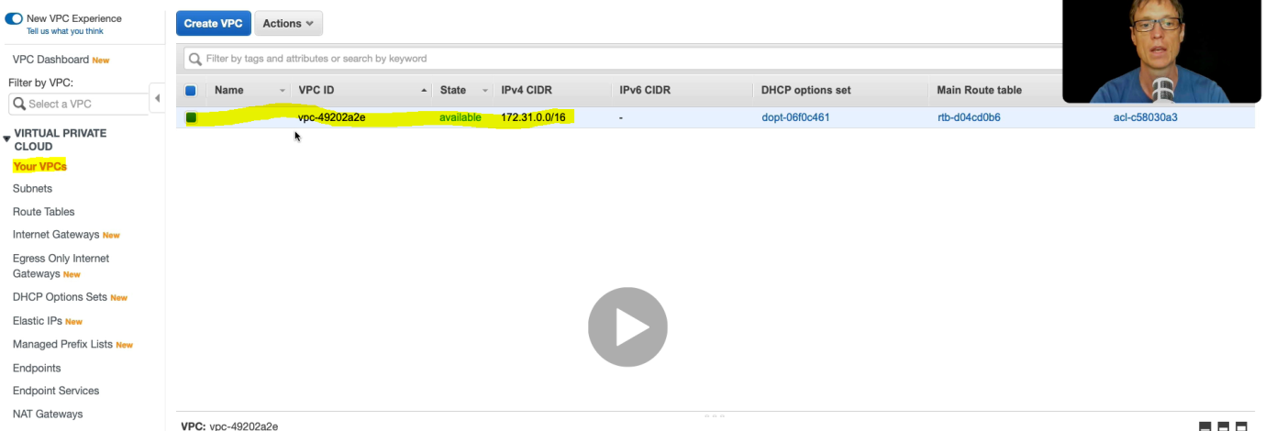

1 VPC by default.

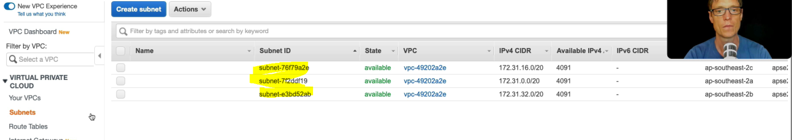

3 Subnet by default with different Availability Zone and Route Table ,default public IP.

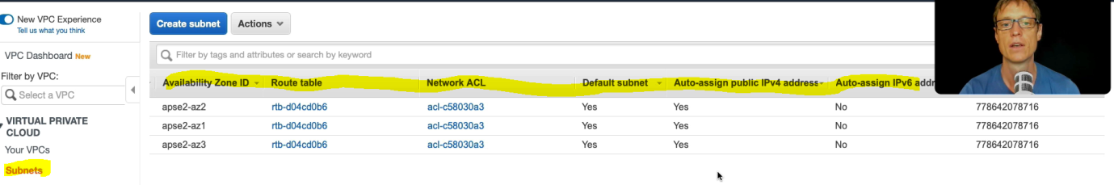

Click on Route Table and here we go.

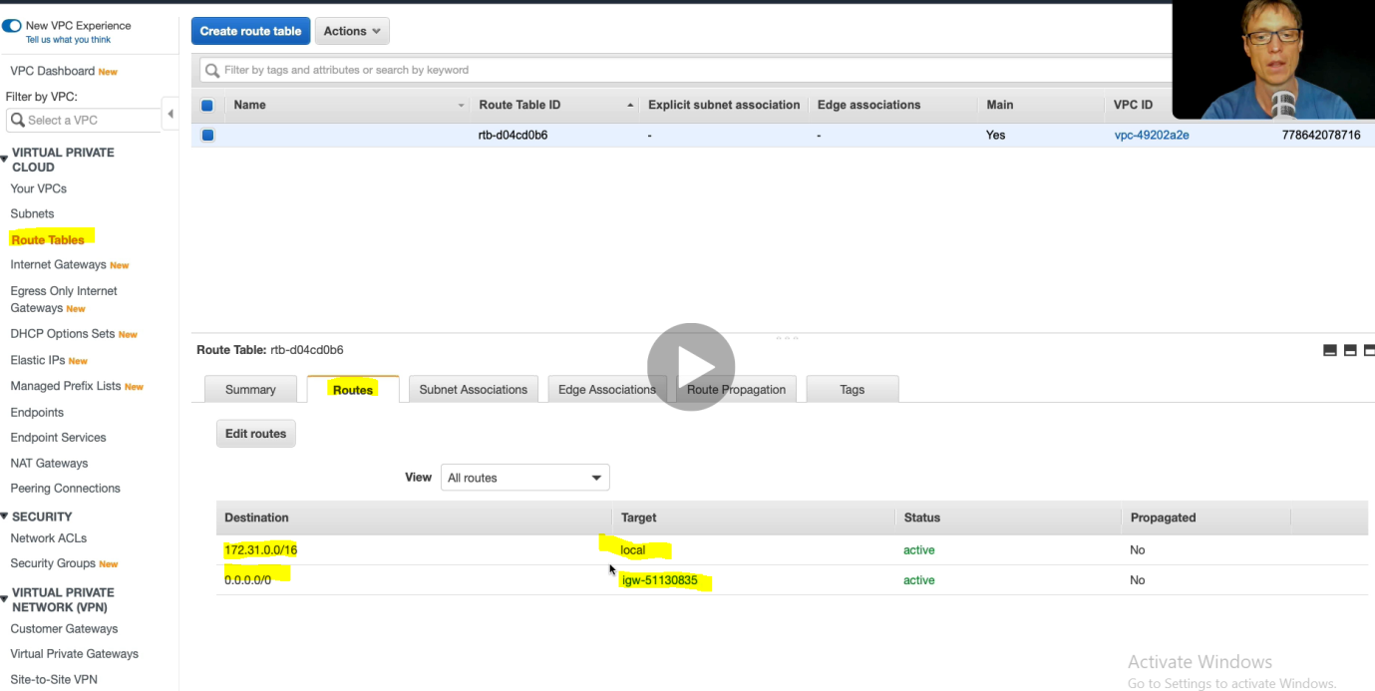

Very similar to diagram.

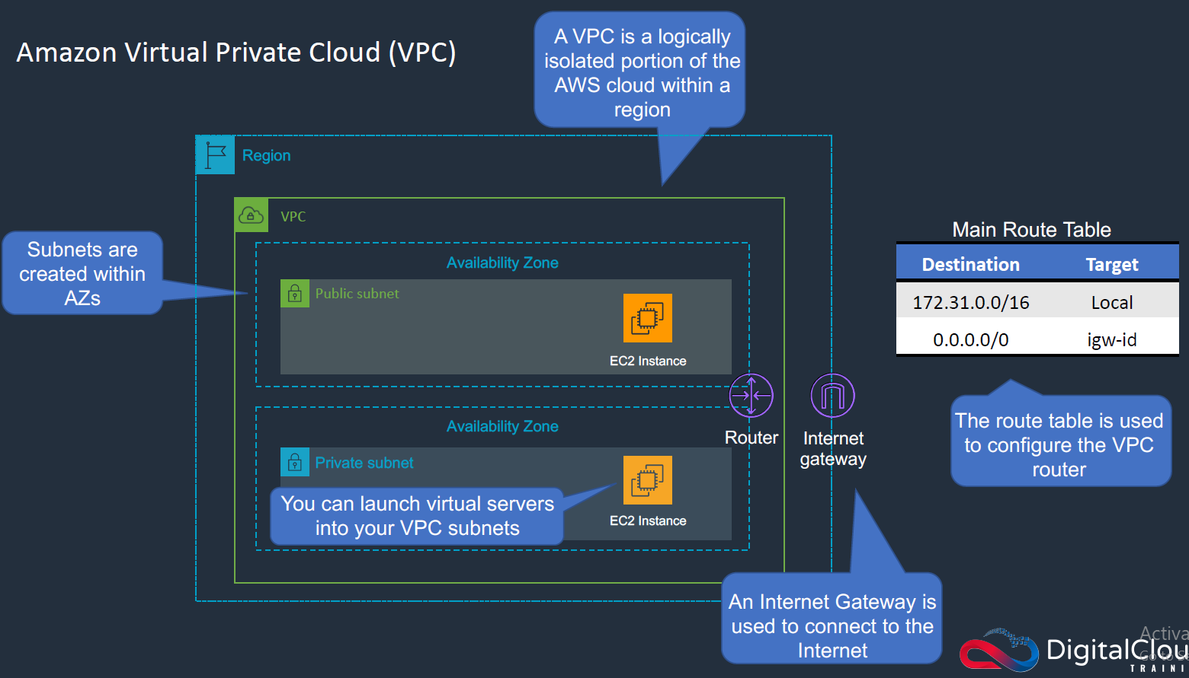

Now Click on Internet Gateway

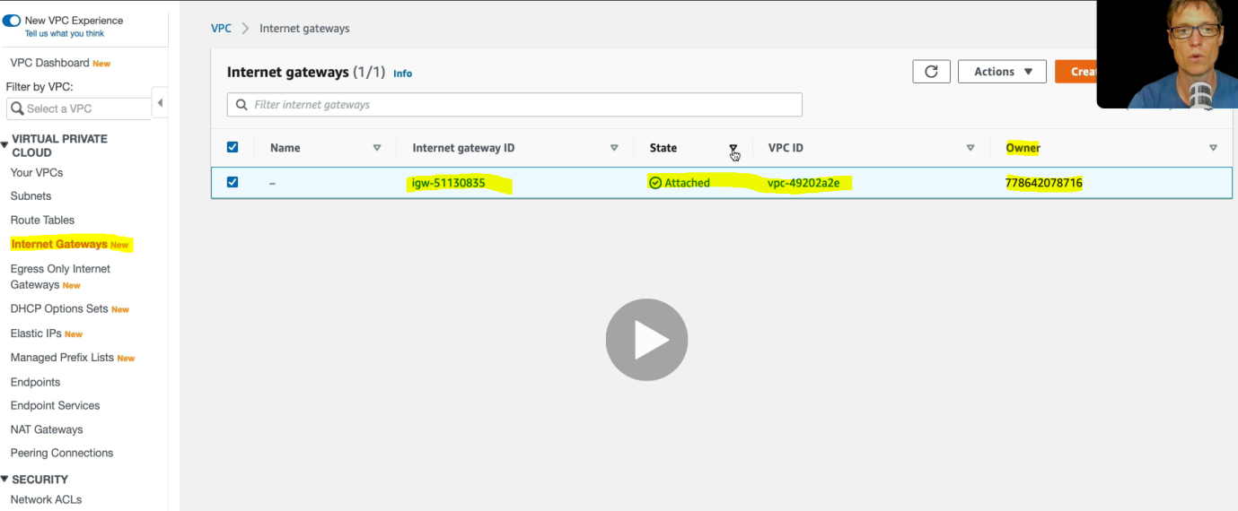

Security Groups & Network Access Control Lists( NACLs)

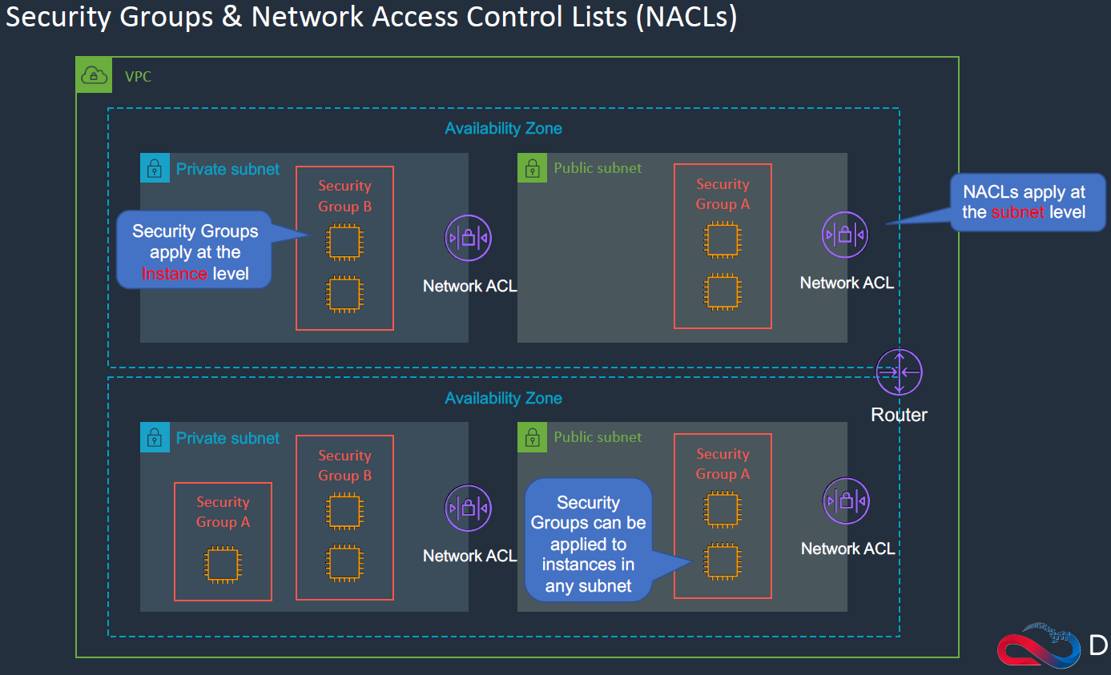

As here we can see that Security Groups can be applied at the instance level and NACLs can be applied at network or subnet level.

Let’s do it in AWS console.

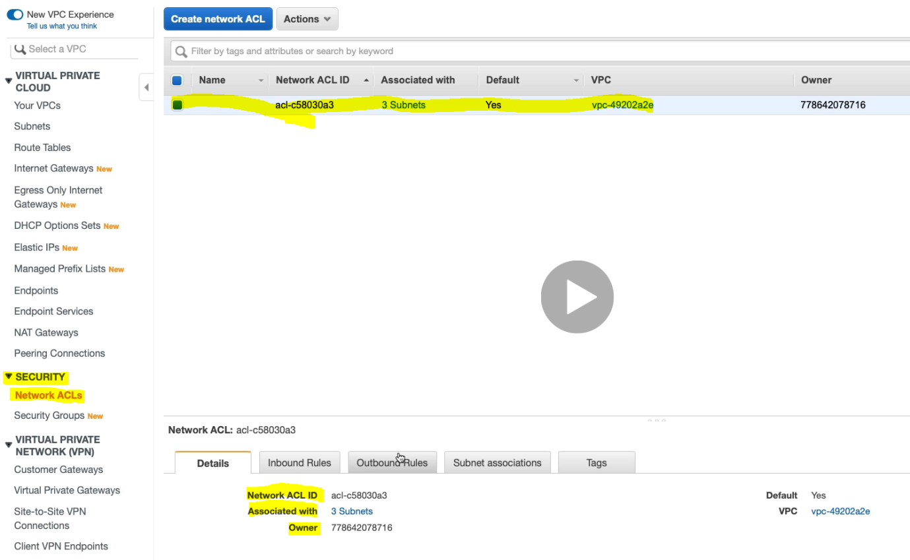

We can edit default Inbound / outbound Rules

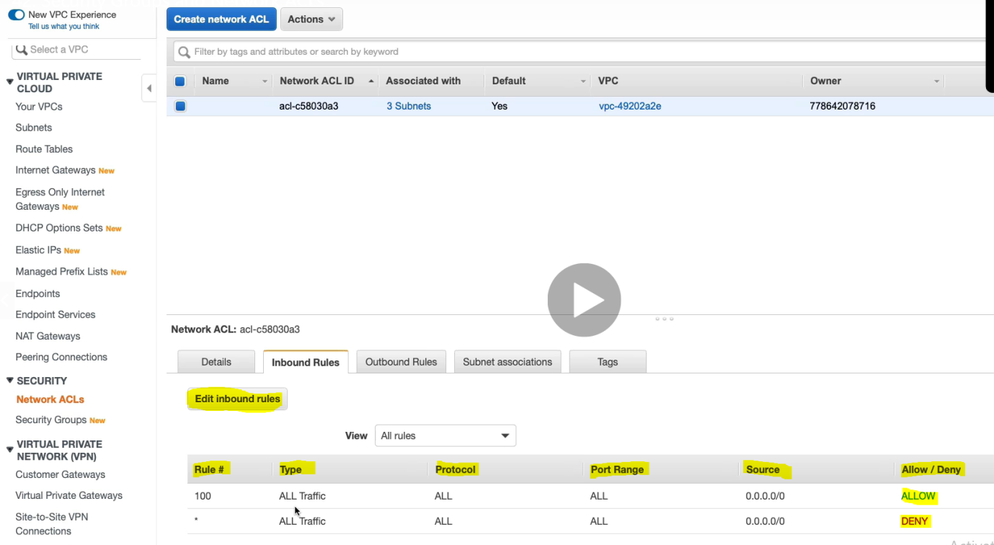

Let’s know about Security group:

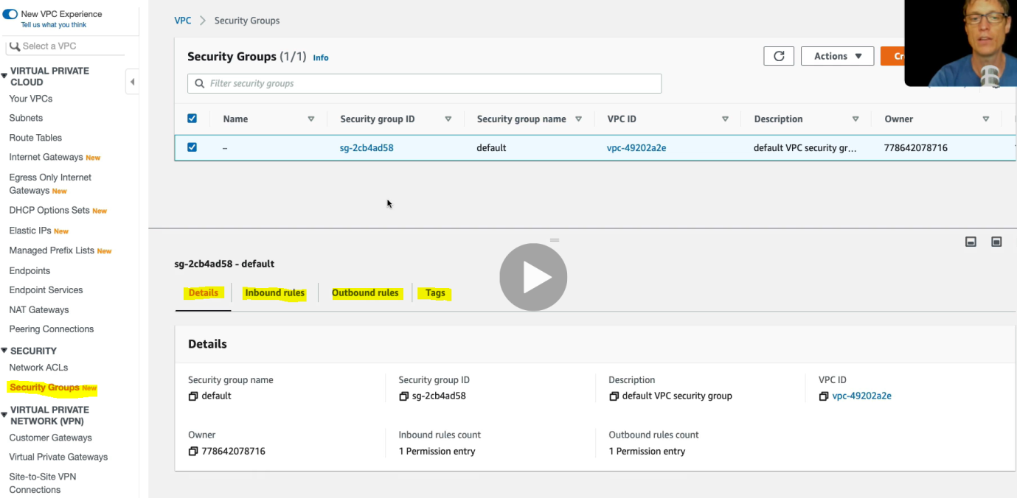

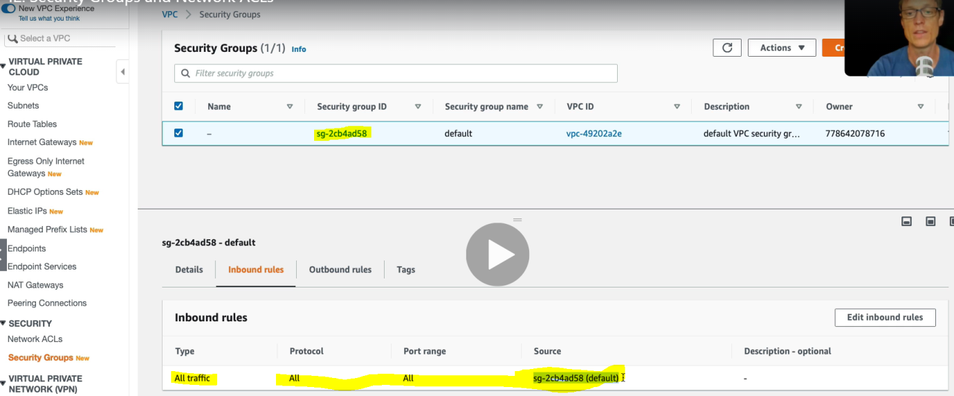

By- default here also it allows all traffic among the instances in the same security group. For example if we see the first diagram then all the instances will allow the traffic between inside the Security Group A. But instance of Security Group A and B are not allowed any of the traffic.

We can edit the inbound/outbound rules using edit rules button on RHS.

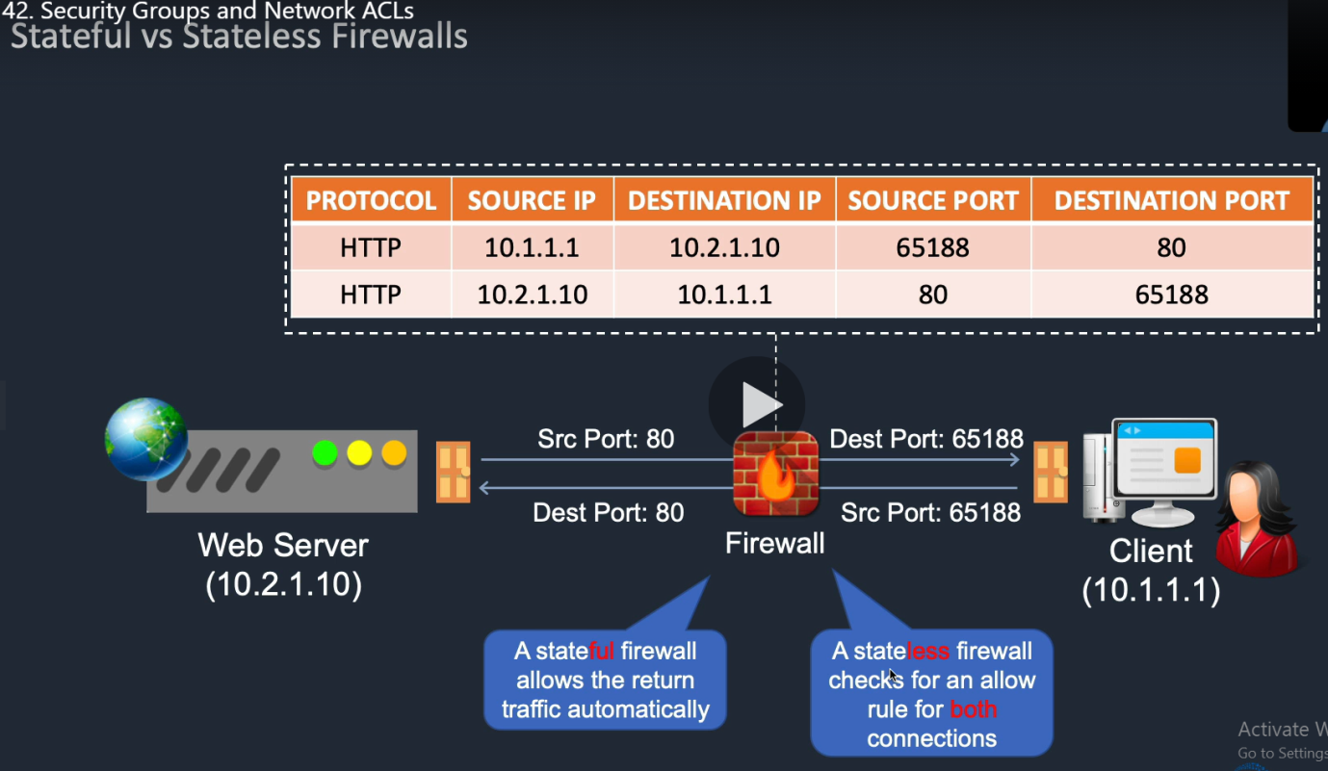

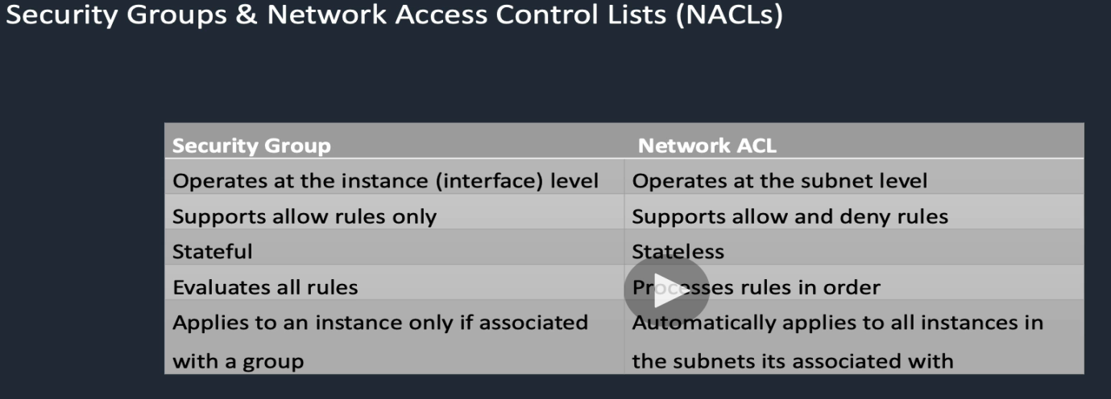

**AWS Public Vs Private Service**: It is one of the more confusing subject in the AWS.

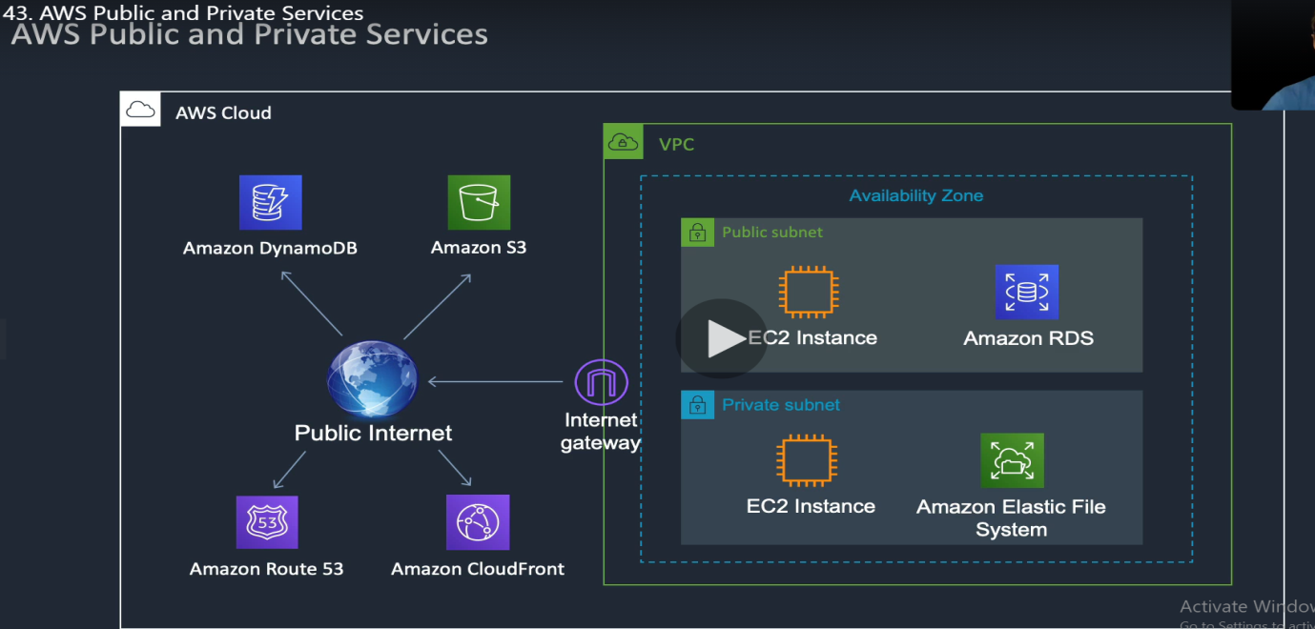

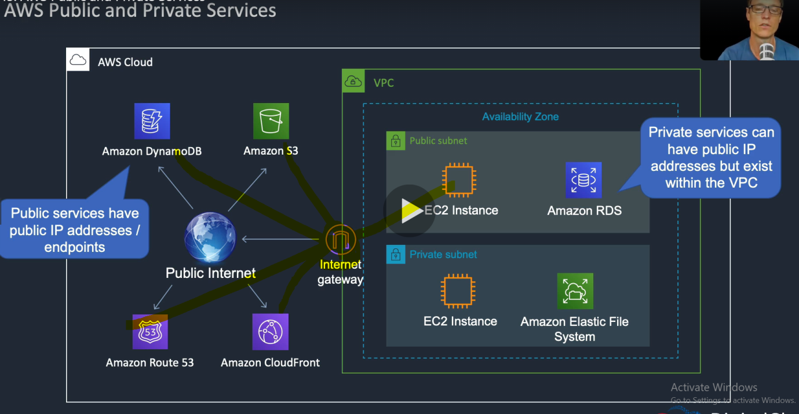

The instance or service in the VPC can connect only through Internet Gateway to the public service

Install the AWS Command Line Interface (CLI)

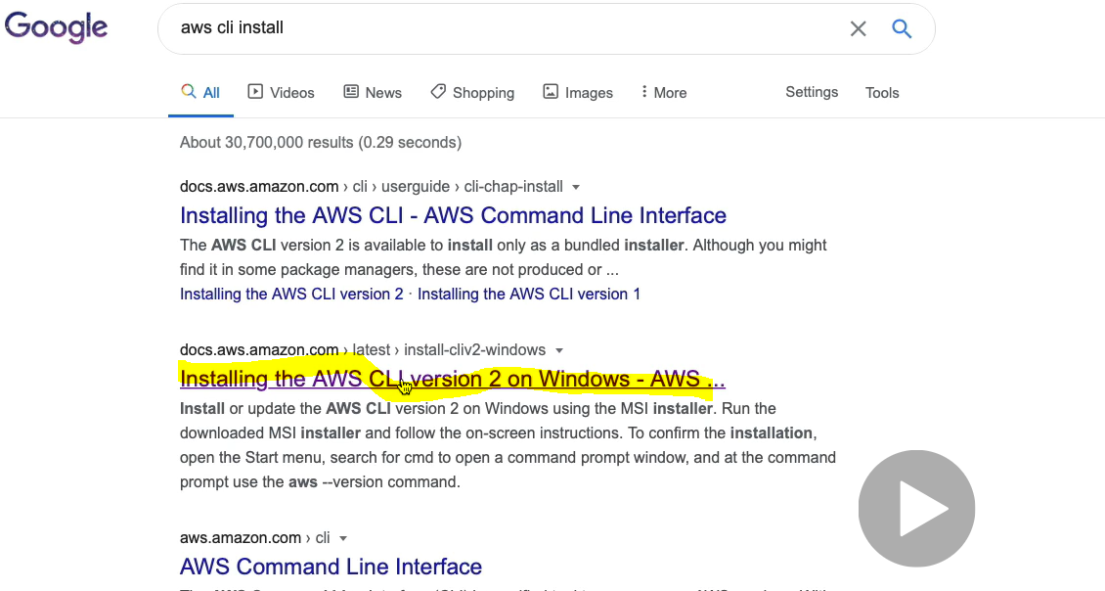 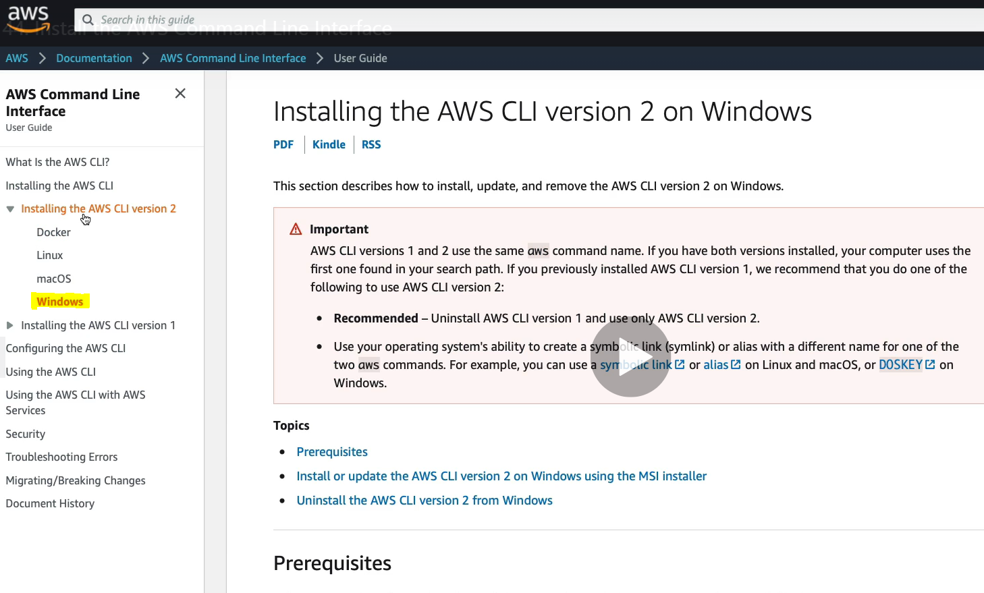

Follow the steps mentioned here and after installation we will get CMD screen like:

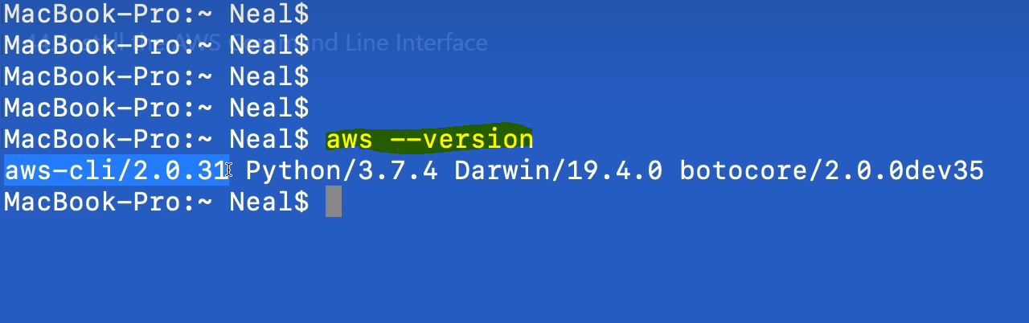

Amazon Elastic Compute Cloud (EC2) Service :

It is one of the core services in AWS. Here we will launch a virtual server in the cloud and will connect this server from the outside world. We will create a dynamic web page, will install web server, we will learn the auto scaling of these instances. We will connect the load balancer with this server.

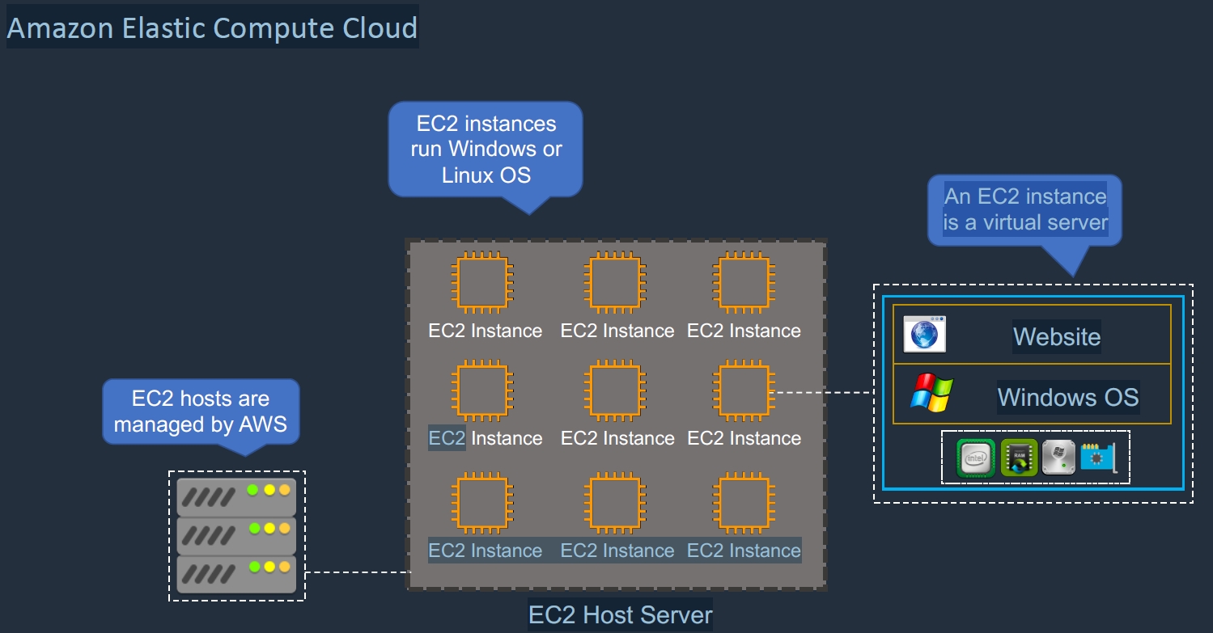

An EC2 instances run Windows or Linux OS in the AWS environment. Each EC2 Hosts are managed by AWS. An EC2 instance is nothing but a virtual server. Each instance will CPU, RAM, HardDisk space and Network Interface, on top of it will have operation system (OS) and then will have some website or other applications.

EC2 instances need an IP address. There are three types of ip address that an instance could have.

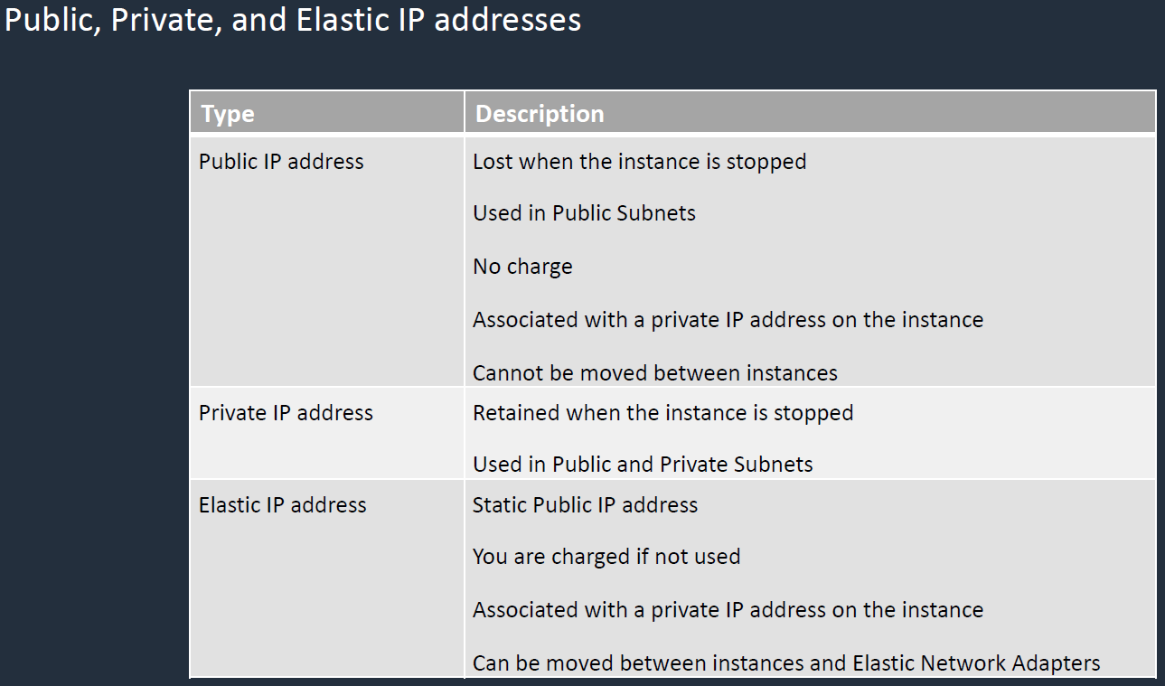

Elastic IP is very similar to public IP but the only difference is that static IP never changed even after instace is stopped.

Pbulic Subnet:

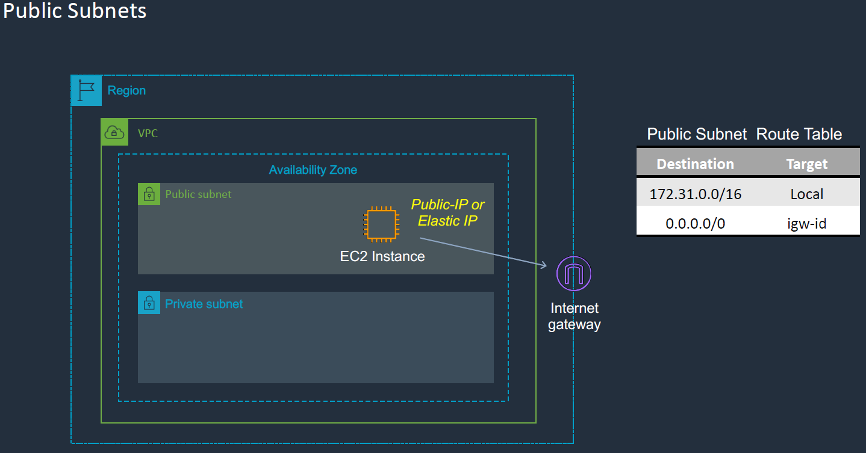

In a public subnet , it will have either public ip or elastic ip and this IP can talk to out side word through a internet gateway.

Private Subnet

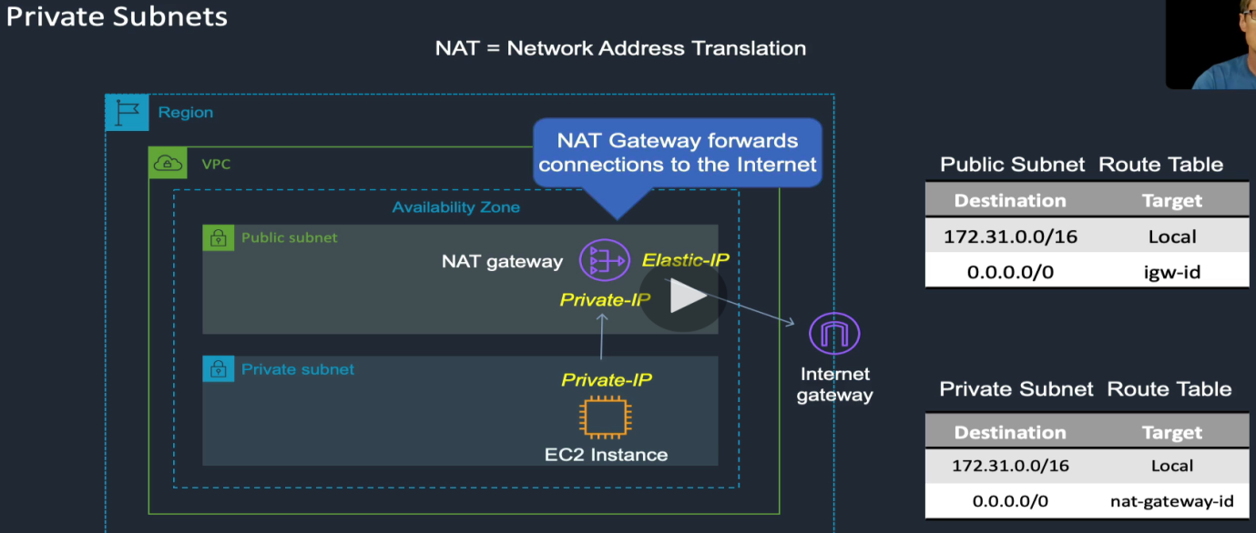

In a private subnet it will have private ip which can not talk to outside world directly through internate gateway. In this case we will use Network Translation Gateway (NAT) . This we can create in the AWS account. So private subnet sends and network gateway id to NAT Gateway defined in the public subnet and in turns it connect the outside world through the Internet Gateway.

**Launching an Amazon EC2 Instance:**

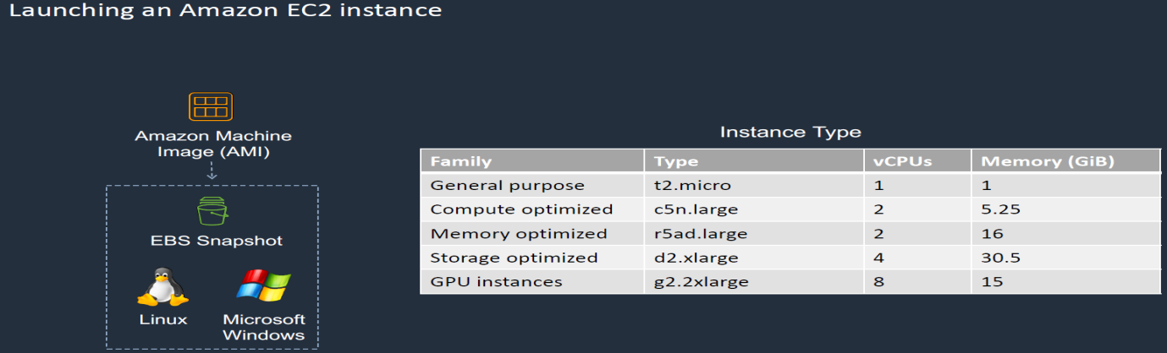

* We will use AWS management console to launch Amazon Machine Image. It already consist of the Machine image with the all the different versions. We can select the instance type and their configuration during their launch.

AWS management console:

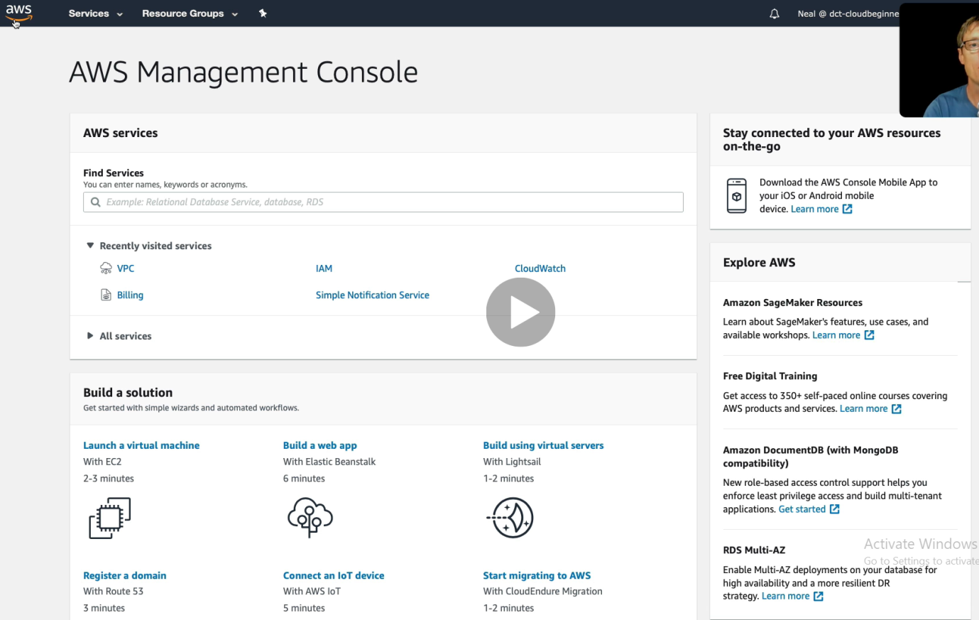

**Go to services > compute > click on EC2.**

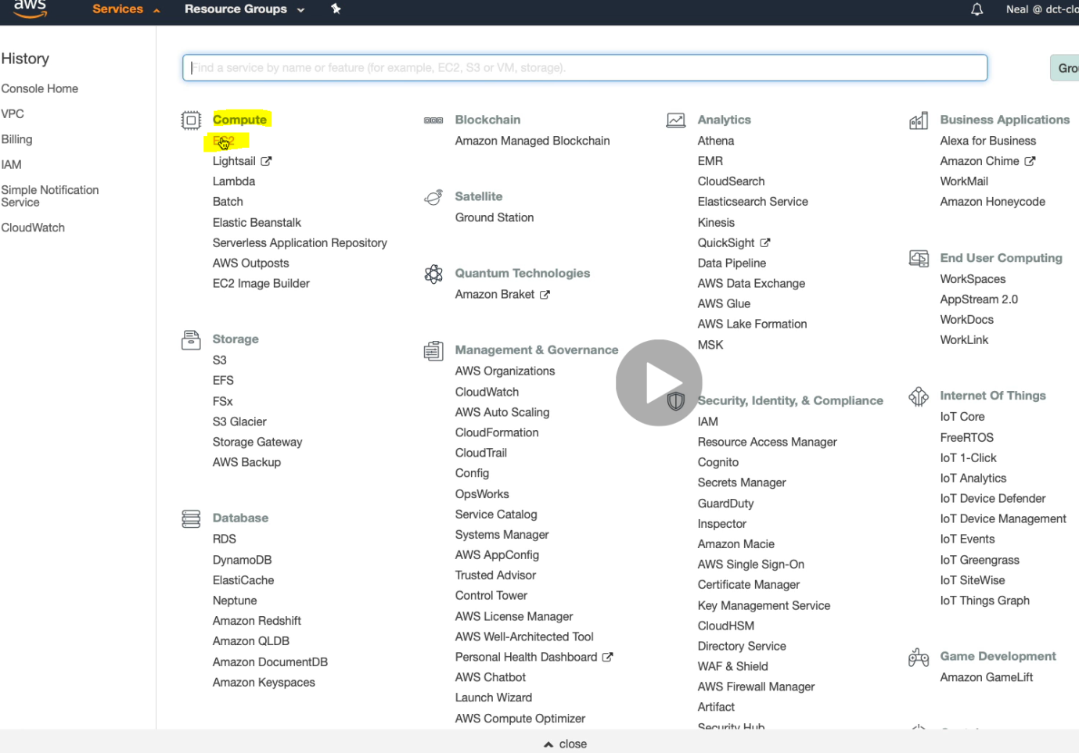

**It Lauches the EC2 Dashboard**

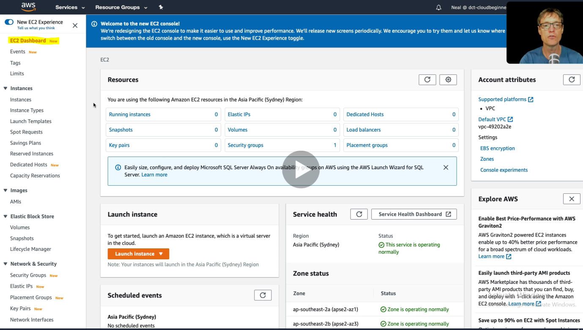

**Click on Instances**

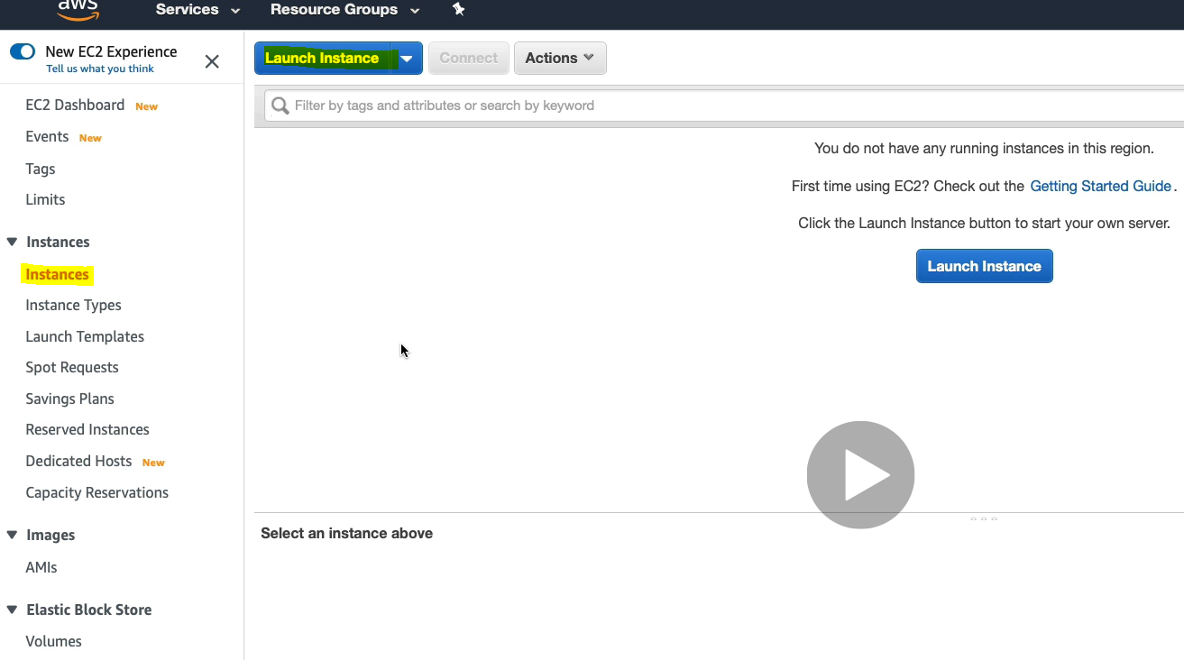

**Click on launch Instance:**

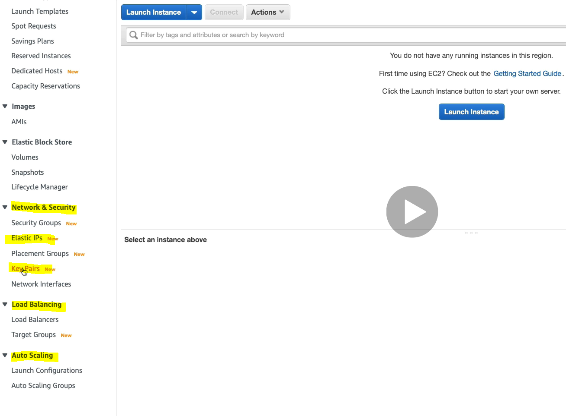

**As in the LHS, we can configure all the things mentioned in LHS in yellow marked. (Network Security, Load Balancing, Auto Scaling).**

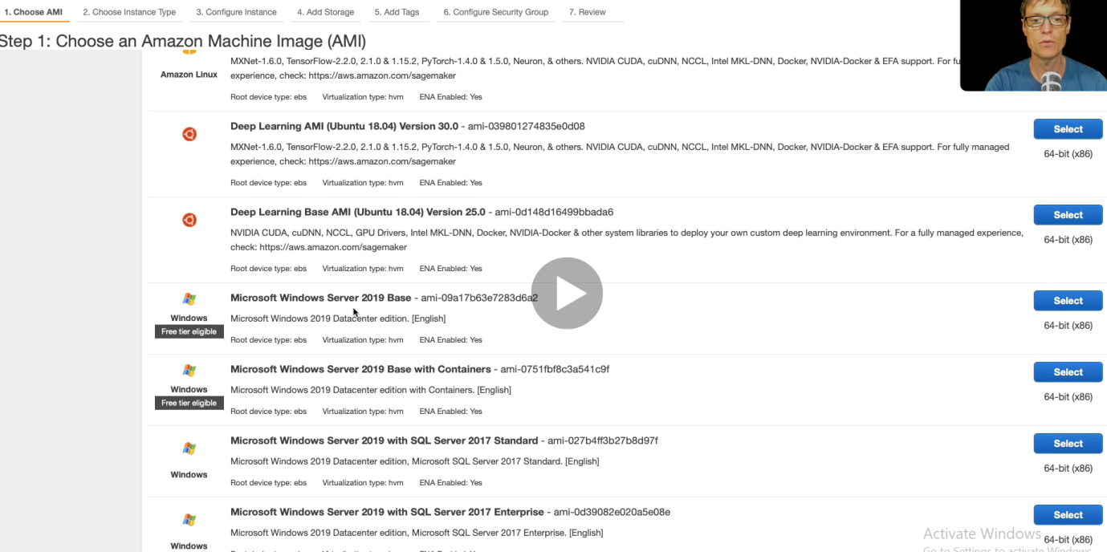

**And now we have got a series of OS to be selected**

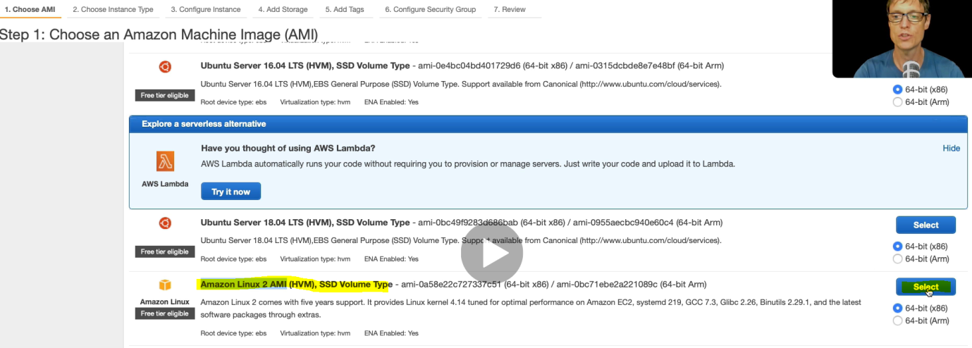

**Let’s select Amazon Linux 2 AMI**

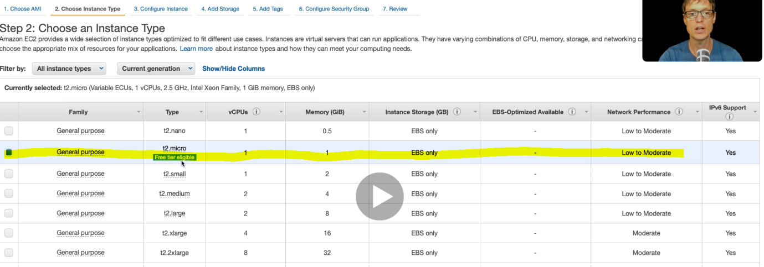

**Click Next:**

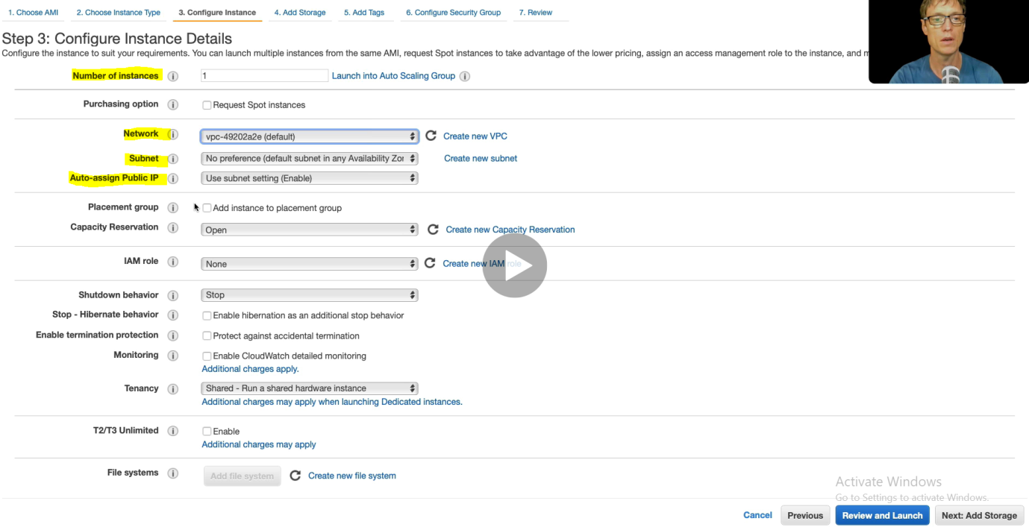

**Next**

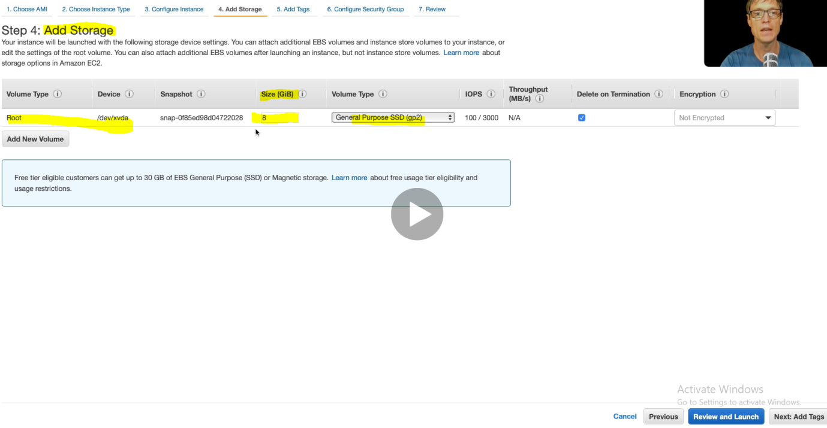

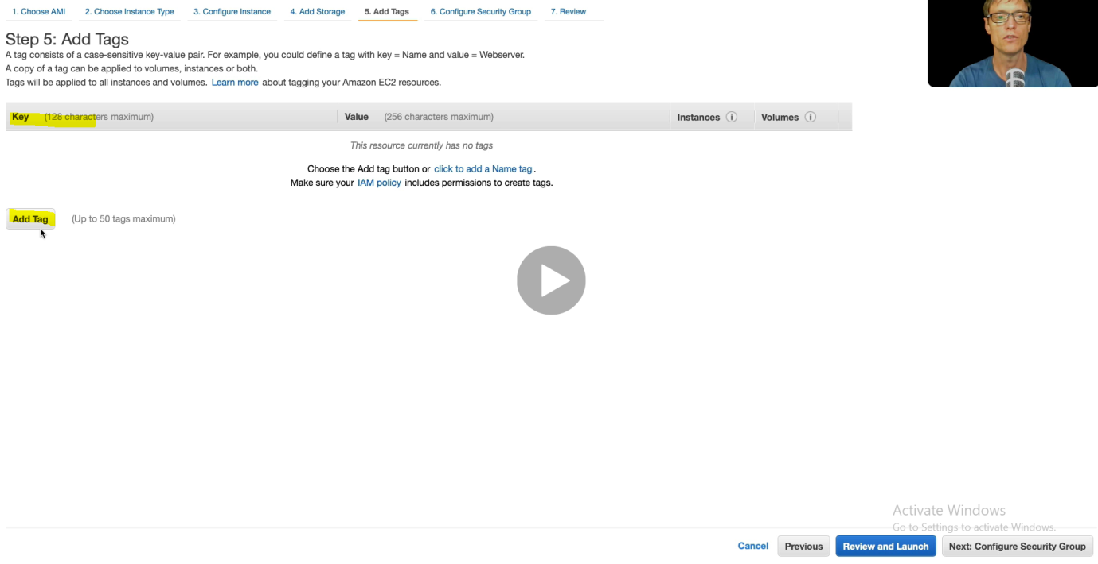

**Next**

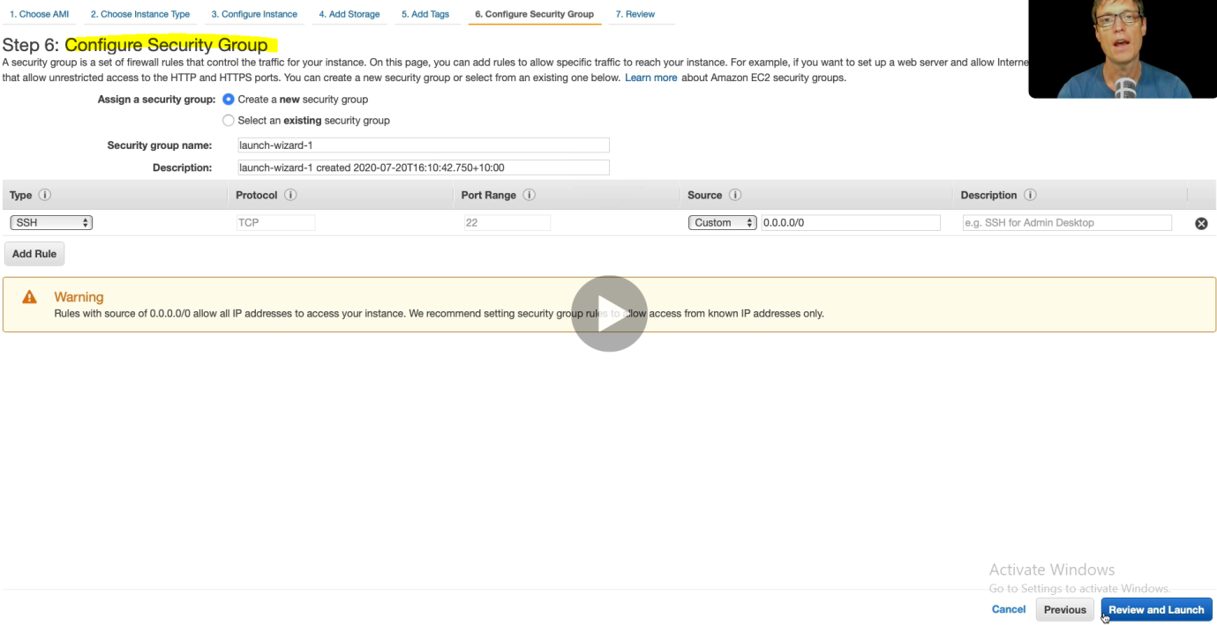

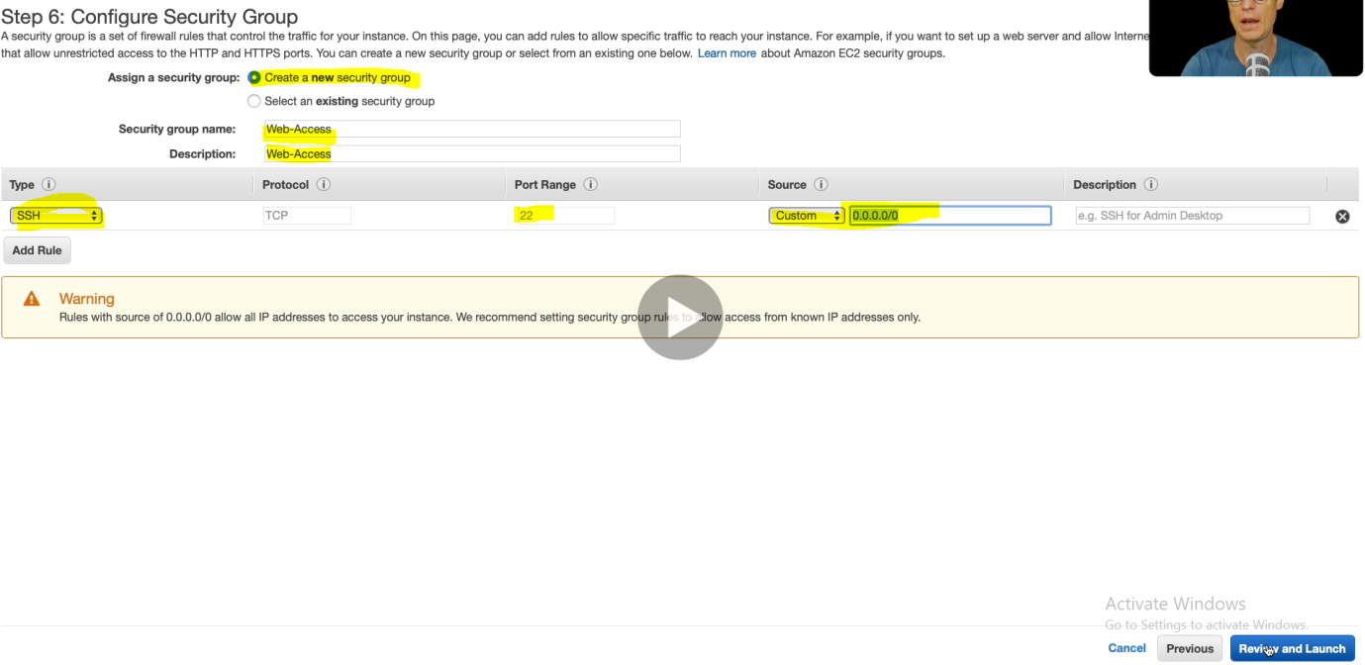

**Here 0.0.0..0/0 means source from anywhere**

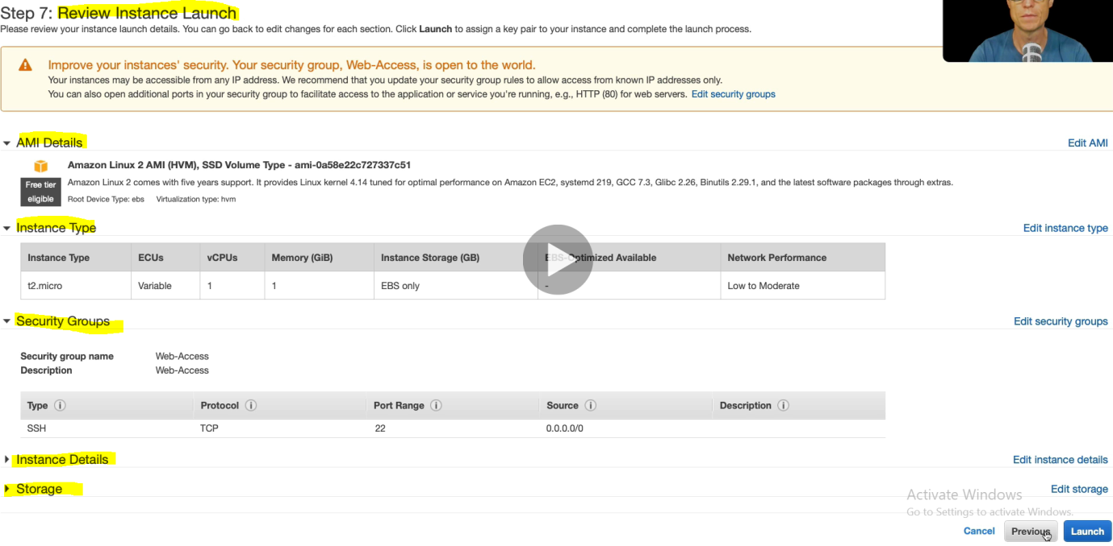

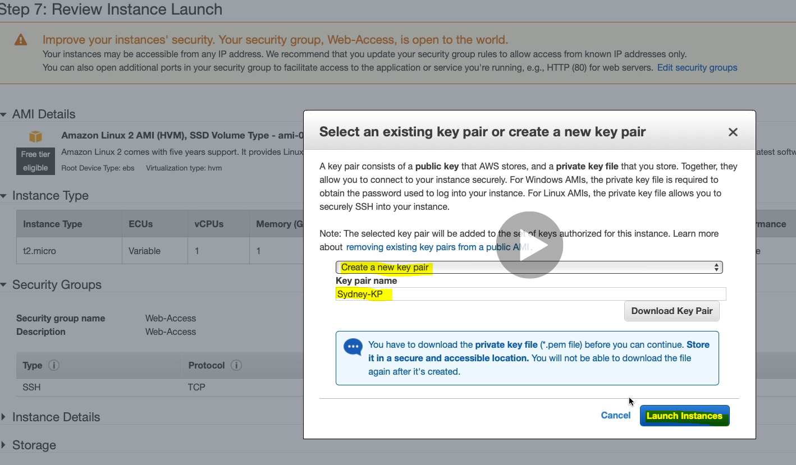

**Create the key pair which contains the private key which will use to connect with Linux machine created on AWS**

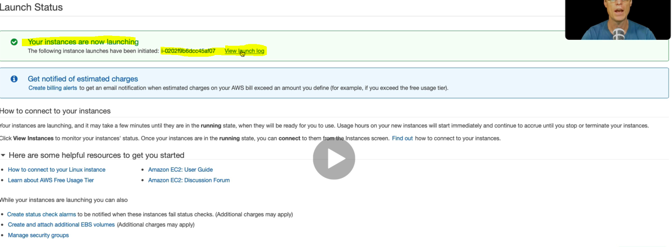

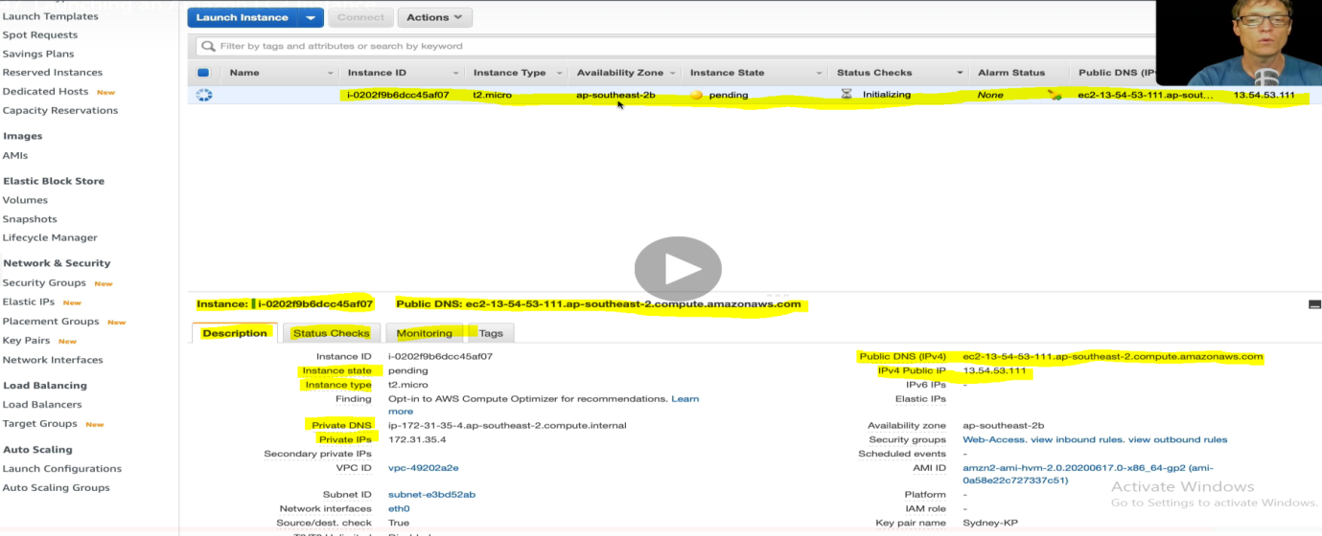

**Here we have got the new instance and its detail. We can check the status and monitoring also.**

**Connecting to Amazon EC2 instances**

So we have now launched linux EC2 instance in AWS and now we will see how to connect this EC2 instance with our local machine or from other remote machine.

Now let’s launch Windows EC2 machine in AWS from different region.

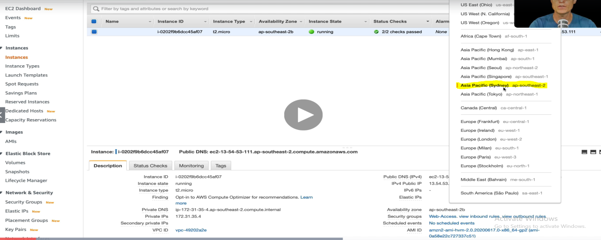

Selected another region Asia Pacific (Sydney)

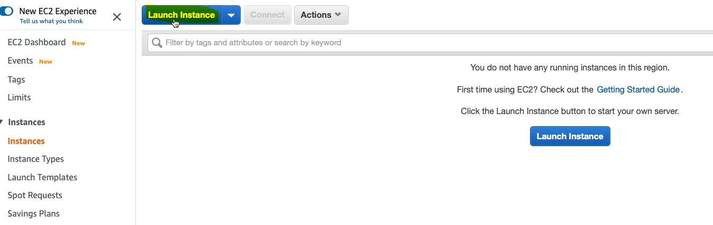

Click Launch to another Window machine.

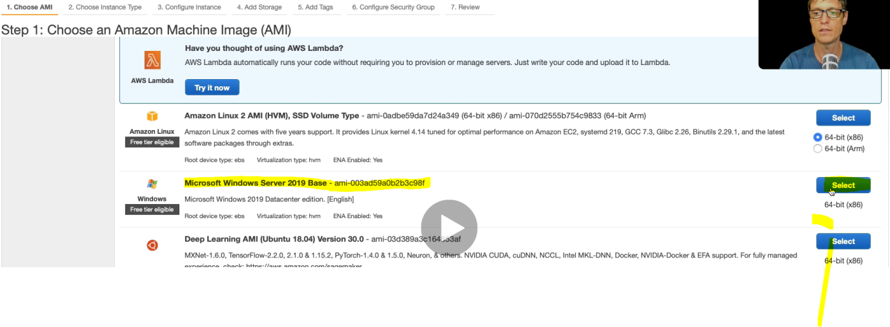Select Windows Server 2019

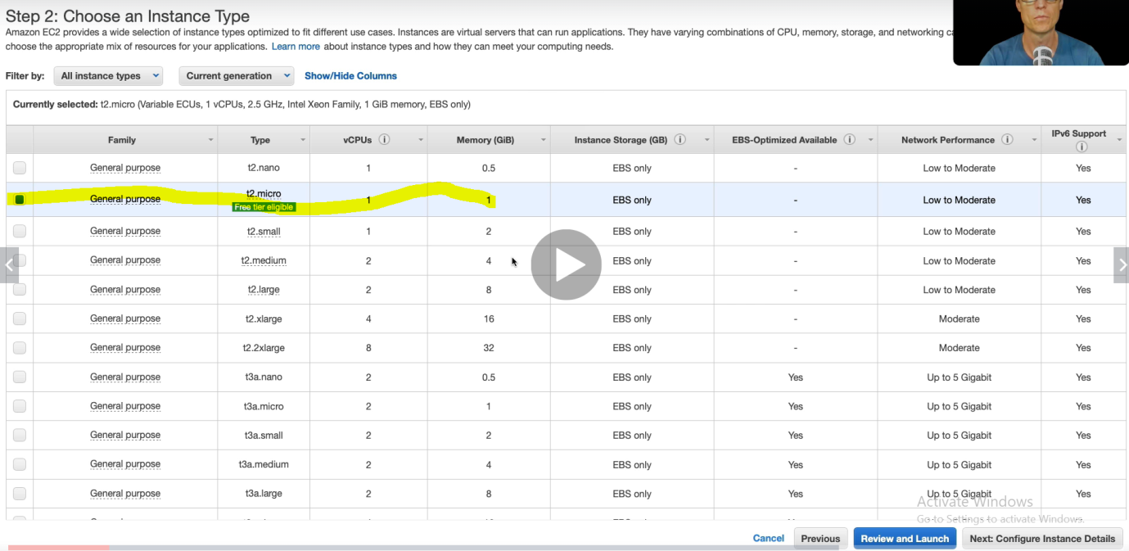

Click Next

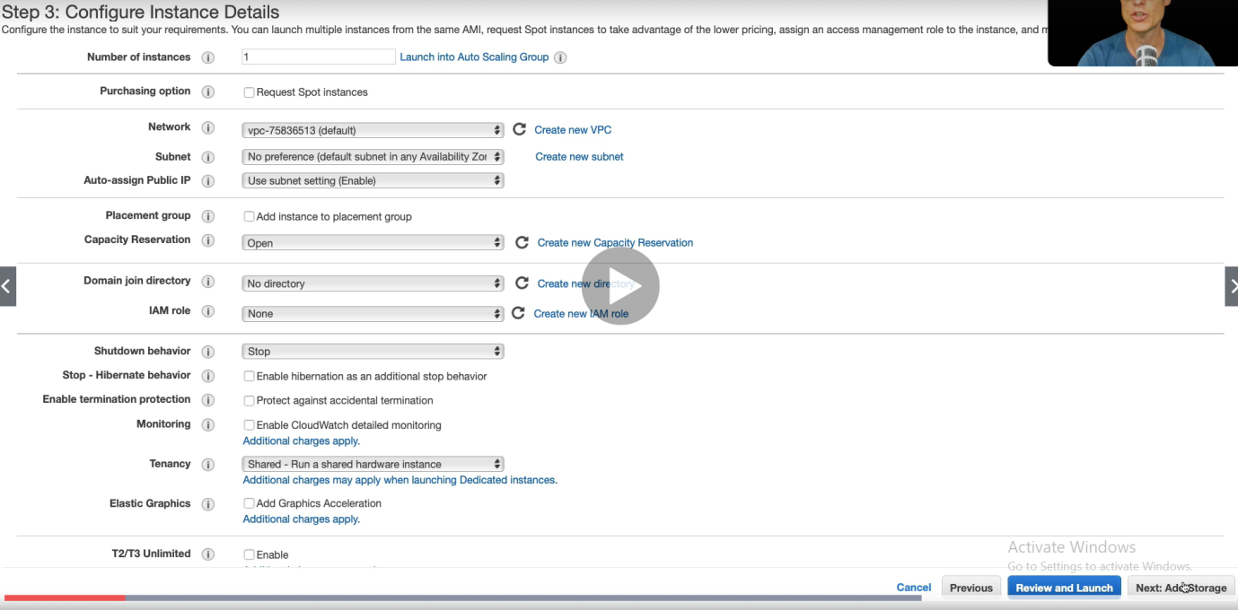

Click Next.

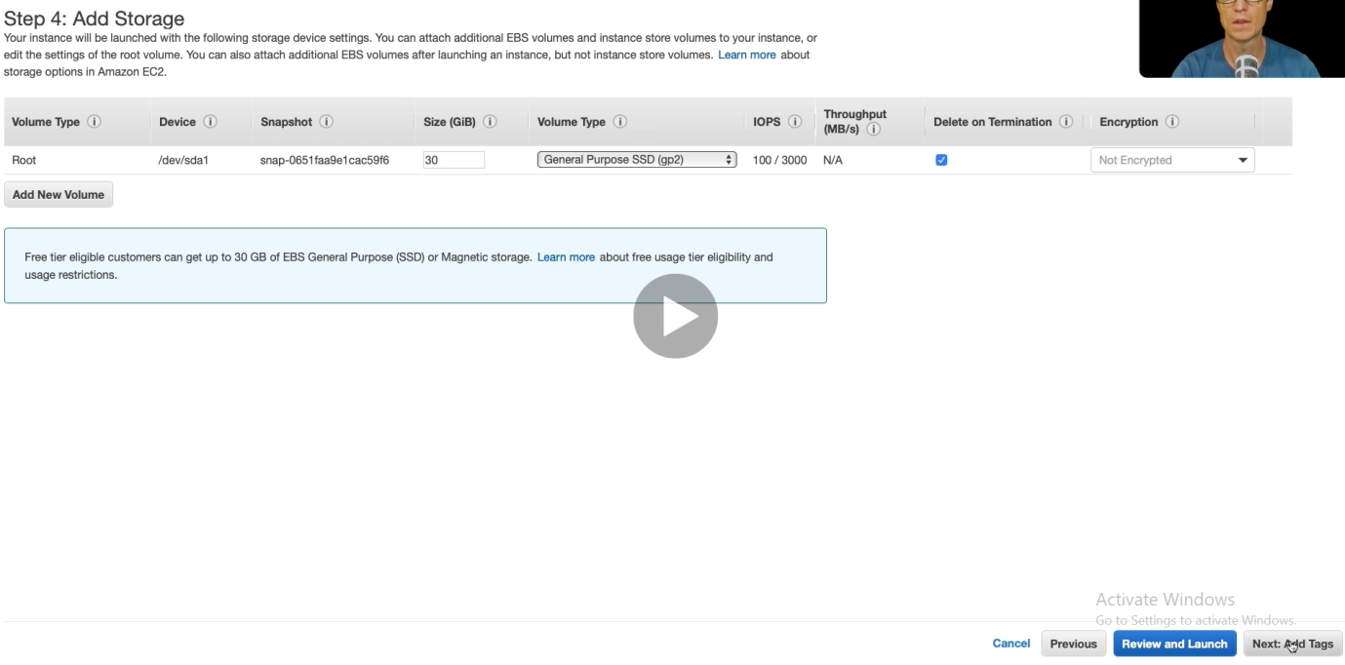

Click Next

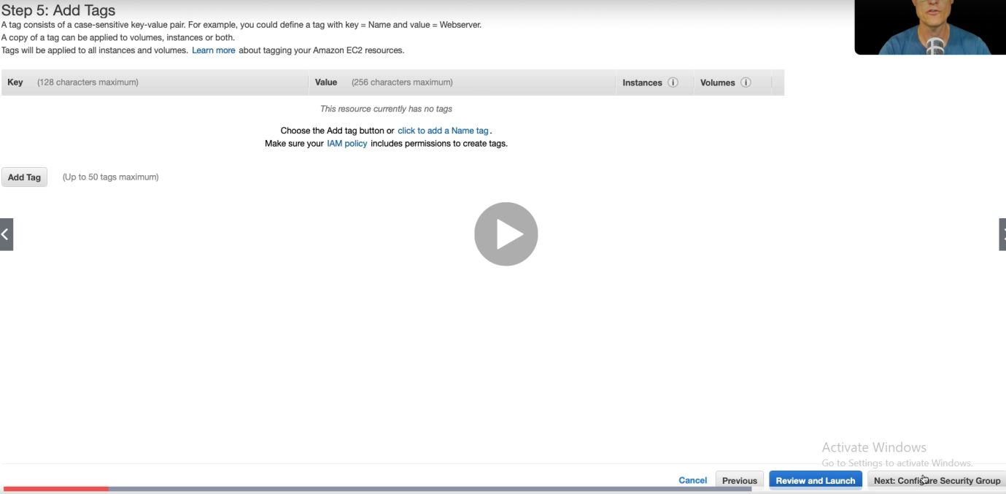

Click Next

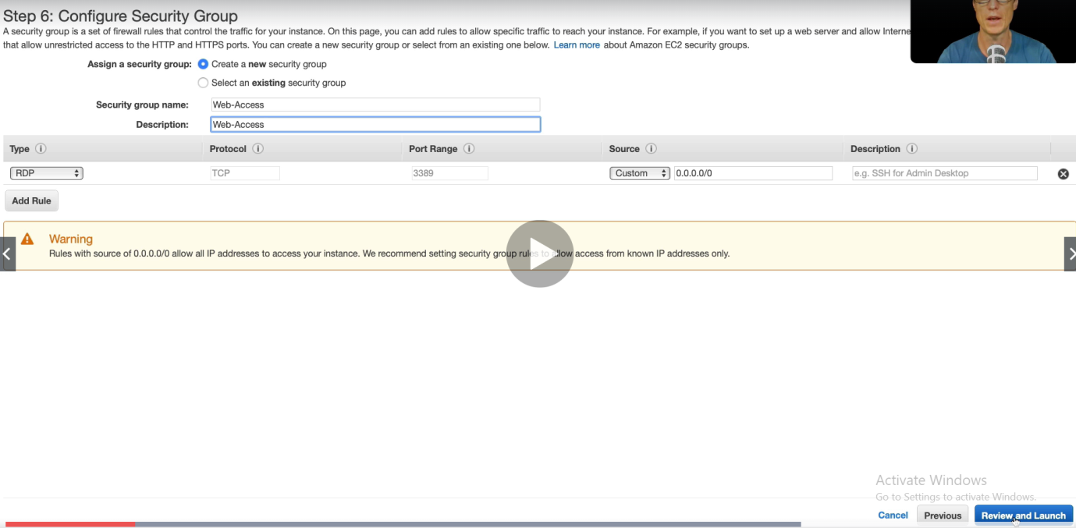

Here we have RDT (Remote Desktop) because it is windows server instead of SSH (in Linux Sever)

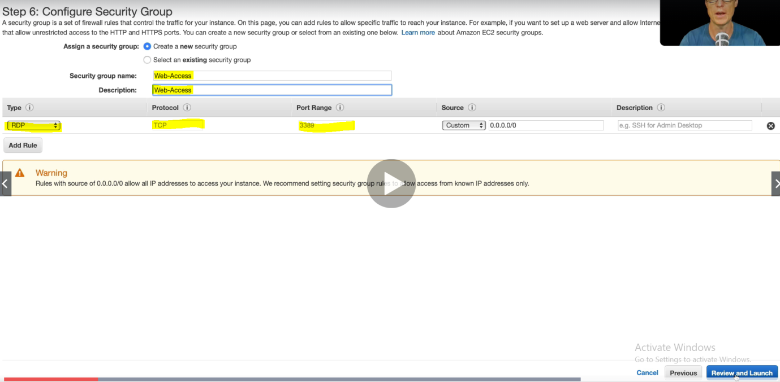

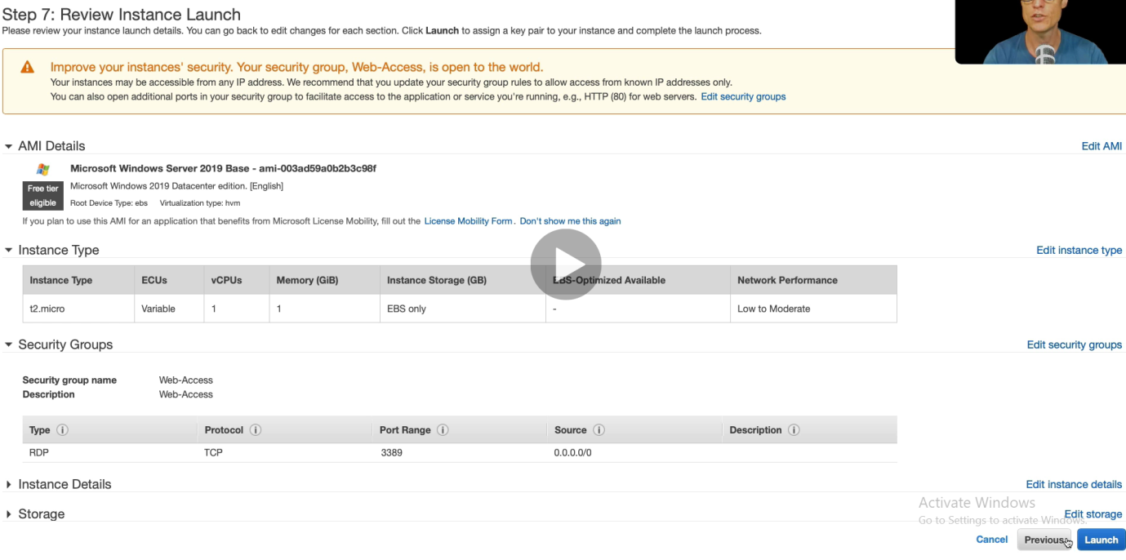

Click Launch

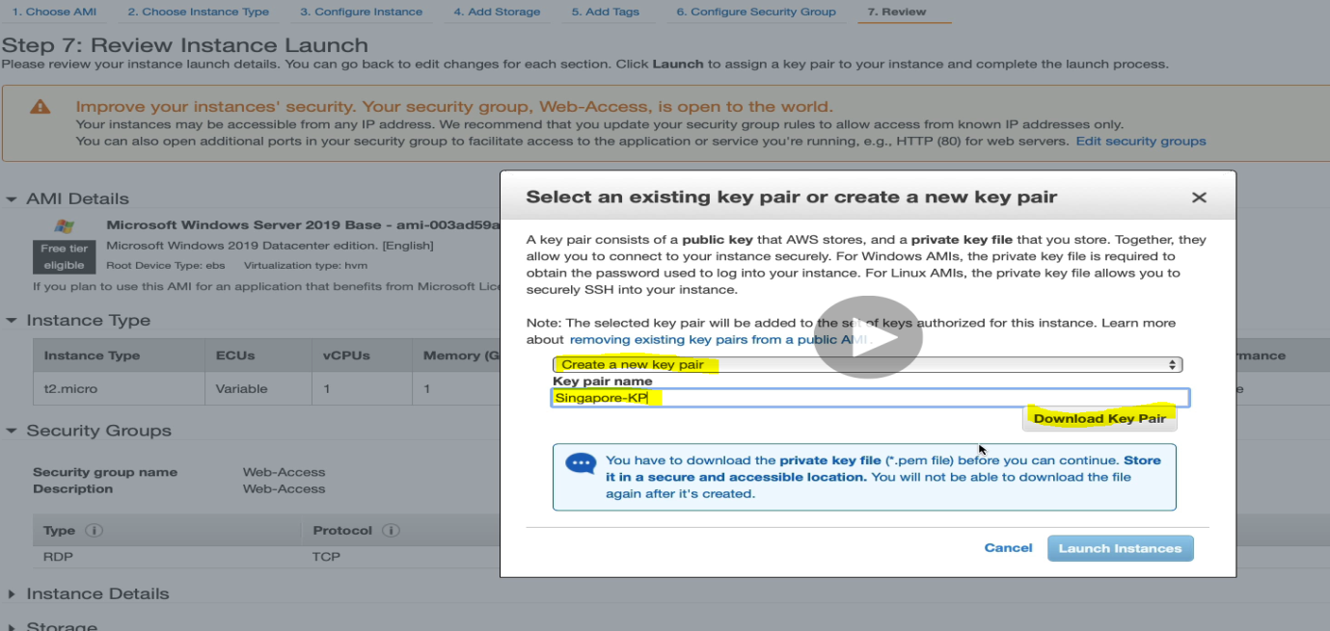

Now to connect this Window machine with Linux machine**, let’s go back to Linux instance**.

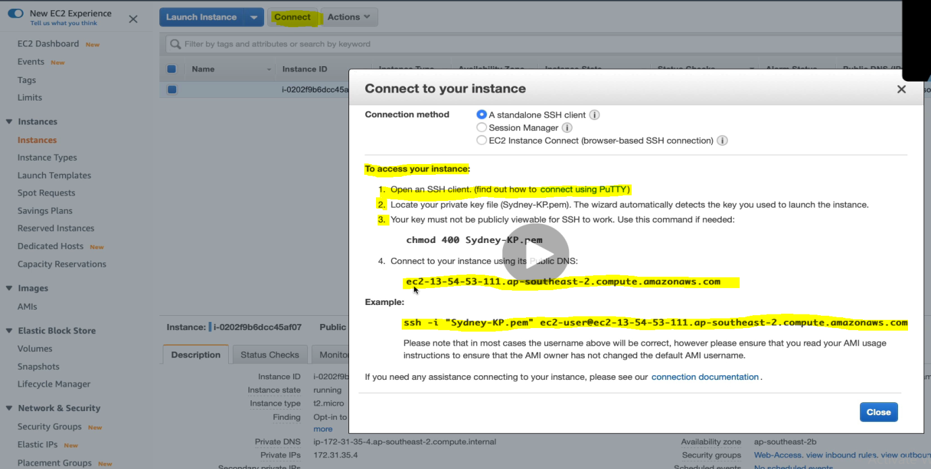

While click on connect it provides the important information as highlighted in the yellow.

It tells us that first run the command [chmod 400 KeyPairFile] the change the permission.

And then using the Public DNS name we can connect our machine. Example to run in the command is given below.

Now let’s go back to AWS command prompt.

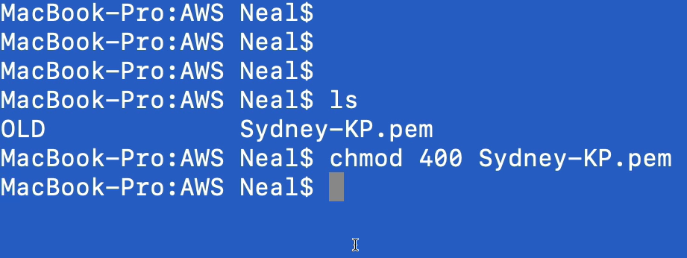

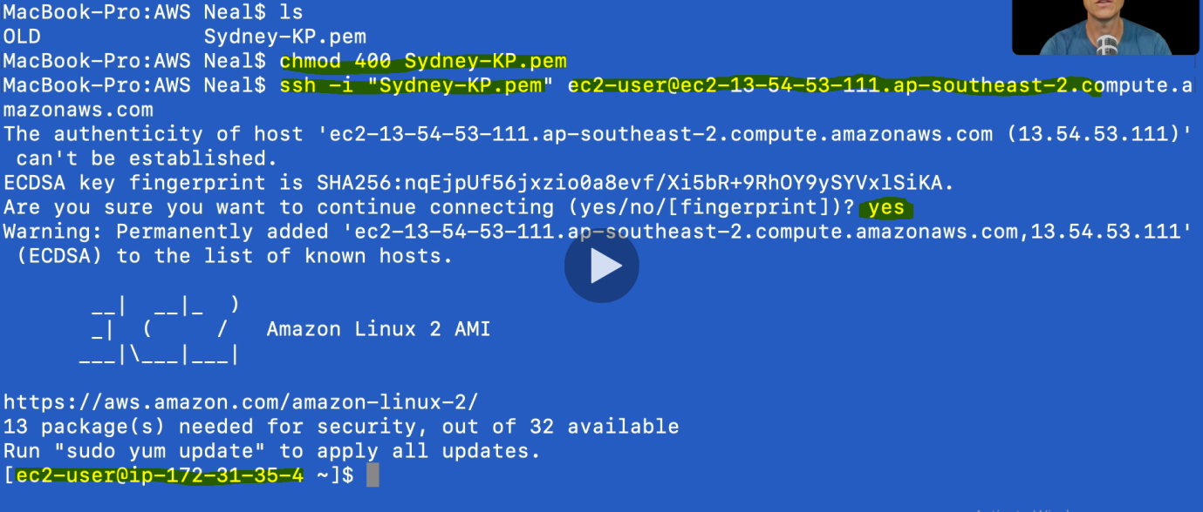

Now we have logged to our instance: ec2-user@ip-172-31-35-4

Run the YUM command to update Linux software repository to install all the packages.



Now let’s back to another region Windows and connect linux machine from Windows.

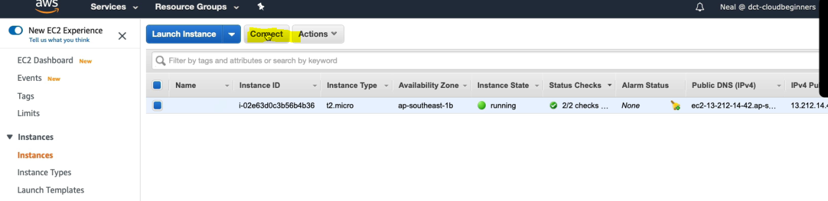

Click connect

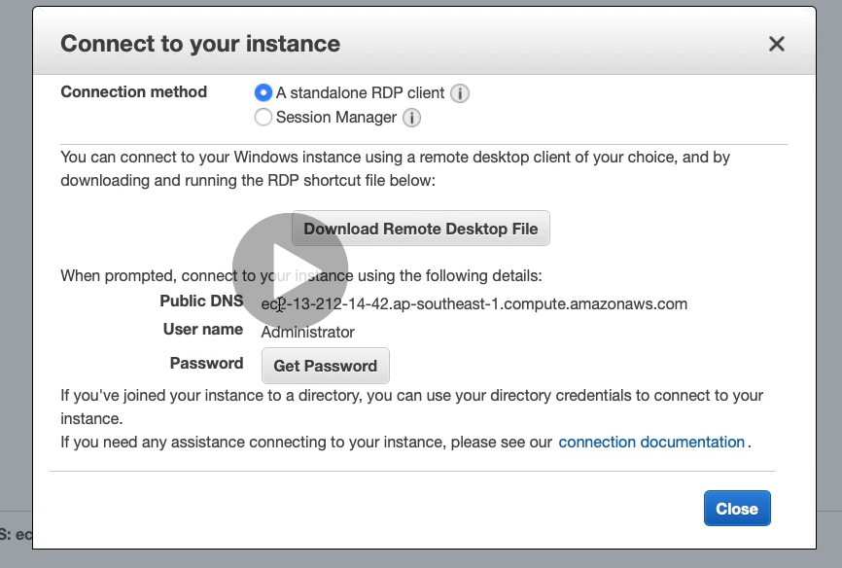

We have few info like Public DNS, UserName > now click [Get Password]

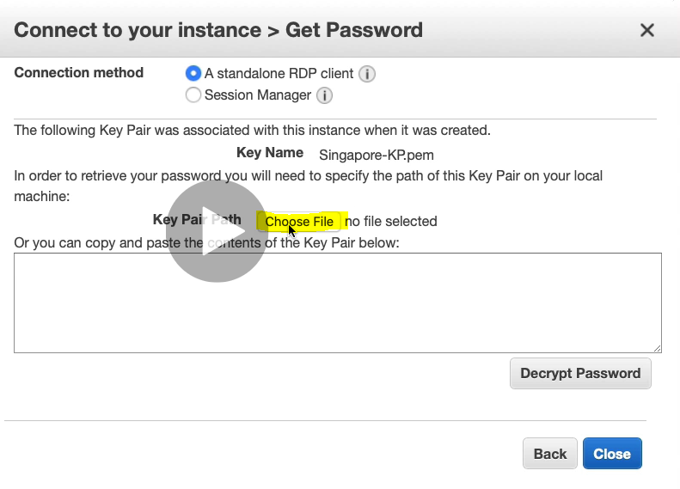

Choose Key Pair file. And click on Decrypt Password

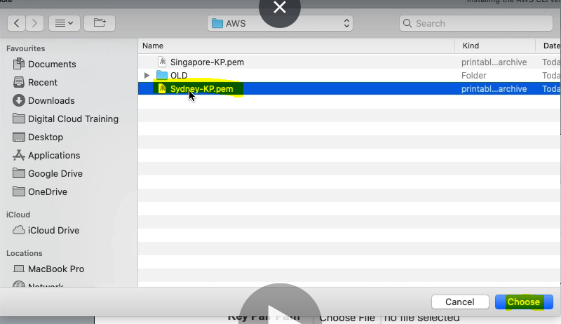

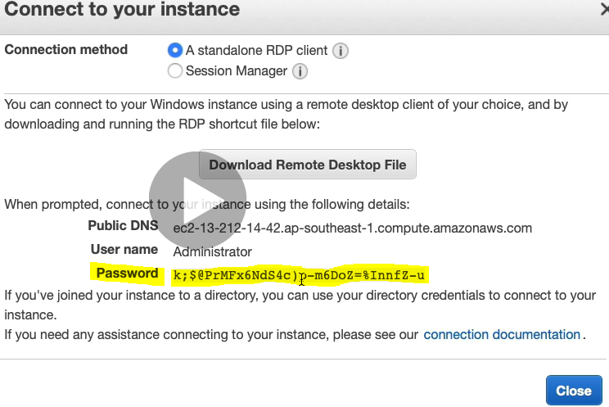

Now we have got all the information [Public DNS, UserName & Password]

Now go to our local machine and open the RDP client to connect windows machine.

|  |  |
| --- | --- |
|  |  |

Proved the PC Name( Public DNS) username & password and click continue.

Once we continue it will connect to Window machine.

Now connect Linux machine from this windows server machine. To connect Linux from this window machine

1. Download putt and puttgen
2. Generate ppk file from choosing AWS window key pair file
3. Open the putty and provide the DNS name and .ppk file to connect

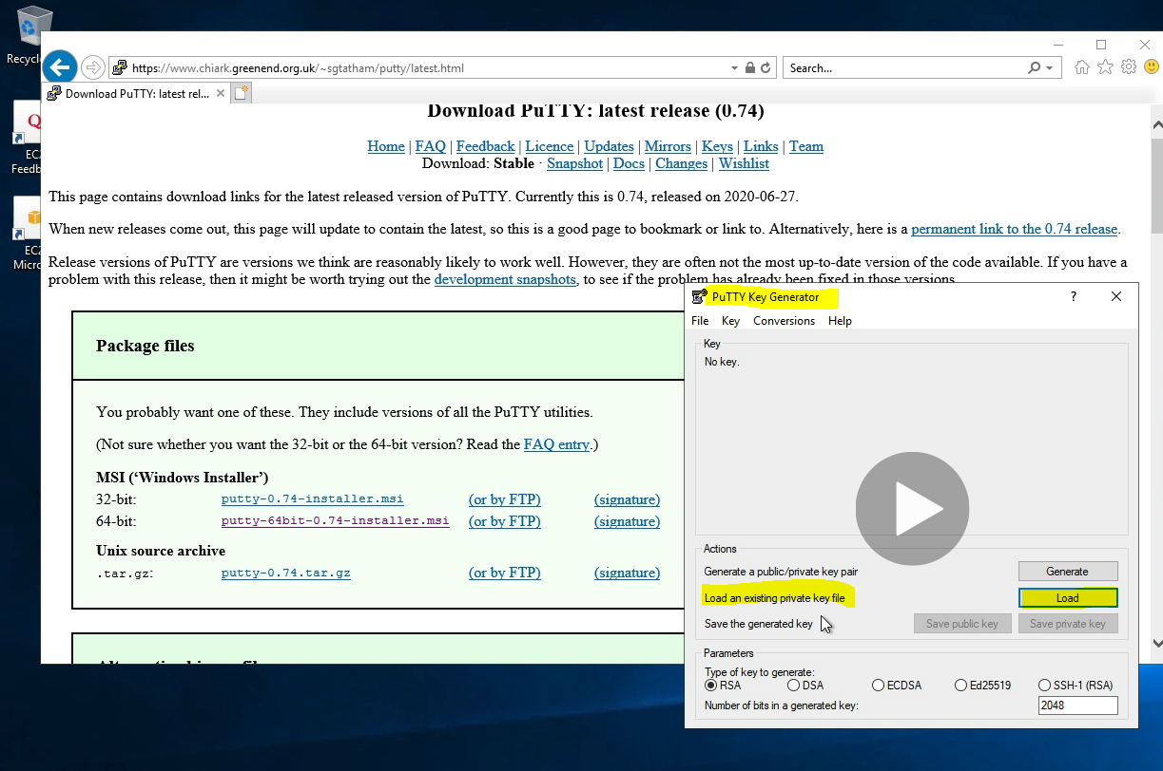

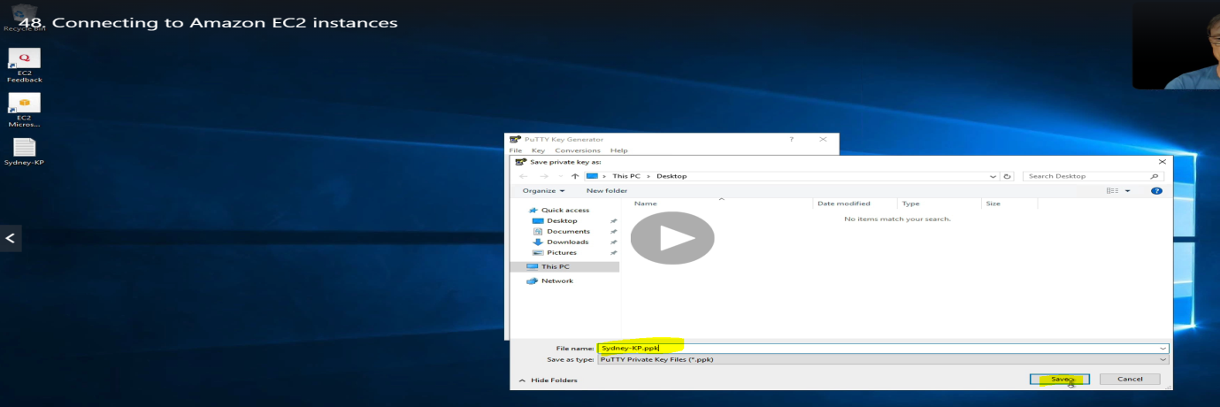

Now we got .ppk file which will be used in putty to connect Linux machine from putty.

Open the Putty. Select SSH

|  |  |
| --- | --- |
|  |  |

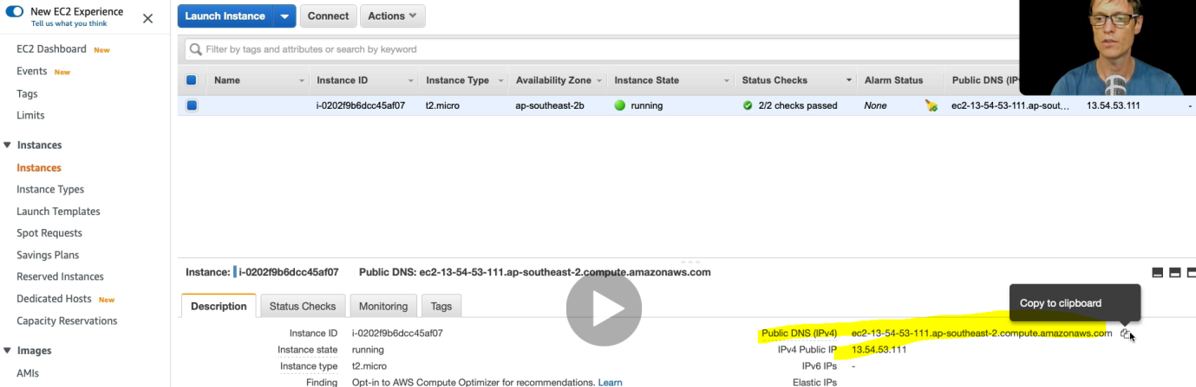

Copy Linux Machine DNS name or public IP from AMI. And provide in putty as shown in the second column. Note: put the username@DNS_Name

|  |  |
| --- | --- |
|  | Select the ppk file and click open |

And now logged in Linux machine from Windows machie.

Deleating the instance : Step . Actions> Instance State > Stop > Terminate

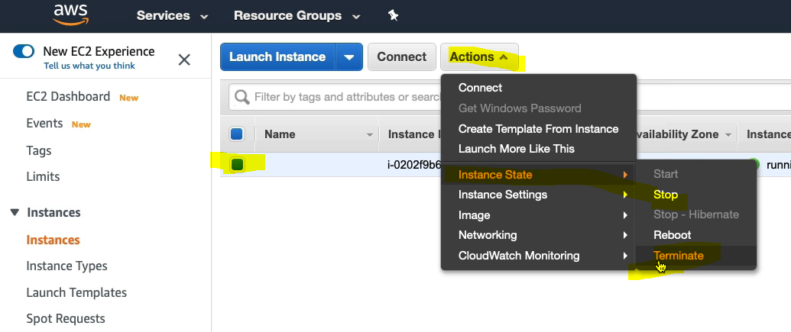

**Creating a Web Site using user Data option during AMI linux machine creation**

We have already covered this part so documentation will do later.

**Using Access Keys with Amazon EC2**

When we launch Amazon EC2 instances in the cloud then we need to connect these instances with others AWS services.

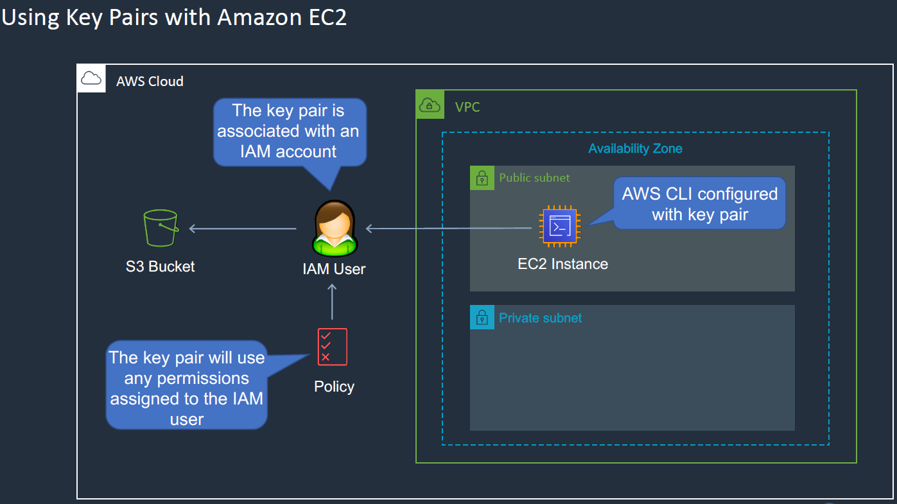

For example here EC2 Instance created in VPC Public subnet wants to connect S3 Bucket service available in the AWS cloud. This EC2 machine wants read and write the data in S3 Bucket. AS in the above screen the S3 buckets sits in the AWS cloud public space means it is outside of VPC and our EC2 instance need to authenticate the S3 Bucket , so here in S3 bucket we will not allow any body to access this S3 bucket, so we need to authenticate from different ways. In this case EC2 instance need to authenticate S3 bucket to allowed to access the data. So there is two way to authenticate this S3 bucket.

1. Using the access key with the Amazon EC2. So we will configure key pair in the EC2 instance using AWS CLI and this access we will associate with the IAM user account. So in this case the user is allowed to do all the things based on the their role defined in EC2 instance. This method is less secure because the access key is stored in EC2 instance itself and in case if someone got access to EC2 instance then , access key can be used for other purpose.

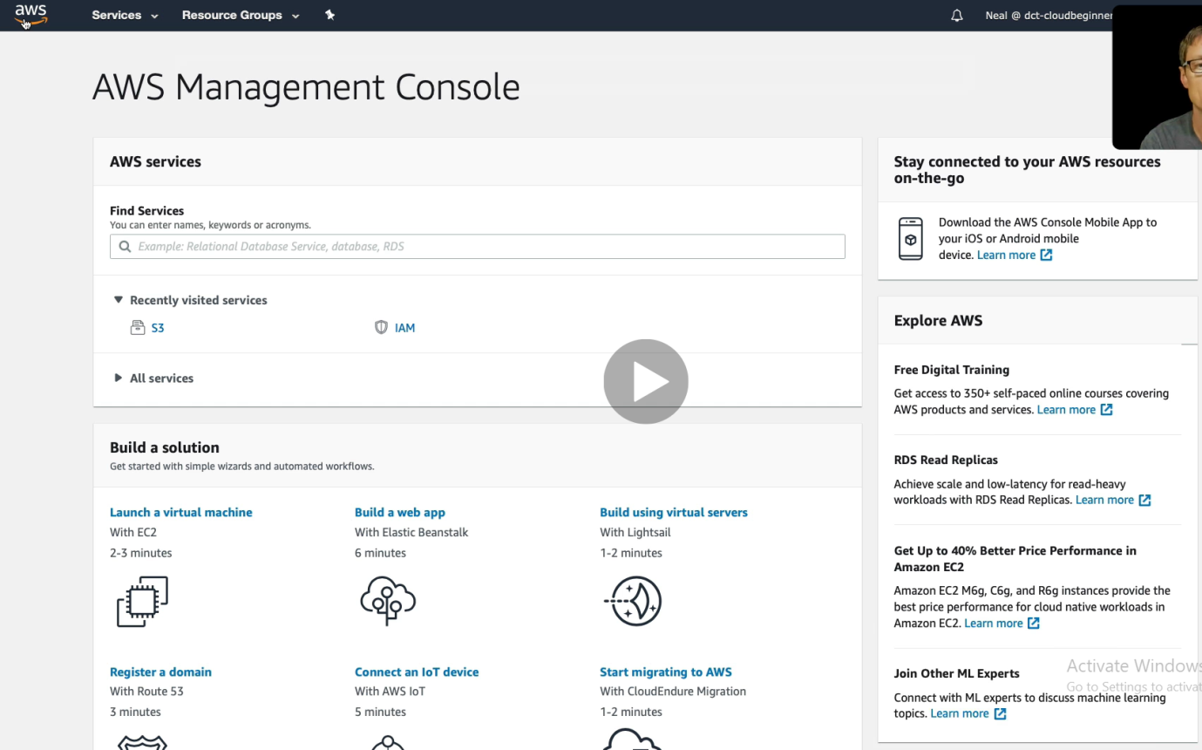

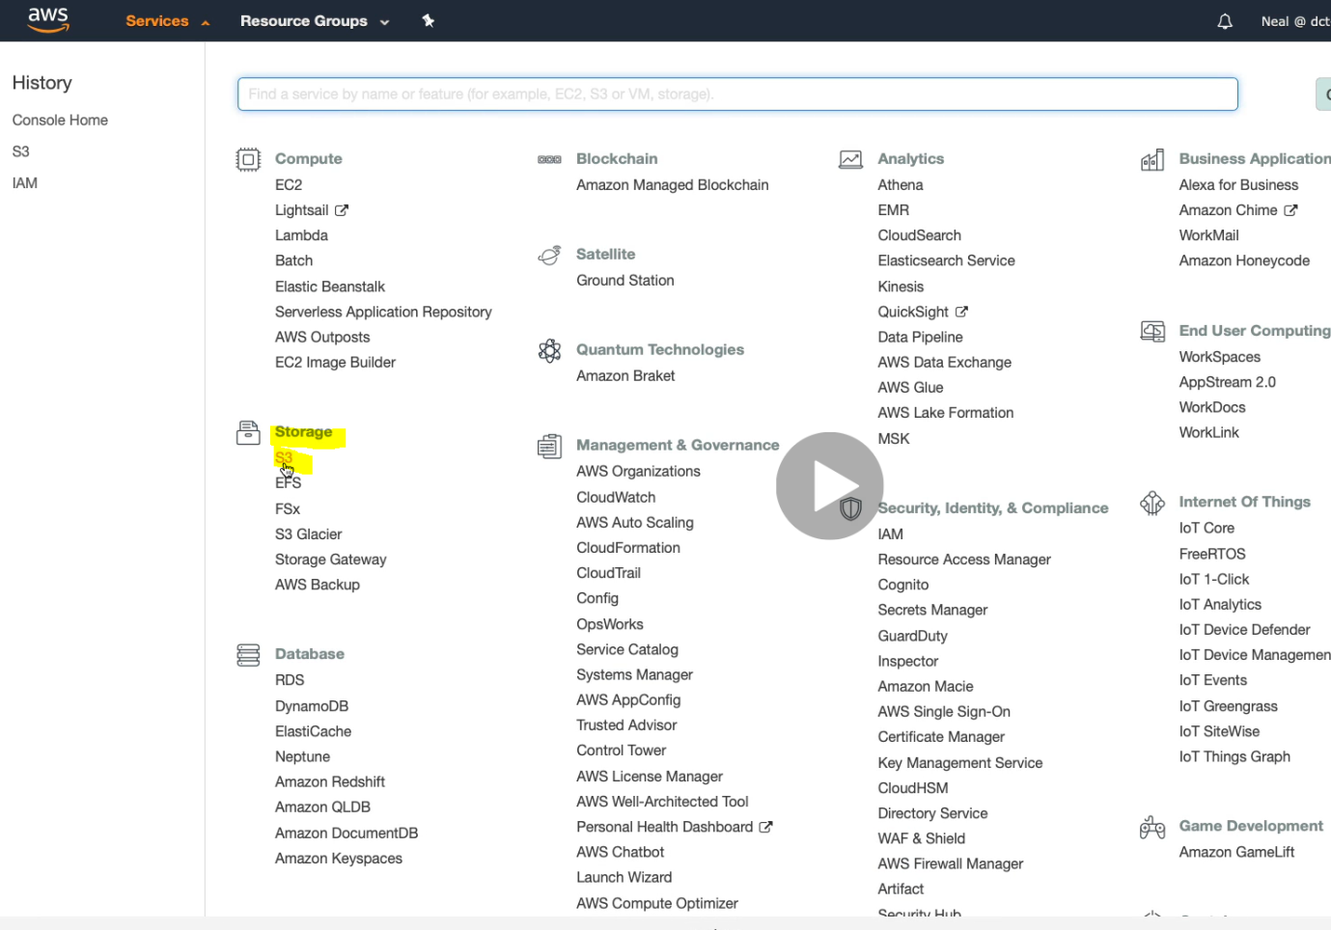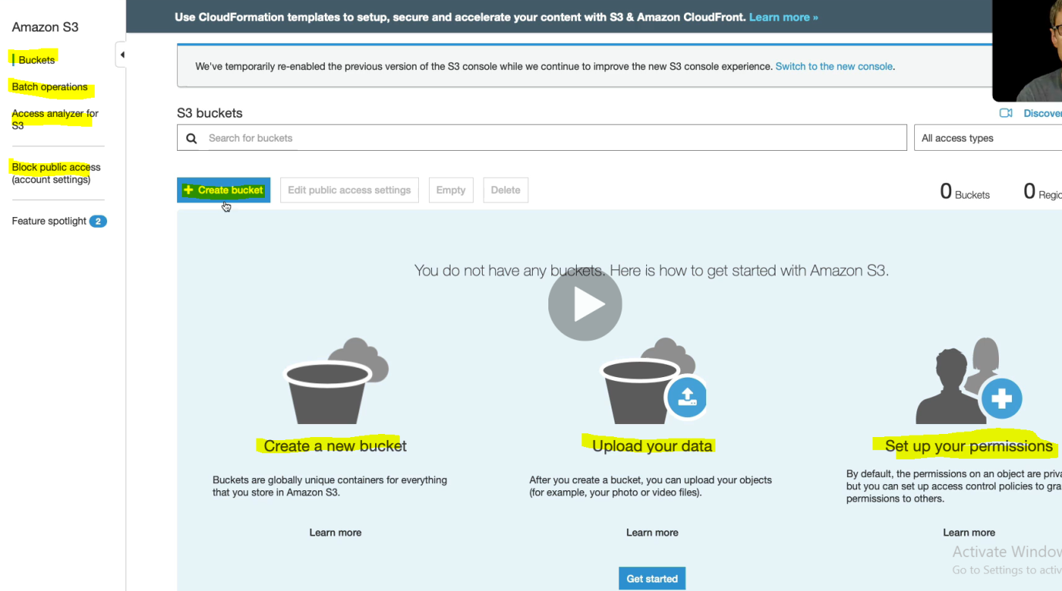

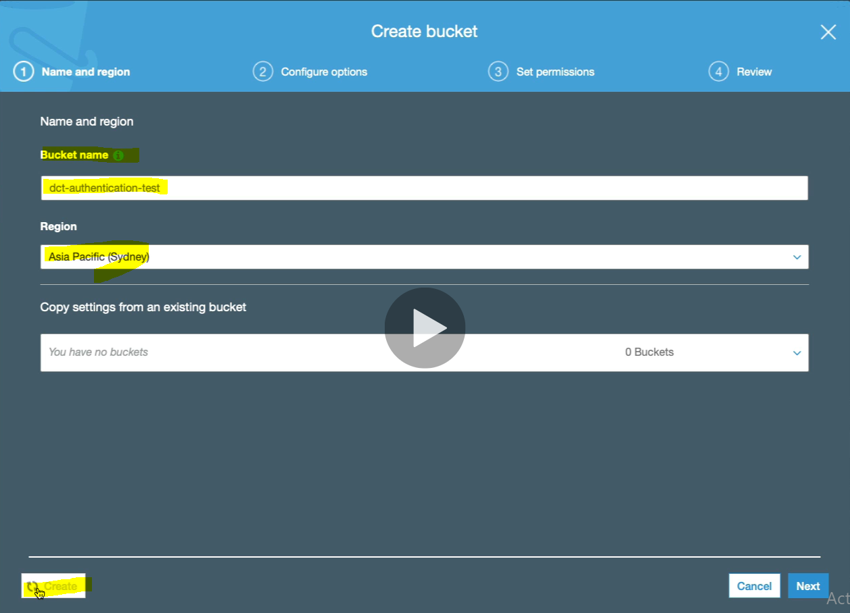

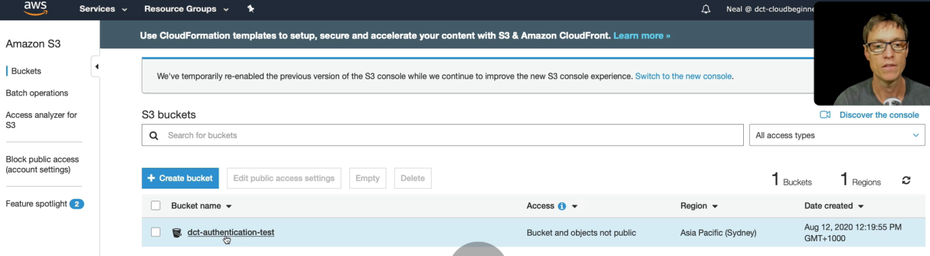

Click on the link to upload some files or objects.

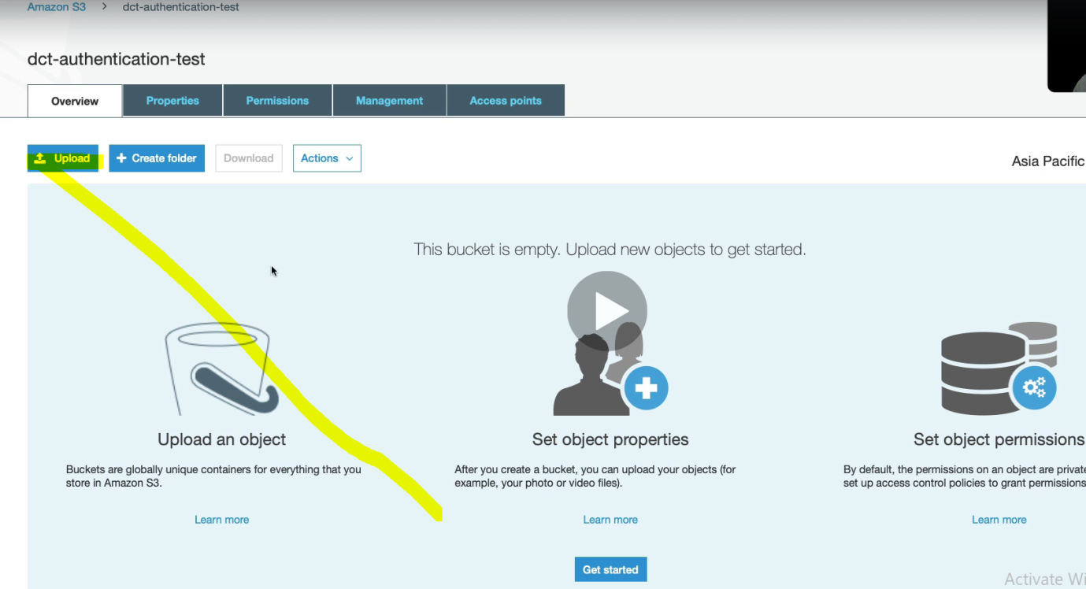

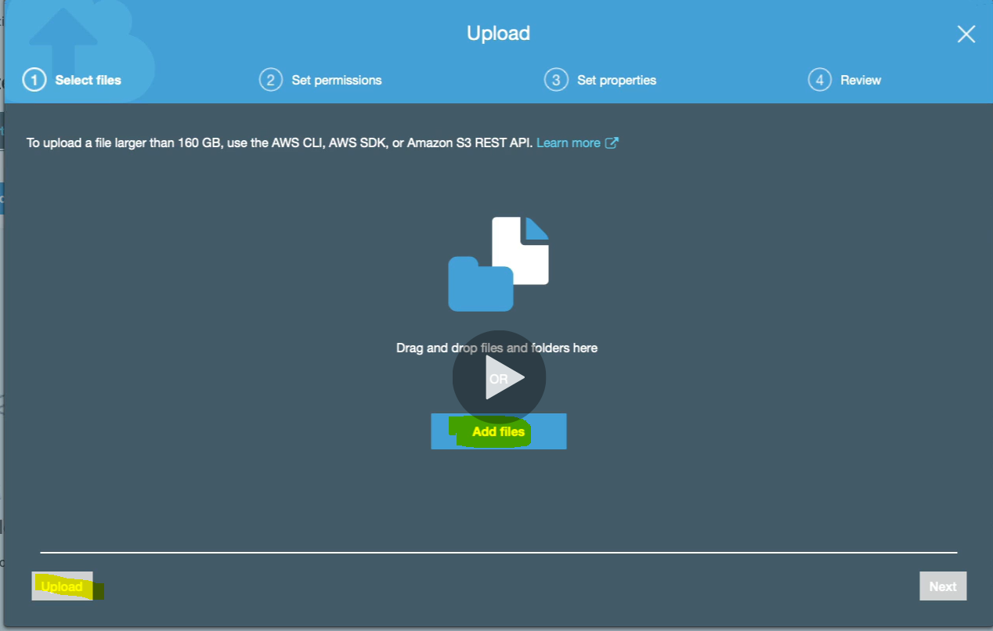

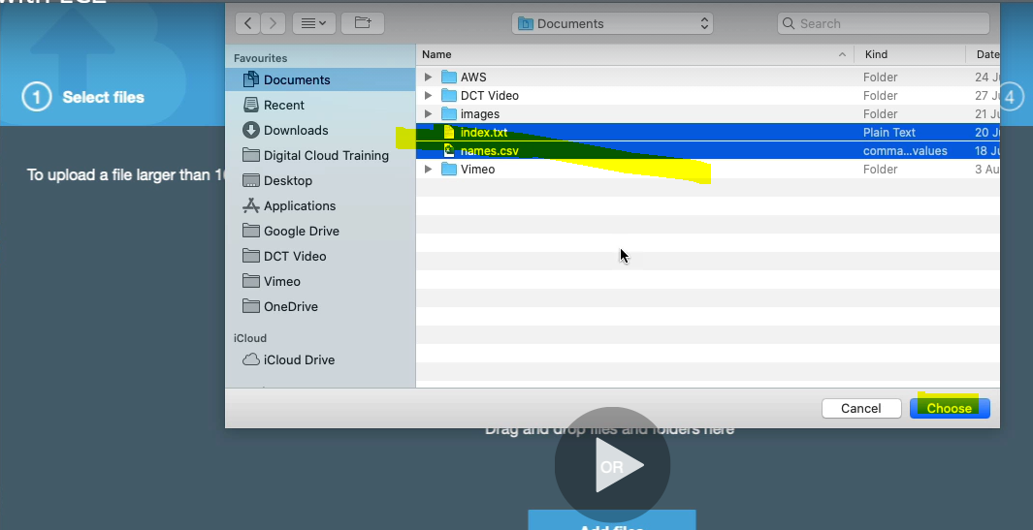

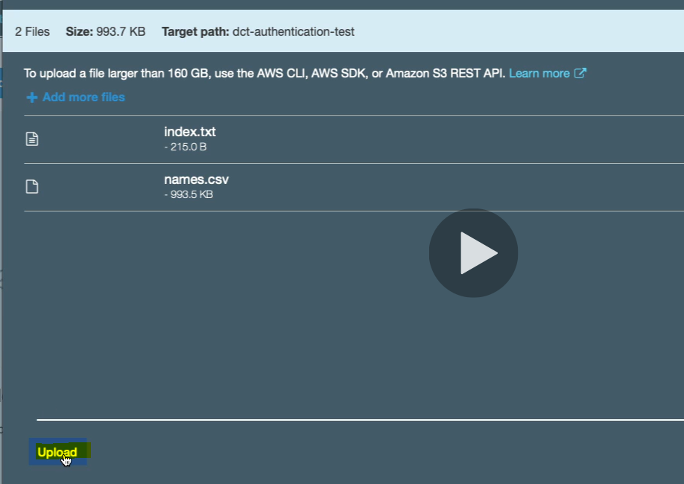

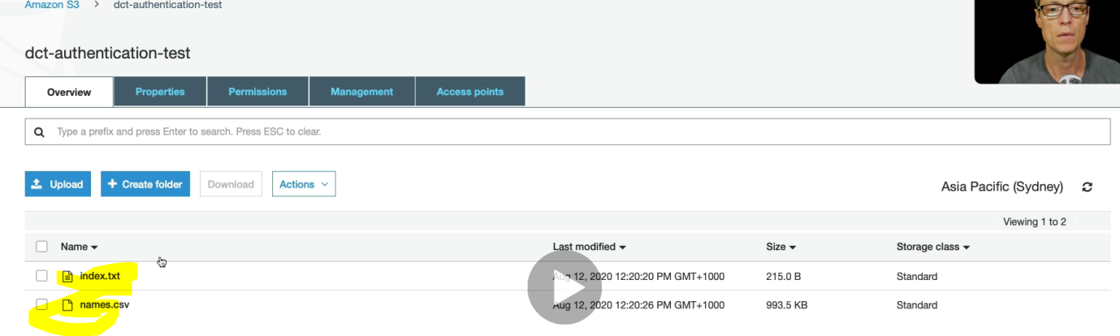

So now we have created S3 Bucket and uploaded two files in the bucket.

Now Let’s go to EC2 instance and create and EC2 Instance

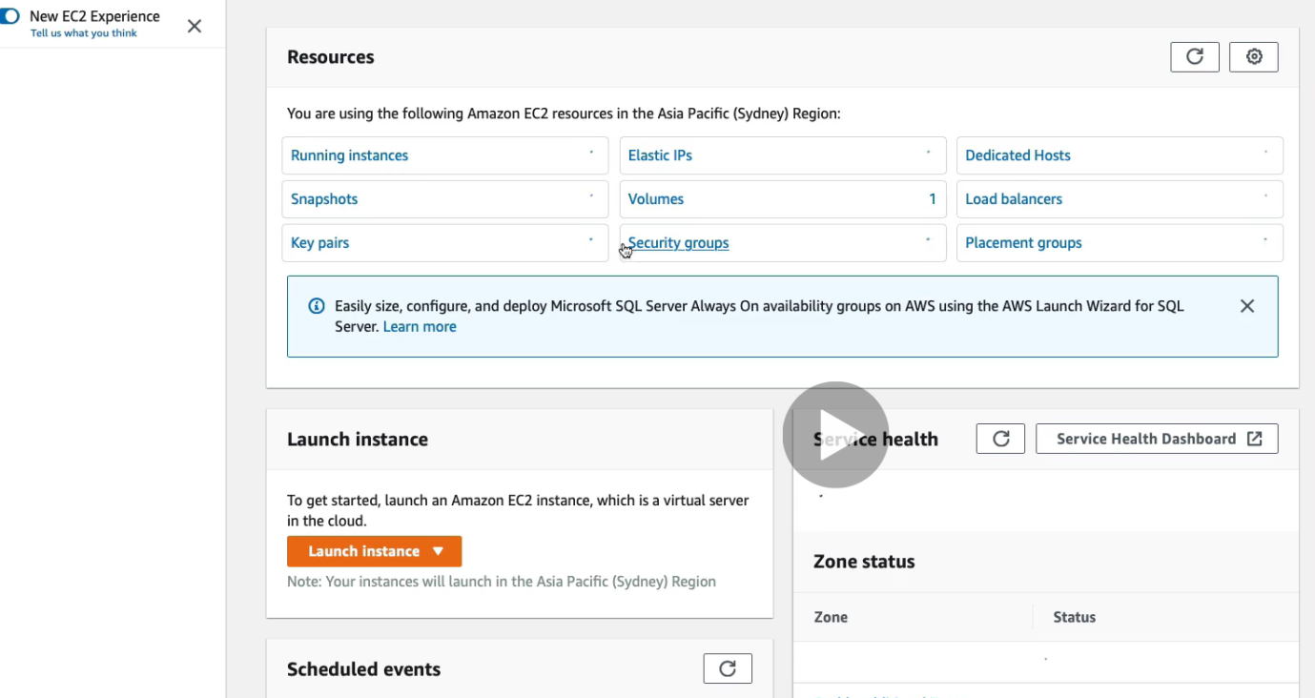

Click on already running instance

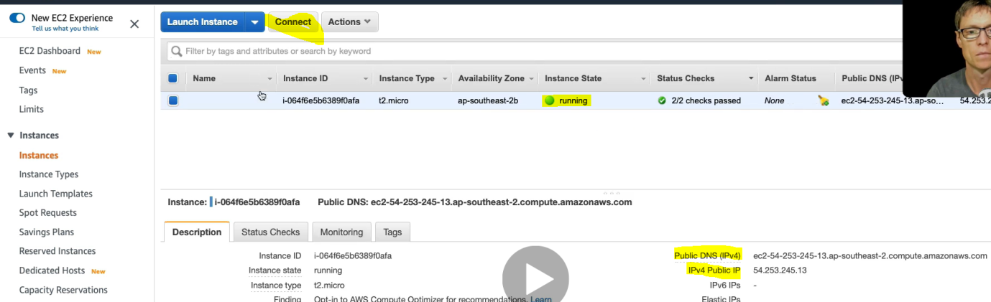

Click on connect

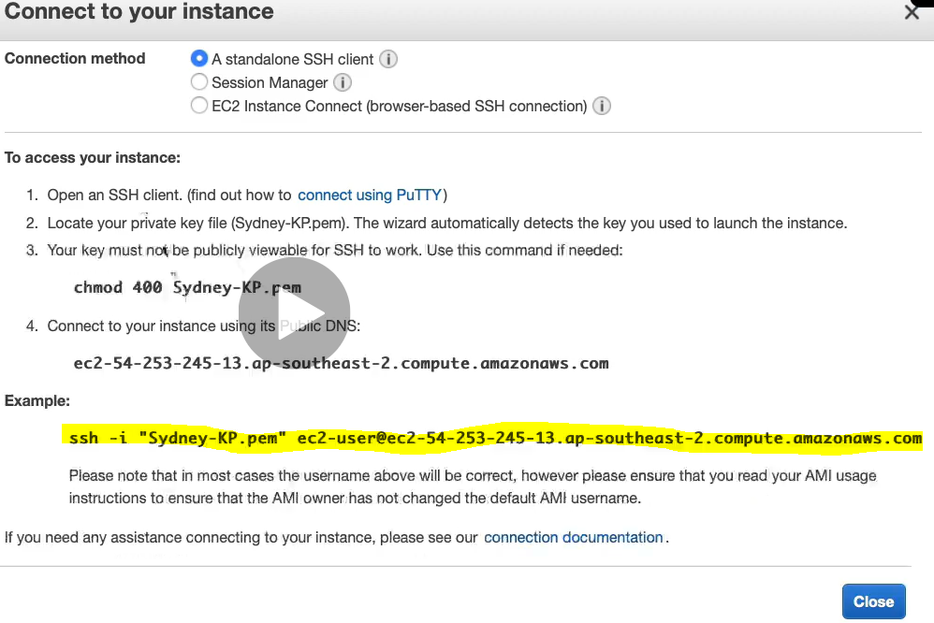

Run the yellow marked command into AWS cmd.

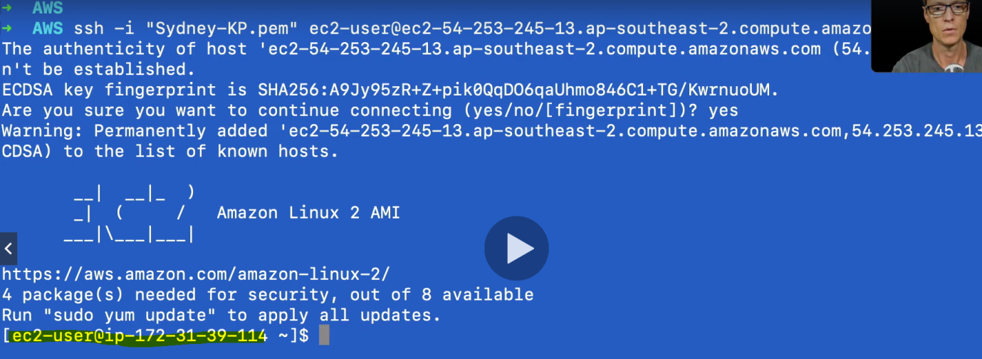

And now connected to ec2-user@ip-172-31-39-144

Run AWS S3 command in this command line



This command is use to see the storage S3 object installed into ec2-user machine.



We got the error message after running this command. So first run “aws configure” command and we need to provide credential.

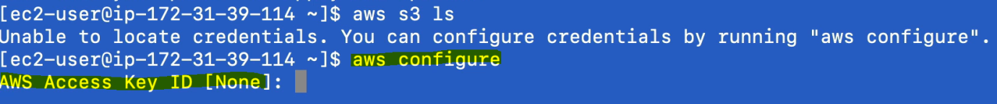

And now it ask for Access Key ID to authenticatte: So we need to go and generate access key.

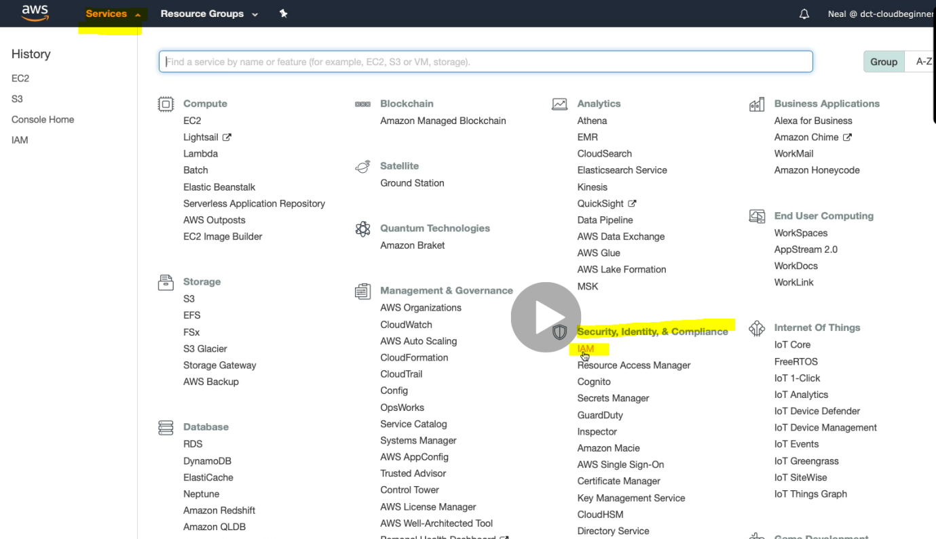

Click on IAM

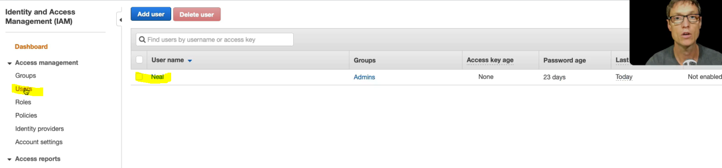

Inside IAM click on user. Select the user Account Neal

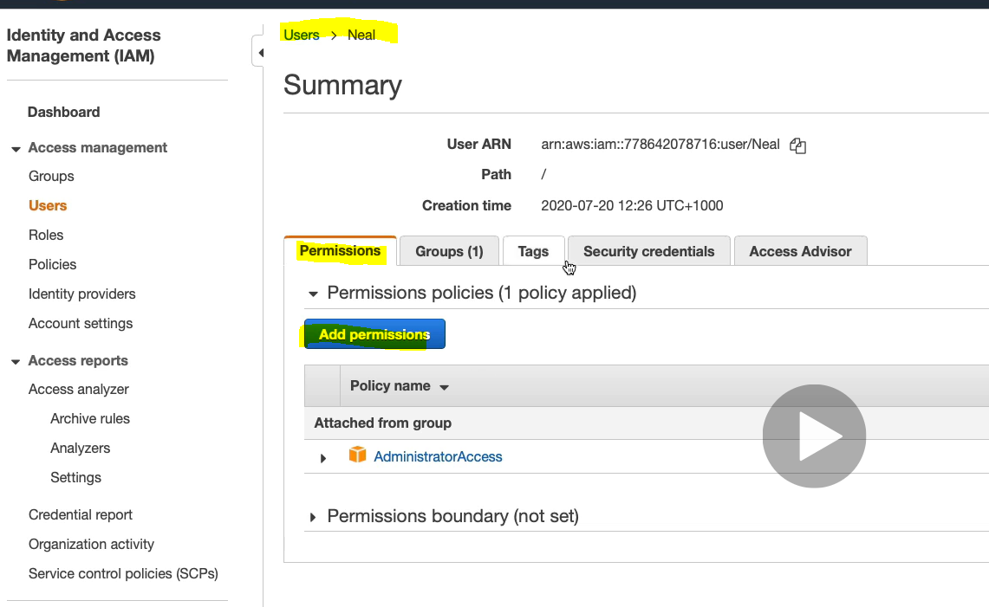

Click on Security Credential

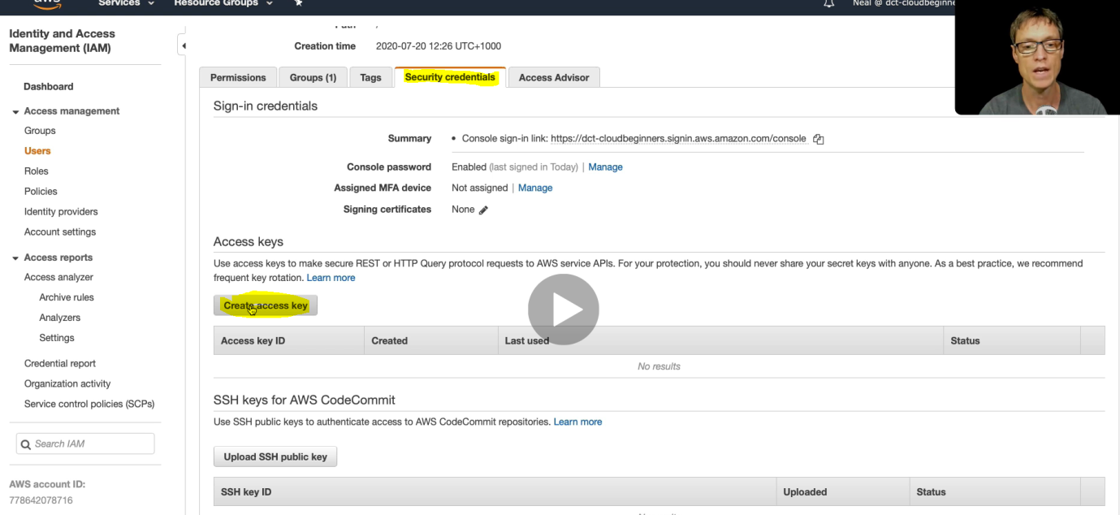

And here we have access key : Click on Create access key

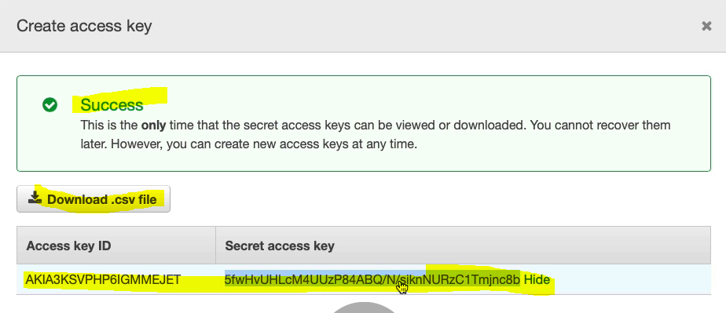

Copy this access key and paste into AWS command to authenticate

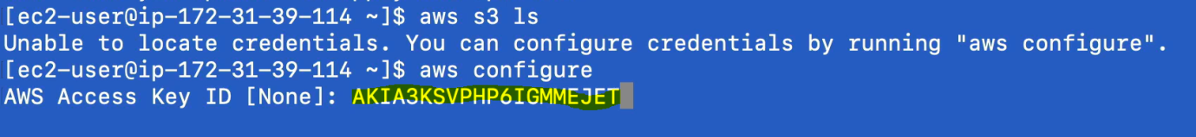

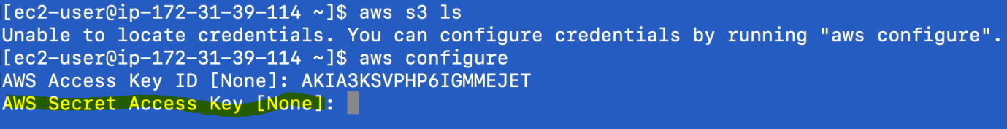

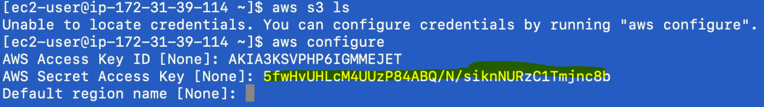

Asks for the default region name which is not mandatory but we can take it from the right top corner.

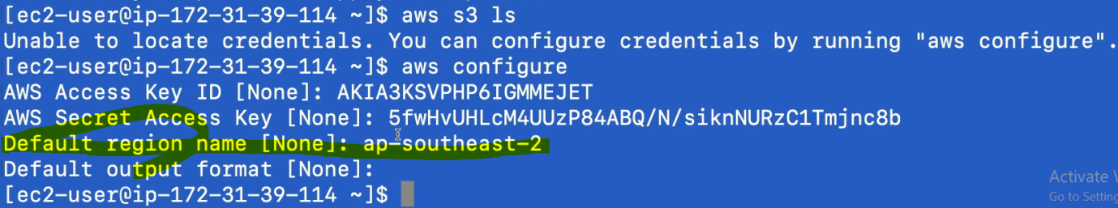

Now when we run the same command AWS S3 ls then

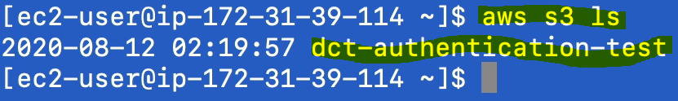

It displayes the S3 bucket name

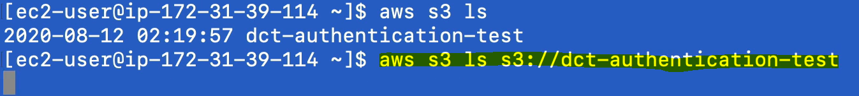

Now when we proved [aws s3 ls s3://bucketName], it displays all the files inside the bucket

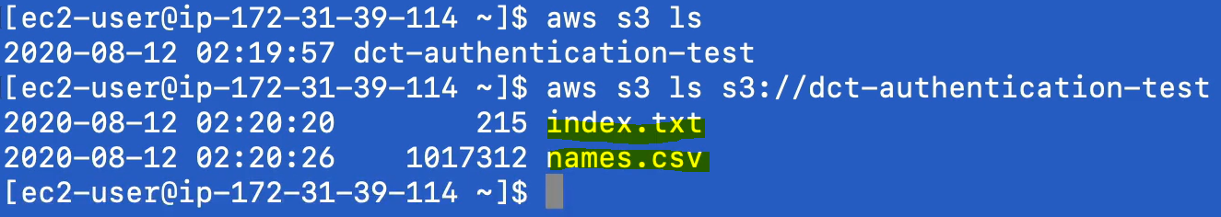

So have been able to authenticate successfully the S3 bucket inside ec2-user machine.

So as we told you already that this is not safe way to authenticate to S3 bucket because if the file is available in the EC2 machine then anyone can access the file and do whatever he want. For example we have downloaded the authentated file in aws folder, now anyone can go inside aws folder and can see the information.

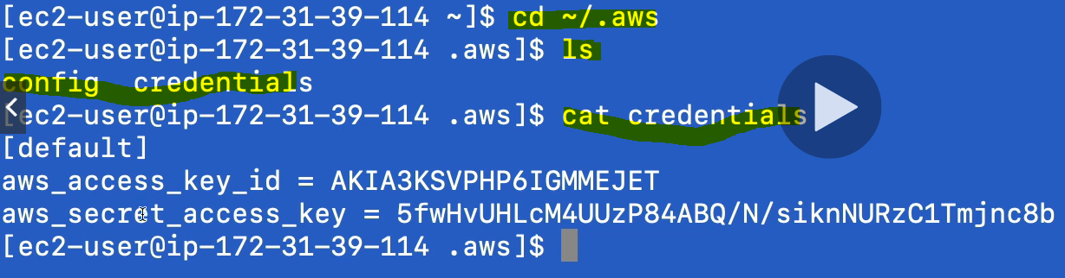

Here “credentials” is the file name that we have downloaded in the EC2 machine and using cat command we can get all the information from the file. So the access key id and secret access key is not encrypted and not protected at all.

So let’s delete this credential file so that no can access the information

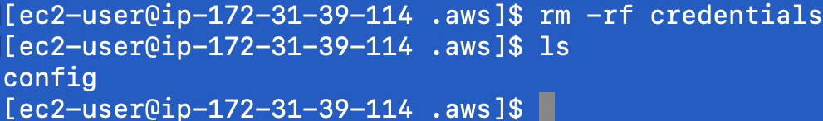

And if I run the aws s3 ls command again then again it ask to configure and get access key



(2) **Now let’s look another more secure way to access the file from S3 bucket.**

**Using IAM role with EC2.**

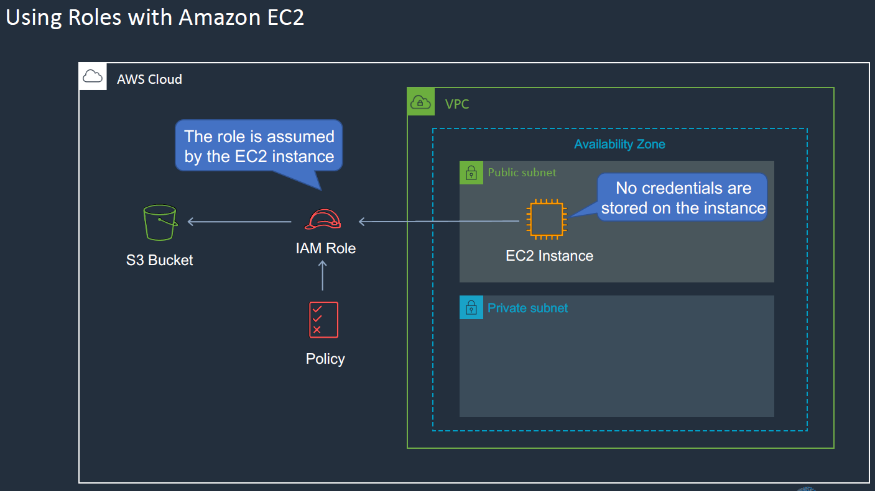

Here in this case we are going to create an IAM role for EC2 instance and whatever access is permissioned to the role will be able to access S3 bucket accordingly.

Let’s go to IAM.

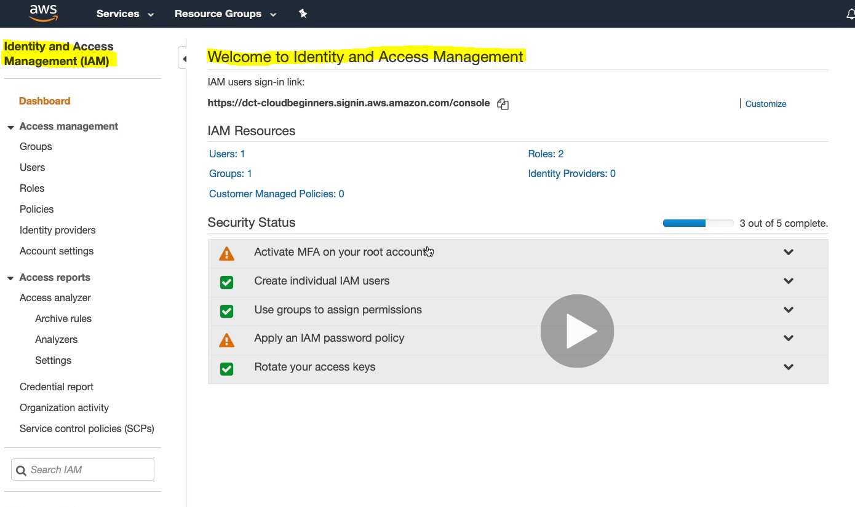

Click on Roles from the Dashboard.

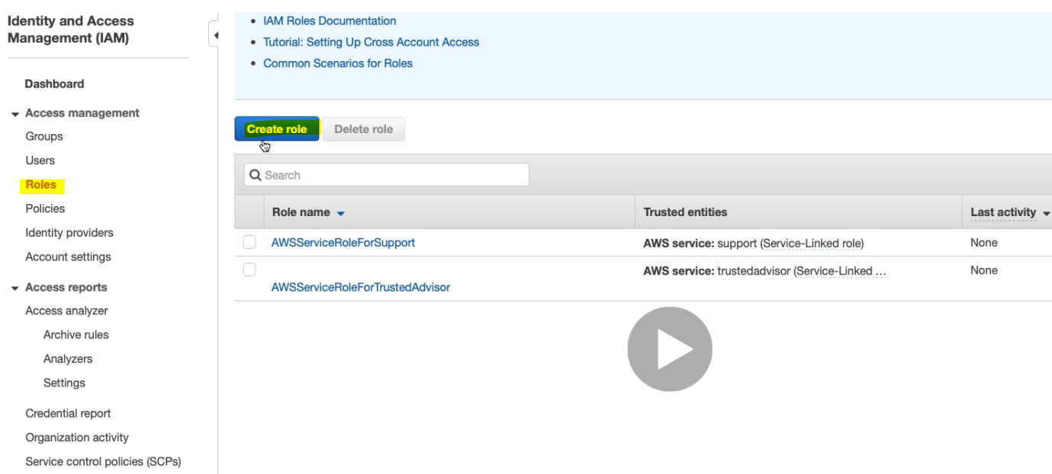

Create role.

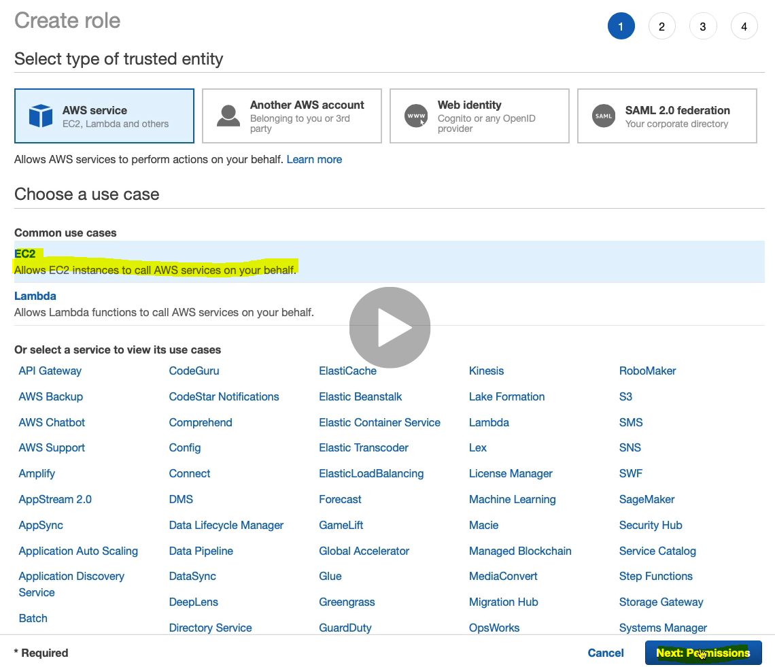

Select EC2 and click Next.

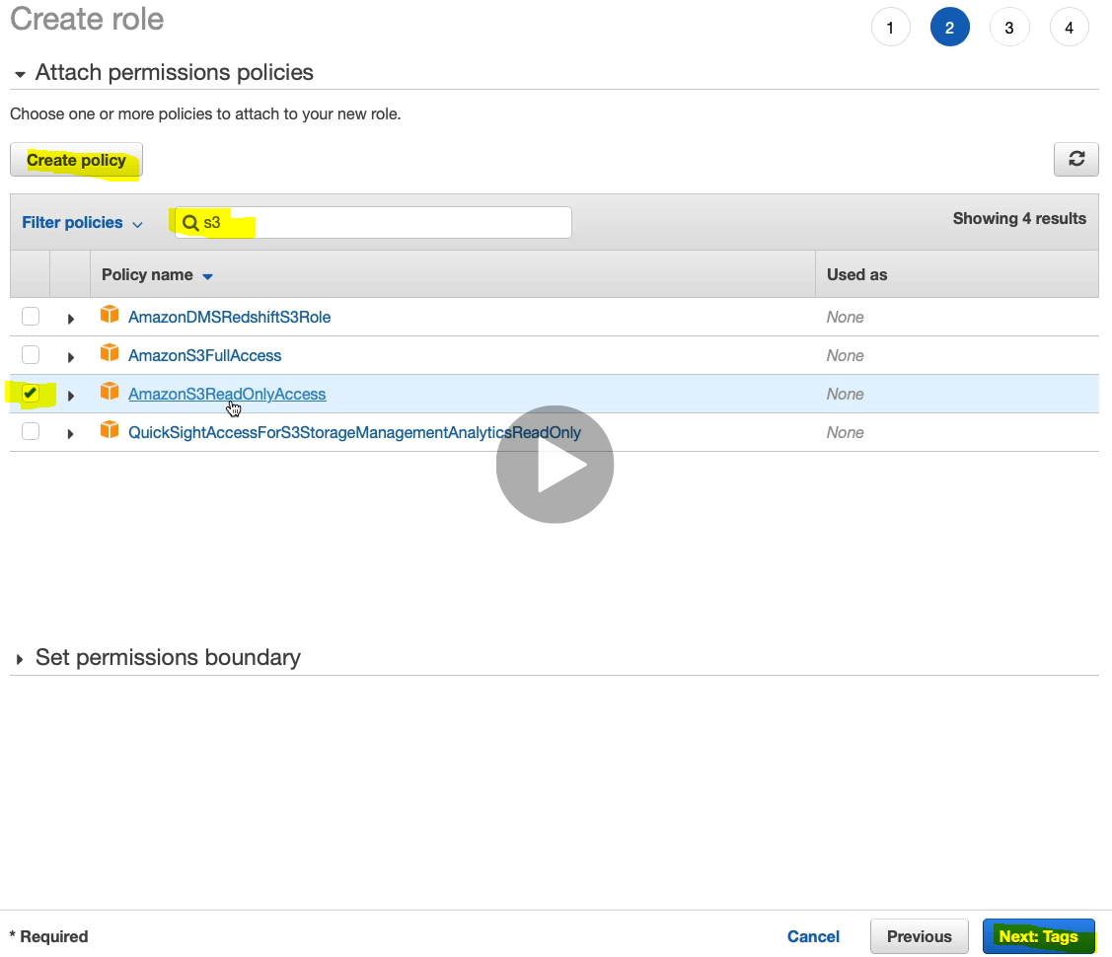

Read Only permission to the S3 bucket.Click Next>Next

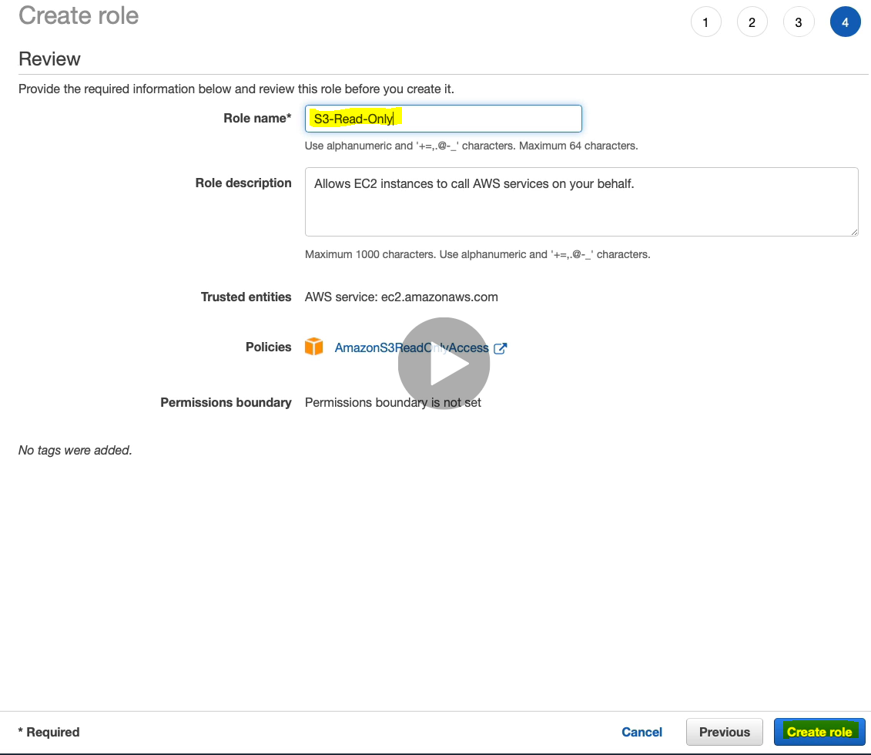Write the Role Name” S3-Read-Only” and click - create role

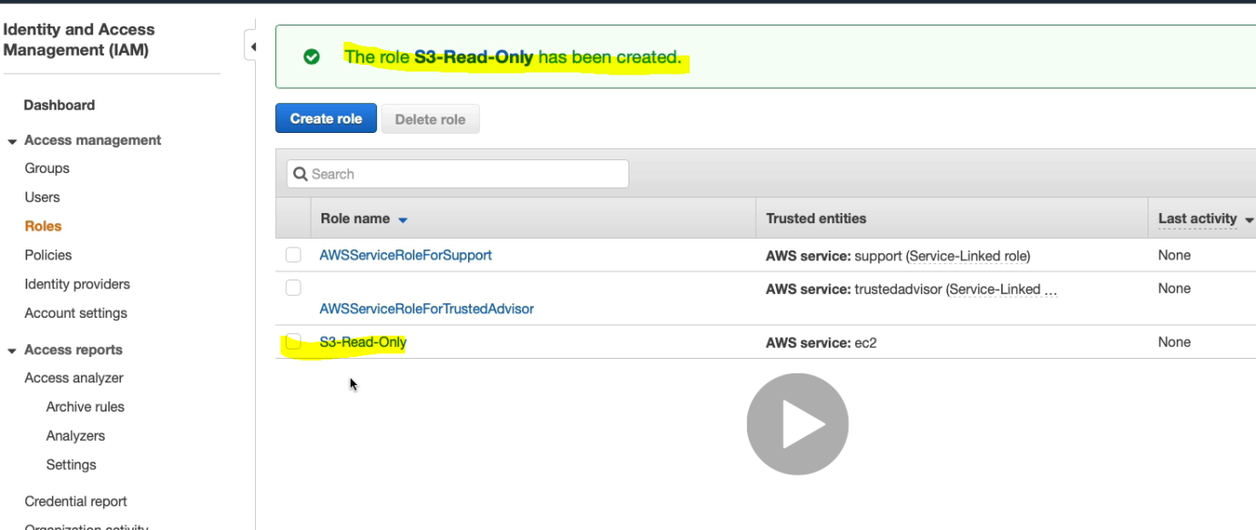

So role got created. Now go the EC2 instances >Actions >Instance Settings> Attach/replace IAM role

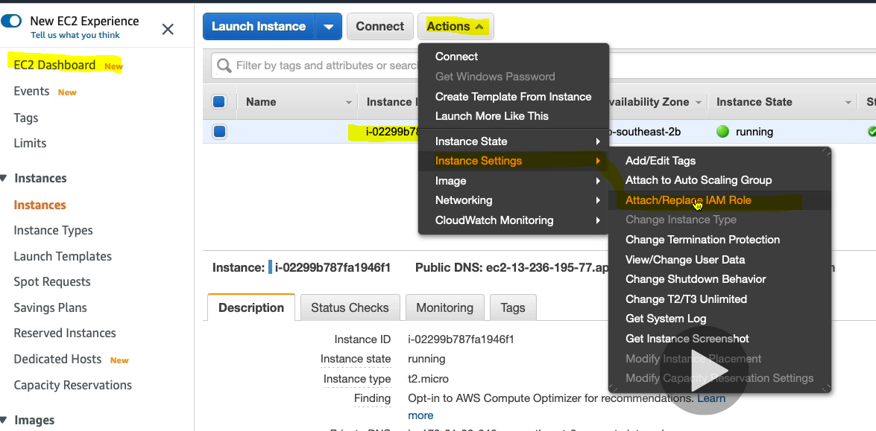

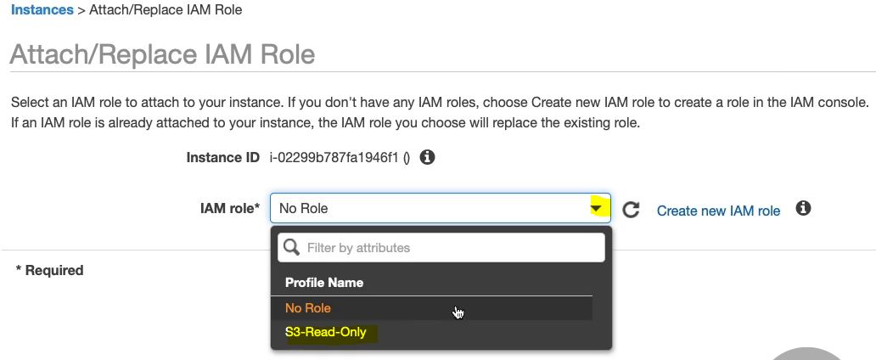

Select IAM Role and click on apply button

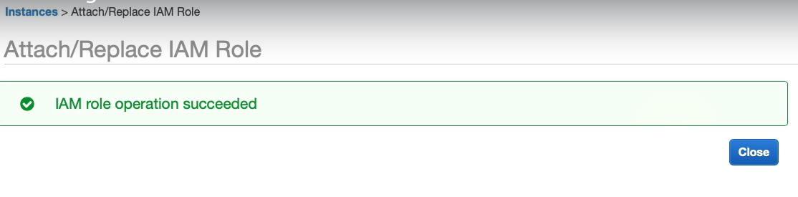

Another way to assign IAM role to EC2 machine, in configure instance step during EC2 creation

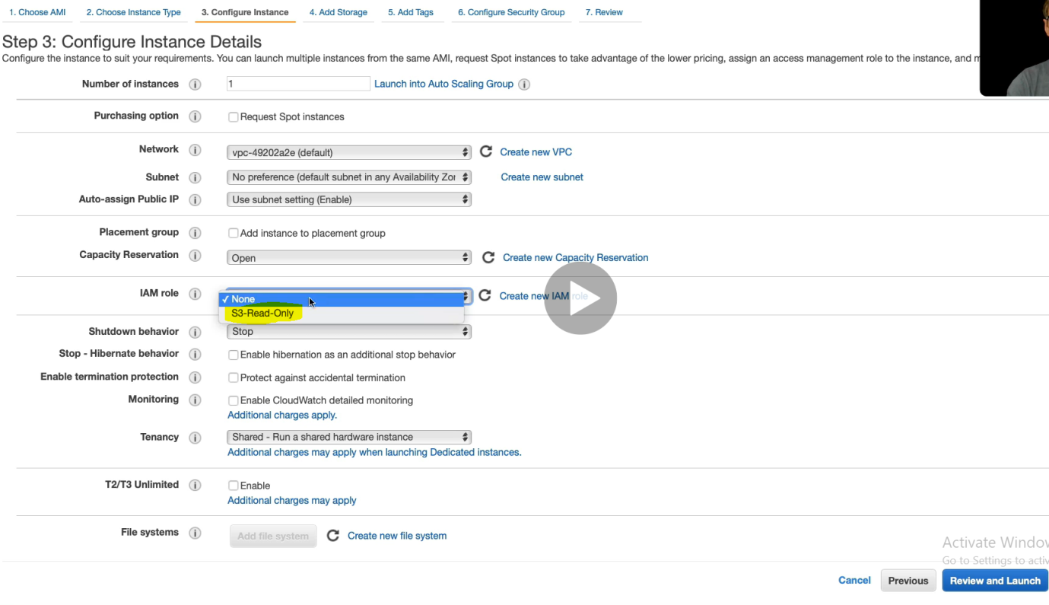

Now back to the command line and if run the “aws s3 ls s3://bucket_name” then it will display all the file from the bucket without asking any authenticate and security key.

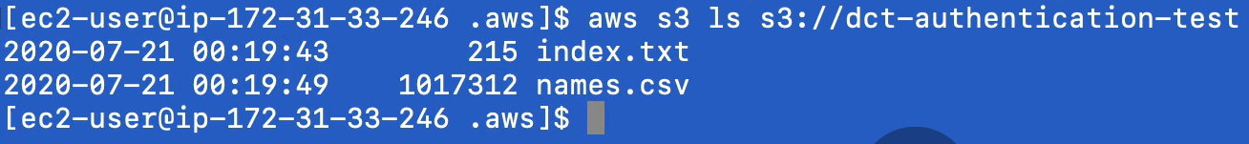

And the most important thing is that since the user have only read only access so he cannot modify any of the content of the bucket file.

**Amazon EC2 Auto Scaling:**

Auto scaling is the way of adding elasticity for our EC2 instances. So it automatically launch and terminate Amazon EC2 instances and it sends alert to the server if any instances found incorrect so that the correct action could be taken. It manages the CUP uses for an application to be run efficiently

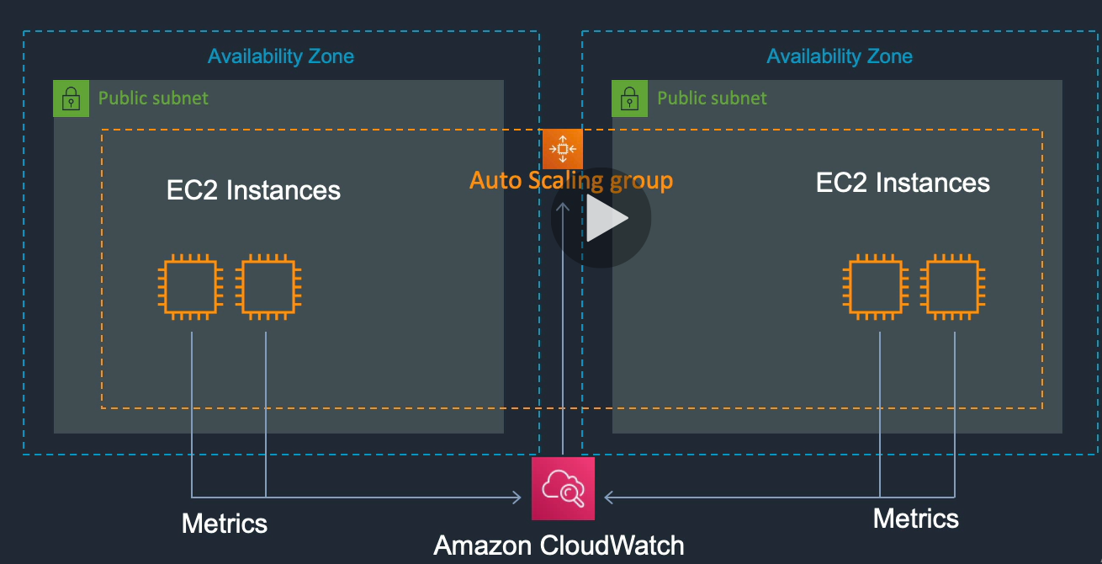

Here as we can see that we two instances in each public subnet and availability zone and we have integrated Amazon cloud watch service between these two public subnet , which monitor the service performances. These EC2 instances sending information the CloudWatch and also to EC2 itself.

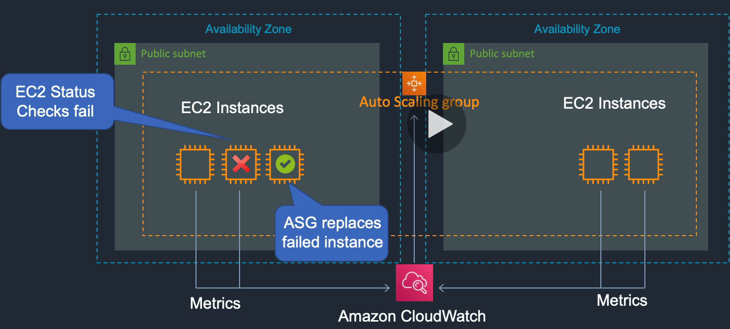

Now in case any one of EC2 instances status check fails, it tells the Auto Scaling Group, and it automatically replace and launch a new EC2 instance.

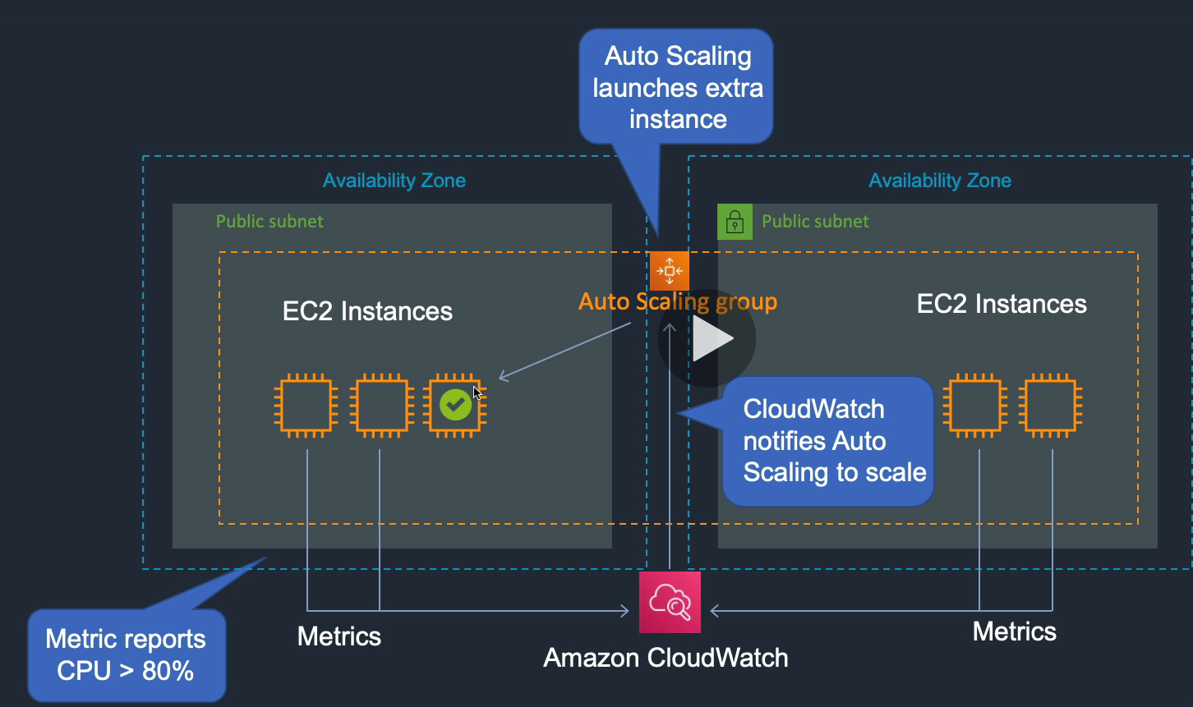

In another example a metrics is being sent to cloud watch where it is telling that EC2 instances CPU uses reached to more than 80%. Now the cloud watch notify this to Auto Scaling Group and it launches a new instances. So that is how we can have resilience (flexibility) and elasticity (expansion).

Note: Reverse is also possible. Let’s say if CPU uses goes down to less than 60% then notify cloud watch and cloud watch in-turn notify the Auto Scaling group and it just remove the EC2 instance. So that is how scaling works.

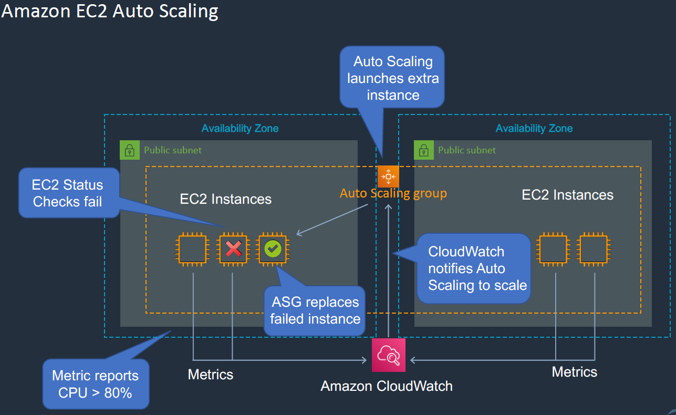

Let’s do it in AWS cloud.

Go to EC2 management console > Go to AutoScaling > Click on Auto Scaling Group.

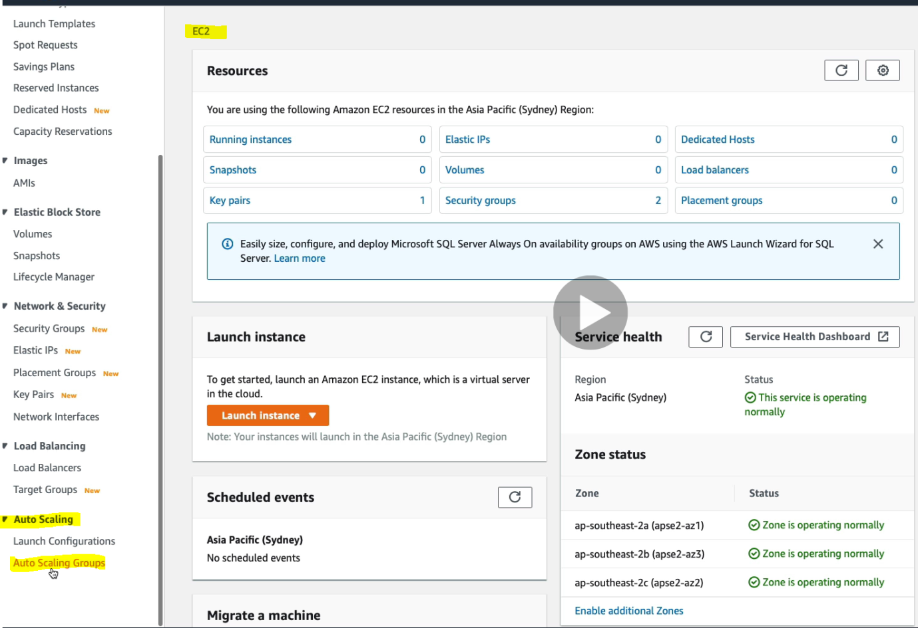 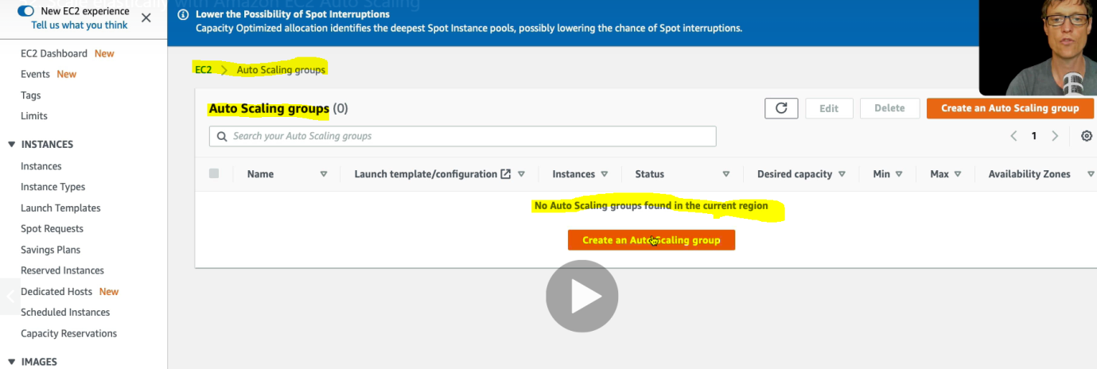

Click on Create an AutoScaling Group button.

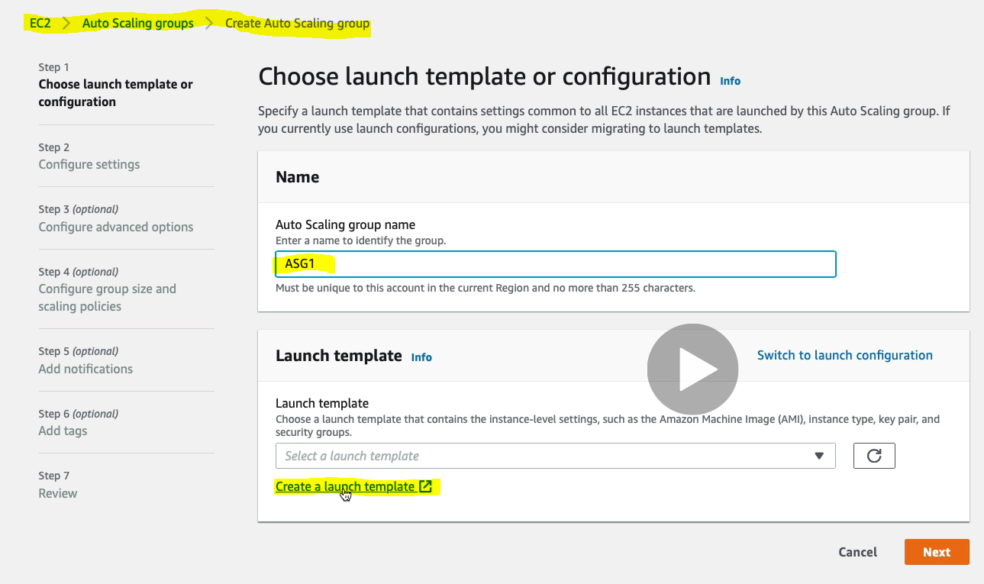

Give the name ASG1 and – click on Create a launch template.

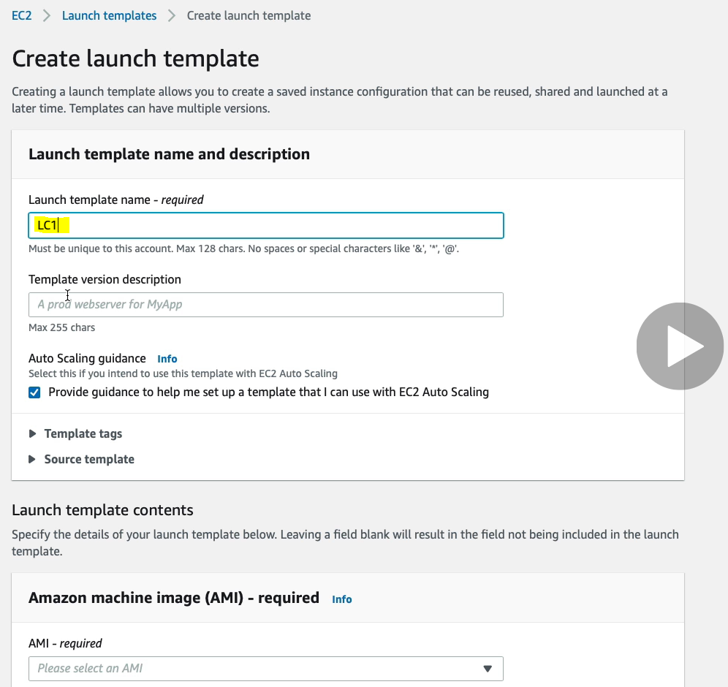

Just scroll down and choose an AMI

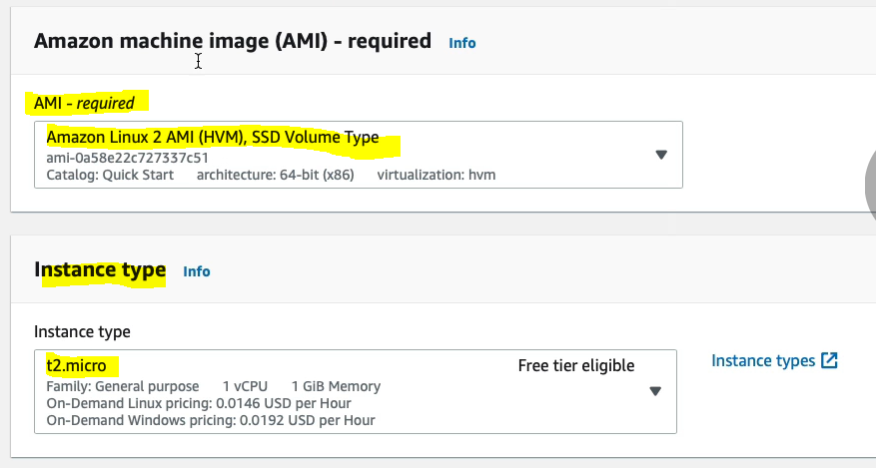Scroll down and select the Key pair.

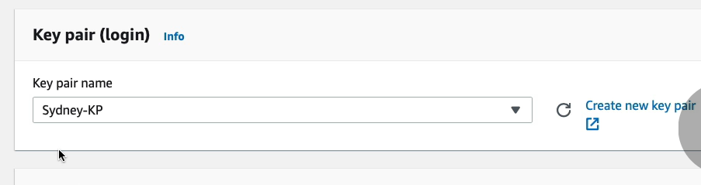

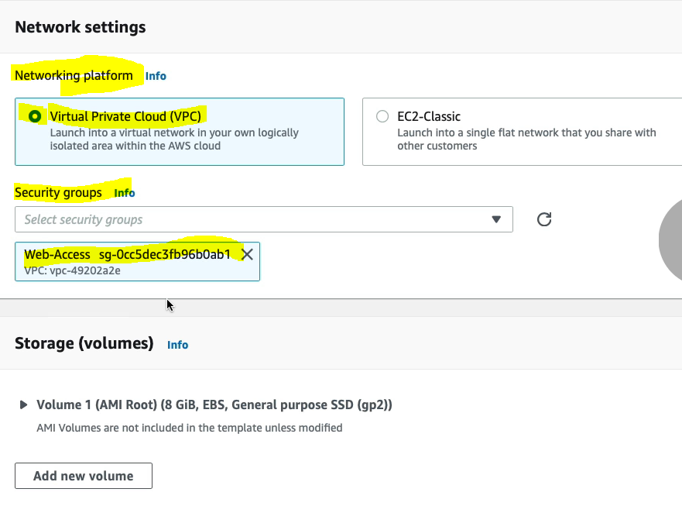and leave the rest as it is. Now click create launch template.

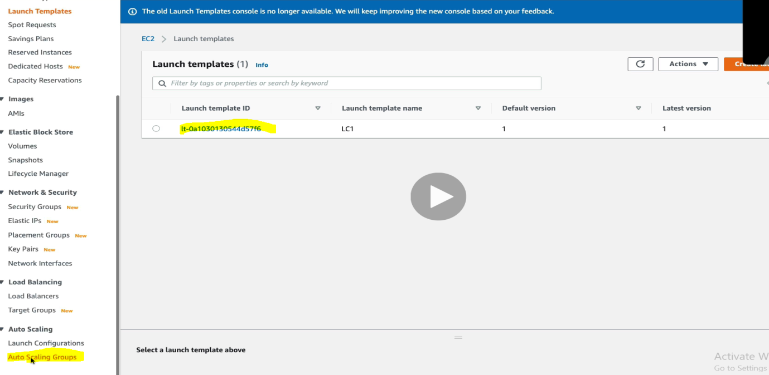

Now we got the new template with name LC1. Now let’s go back to Auto Scaling Group.

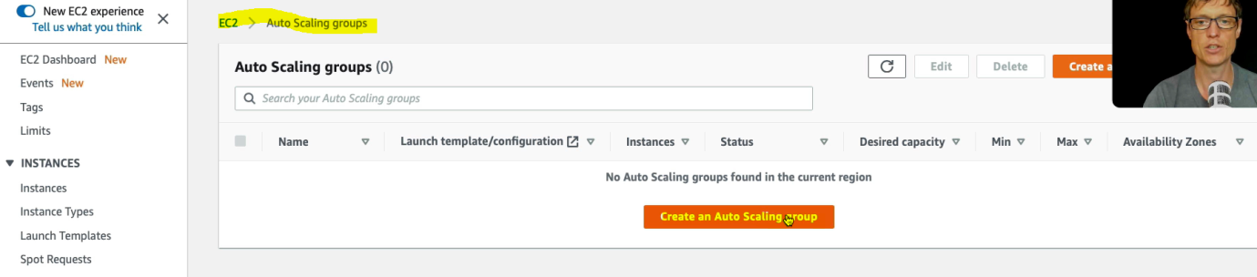

Click “ Create an Auto Scaling Group” button.

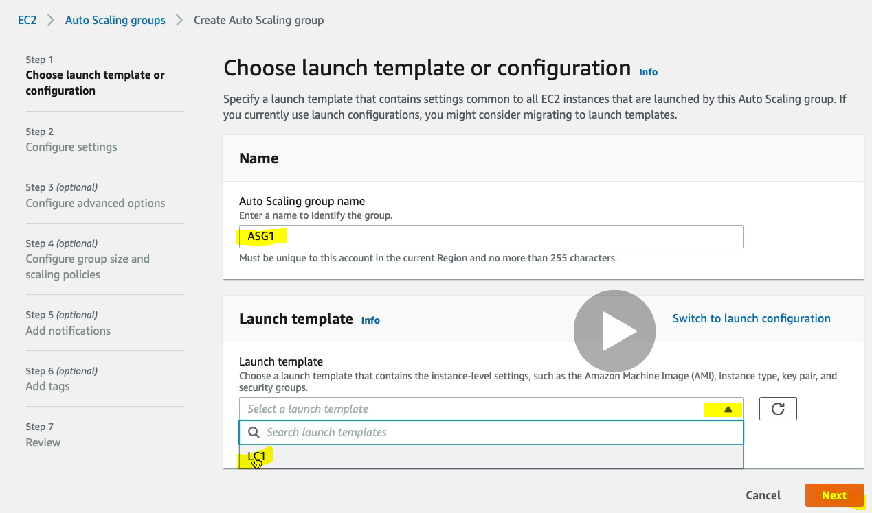

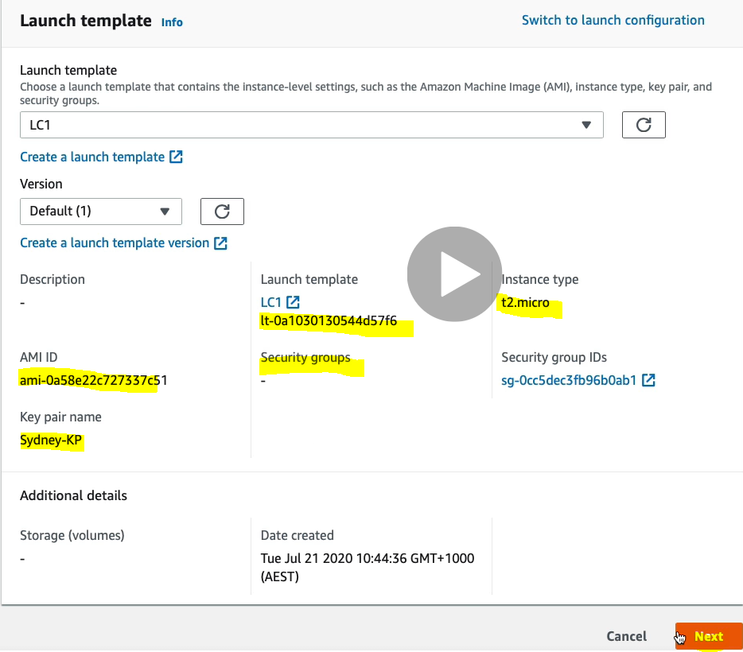

Give the name of Auto Scaling Group and select Launch Template LC1 and click next.

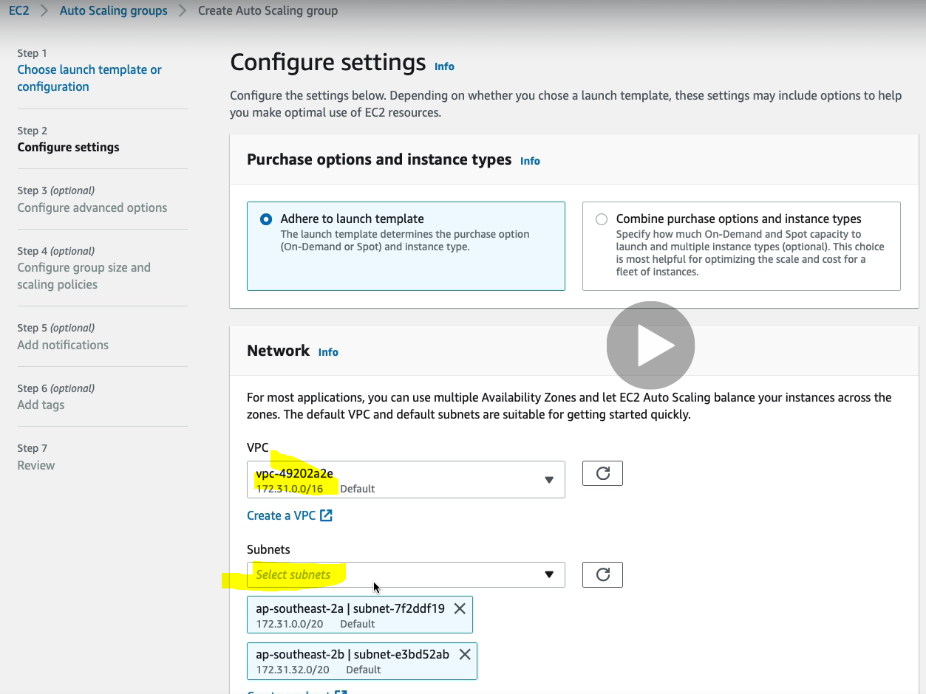

Select the VPC and subnet of different availability zone.

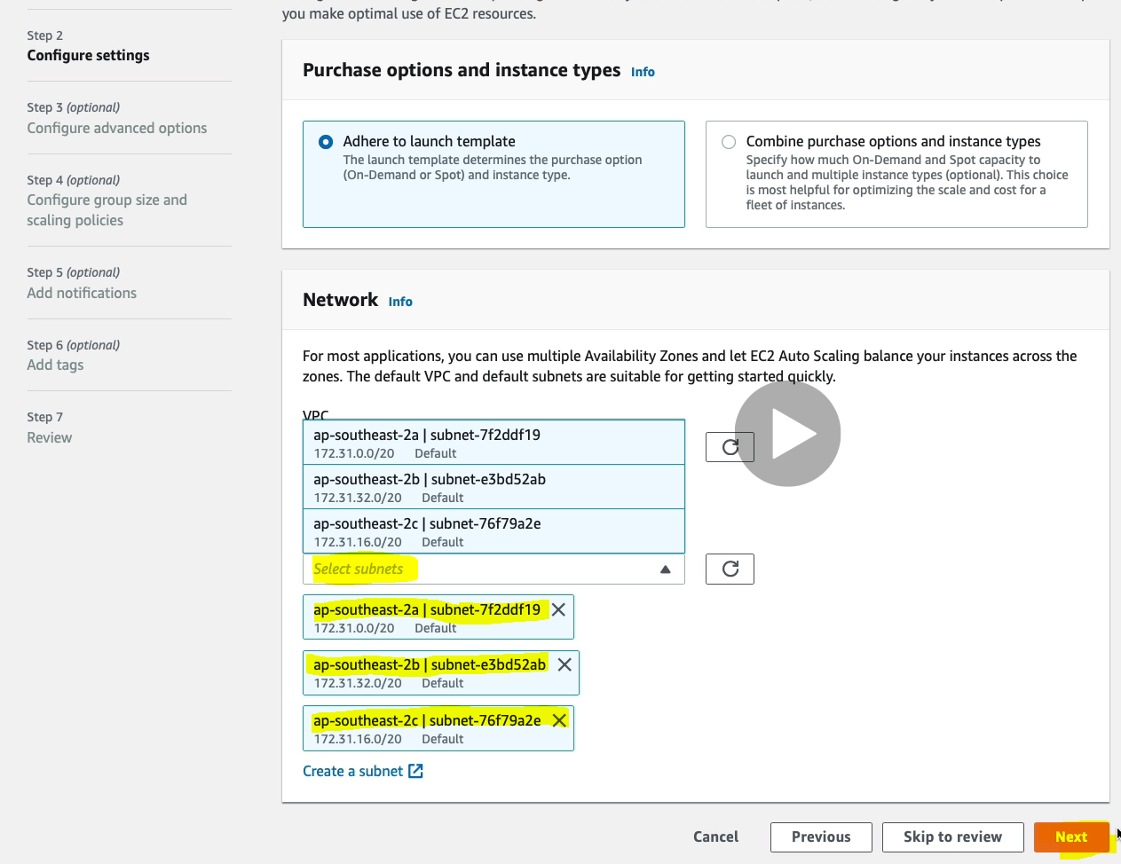

Click Next.

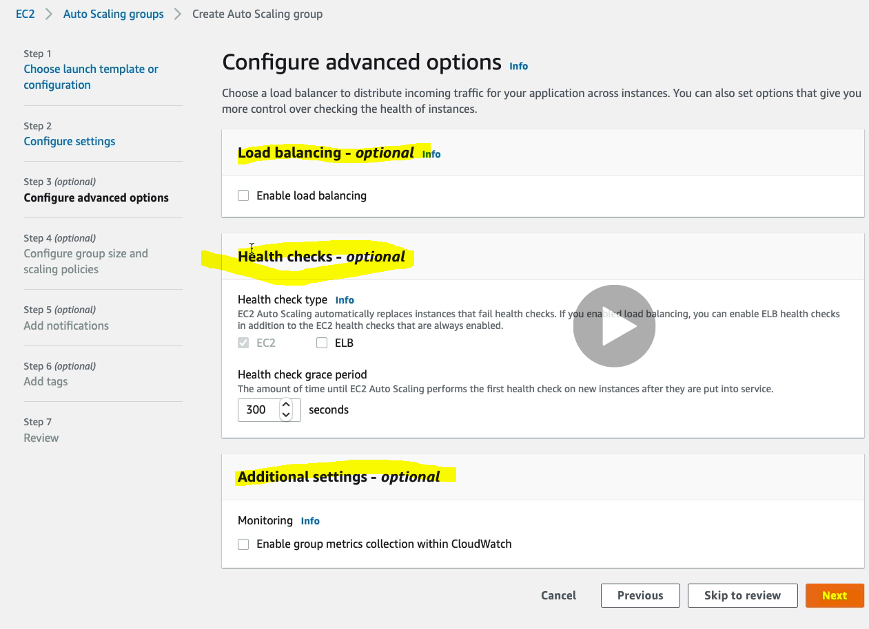Keep all the things as it is and click on Next.

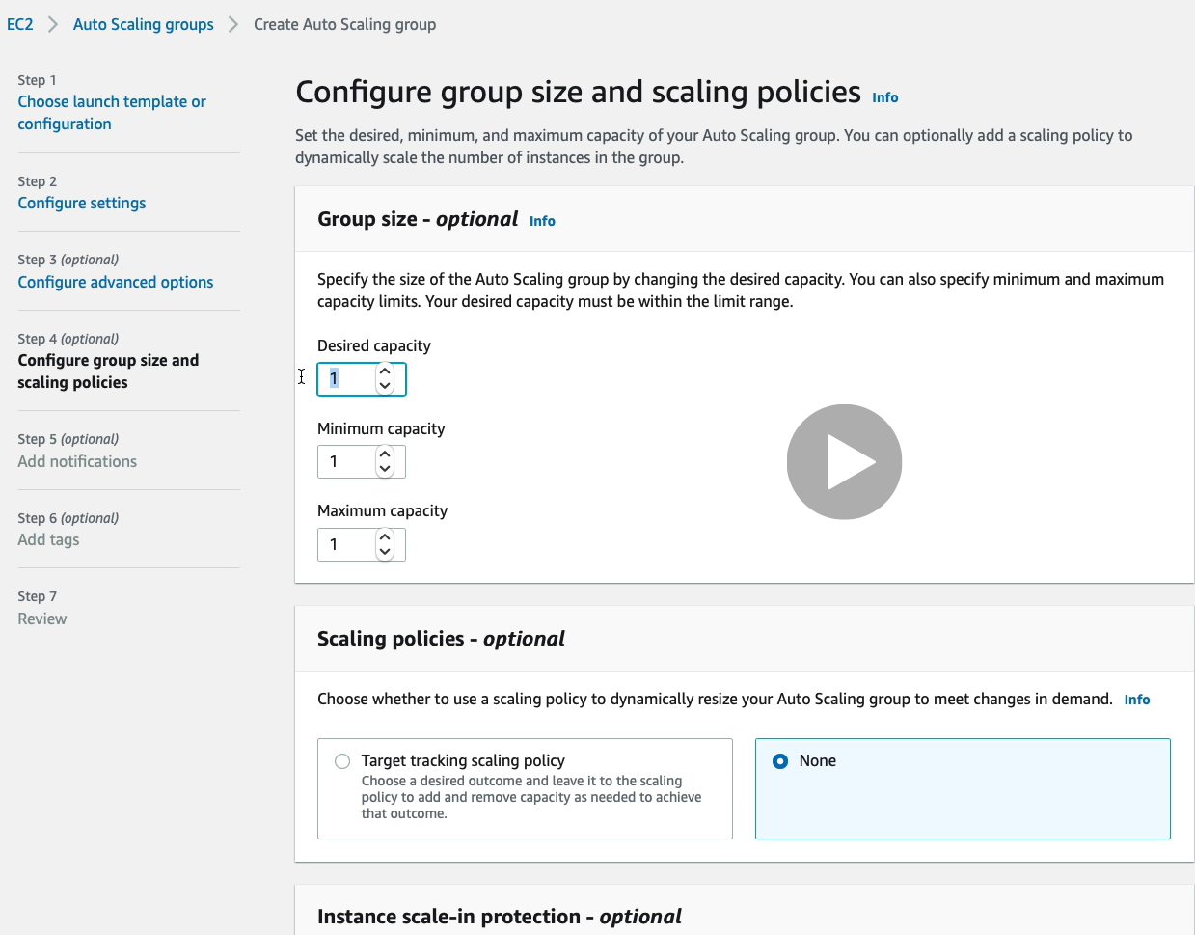

Now here we can define the group, like how big our group could be.

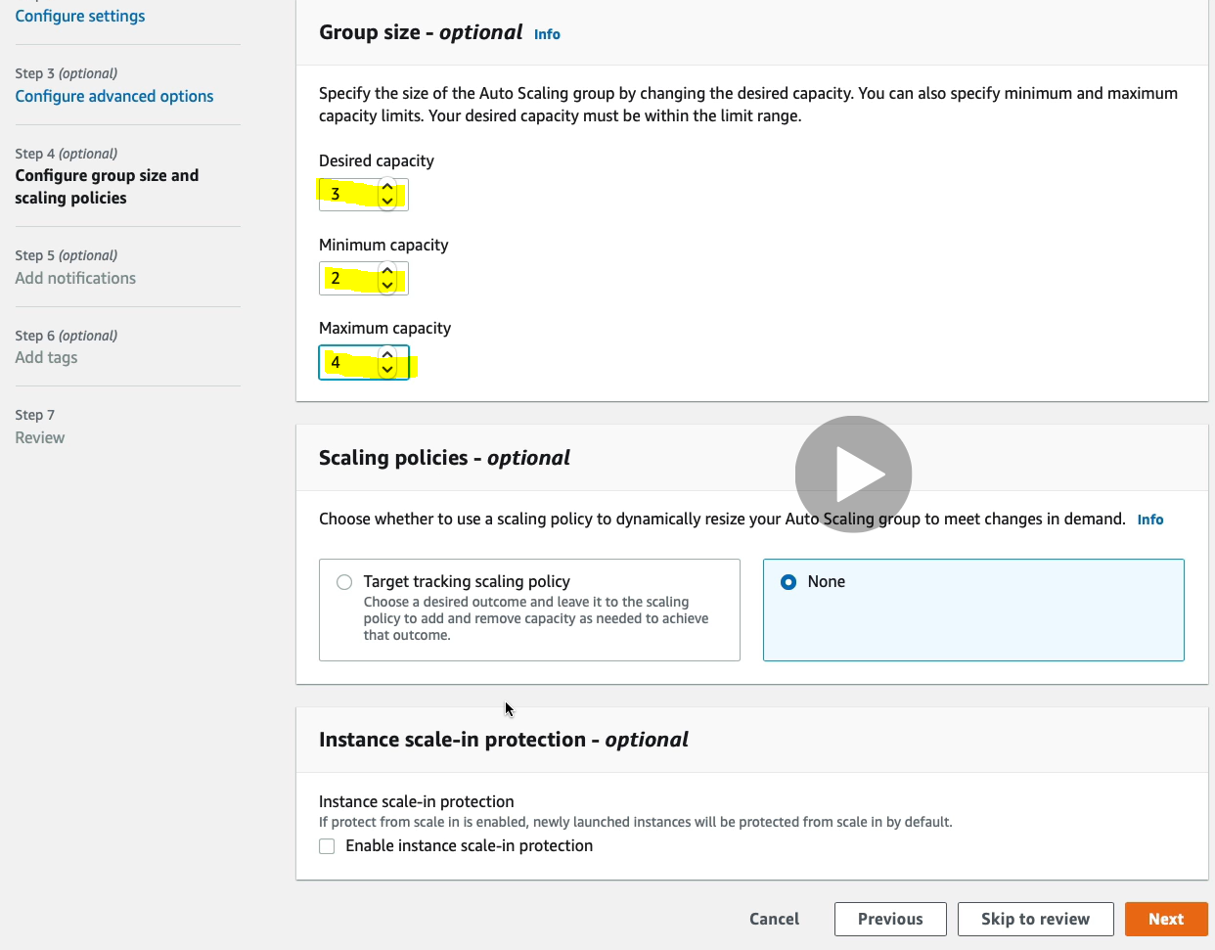

Click Next> Next> Next . And now we will get review screen.

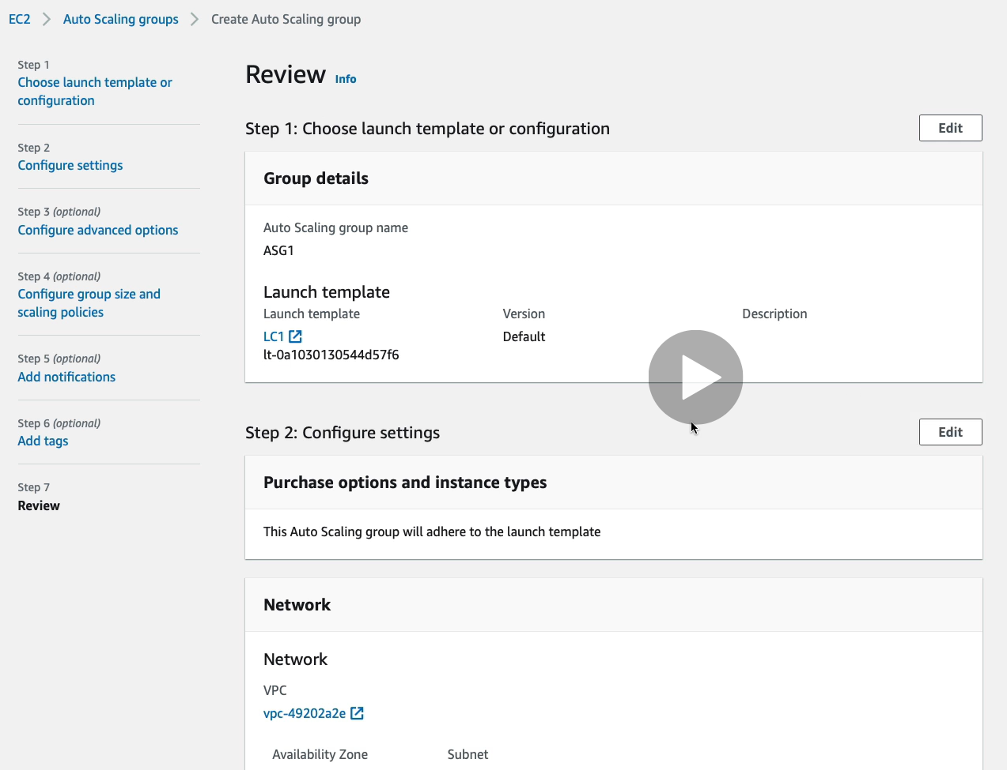

Click on Create Auto Scaling Group Button at bottom of the review page.

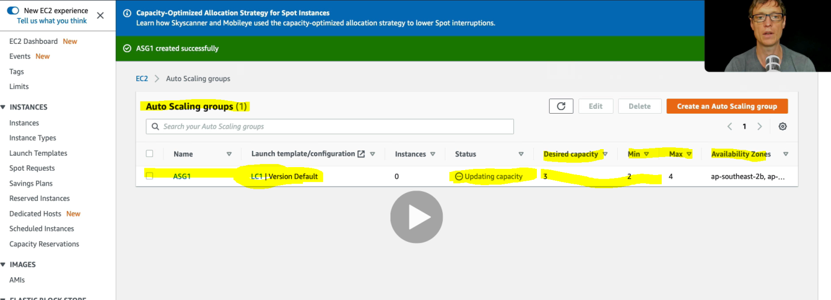

Now let’s go and click on Instances to launch the instances.

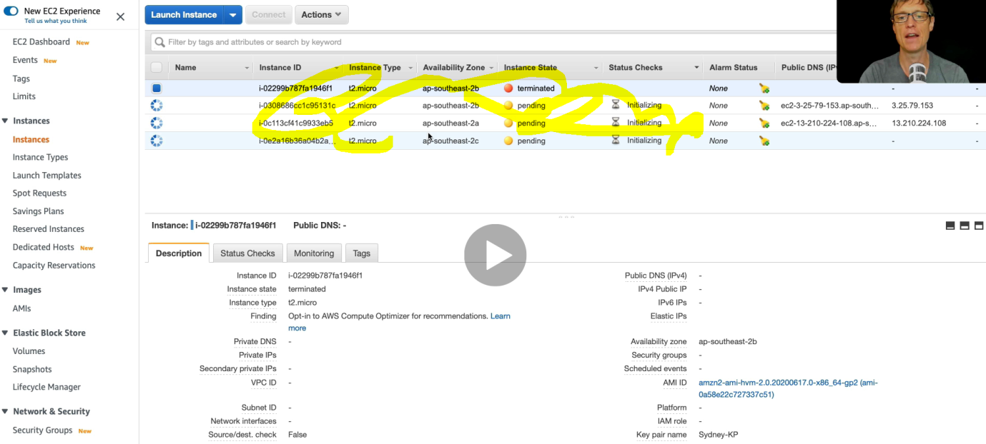

And here we can see that 3 instances is being created automatically and initiating.

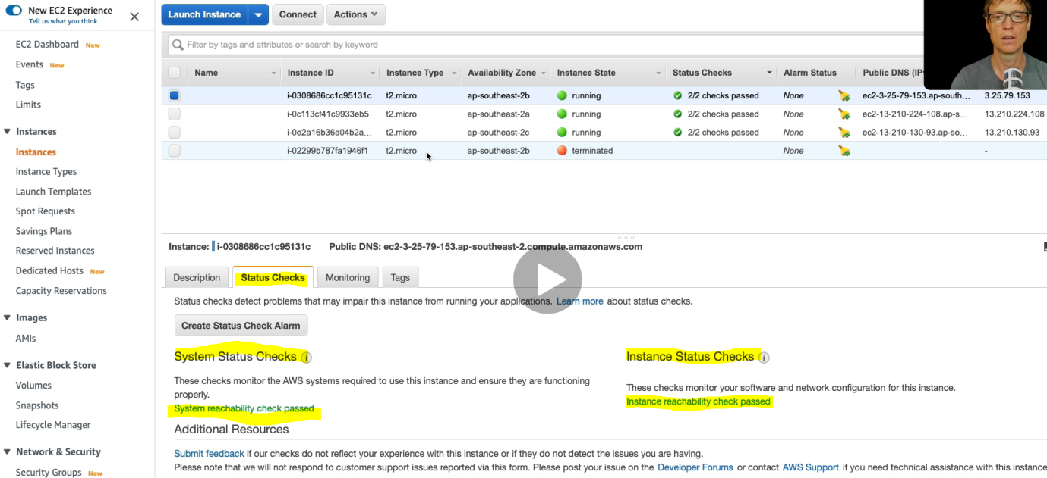

And now after sometime all the three instances are in running state and their status checks are also in pass state.

Now let’s go back to “ Auto Scaling Group” and found the three instances under ASG1

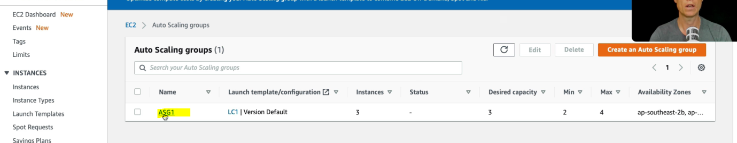

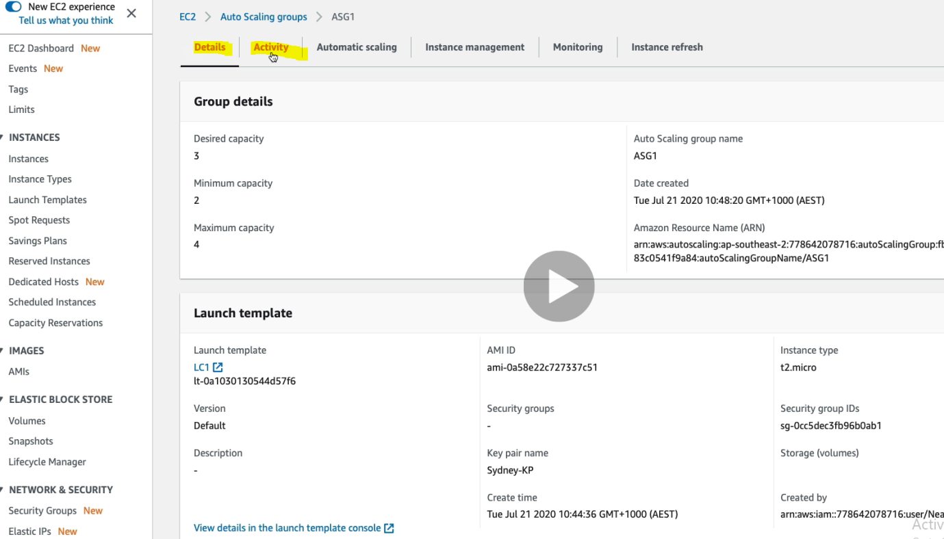

Click on Activity

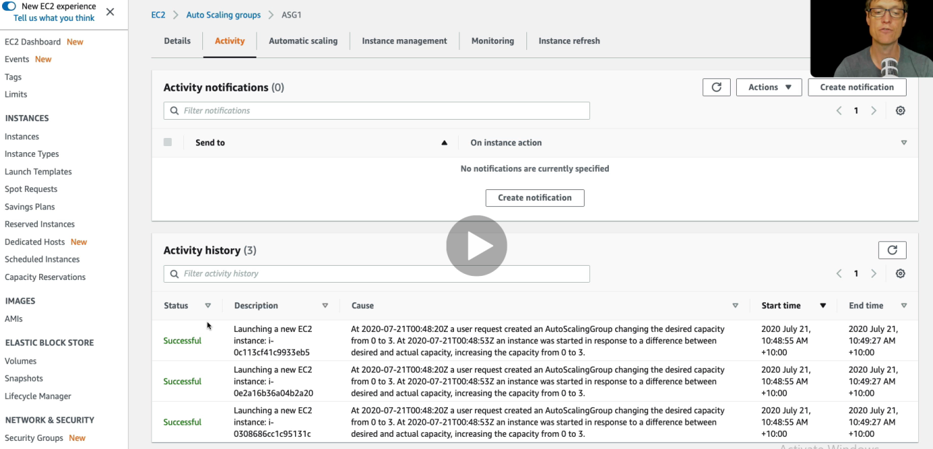

And here we see the log all three EC2 instances, like status, description, Cause, start time, end time.

Note: So now what happens in case of failure? To test the failure case , let’s terminate 2 instances out of three manually ( failure will be done when any problem will occur but here we are terminating 2 instances manually just to test failure case.)

Let’s go back to EC2 instance and terminate 2 EC2 instance out of three.

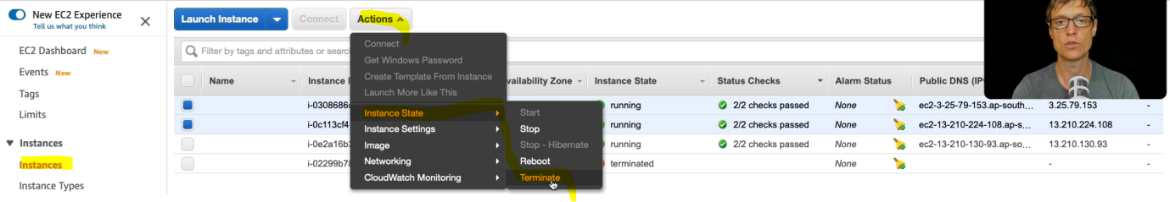

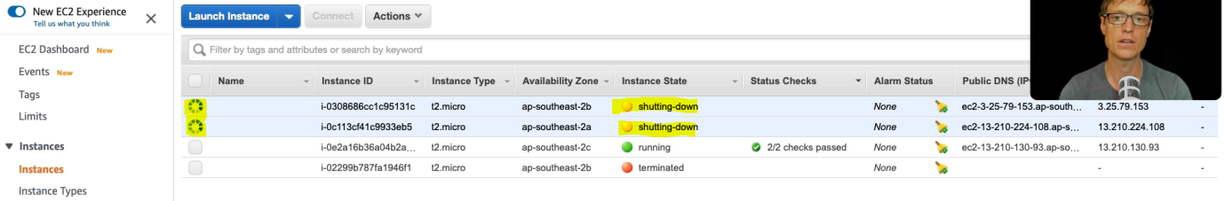

Now again let’s go back to Auto scaling group and check log what happens there?

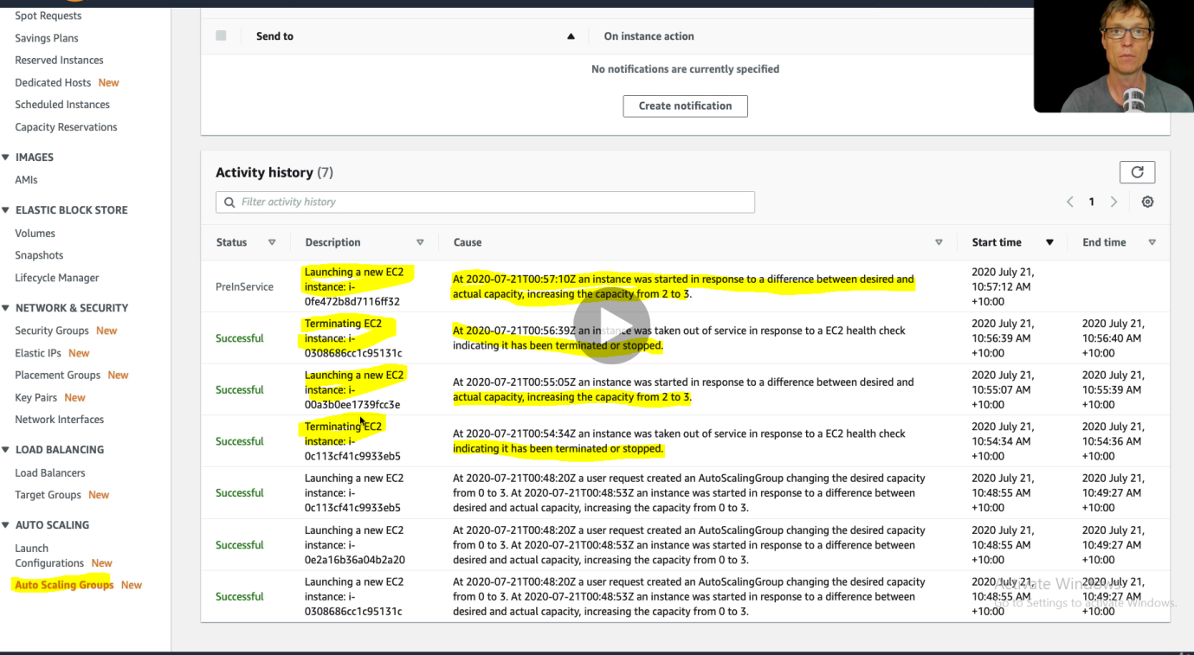

So here in the log we can see that after terminating two instances, again the two Instances got created automatically just in response to a difference between desired and actual capacity. Here in the log we can see all the information about failure and auto scaling of the EC2 instances.

Now again let’s go back to EC2 instance console and check.

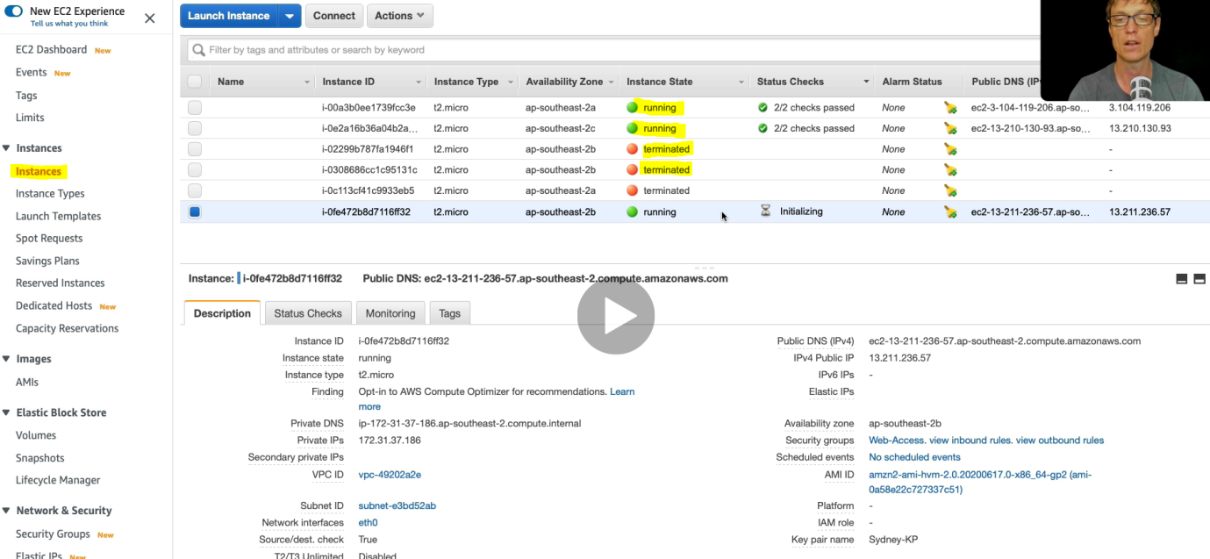

And here we can see that two terminated EC2 instances got created (Scaled) automatically and are in running state.

**Auto Scaling Based on CPU uses:**

Here in this case we are going to reduce and increase load on the CPU. Here in this case we are going to set up a policy in the Auto Scaling group and will see what the EC2 matrix react to cloud watch.

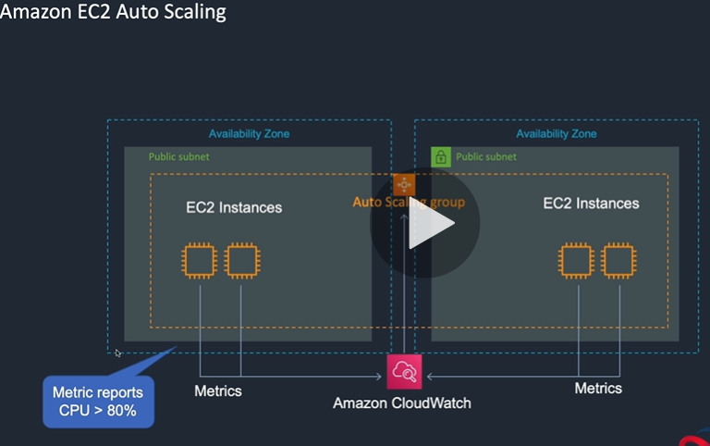

And when the matrix report the CPU Uses more than 80% to the cloud watch then in-turn cloud watch notify the Auto Scaling Group for the auto scaling (increasing) the EC2 instance.

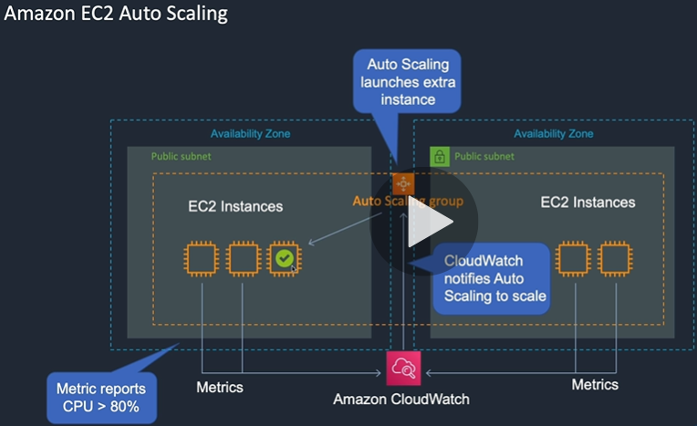

Now let’s see how we do in AWS cloud.

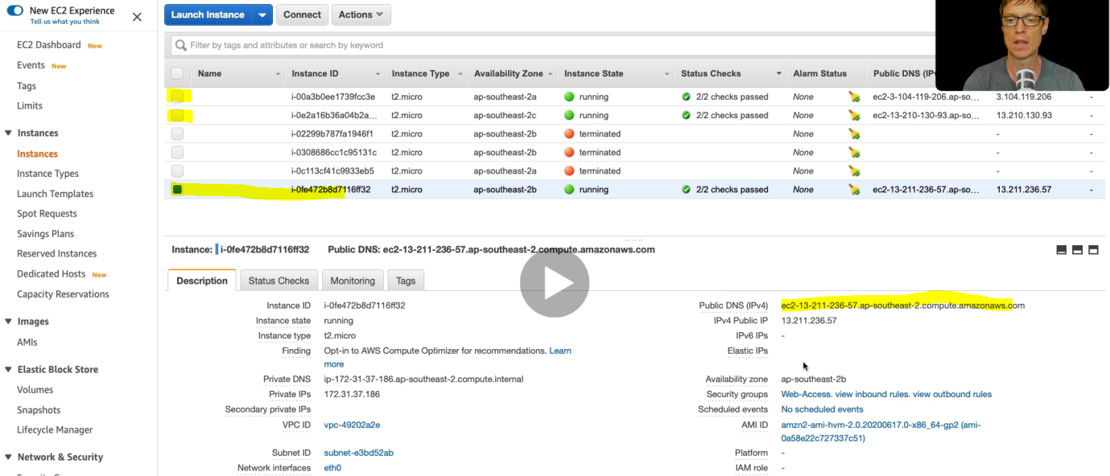

So first of all let’s connect all the EC2 instances through the command prompt.

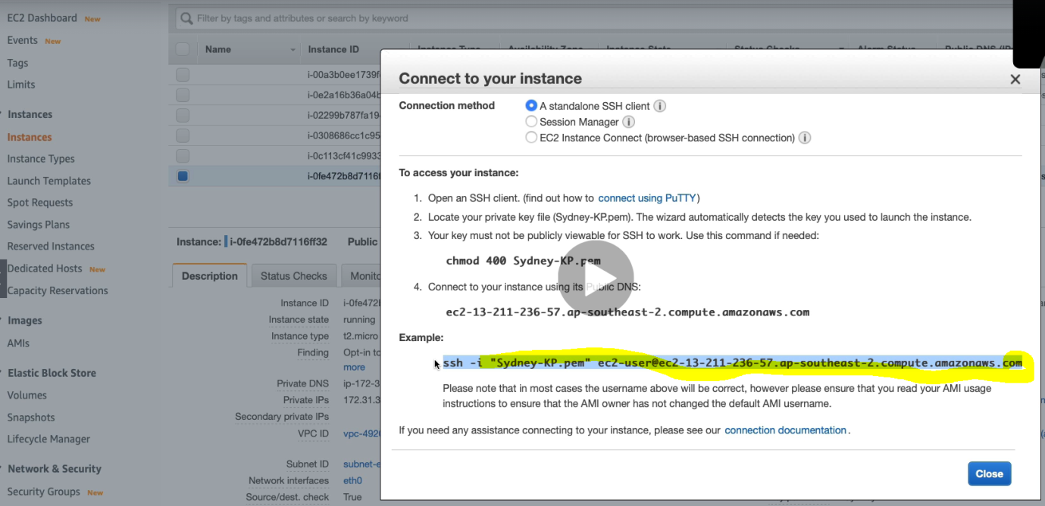

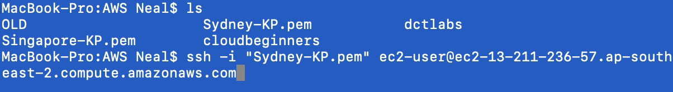

Connect another instance

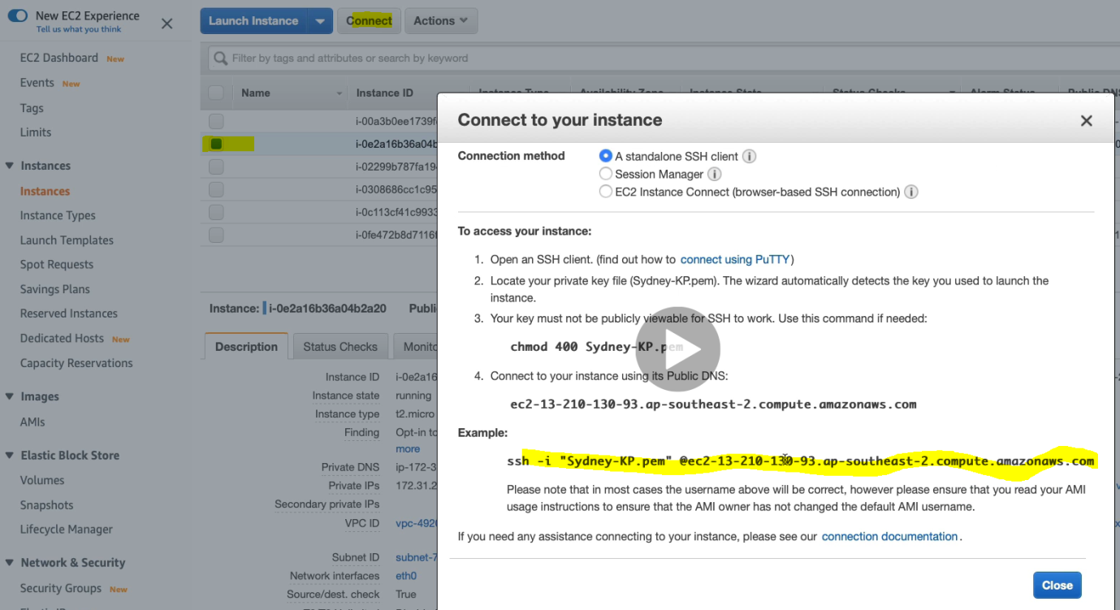



Connect the third instance

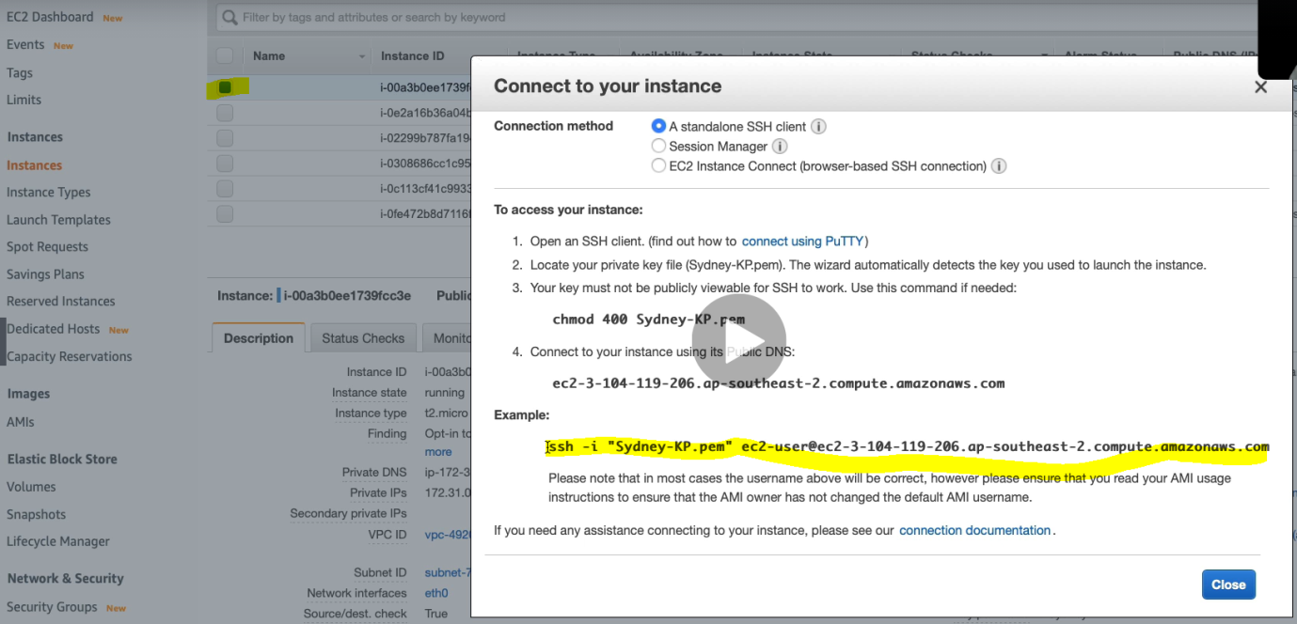

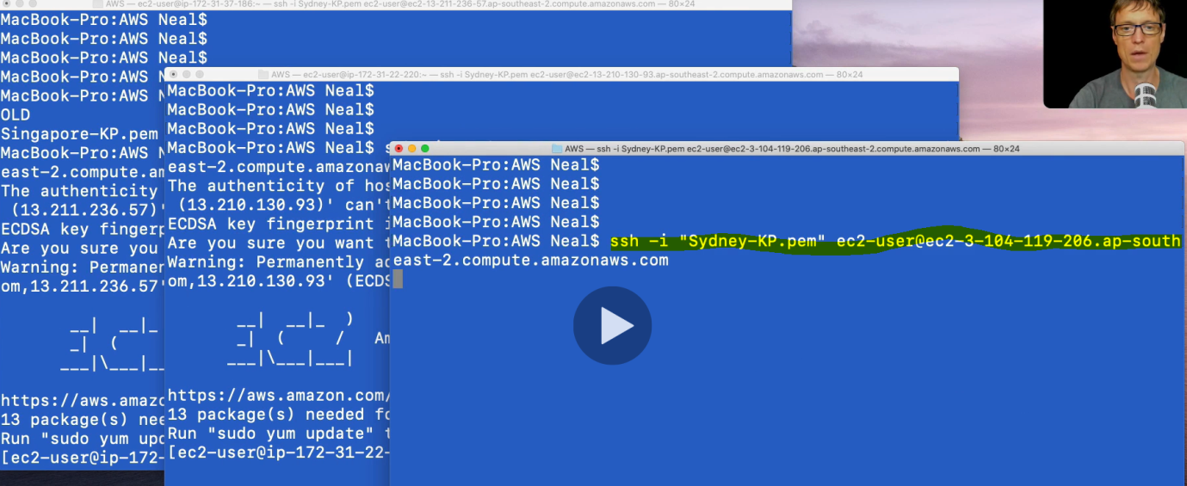

Now the next step is we will run some utility command to generate load and check

But before putting load let’s configure policy.

To Create Auto Scaling CPU uses policy : Go EC2 Console > Auto Scaling Group> ASG1 >Automatic scaling > Click Add Policy.

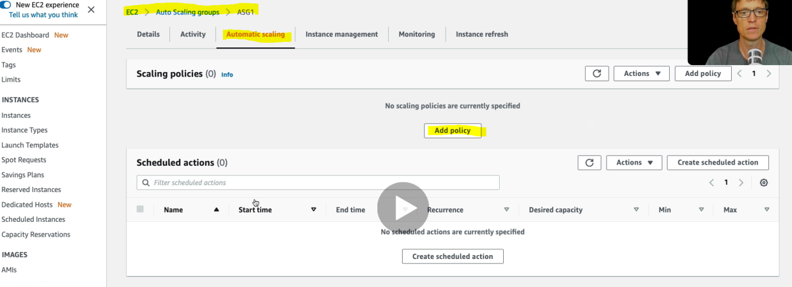

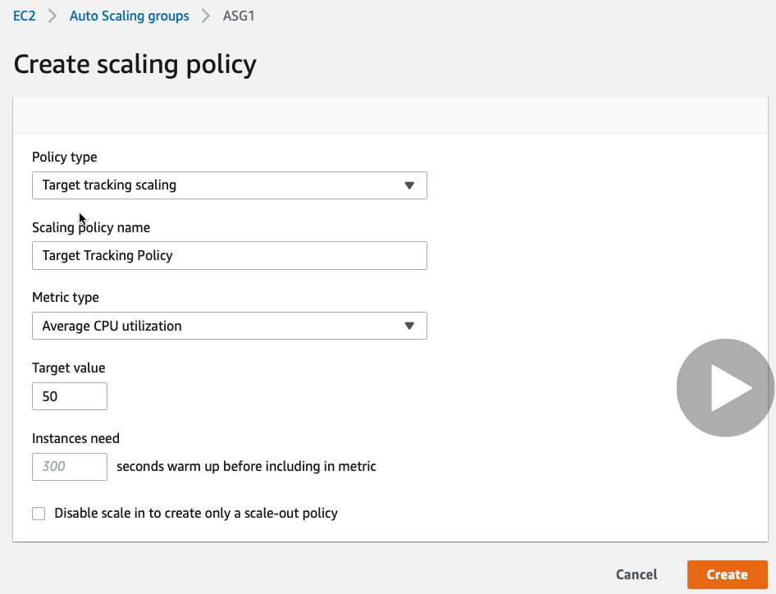

So here we goanna define average CUP uses is 50% > Click create.

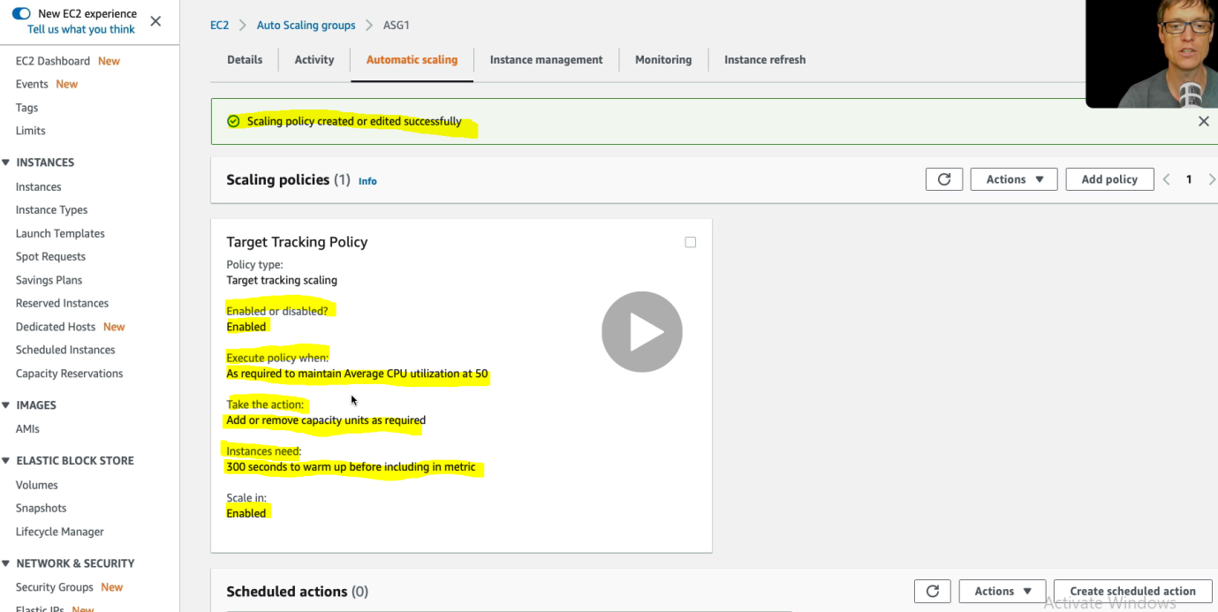

Now let’s define the minimum and maximum capacity of EC2 instance.

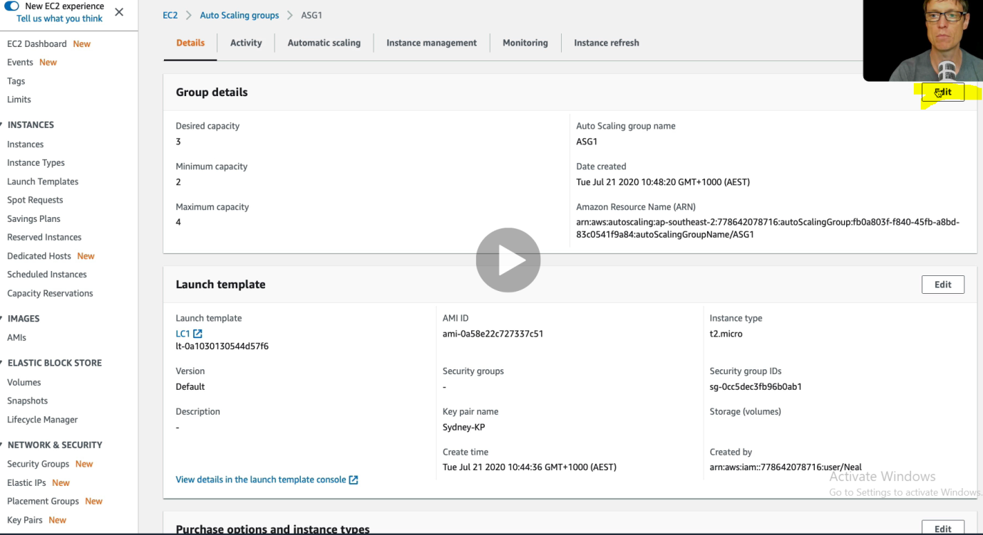

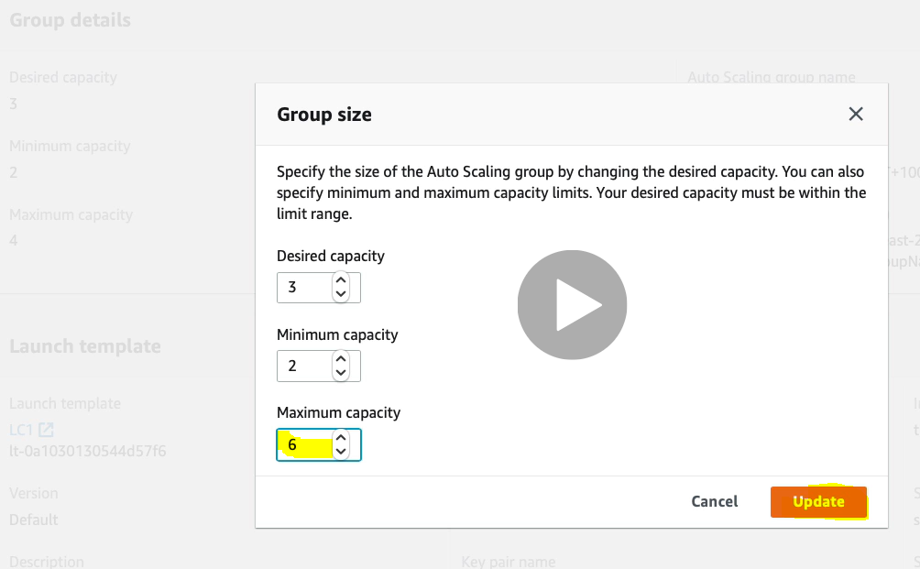

Now let’s see in the log if anything is happening.

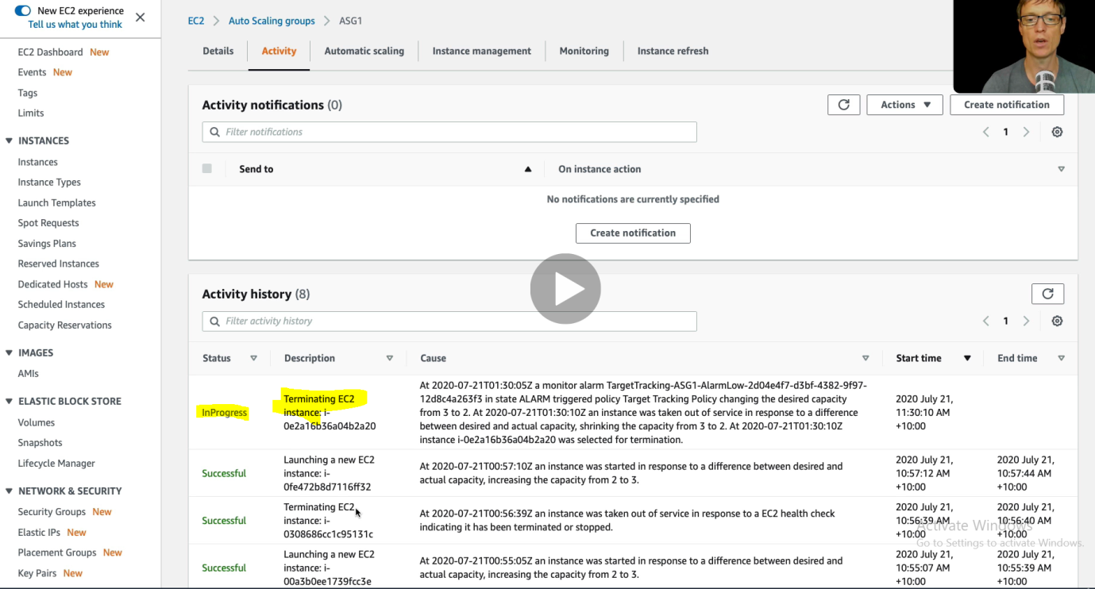

So here we can see that one EC2 instance is being terminated because CPU uses is less than 50%. Since here we have defined Min =2 and max =6 so the auto scaling will happen within this min and max range.

Now let’s go back to EC2 Console and check the number of instances.

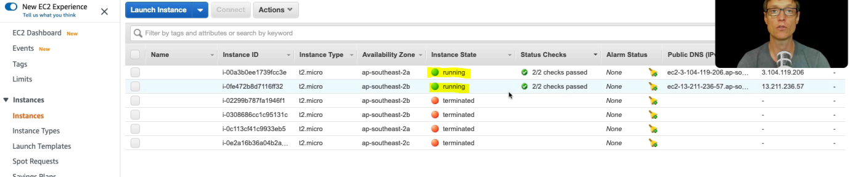

So we can see that it terminated automatically one additional instance because the CPU uses is less than 50%. Hence using the auto scaling CPU uses we can save money.

Now let’s take another case where we increase the CPU load. To increase the CPU load let’s run some command.

Run the below mentioned command in the command prompt

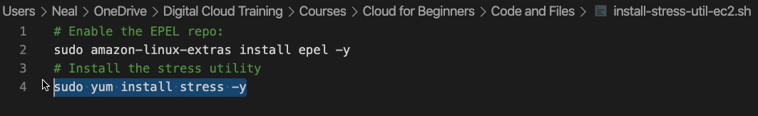

After running these two command , let’s run one more command to generate stress on CPU.





The above command increases the number of process on the CPU

After running the above command it will take some time to do the Auto scaling based on the number of process

Initially after running the above command.

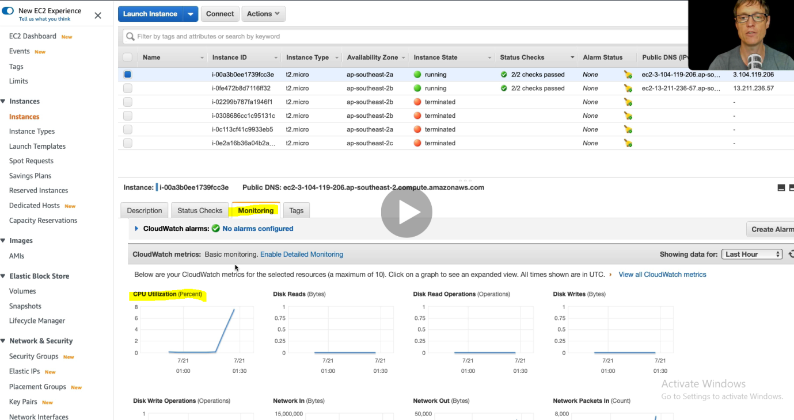

And after some time , let’s check the Monitoring window again. By default it update the monitoring status in few minutes, but if we want to modify it then we can enable Detailed Monitoring and which is chargeable.

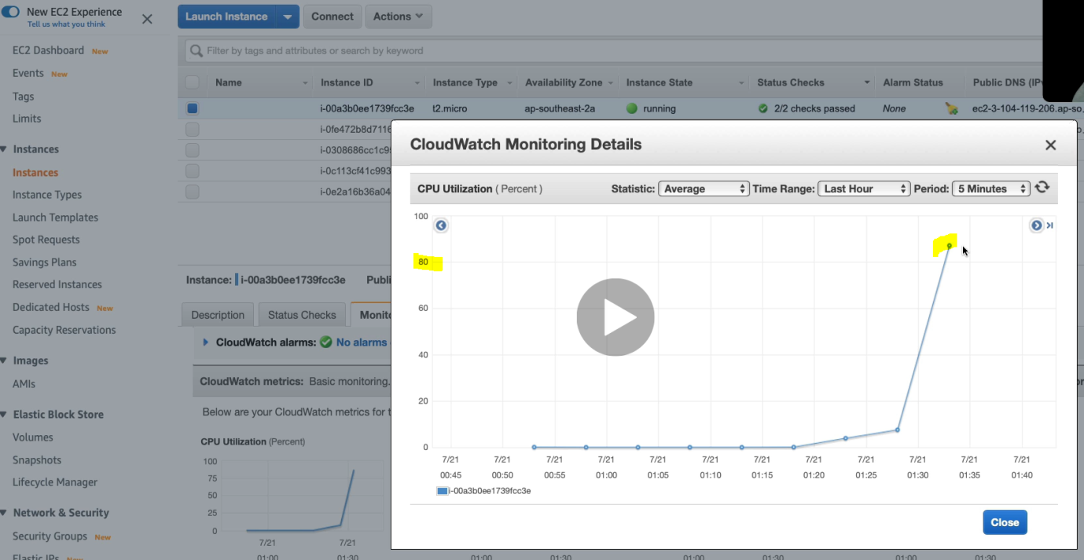

Now the CPU utilization jump up to more than 80% almost 90 %. And now EC2 Matrix will inform to Cloud watch and in-cloud watch send the info to Auto Scaling Group to increate EC2 instances.

After some time we just refresh the page and found the addition EC2 instances got added and are in initializing state

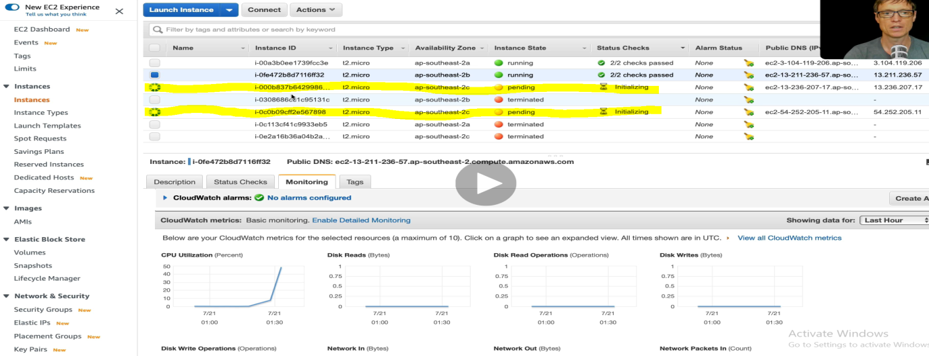

Hence two more EC2 instances got scaled (increased) automatically based on the CPU uses and Min and Max EC2 instances policy.

Now let’s go back to Auto Scaling Group log page.

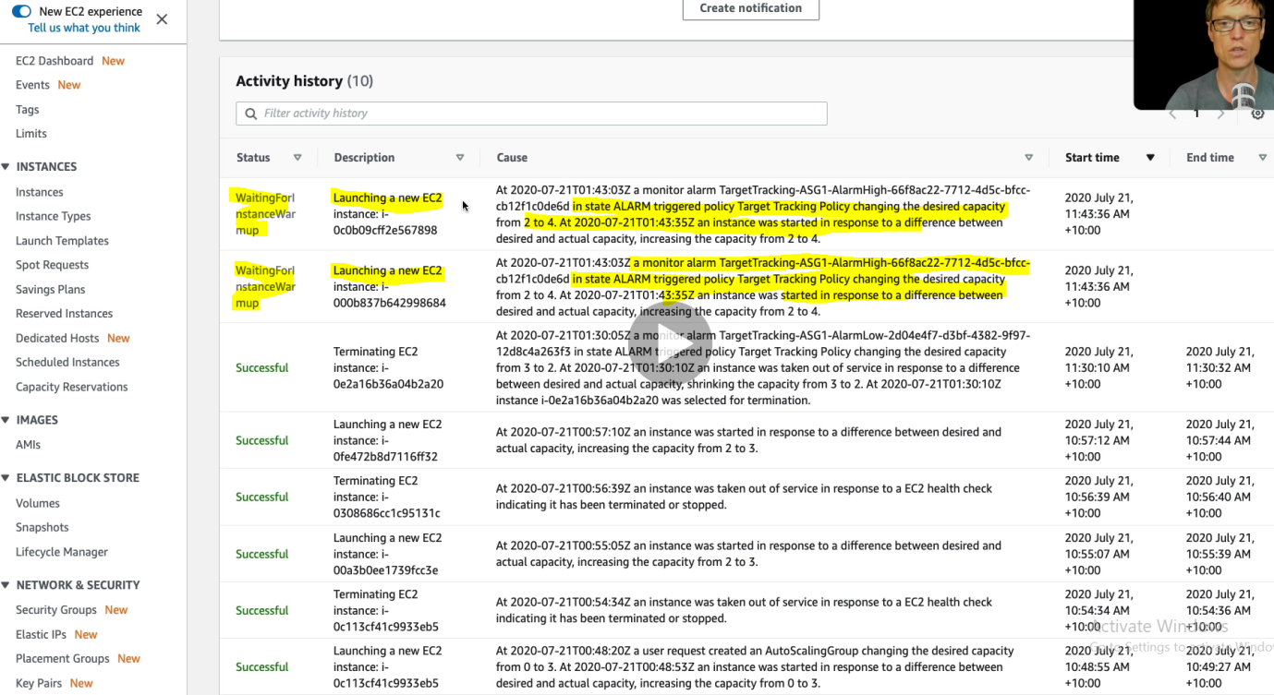

To Terminate Auto Scaling Group.

Go to Auto Scaling Group> Select the ASG1 > Click delete.

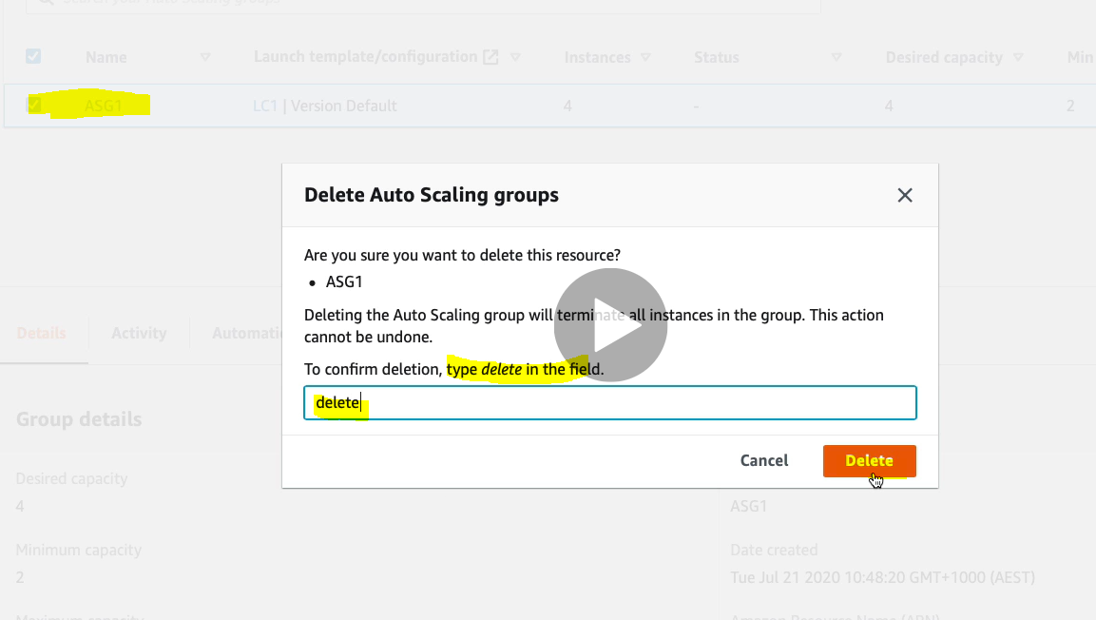

**Adding Load Balancer with Amazon ELB:**

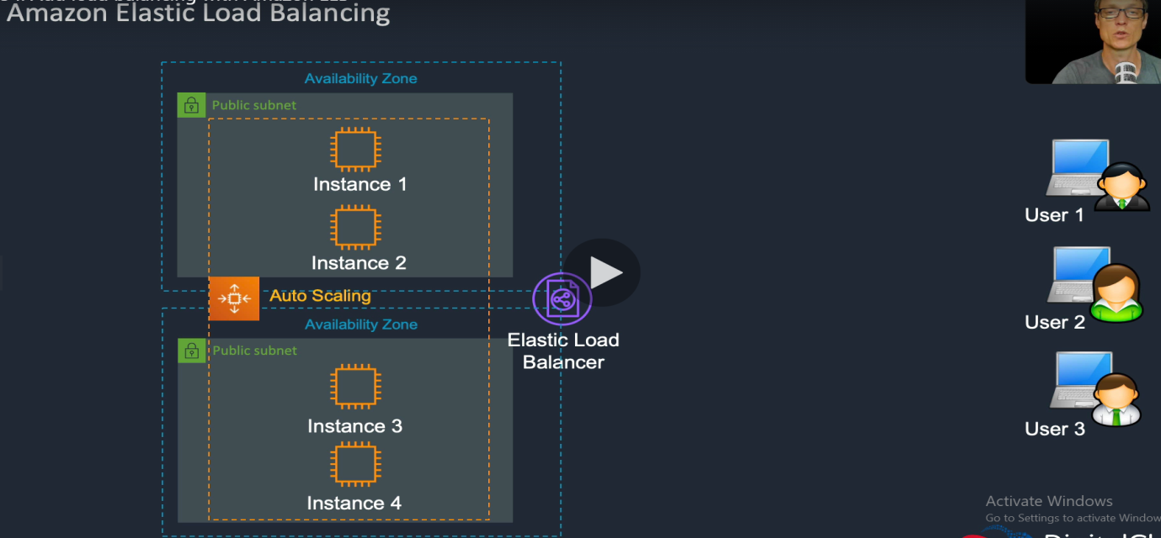

As here we can see that we have two public subnet and Availability Zone. Each public subnet contains two EC2 instances and we have integrated Load balancer between these two Availability zone and public subnet. We have integrated Auto Scaling between these two availability zone and public subnet.

|  |
| --- |
|  |
| User 1,2,3 connect to EC2 instance 1 & 2 via load balancer. These instances could be present into different subnet and different AZs. |
|  |
| As her we can see that one of EC2 instance is not working, so the load balance routed the request to instance 2 available in another subnet and AZ. |
|  |
|  |
| Here the Auto Scaling terminates instance 1 |
|  |
| Here we can that EC2 Auto scaling launches another instance 5. And again the load balancer routed the request to instance 5. |

So in short the load balancer balance the request among the EC2 instances, apart from the load balancing it keep checking the health of all the EC2 instances and in case of failure of any one of the instance, the load balancer notify the auto scaling about the instance failure and route the request to available instance in the subnet and AZ. Now auto scaling remove the failed instance from the subnet and AZ and launce a new instance at the pace of failed instance. Thus the load balancer keeps your application running in case of EC2 instance failure by routing the request to available running instances. The above architecture includes high availability and fault tolerance.

Let’s see how we do it in AWS cloud.

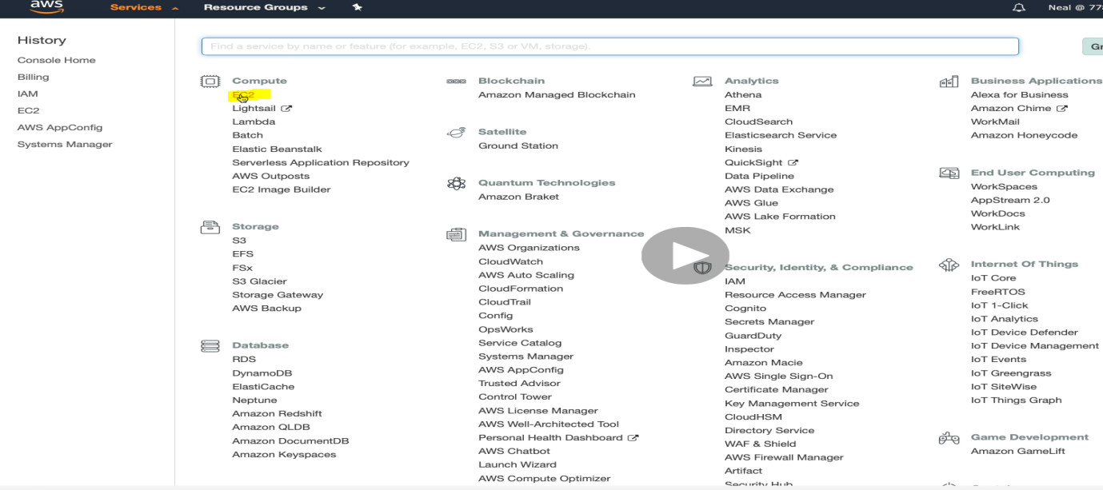

Click on EC2

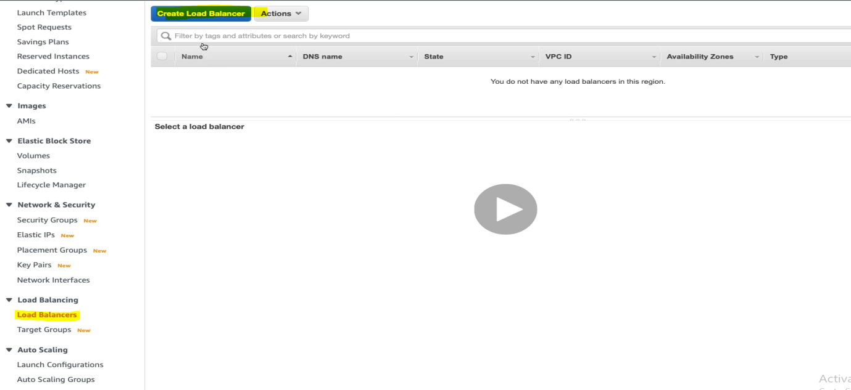

Click on Load Balancer > Click on Create Load Balancer.

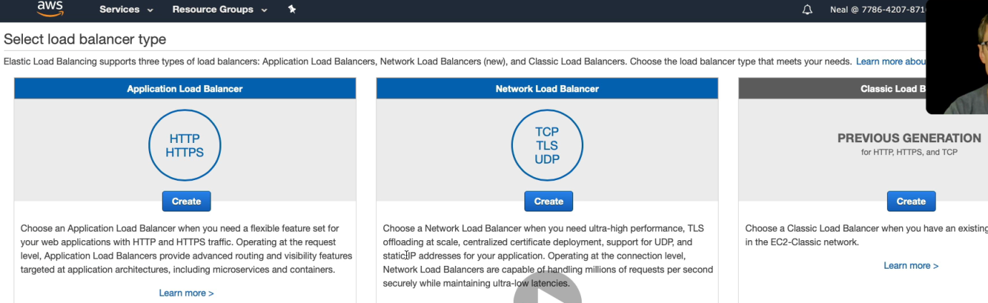

Here we can see that there are three types of load balancer ( Application , Network & Classic). Classic load balancer is now deprecated. So Select the Application Load Balancer

Click on Create of Application Load Balancer.

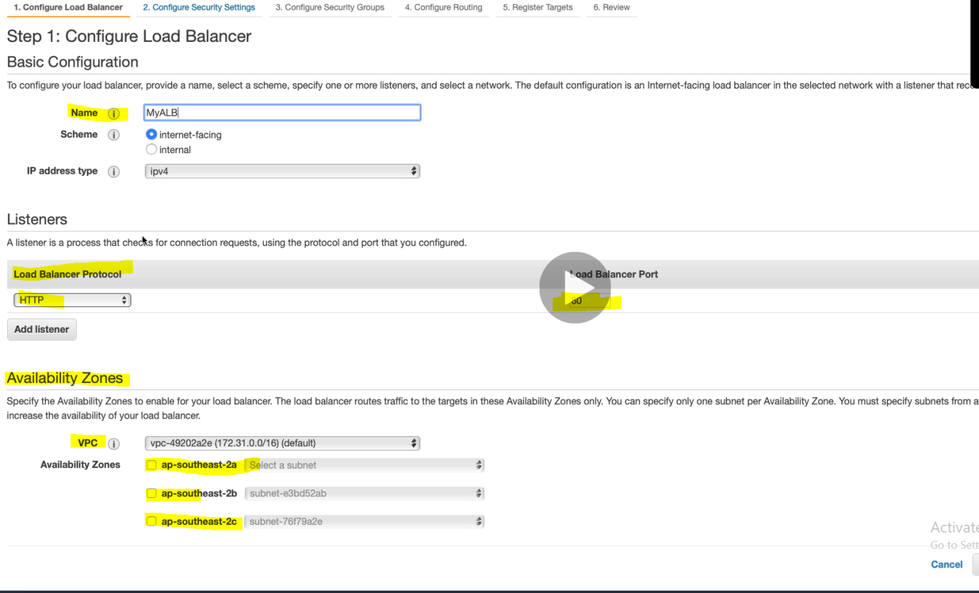

Since we have selected Application LB and application server listed on HTTP at 80 port. Let’s select the VPC, subnet in the Availability Zones. Mark check and select the default subnet.

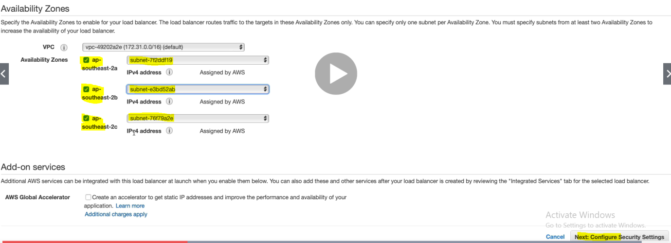

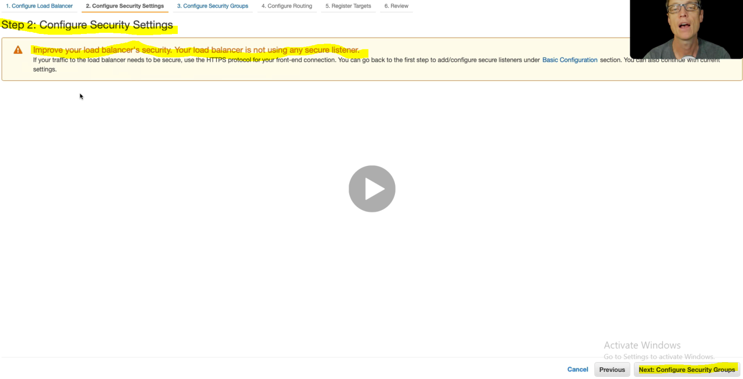

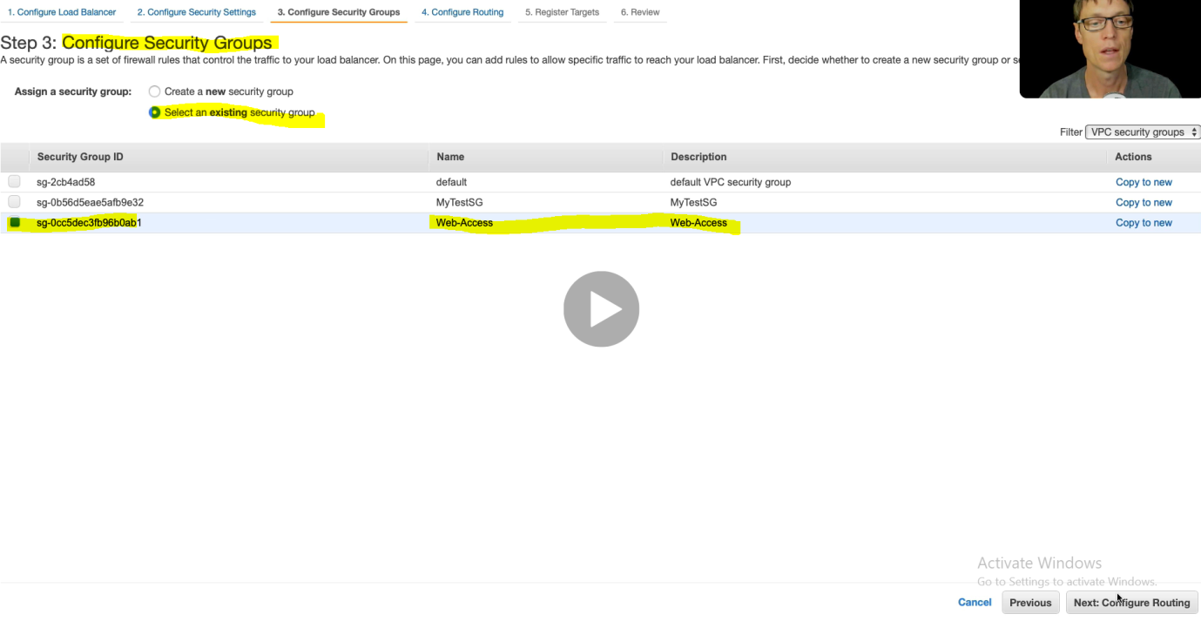

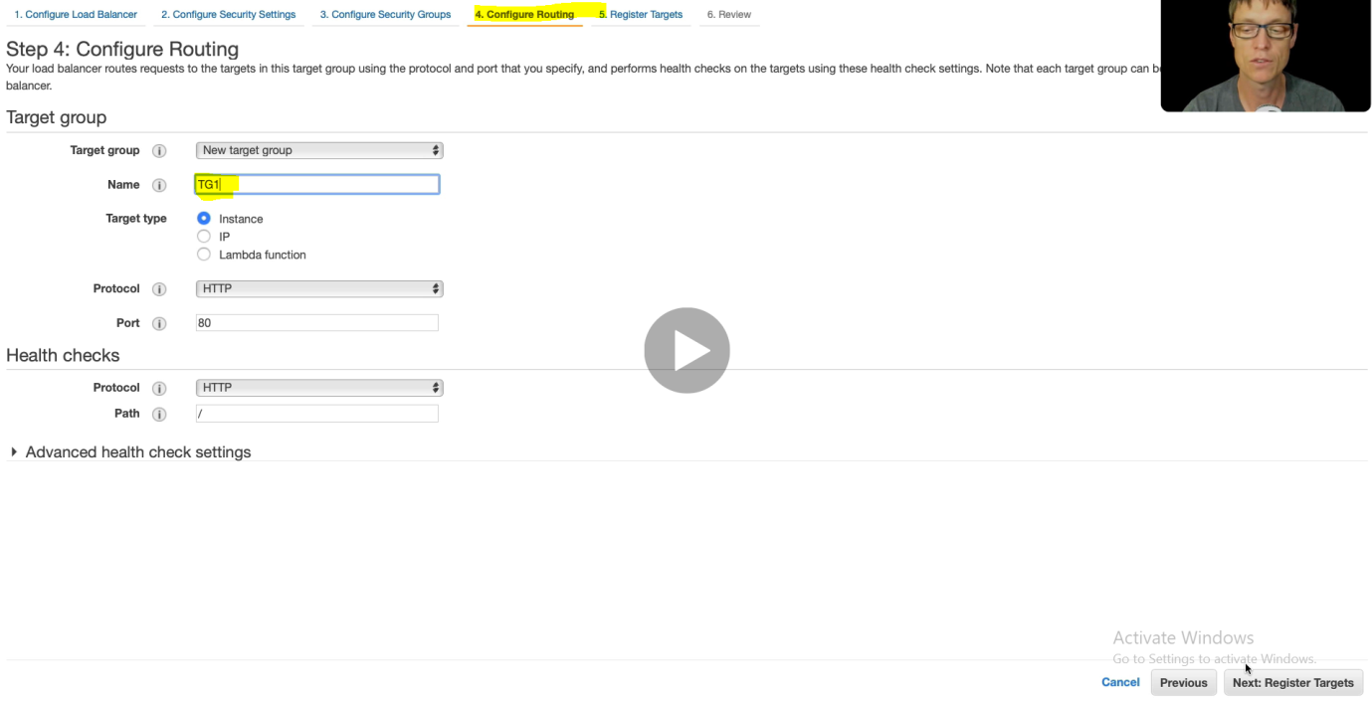

Click next > Next > Review and got created load balancer with Name MyLb

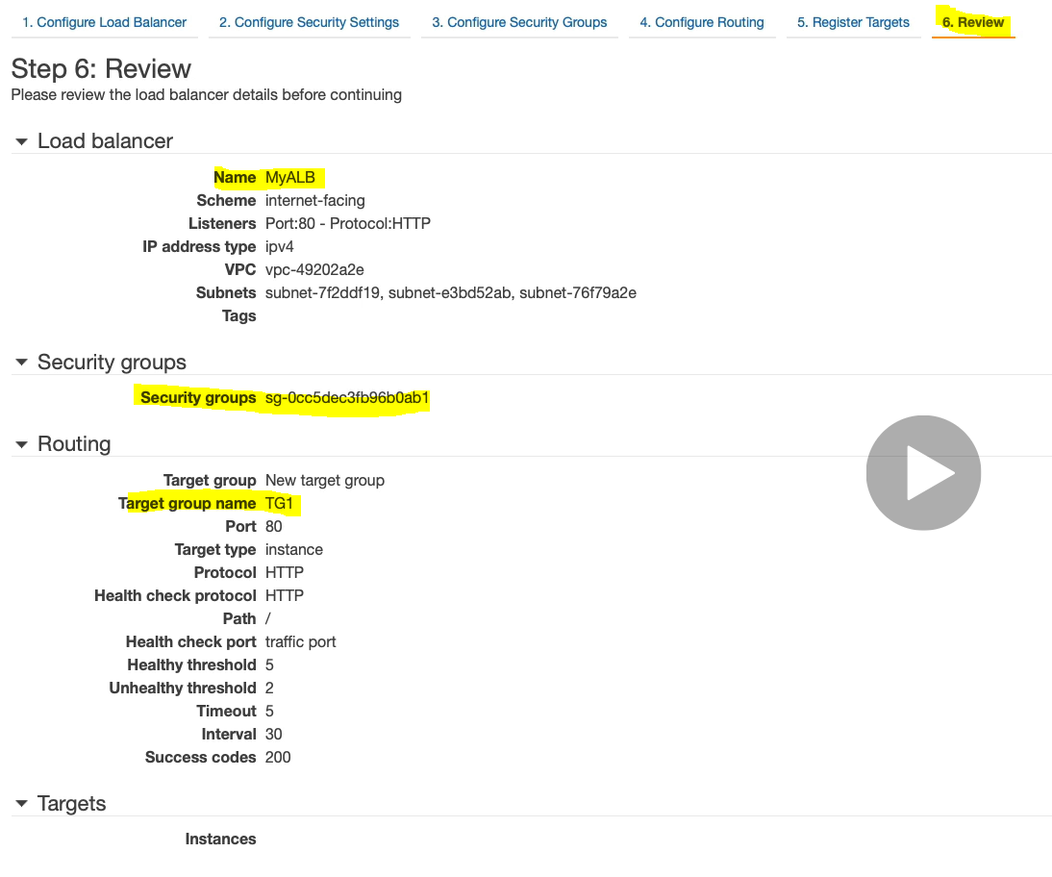

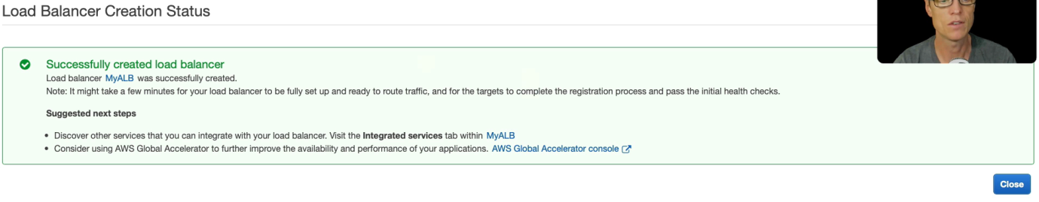

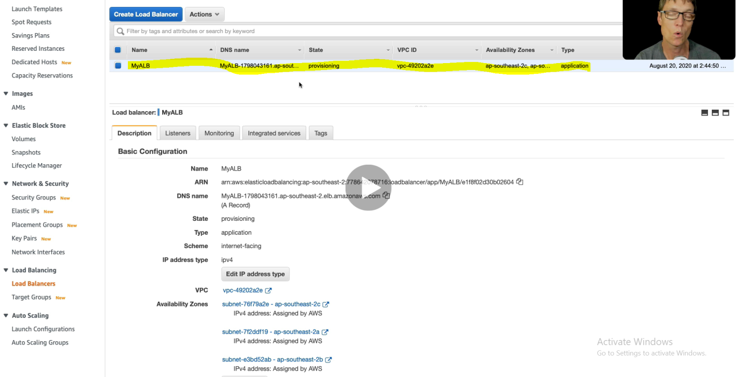

AWS Storage Service:

As we know that we have three type of storage.

1. Block based storage system
2. File based storage system
3. Object based storage system

Elastic based storage system which is nothing but block based storage. Then will move towards Elastic file based storage system and filly we will look Amazon S3 (Simple storage service) which is object based storage system.

AWS Storage Service Overview:

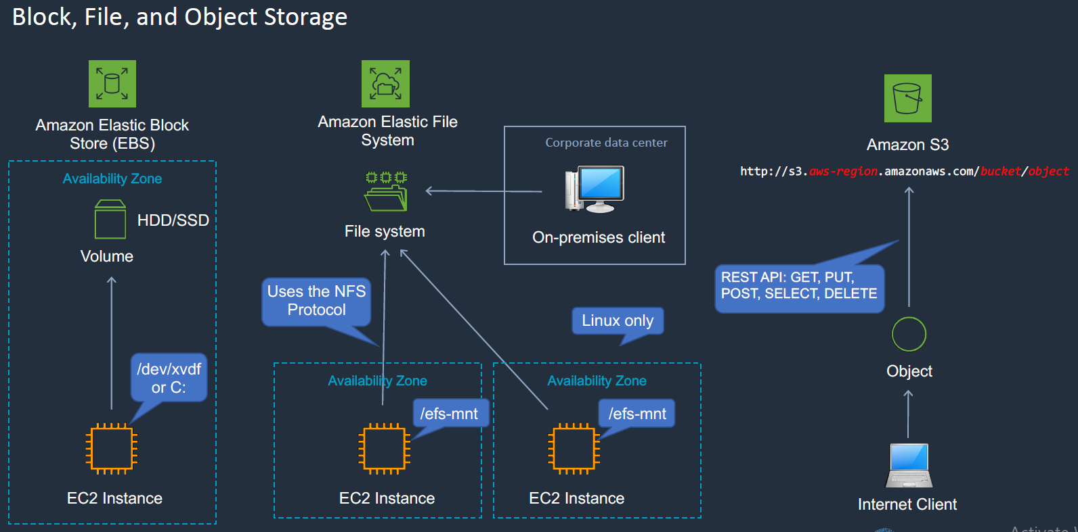

As we can see that in the Block storage, it gets mounted with the EC2 system C drive in case of Windows and in case of Linux it gets mounted with file system. Here the Block storage can be partitioned and format.

In case of Elastic File System (EFS), we have File based storage system (File System), we can mount this file system to the EC2 instances as shown in the middle image. Here the storage cannot be partitioned or format. This File System is for Linux only, so we cannot attach File System to Window EC2 instances. We can connect corporate data centre to the File System.

Finally we have Amazon Simple Storage System (S3). This is object based storage system, so we will create bucket and bucket can contain the objects. We will access this bucket using URL. Since the bucket name is used in the URL so the bucket name should be unique. We will use REST API to upload and get the file from this S3 as shown in the third image.

Create and Attach EBS (Elastic Block Storage) Volume:

Here with EC2 instance two EBS volume is attached. These EBS volumes are mounted in the AWS network in to their Availability Zone, but when these EBS volumes gets attached with EC2 instance then it appears like local partitioned volume.

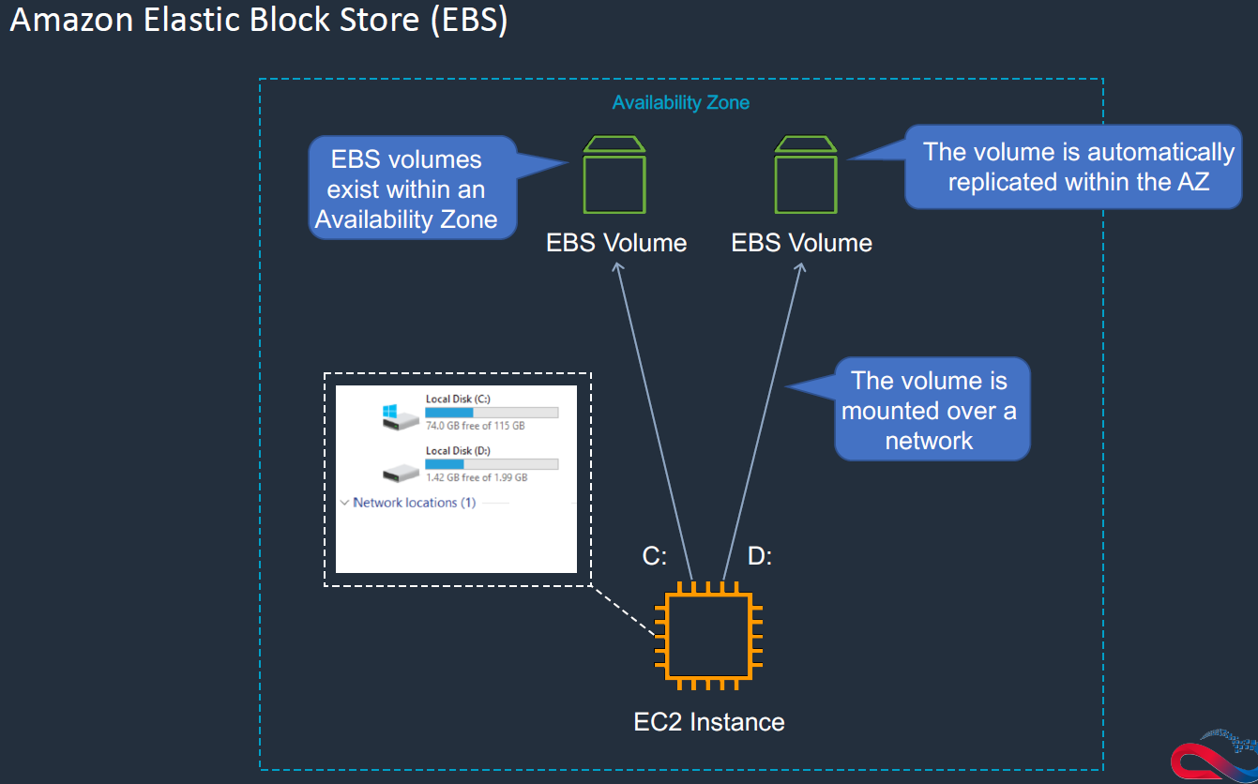

EBS basically comes under two categories.

1. Solid State Drive (SSD). (2) Hard Disk Drive (HDD)

The SSD is basically high performance drive. Let’s see the difference between them.

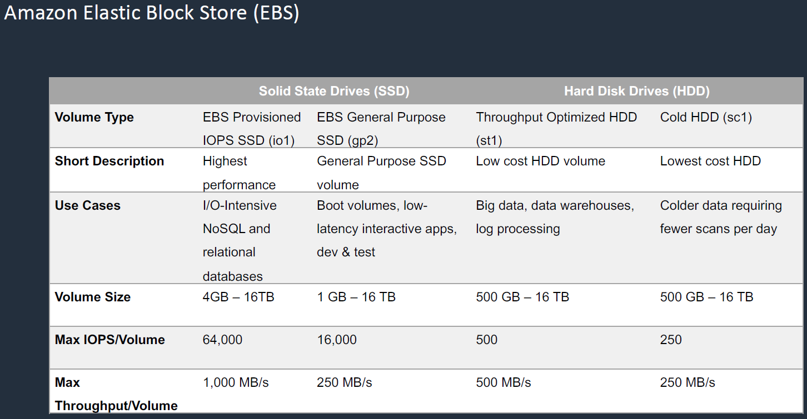

Here IOPS stands for Input/output per second.

Let’s go to AWS console and try to do some hands on. Basically EBS is found on EC2 dashboard menu only.

EC2> Elastic Block Store> Volumes

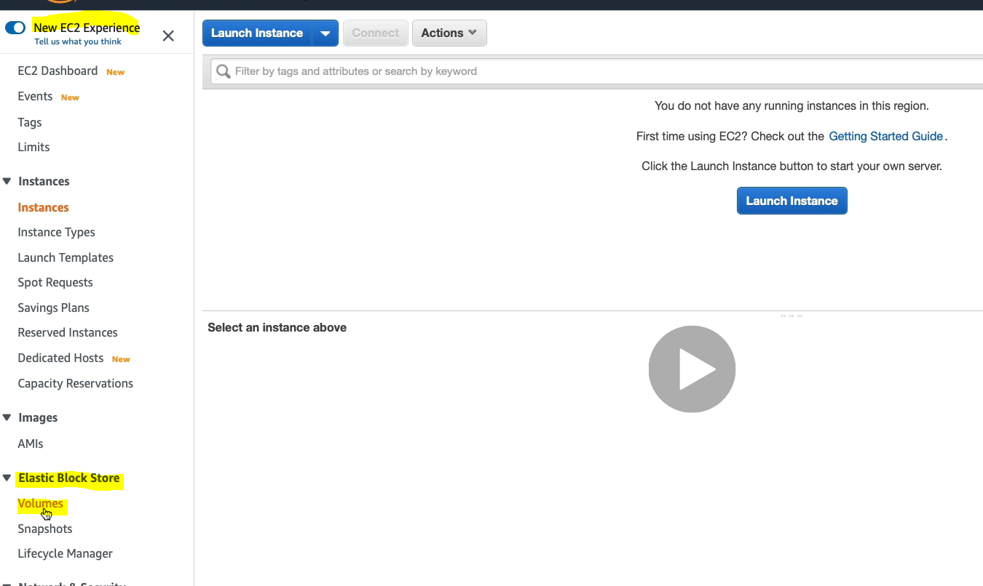

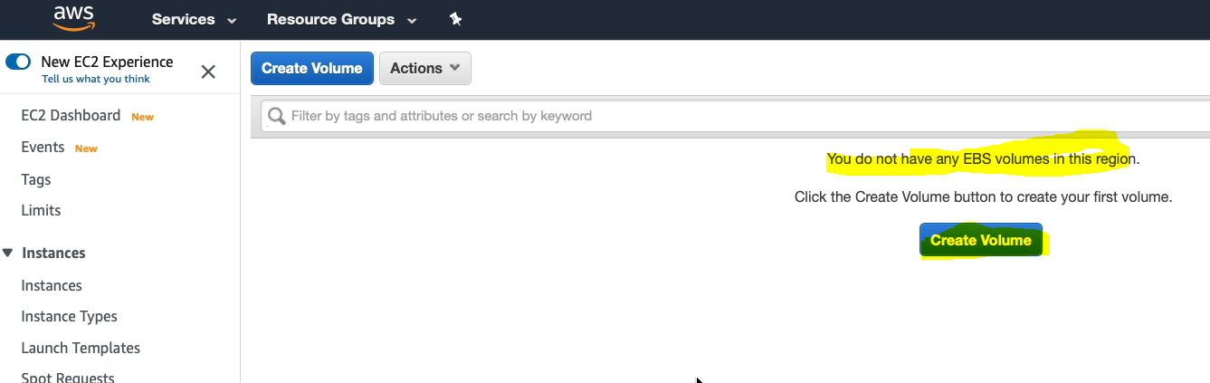

Click Create Volume.

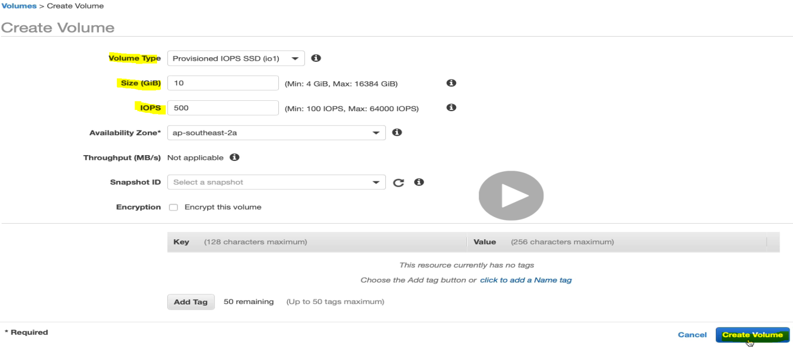

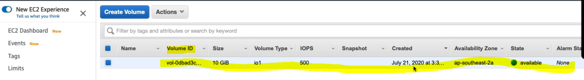

Now we have created EBS volume. Now let’s create new EC2 instance and attach to Volume.

Follow same steps to create EC2 what we have done earlier.

EC2> launch Instance> Select Microsoft Windows Server 2019 Base> click select

Select free Tier Eligible t2 Micro > Click Next.

Here in the next step we have to keep in mind that we have to select the same availability zone where these EBS volumes are gets created under the subnet field

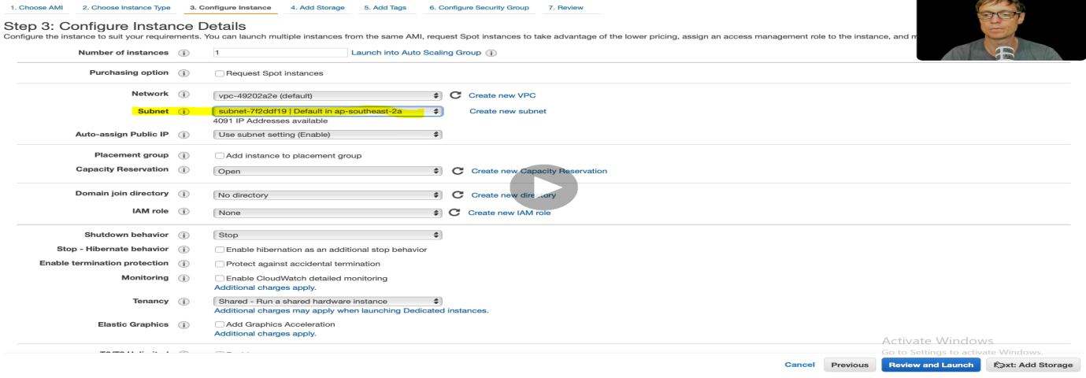 Click Next: till launch

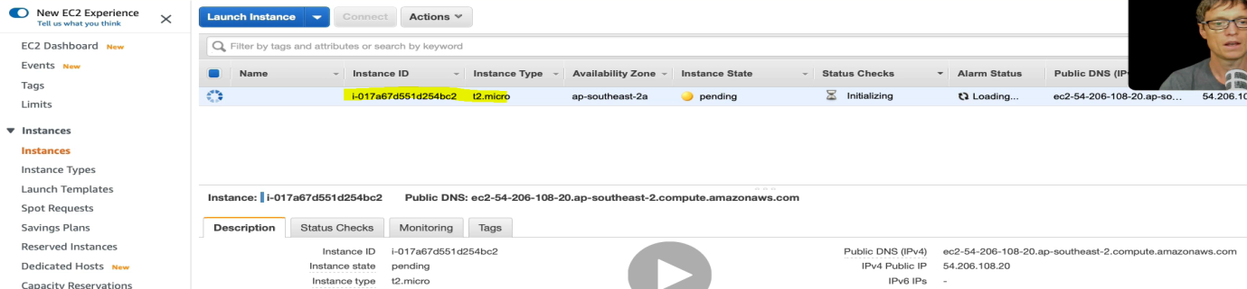

Now we have launched EC2 Machine.

Let’s go to Security Group.

EC2> Network & Security > Security Group > Click

And for web access create an inbound rule . Go to inbound rules > click Edit inbound rule.

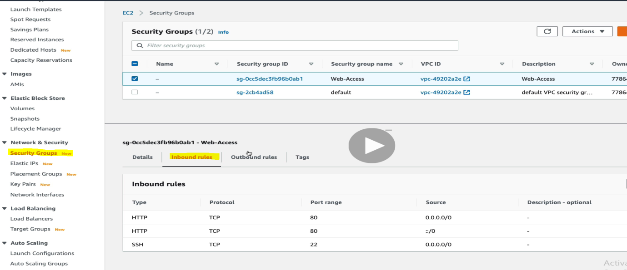

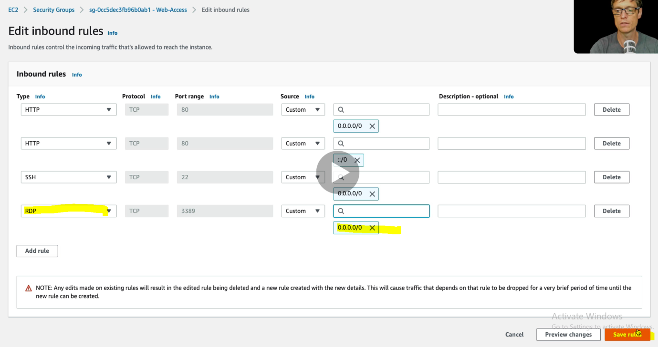

Created a RDP rule > Click Save Rule

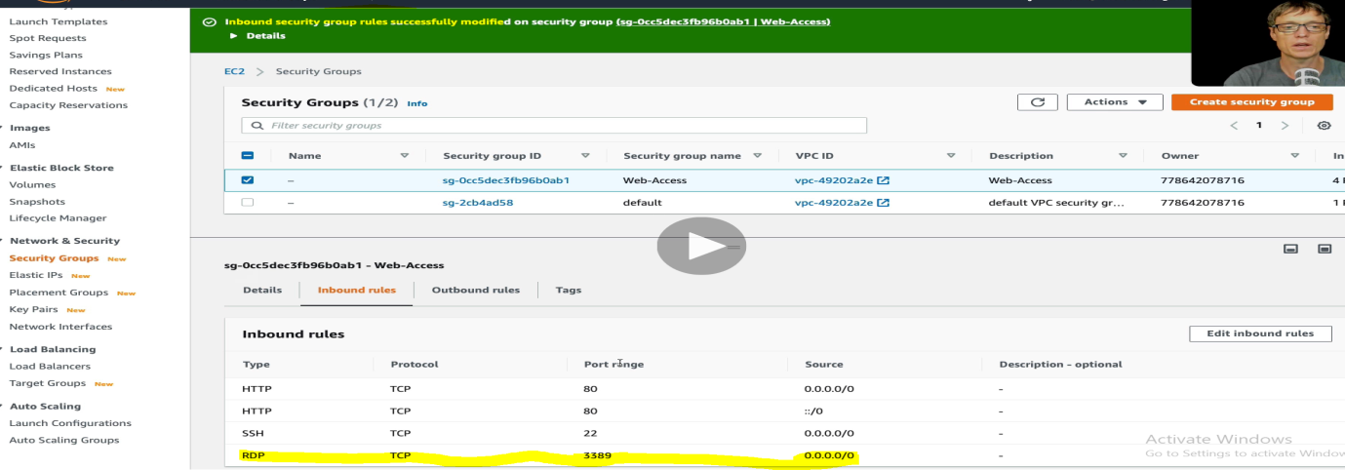

Now let’s Go to EC2 instance and connect it with

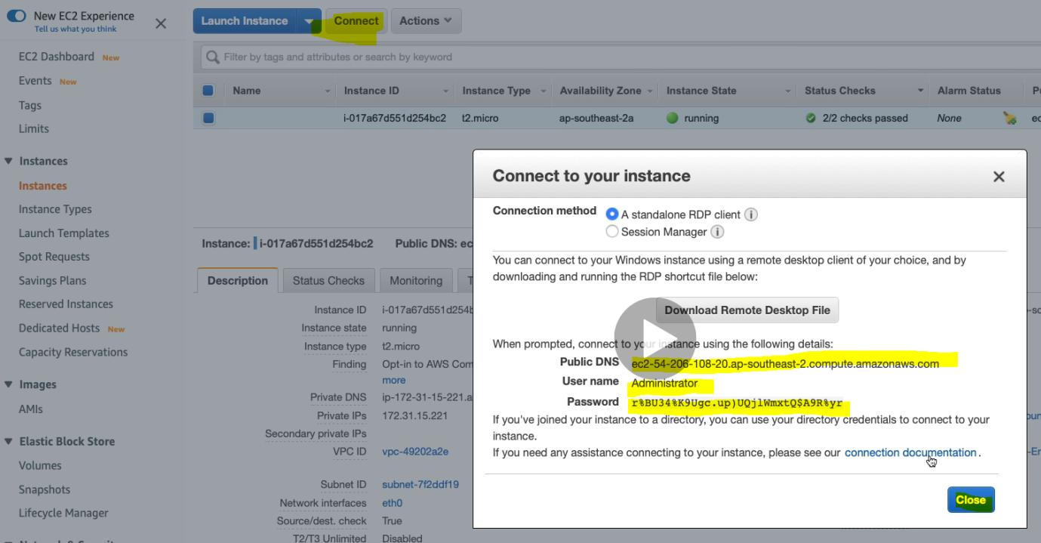

Let’s connect to our local machine with Remote Desktop.

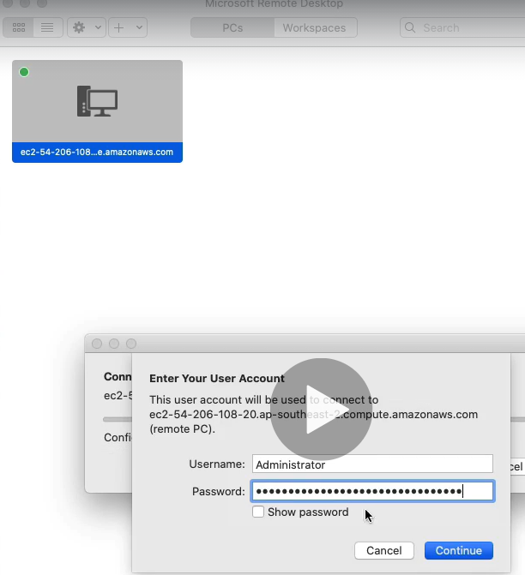

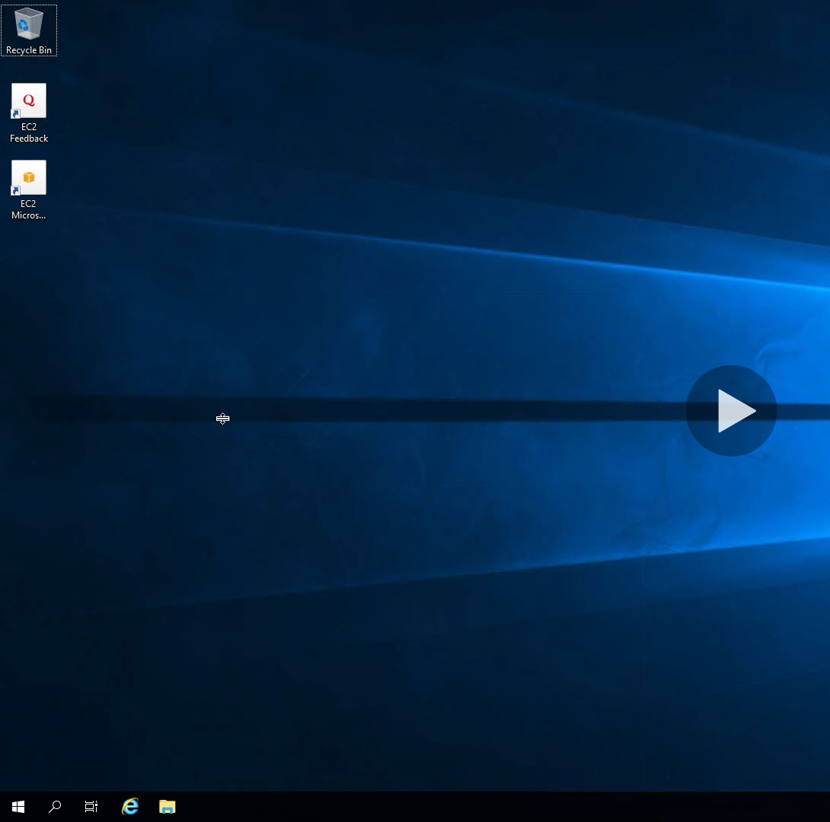

Now we have logged into EC2 machine.

Let’s go to Disk management of this EC2 windows machine.

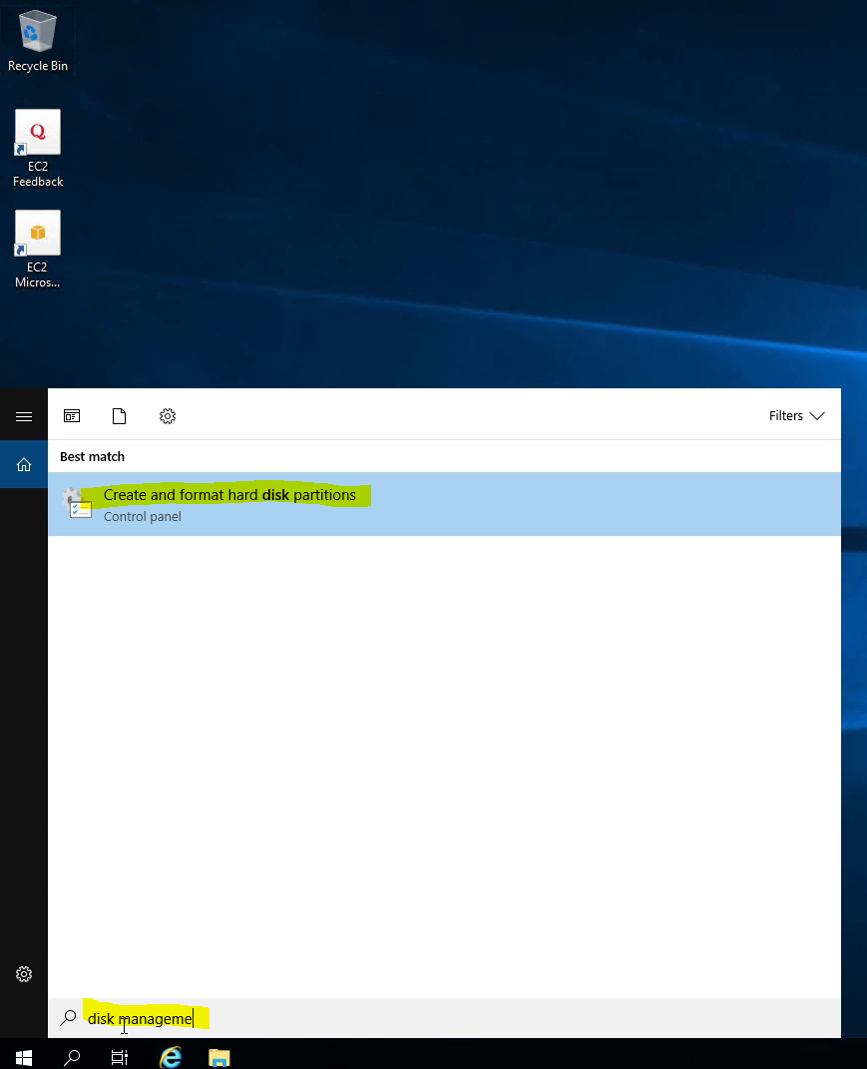

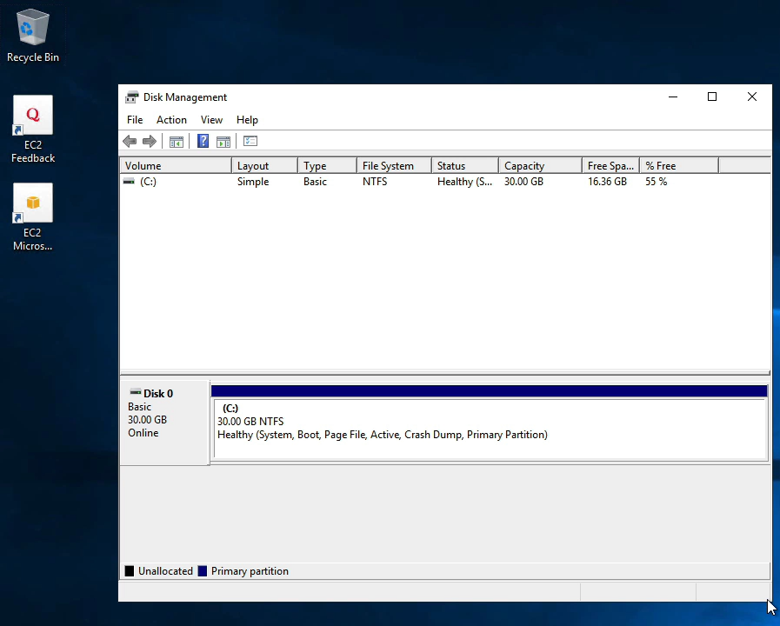

It shows the default drive in our EC2 machine.

Now let’s attach the created volume to this EC2 instance. To do it let’s back to EC2> Elastic Block store> Click Volume

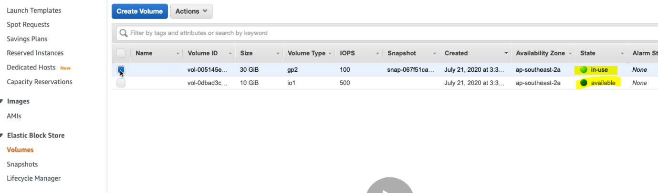

Here we can see two volume, one is “in use” default C drive volume comes up with EC2 machine. Another one is available just created EBS volume which we are going to attach with EC2 machine.

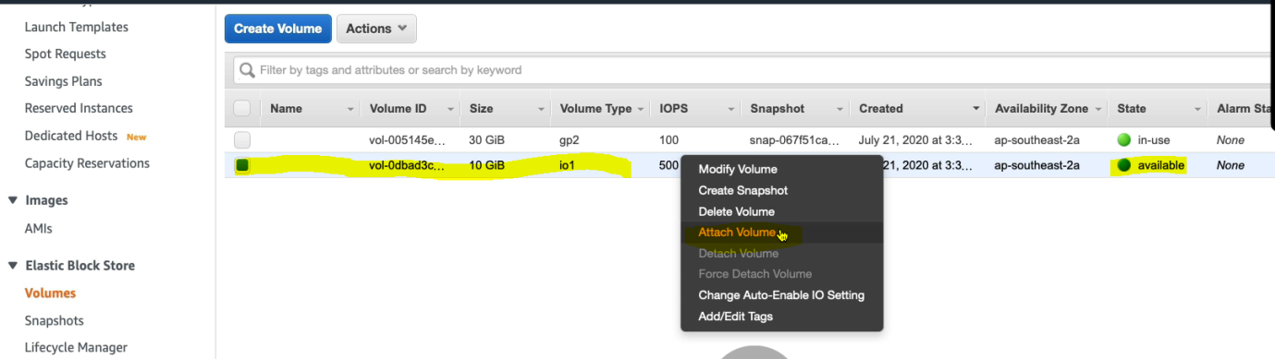

Select the volume & right click and click on Attach Volume.

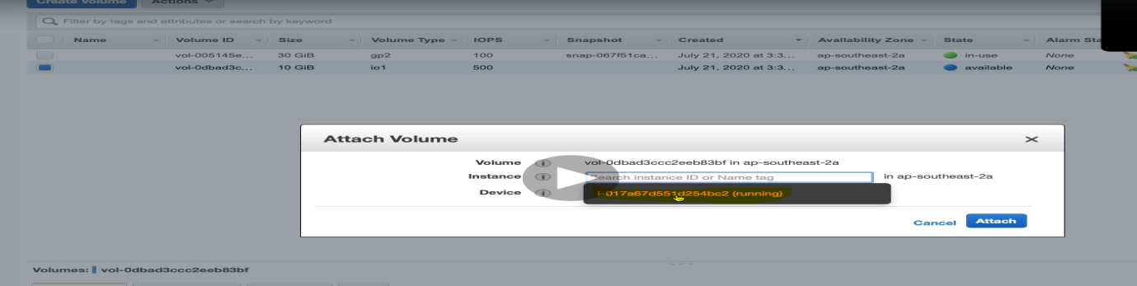

Select the running instance to which volume has to be attached.

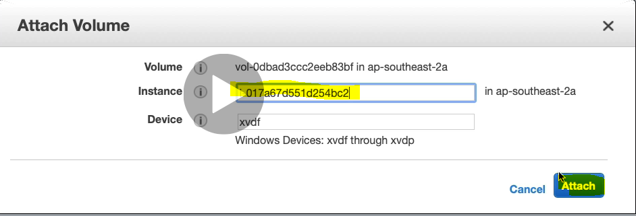

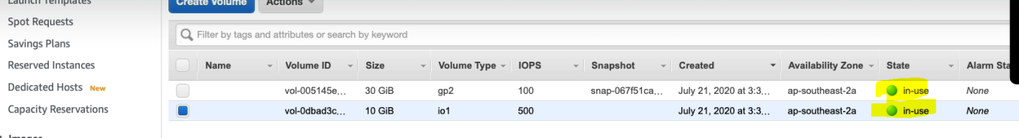

Now we can see that both the volumes are in use.

And now if we comes back and see the disk volume in the EC2 machine then we will the this volumes got attached to EC2 machine.

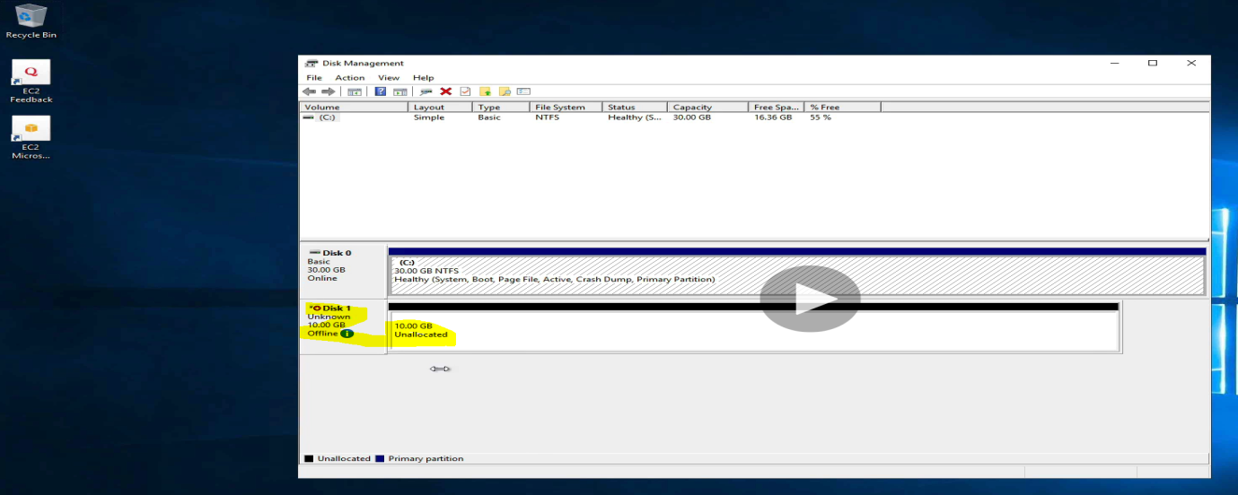

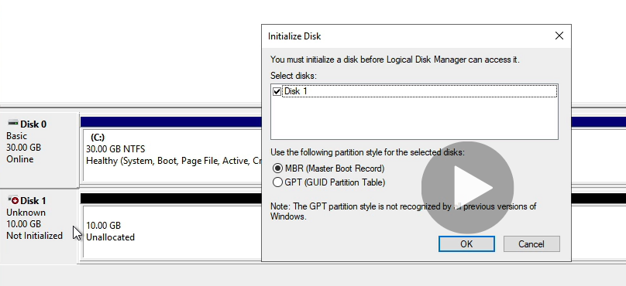

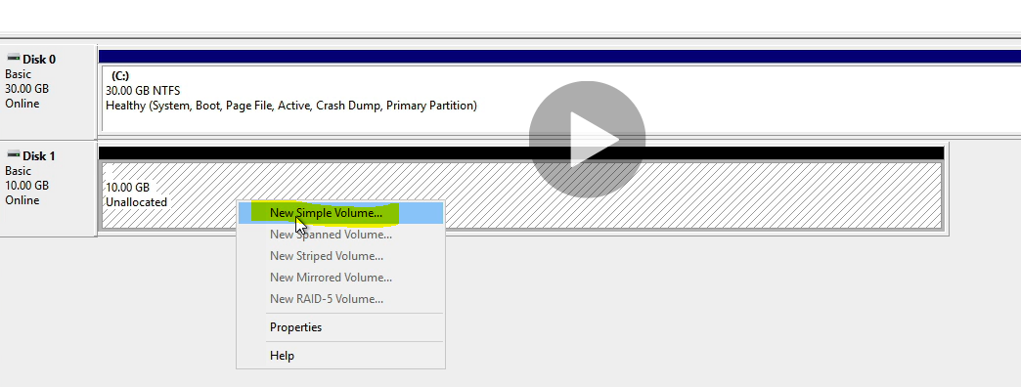

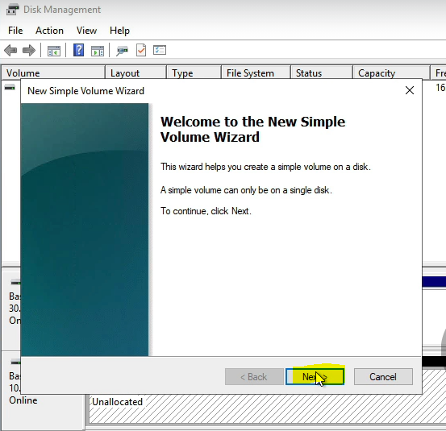

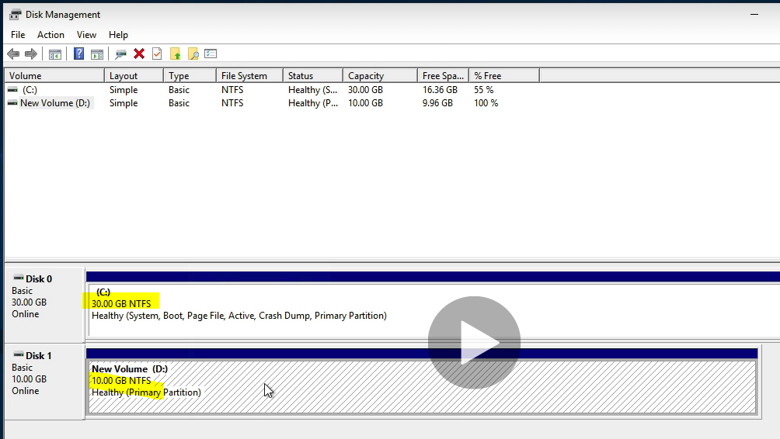

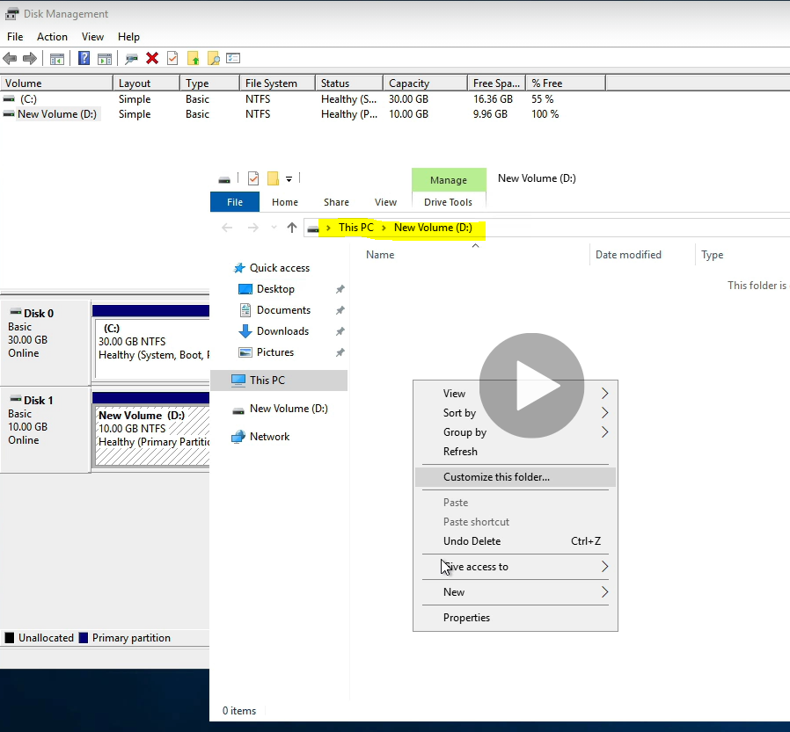

Now we got D drive as local drive attached to EC2 machine. Lets create one text file.

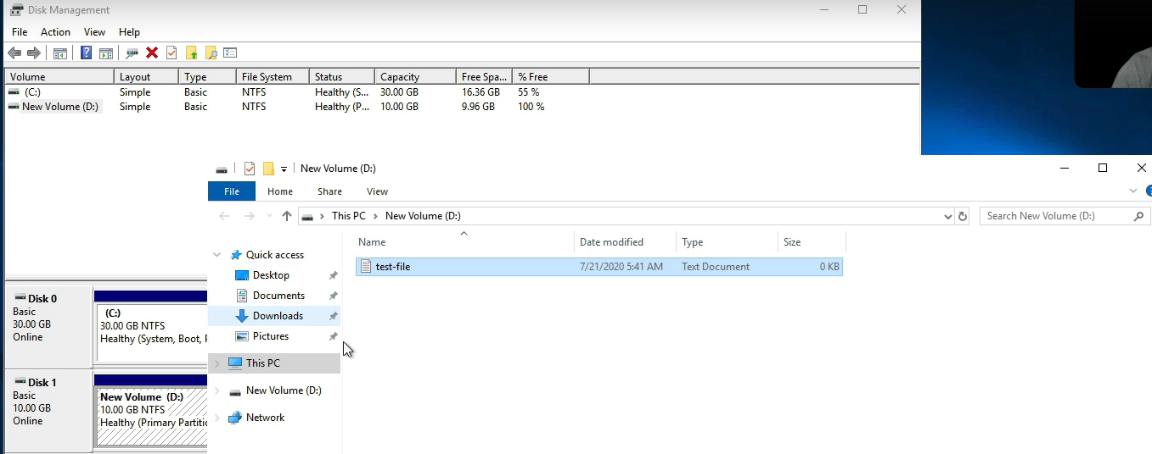

Let’s detach this volume and attach to a different EC2 Machine.

|  |  |
| --- | --- |
|  | Now it shows available. Now if we go to EC2 machine and open Disk management then this volume will not be shown any more. |

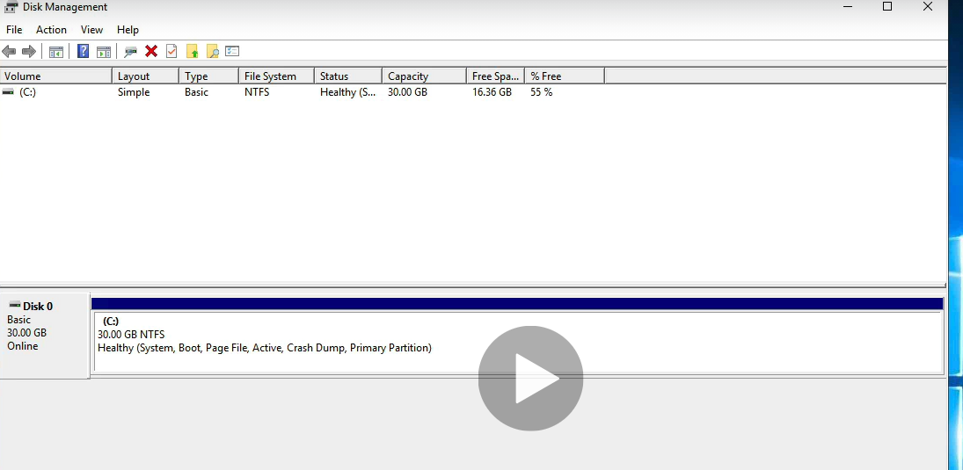

Only Default C drive Volume is showing.

**Attaching the same available volume to different EC2 machine available in different AZ.**

1. Right click on available volume > click on Create Snapshot.

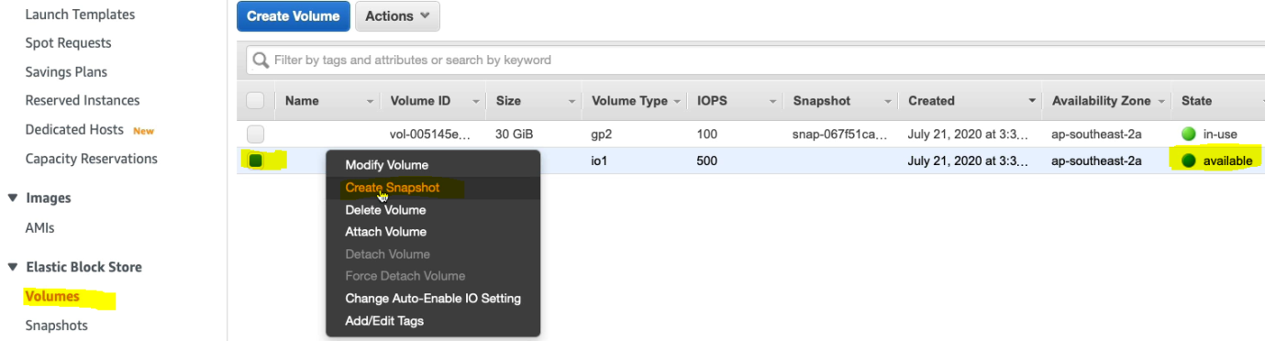

**Instance Store Volume**

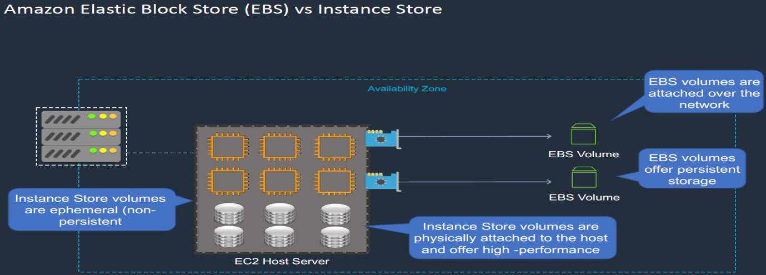

As we can see that we have EC2 instances, as EC2 instances are virtualized which run on some physical underlying hardware. Further we connect our EBS volume to EC2 instance over the network using network adapter, but instance store volumes are physical attached to the host and offer very high performance so these are being used for certain task for very high performance. The problem with instance volume is these are ephemeral (non persistant) means the data will be lost when the power down or restart the EC2 instance.

So EBS is persistent storage and Instance storage is not persistent.

Let’s see where these instance volumes are. When we launch the instance

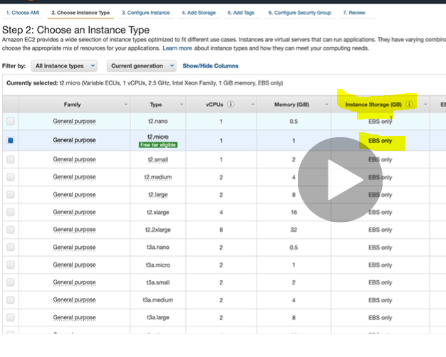

Here the instance storage type is EBS only.

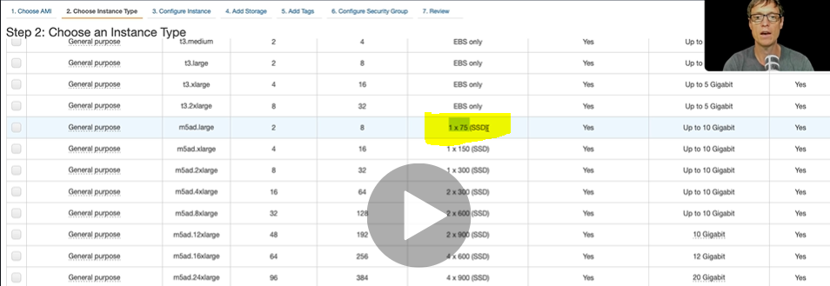

Here the instance storage type is looks different. So if we launce these type of instance then we will get ephermereal type only.

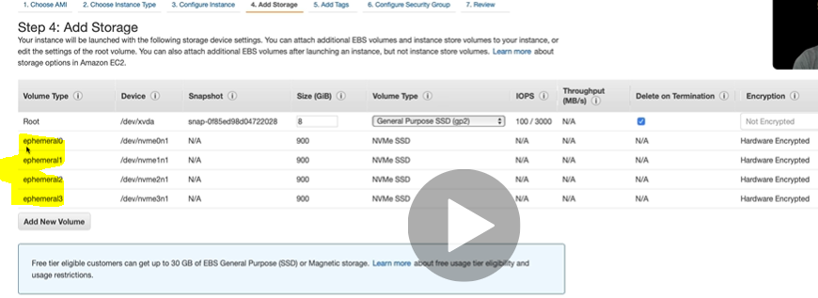

**EBS Snapshots and AMIs**

Few question like how to take a backup of our EBS volume?

There is one built-in way that is called snapshot using which we can take backup of our EBS volume. This snapshot sits in Amazon S3 in the region of AZ. We can create multiple snapshots and take the back of our EVS volume. We can put all these snapshot backup data into different newly created EBS volume of different AZ and further we can attach this EBS volume to a different newly created EC2 instance in different AZ.

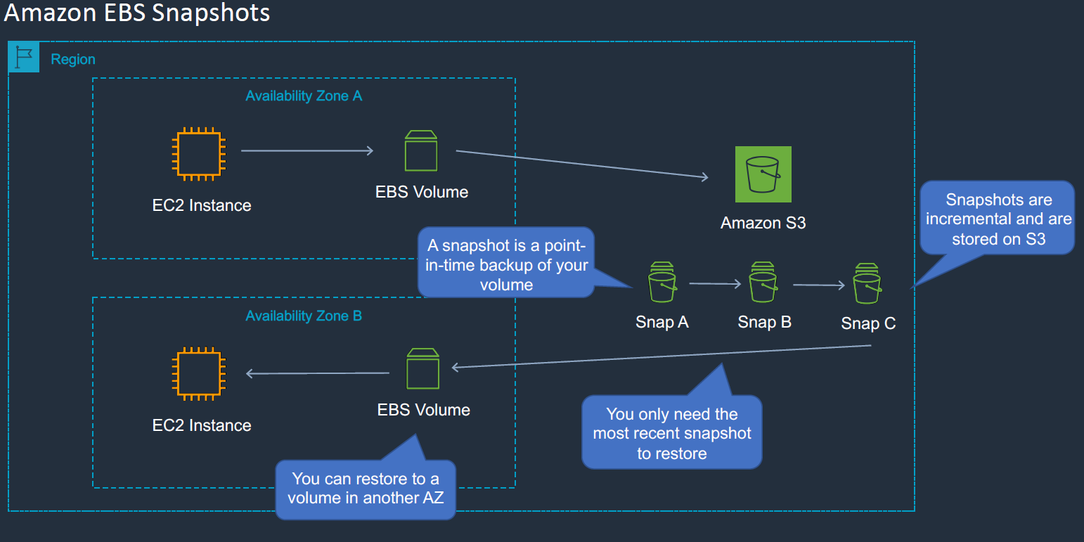

Let’s do in AWS cloud.

Go EC2 > Elastic Block Storage > Volumes > Right click on created volume> Click on create Snapshot.

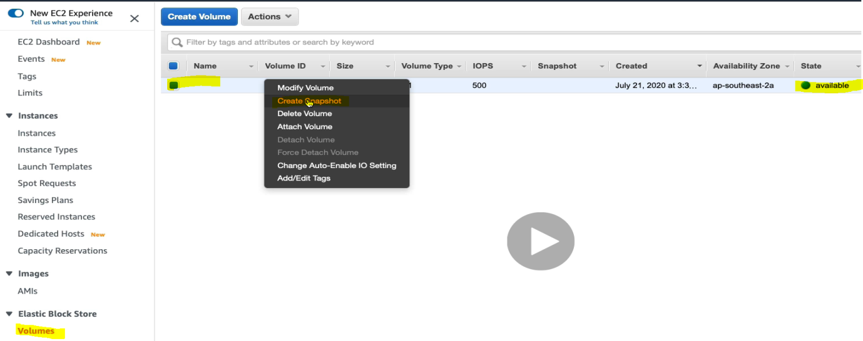

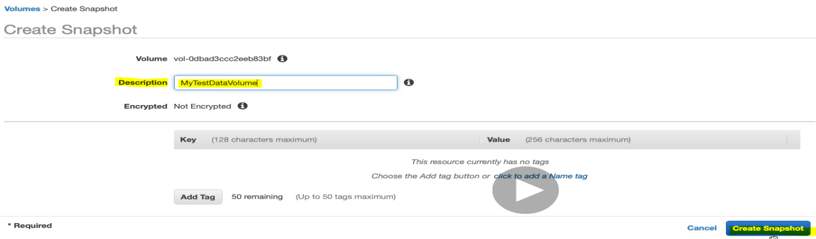

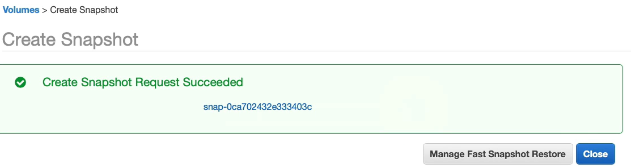

We now have snapshot created. Now let’s open the snapshot comes below the volume of EBS.

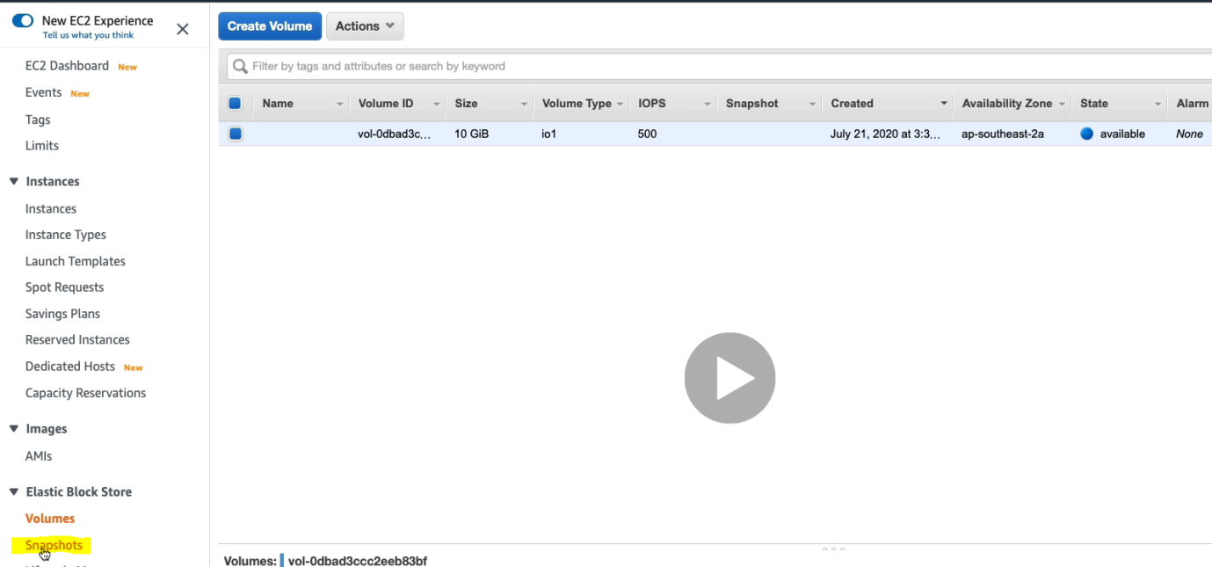

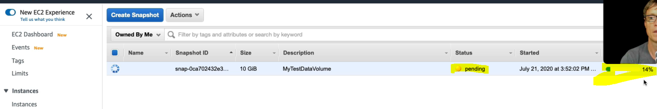

It is showing in pending state which will come in running status. For the time let’s go to EC2 instance and launce a new EC2 instance in different availability zone.

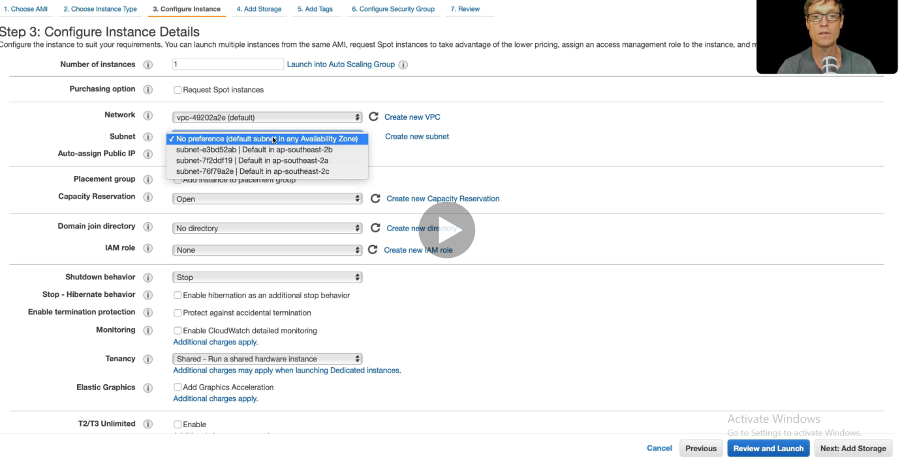

Initially it will show default AZ. Let’s select different AZ as shown below.

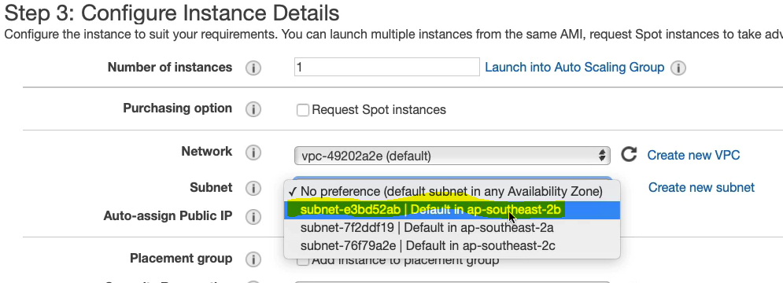

Click next.

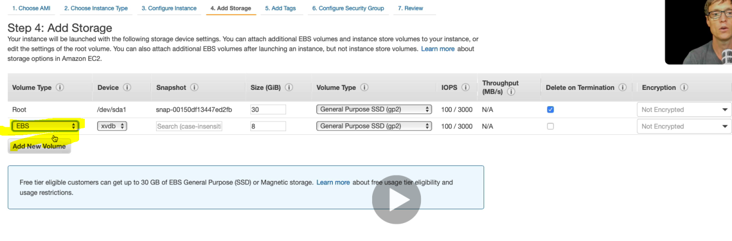**As here we can see that we can create the EBS volume during the instance launch only, we don’t need to create EBS separately.**

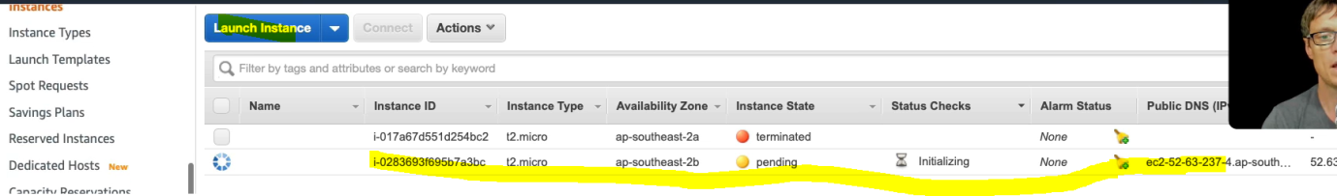**Now we have the EC2 machine into different AZ.**

**Now let’s go to snapshot and create volume.**

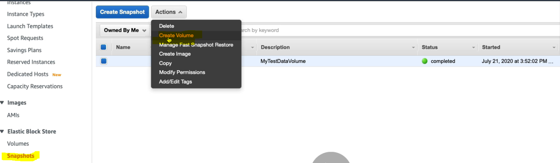

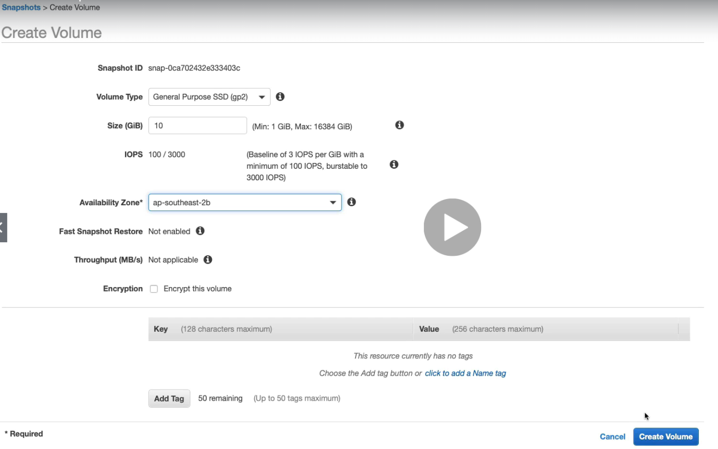

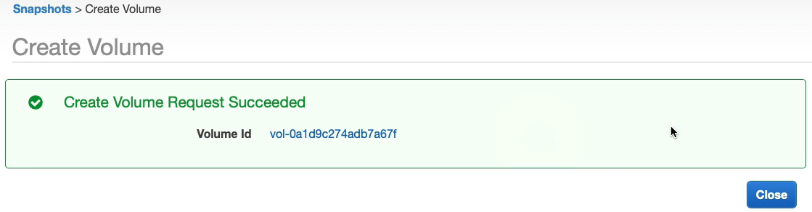

**So now we have created snapshot (different volume) of original volume in different AZ.**

**And now we are going to attach this new volume to a different EC2 instance of different AZ.**

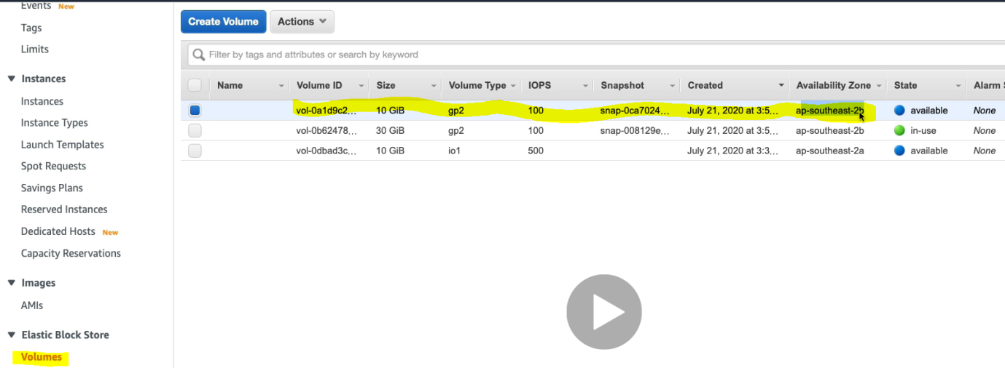

**So this is the snapshot volume created into different AZ. Now let’s attach this Snapshot volume to a different EC2 of different AZ.**

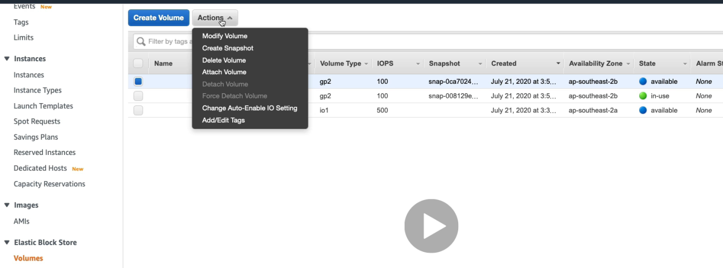

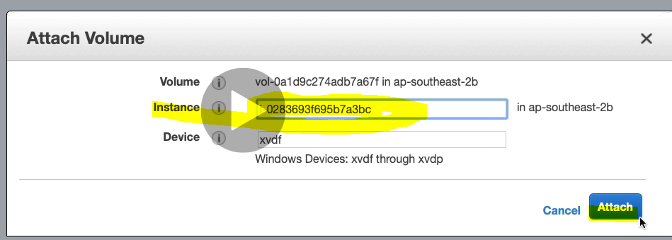

**Select instance and Attach**

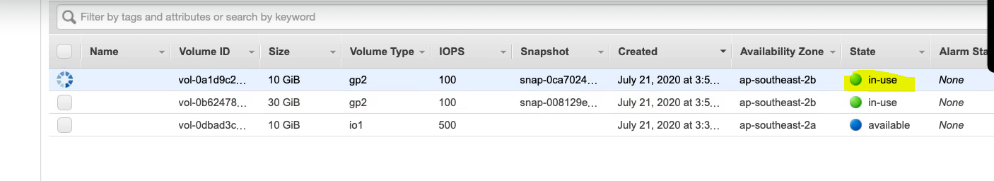

**Now the snapshot start showing in-use. Now let’s log in to EC2 instance and we will see one snapshot volume attach to EC2 instance. Step will same to connect EC2. After connecting**

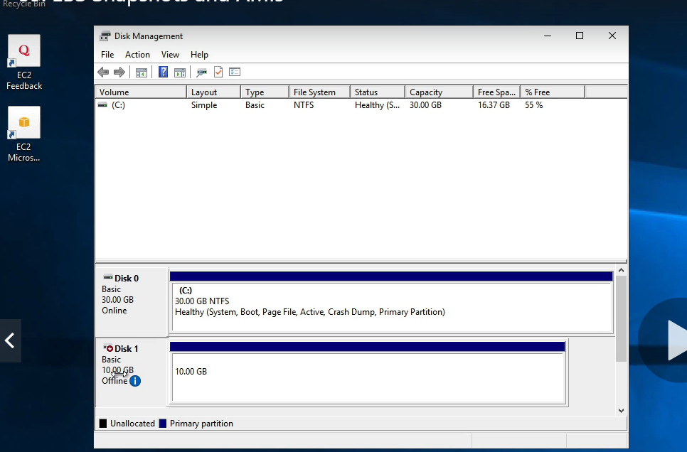

**Snapshot volume got attached to EC2 instance. Now if open this volume then we will see the same text file what we have created into the original volume. In this way we can take backup of EBS volume and could attach to any EC2 instance**

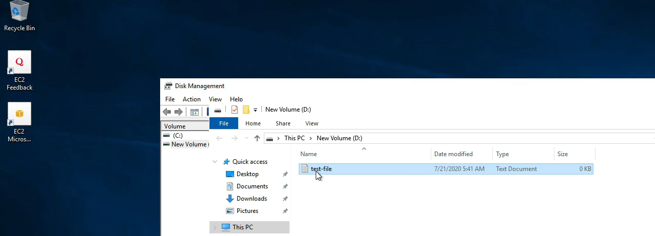

**Amazon Machine Image( AMI):**

As we know that when we create any EC2 instance and launce any operating by default it comes under default Amazon Machine Image. But apart from Machine image provided by Amazon, we can create our own Amazon Machine image (AMI).And we can do it from our EC2 instances.

Let’s open the EBS volume.

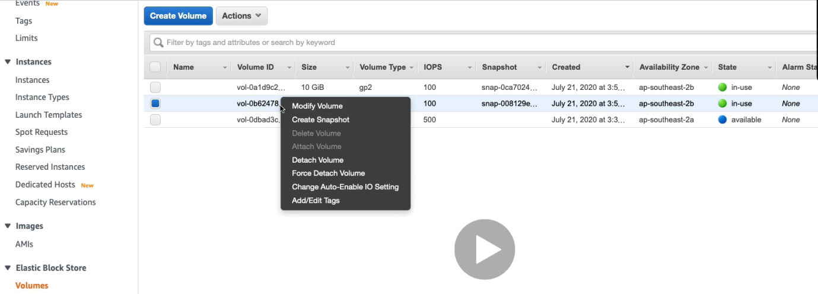

Click on create snapshot

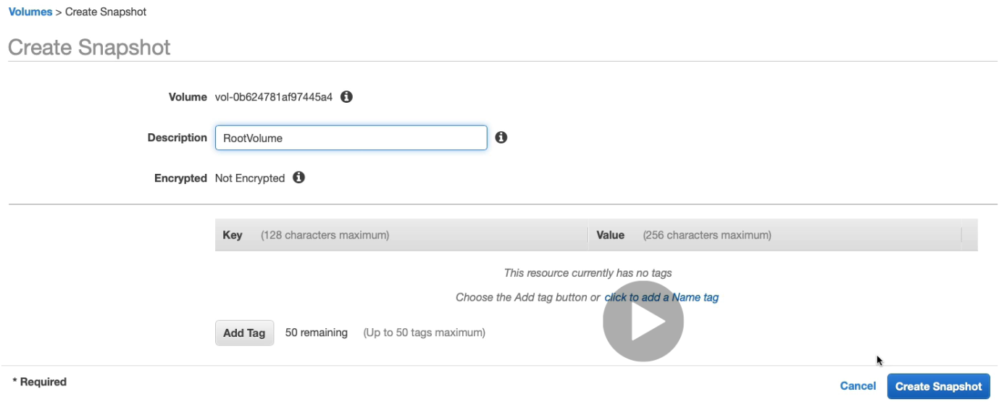 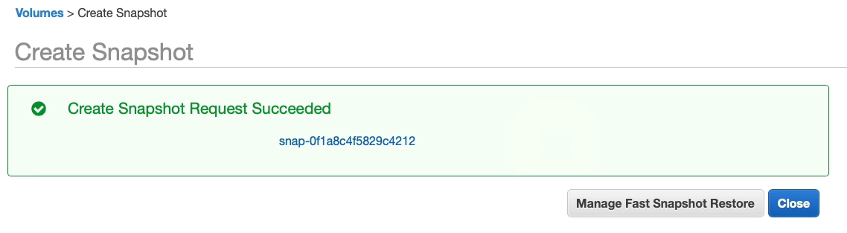

Let’s open the snapshot window.

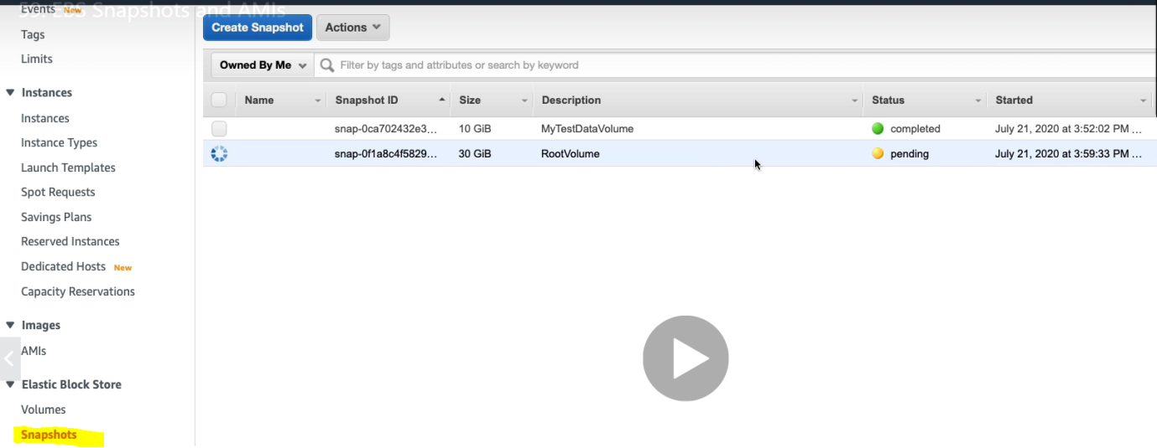

Now right click on this snapshot click on create image.

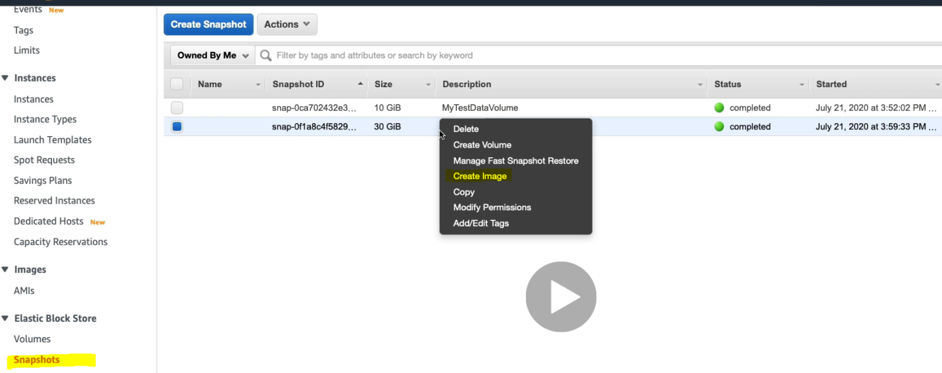

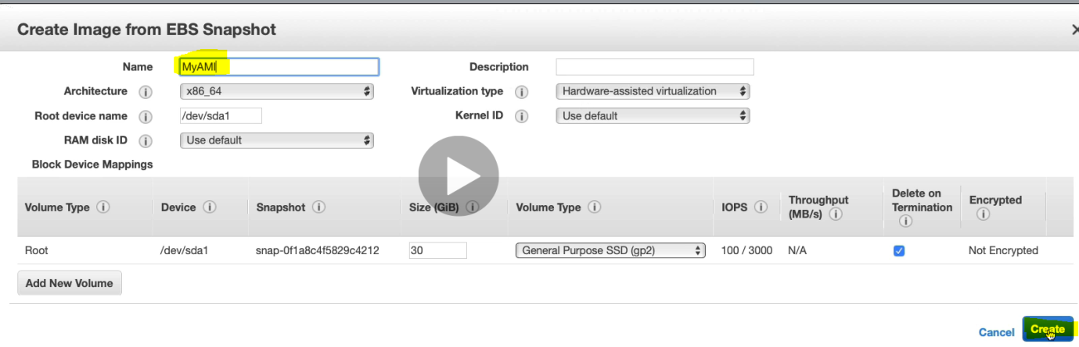 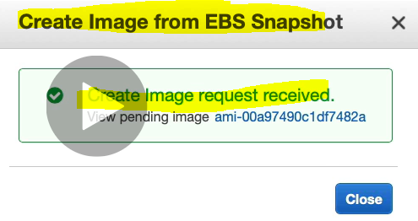 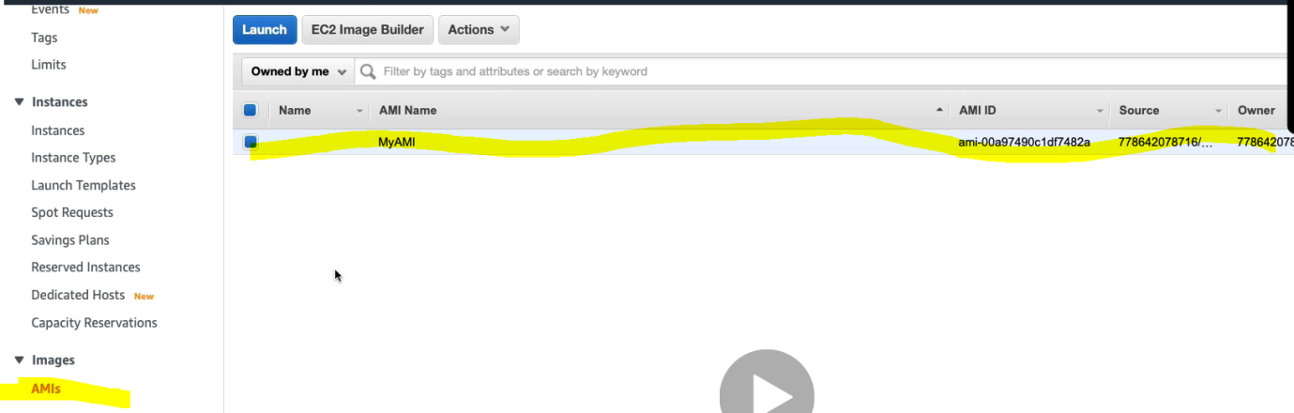

Now we have created our own AMI and now we can create EC2 instance under this own created AMI. Click on launch and fallow the same step to create EC2 instance. Now in this AMI we can configure and install the software according to our need.

To delete this own created AMI. Right click on created AMI and click on Deregister. 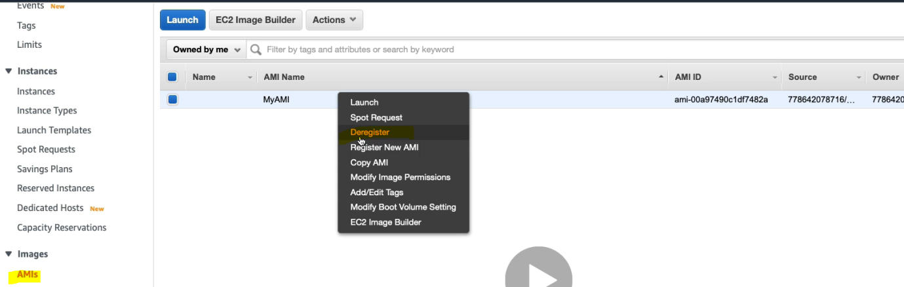 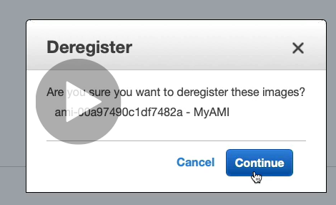

So we can create our own AMI and inside that we can launch EC2 instances.

**Create Amazon EFS File System:**

It is file based storage system on AWS. We can attach EC2 instances from multiple zones to the file system and we can mount the file system to those instances as shown in the screen. Use the NFS protocol to connect File system to EC2 instances and then see the same date at same time in all the instances. This is possible only in Linux machine; we cannot do it in Windows machine. Let’s go AWS management console and create EFS file system.

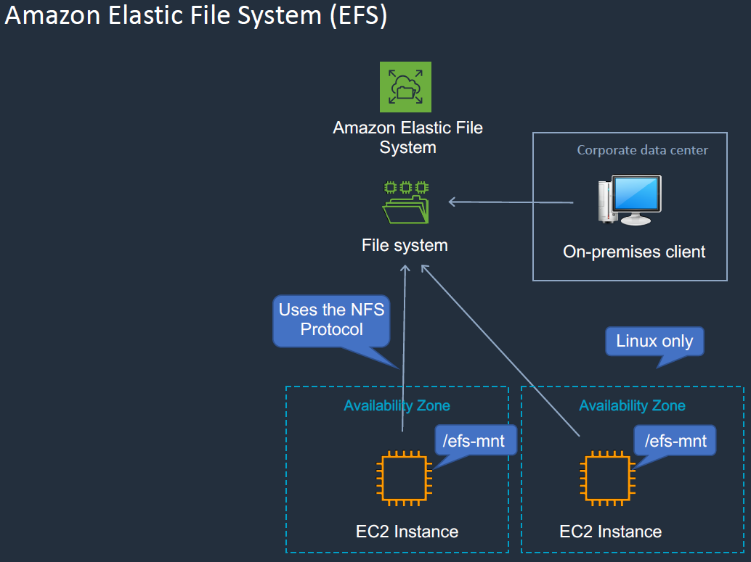

Let’s launch two Linux EC2 instances from the EC2 console with different AZ(subnet) and same security group.

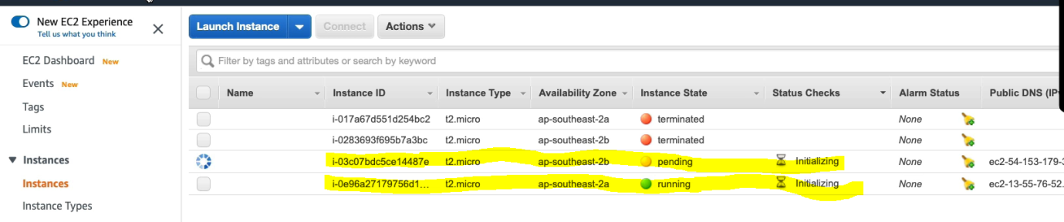

Now go to EFS under storage > EFS

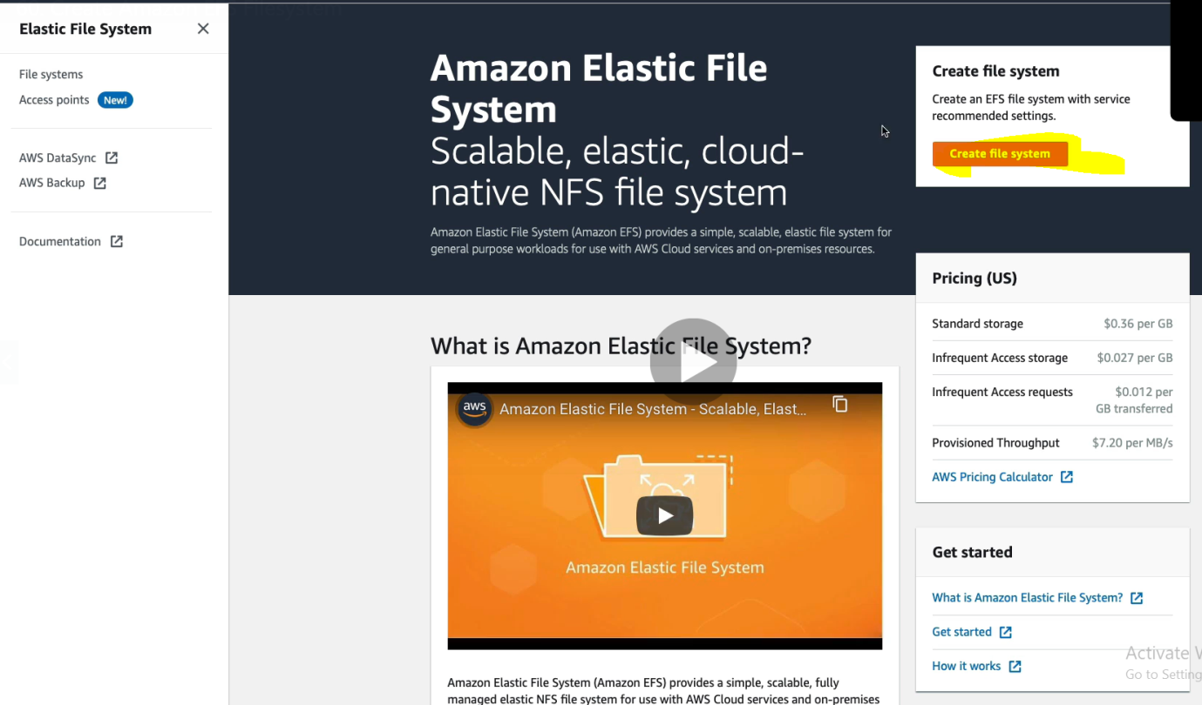

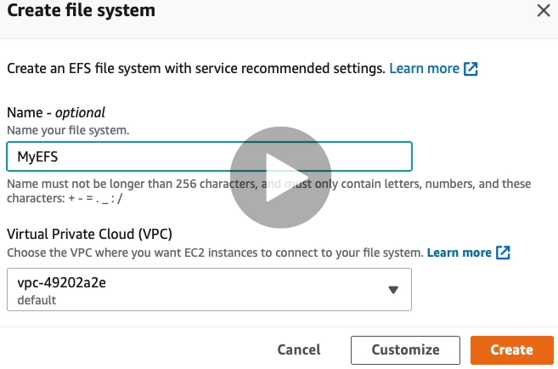

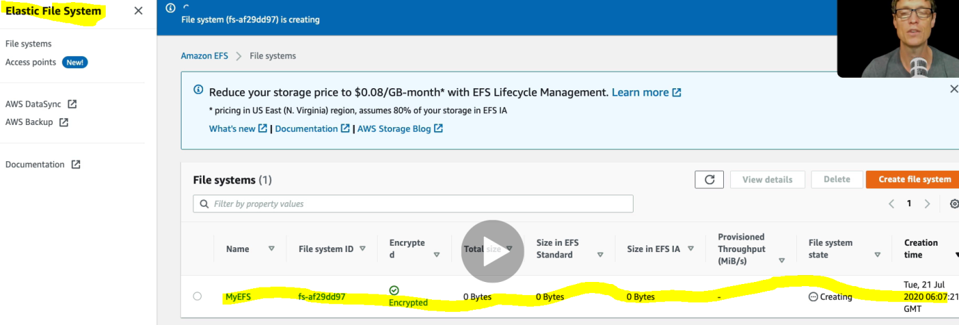

Now we have create EFS. Now let’s connect this EFS file system to our created Linux EC2 instances.

|  |  |
| --- | --- |
|  |  |
|  |  |

Let’s go back to EFS:

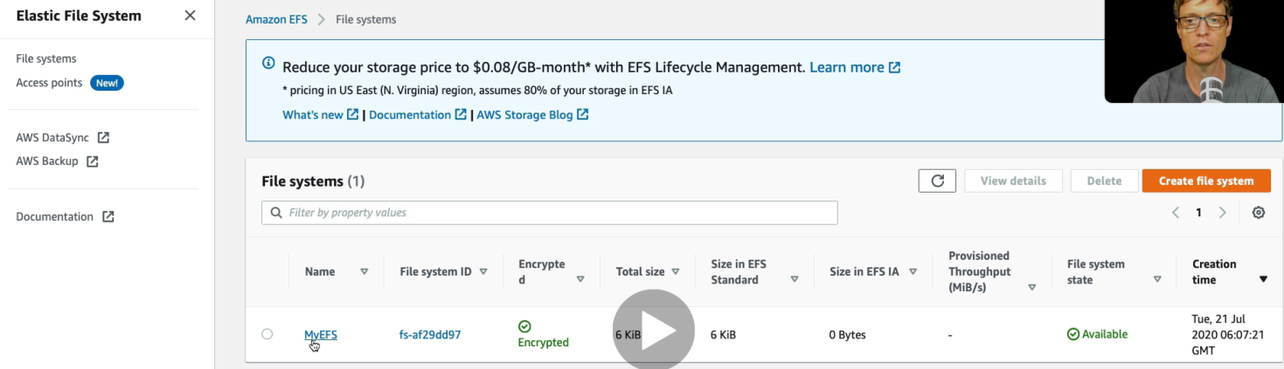

Click on MyEFS

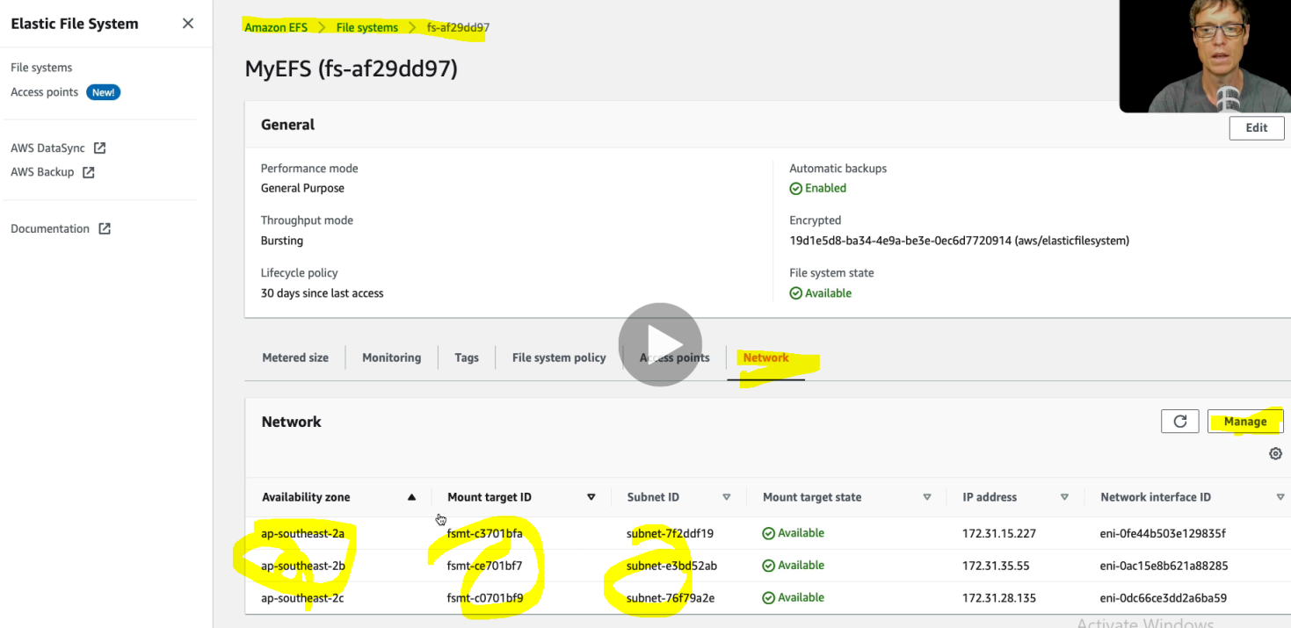

And now we can see the entire target to be mounted with EFS with their mount target id in three different AZ (2a, 2b, 2c).Now click on manage and select the security group for all the AZ.

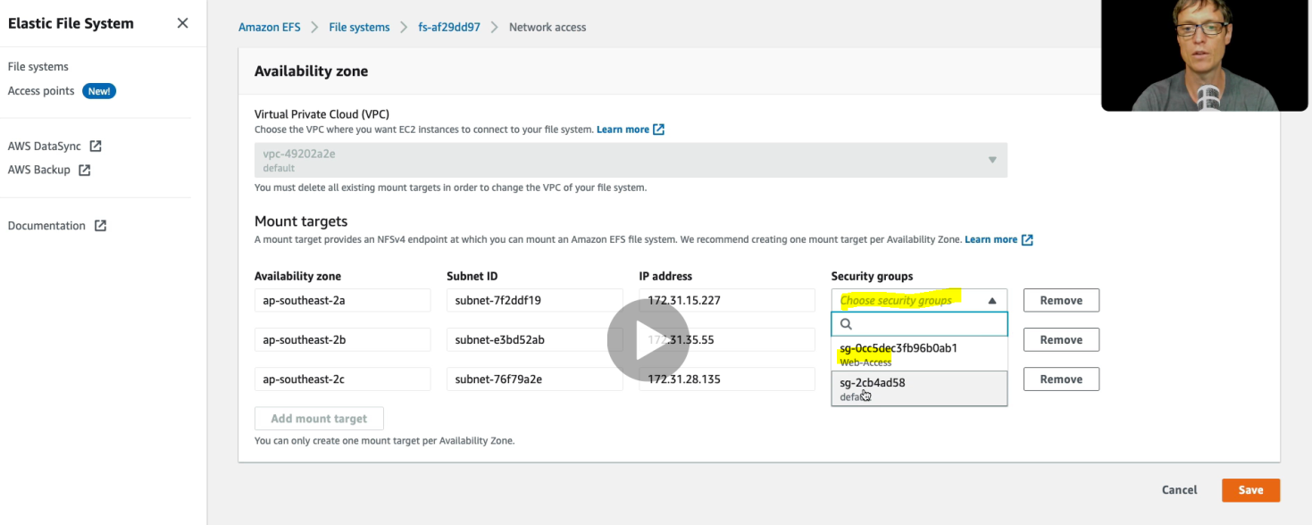

Instead of setting default security group let’s select our security group. And to allow the entire network let’s create NFS protocol in the security group. Let’s open the security group.

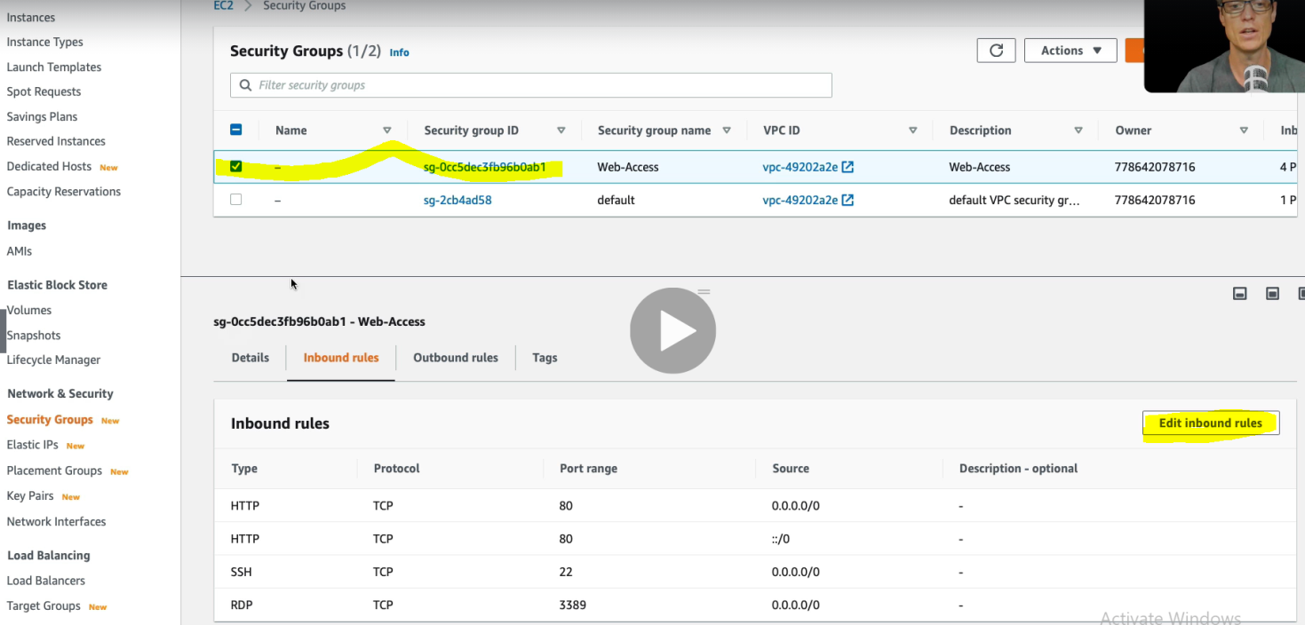

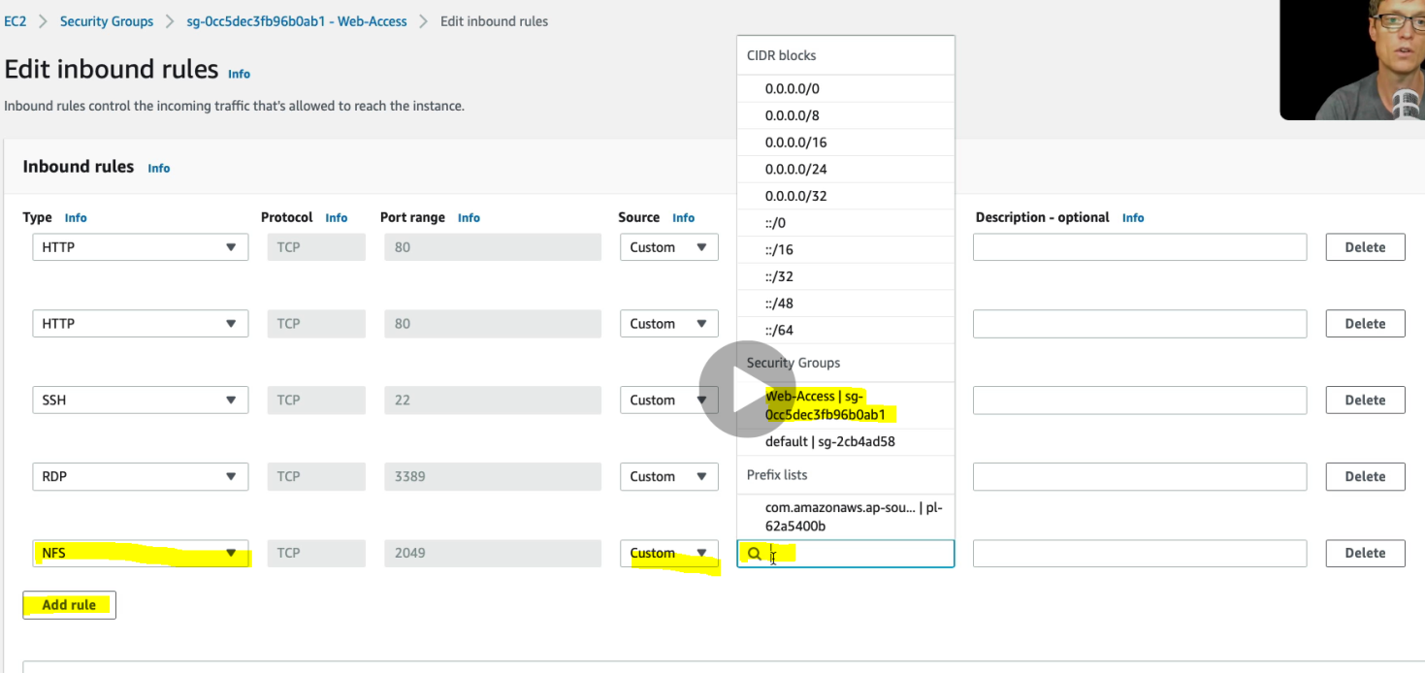 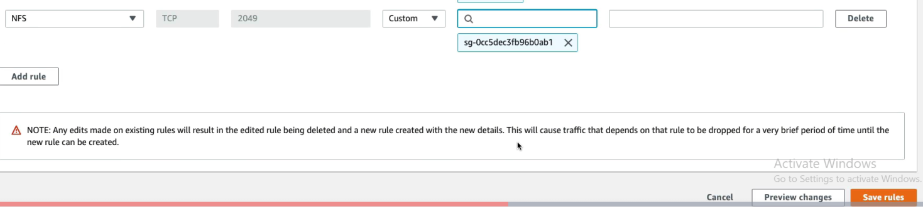

Click save rules.

Default security group allows all the traffic to be passed through EFS and EC2 resources. So instead of selecting default security group will select our SG with NFS protocol. 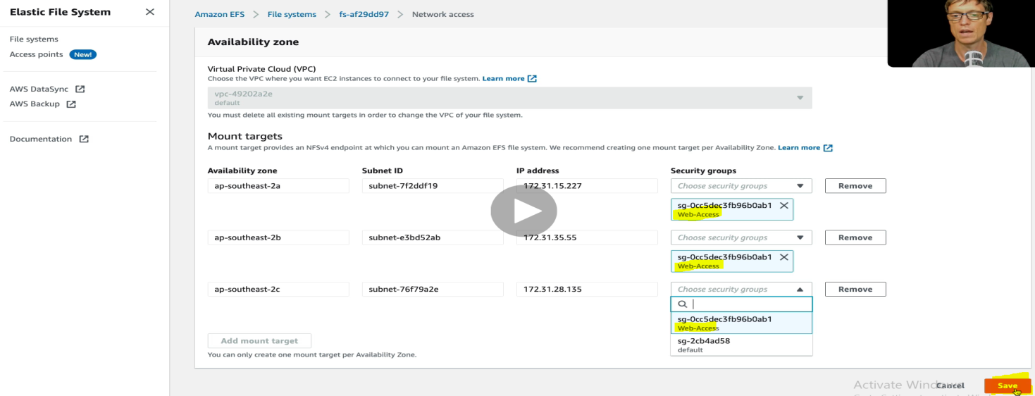

Hence we have selected our own created SG instead of selecting default SC. Click save.

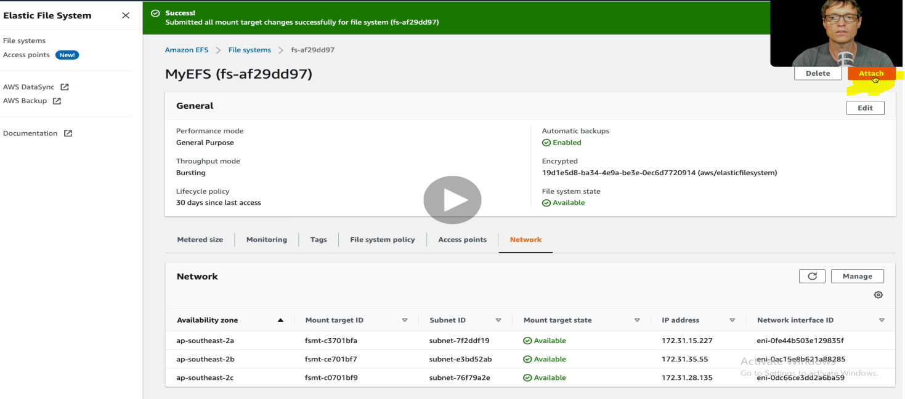

So that’s it now we have configured EFS to all the EC2 available in different AZ. Now let’s try to access these EFS from EC2 Linux system. Click on Attach button on right corner top.

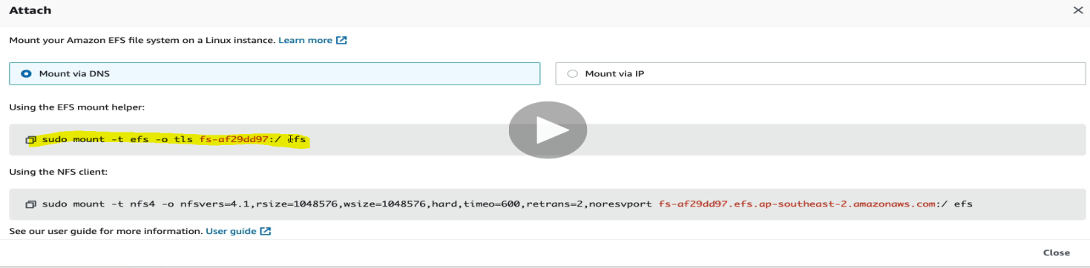

In attach it gives us to command to mount. **Sudo mount –t efs fs-af29dd97/efs**

**But before running this command we have to run some more command in entire instances.**

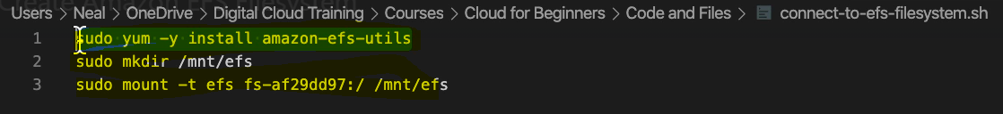

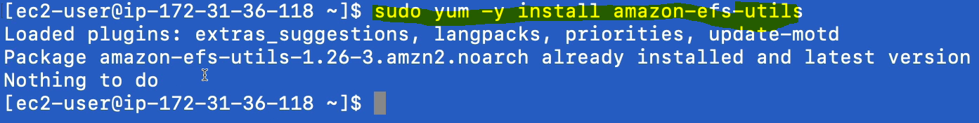

Let’s create one directory where we will mount EFS.



And finally run the command to connect the file system.



The only thing we need to change the mount path as created just above



Do the same thing for other instance. After that let’s change the directory to the mounted path or directory.



Now let’s create a file using touch command.

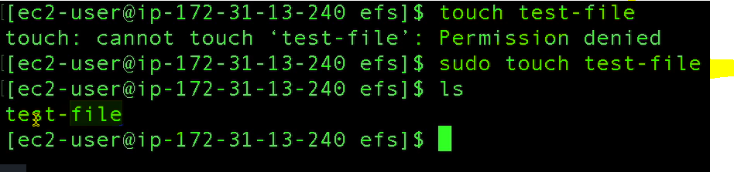

And hence we can see the created file, created in the directory /mnt/efs

Now let’s see into other EC2 instance wheter the created file is showing or not?

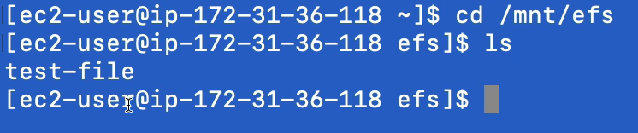

So yes file is being showed here also. Hence we can connect multiple EC2 instances to EFS storage system and file can be shared across all the EC2 instances.

**Amazon S3 Create Bucket and make public:**

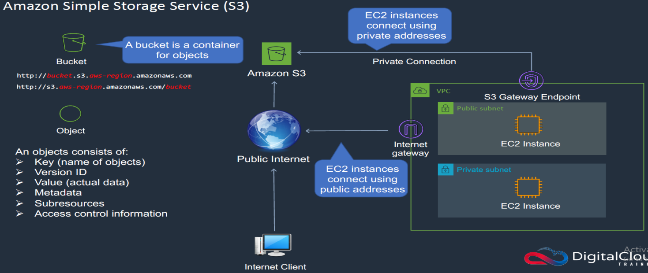

Let’s learn more about Simple Storage Service (S3). It’s an object based storage system and it access over the public internet. So here we will create one bucket and place some object. This object could be anything like file image, media files, documents, spread sheet, video files and we will access this bucket using the URL which why the bucket name should be unique because it would be the part of URL. That is why make the URL unique. So bucket name should be unique globally.

Here an object contains the following attributes associated with it.

1. Key (Name of objects)
2. Version ID
3. Value (Actual Data)
4. Metadata
5. Sub resources
6. Access control information (who is having access to object)

So in short we can say that object is placed as key-value pair.

We can also connect our EC2 instances through VPC via internet gateway using public address as shown in the above image. And another way to connect VPC to S2 via Internet Gateway using private IP. In this way we can avoid public internet to connect S3 bucket.

**Now let’s go Amazon management console and create and connect S3 bucket to EC2 instances:**

AWS management Console > Storage > S3

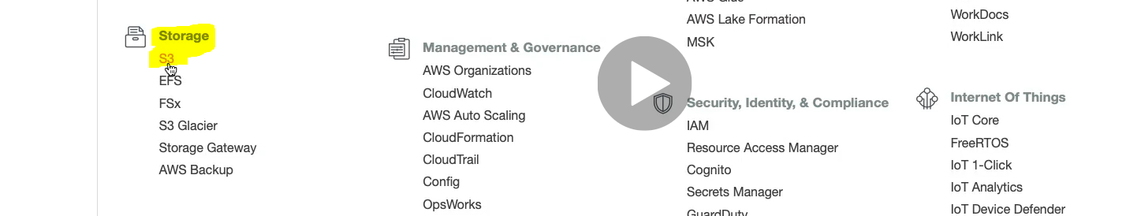

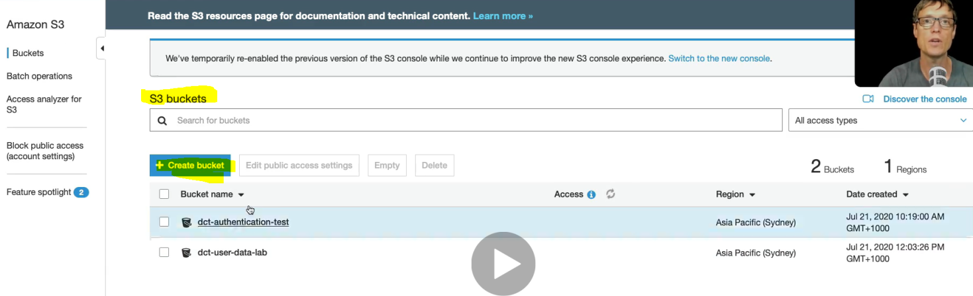

Click create bucket.

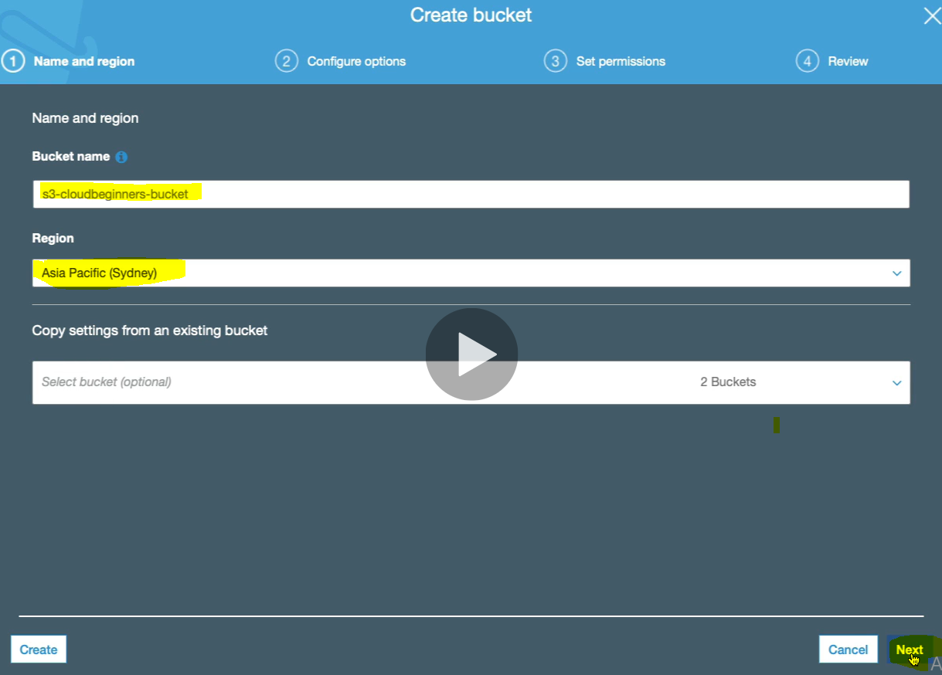

Here while creating bucket we should be very careful for Region selection. Because we have to follow the data compliance according to region.

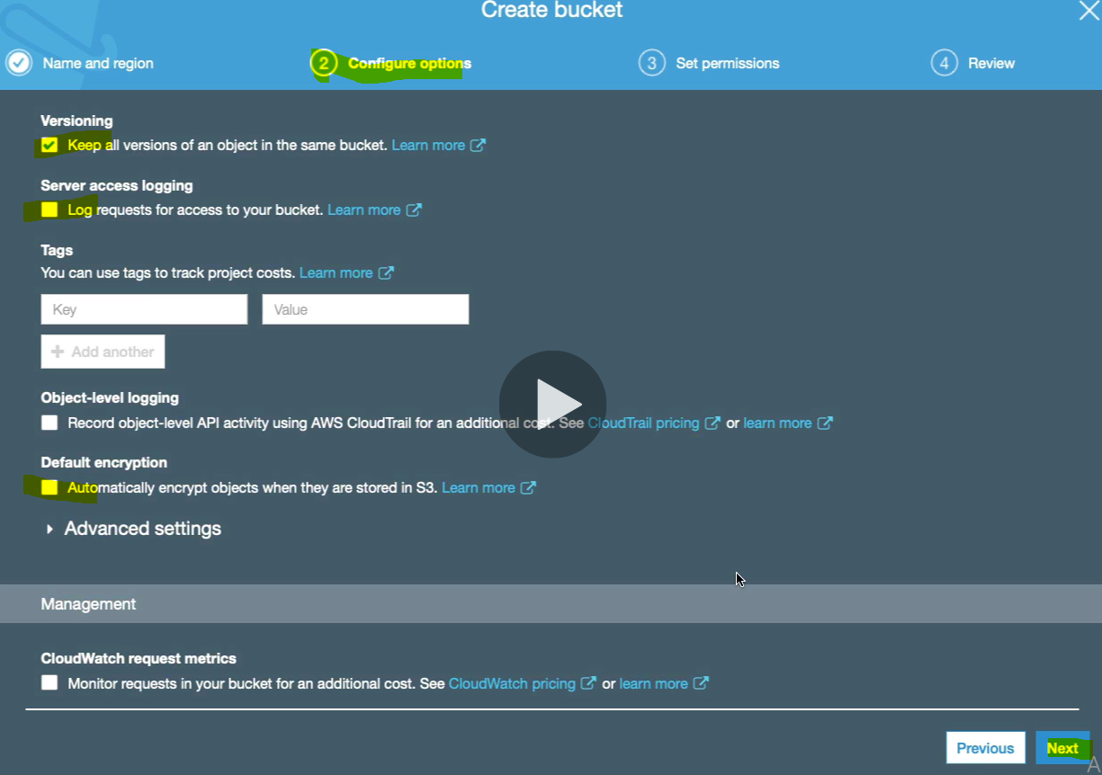

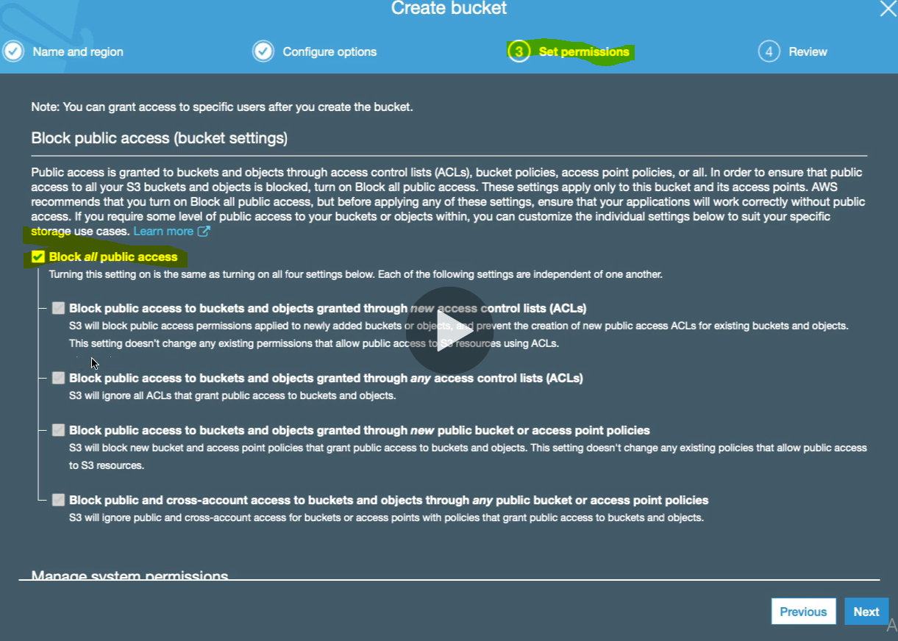

By default the public access is blocked. Click Next

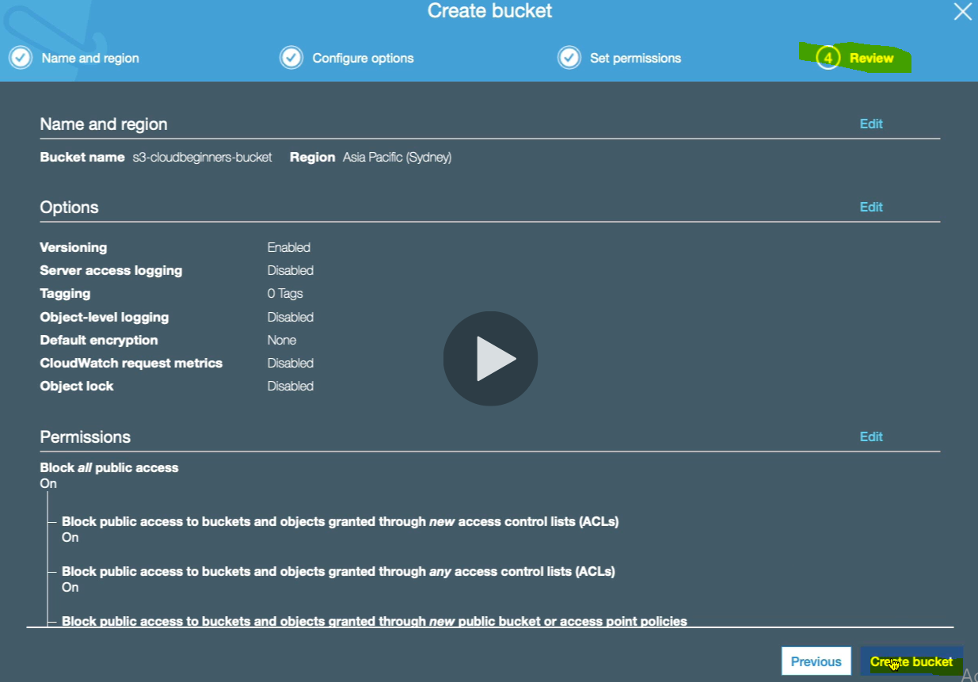 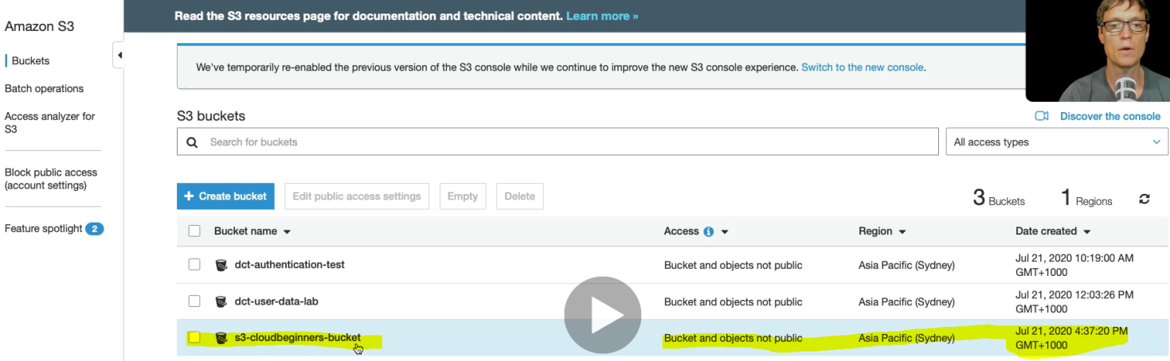

Now we got the S3 bucket. Click on the bucket and upload some object.

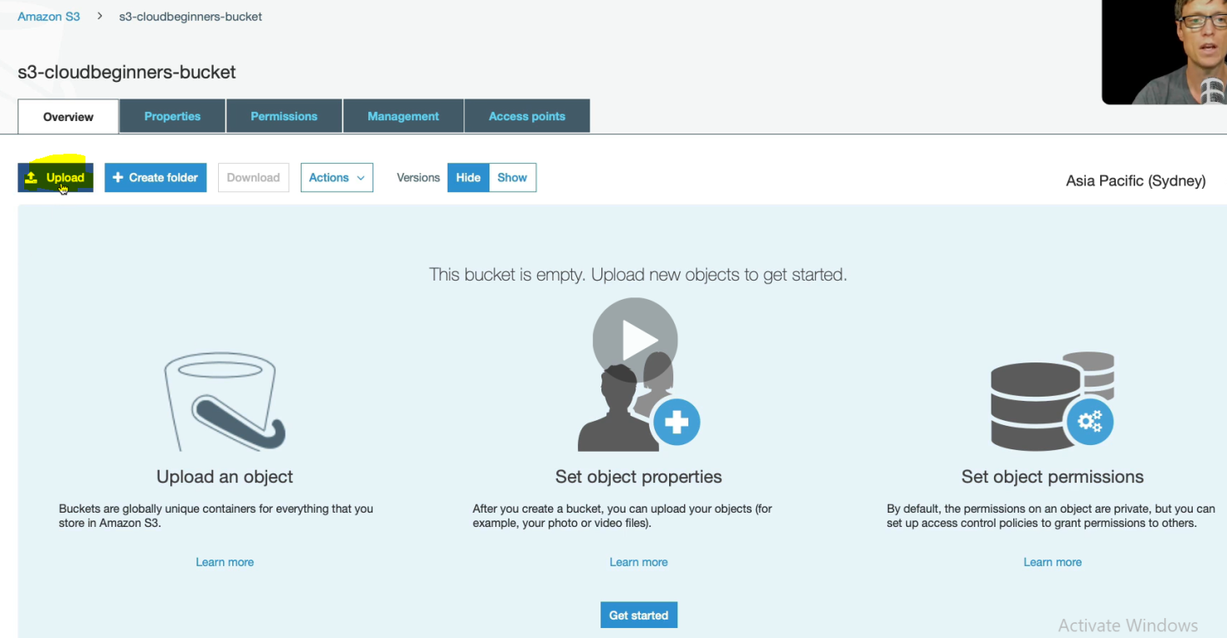 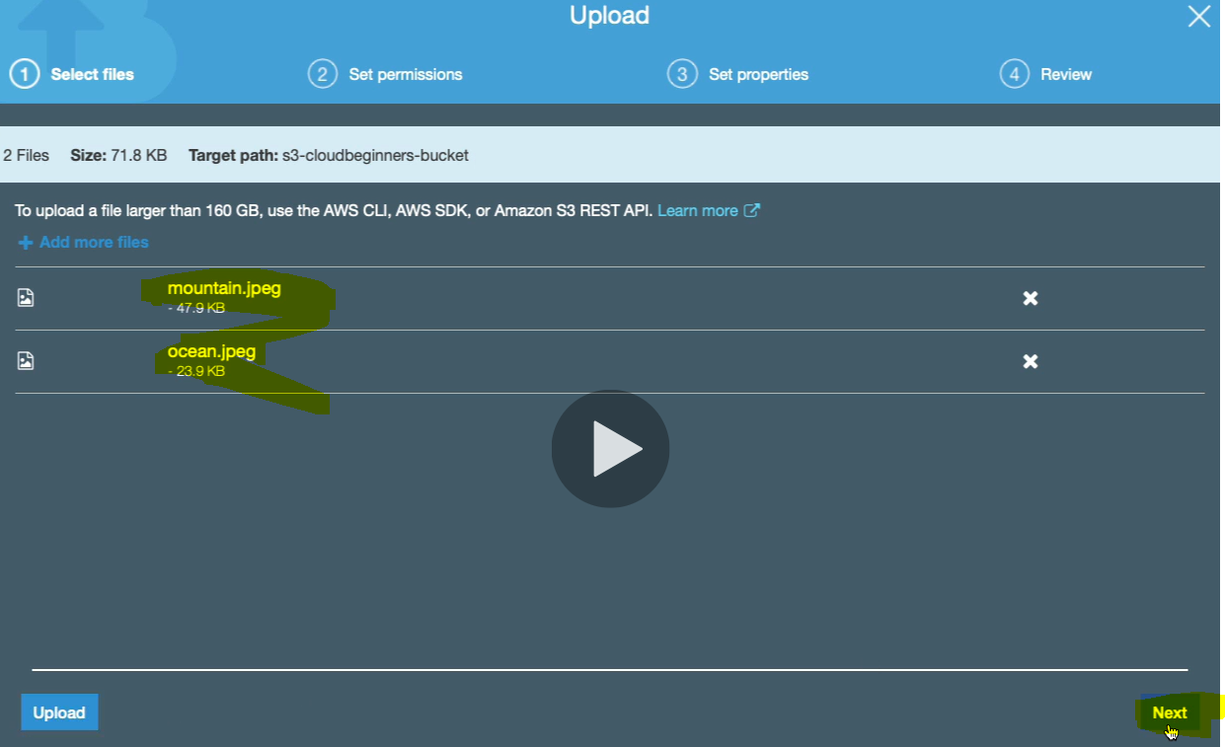

Instead of clicking upload click next to configure some more option like read/write permission etc.

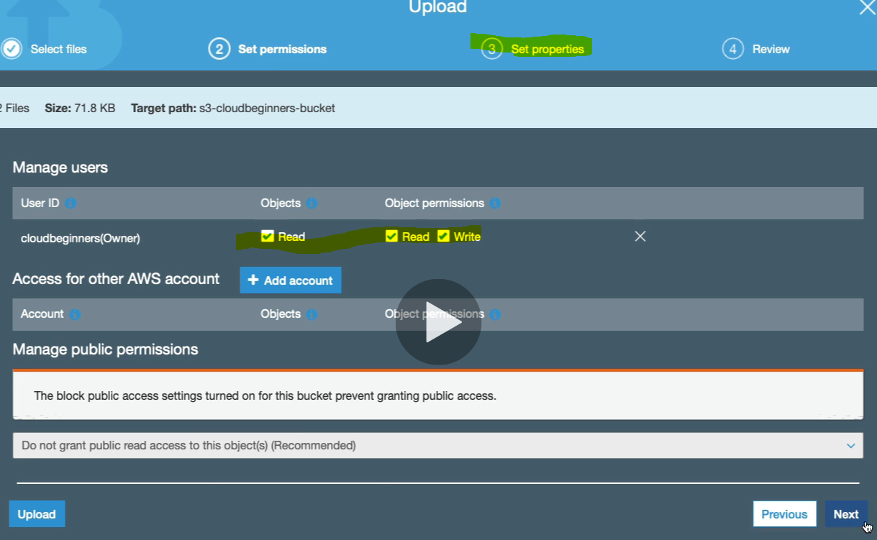

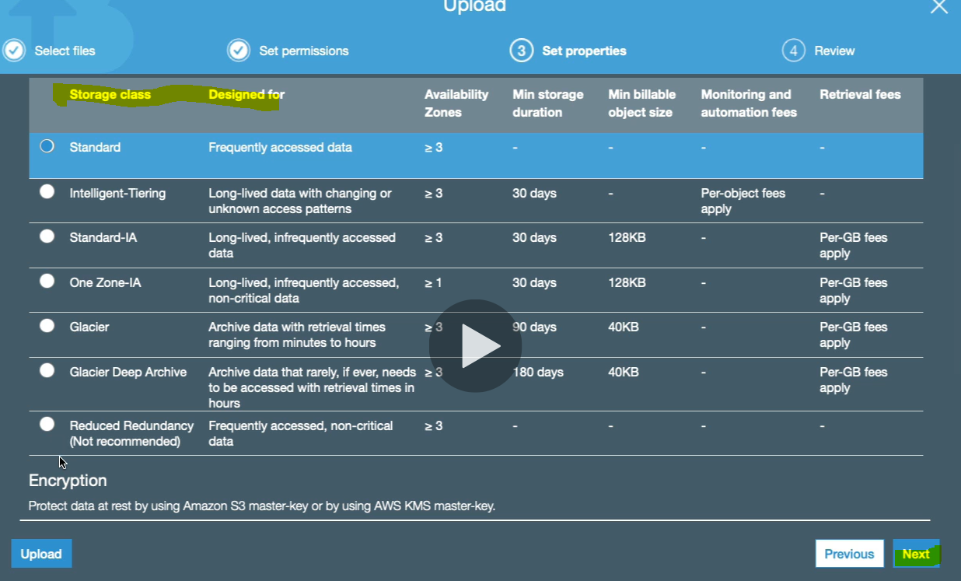

Select the storage class

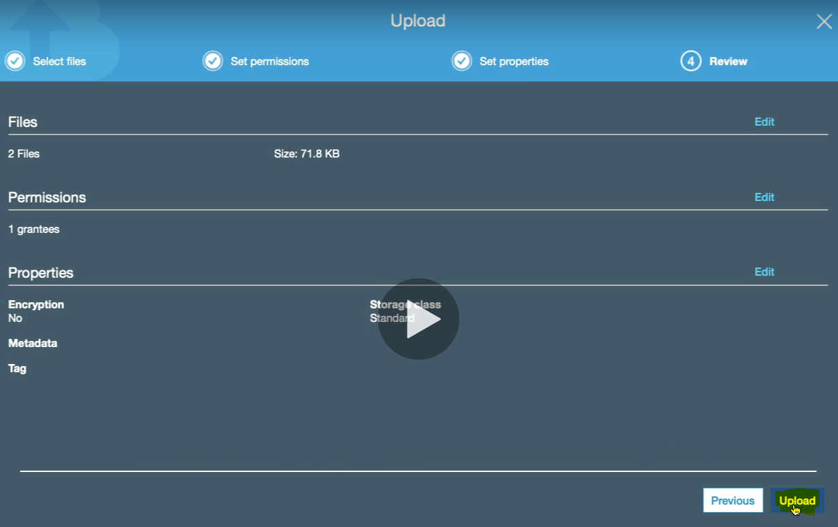

Click upload

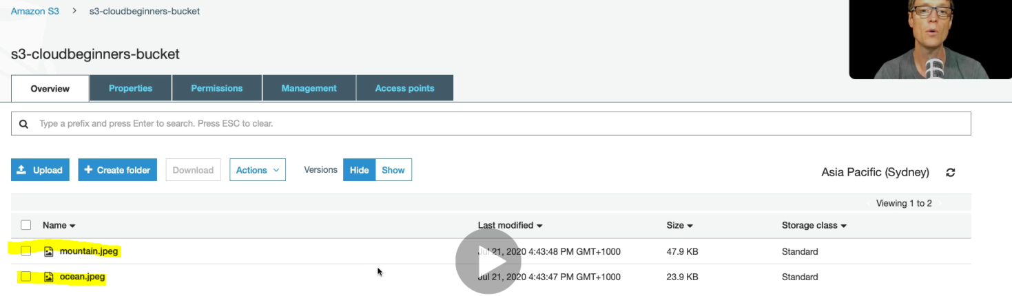

Now we got uploaded file in the bucket. Let’s click on the uploaded image and then we will get several info

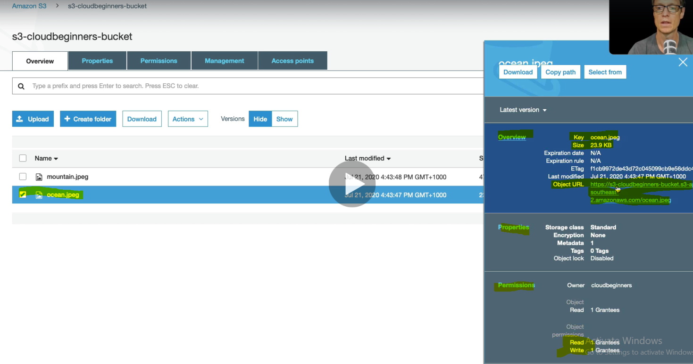

Let’s copy the URL and open into another browser just to check whether we can access the image or not.

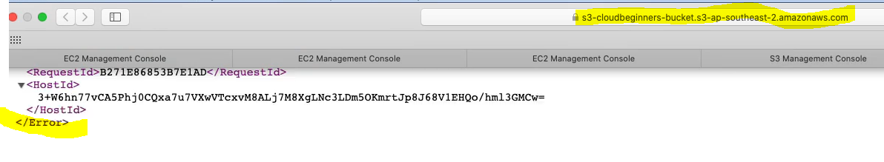

And we have got the response access is denied as given above instead of image. This access denied is because, public access is blocked while creating bucket. So let enable it so that publicaly we can asscess it.

Let’s open the bucket and click on permission tab

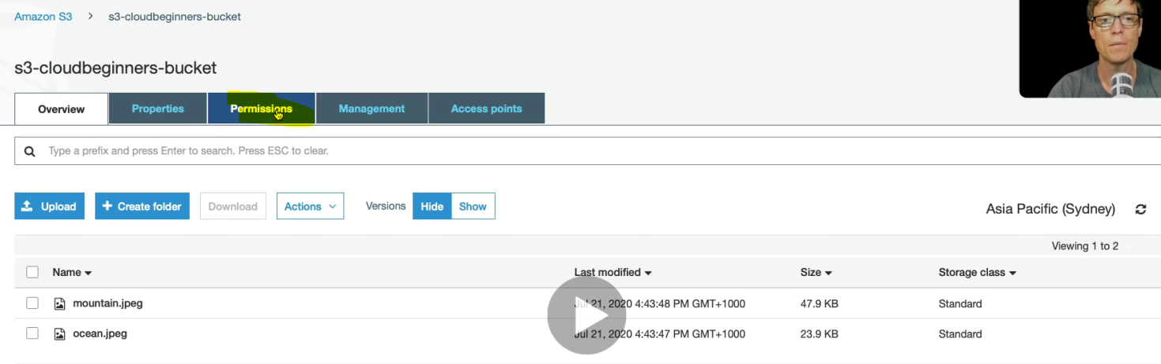

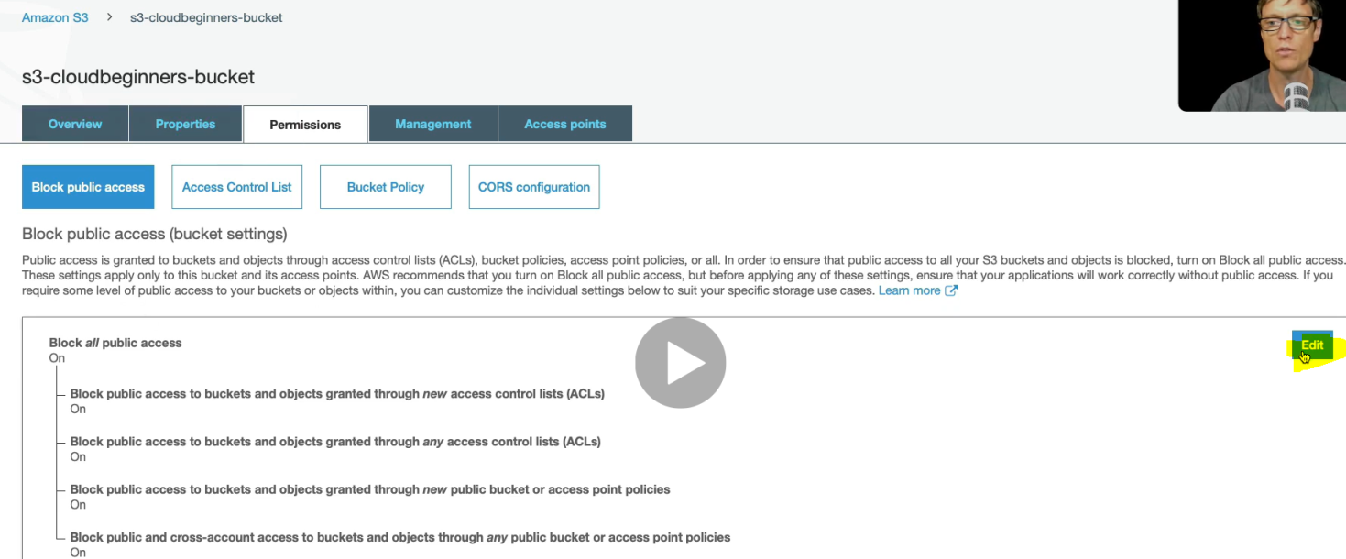 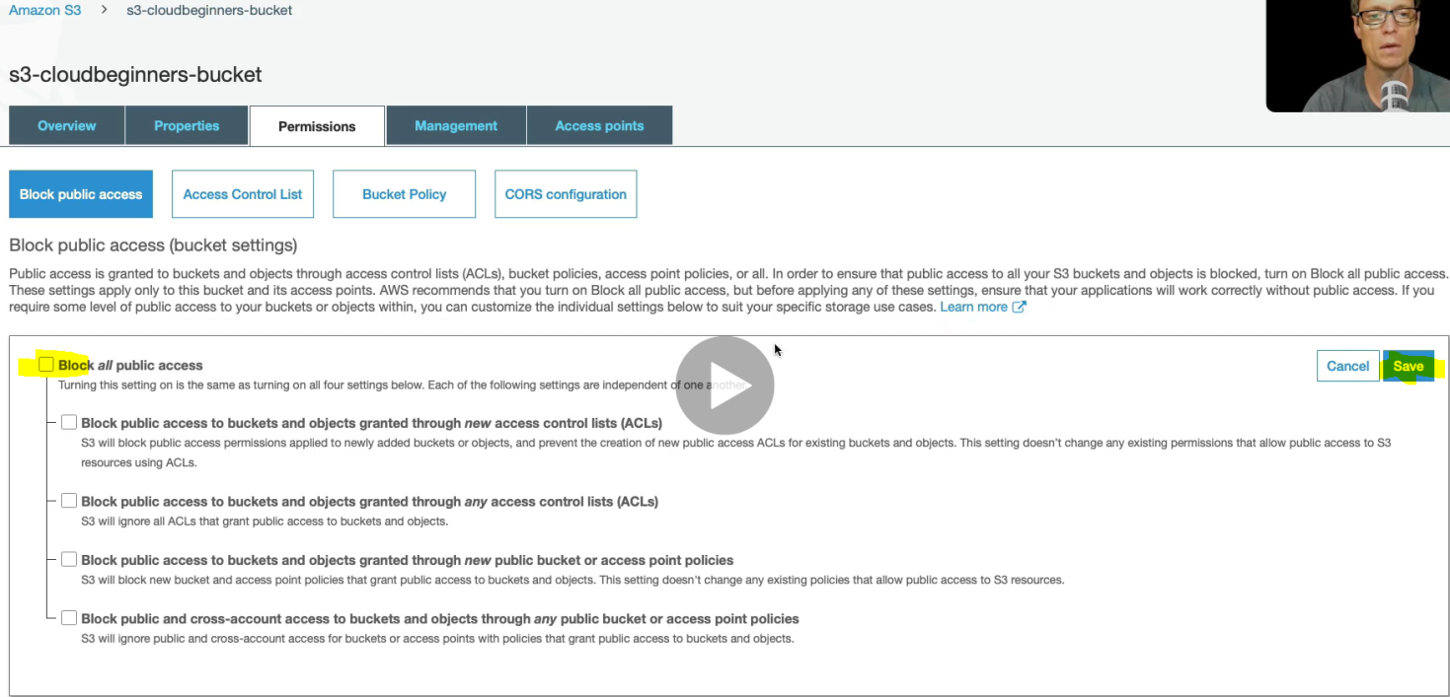uncheck and save and write confirm to confirm the changes

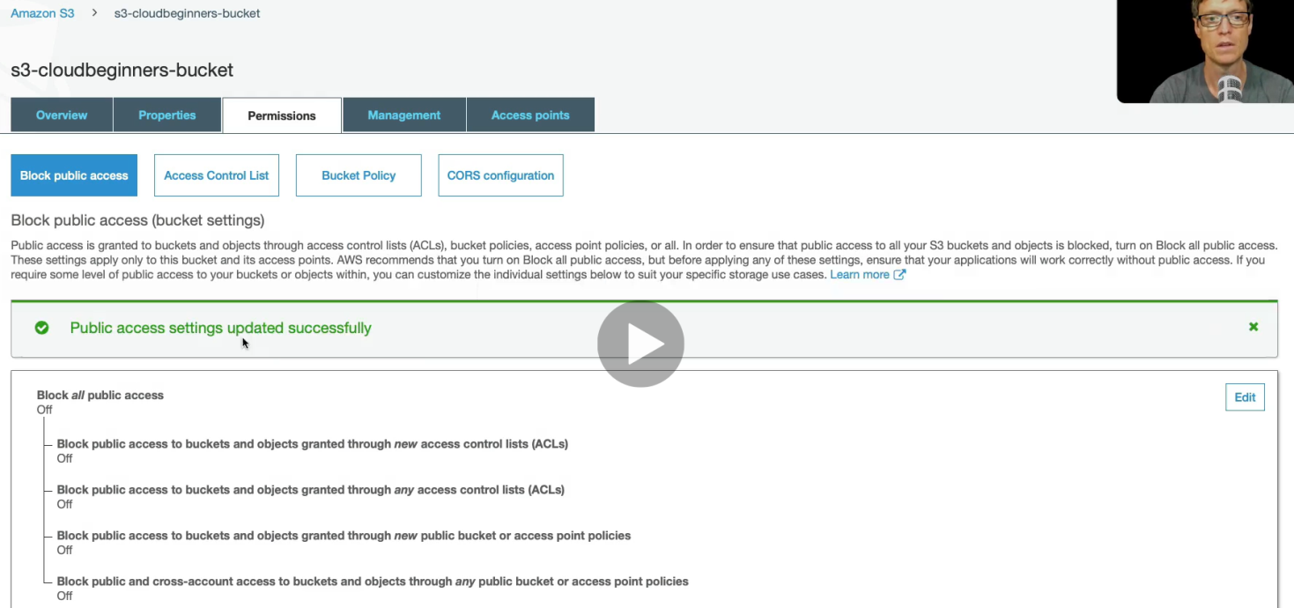

So now we have the public access enabled. We need to write some bucket policy to get public access. Click on Bucket Policy and will write some java script notation.

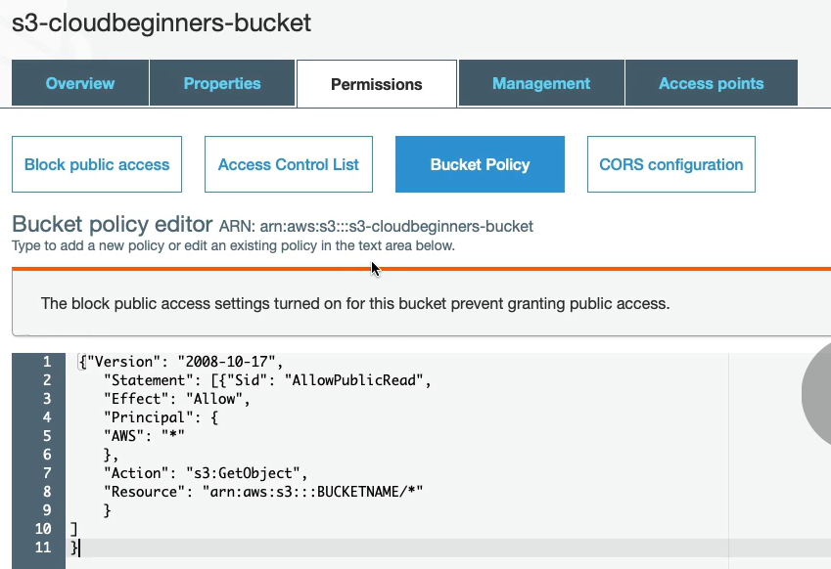

Give the bucket name only and rest will be same

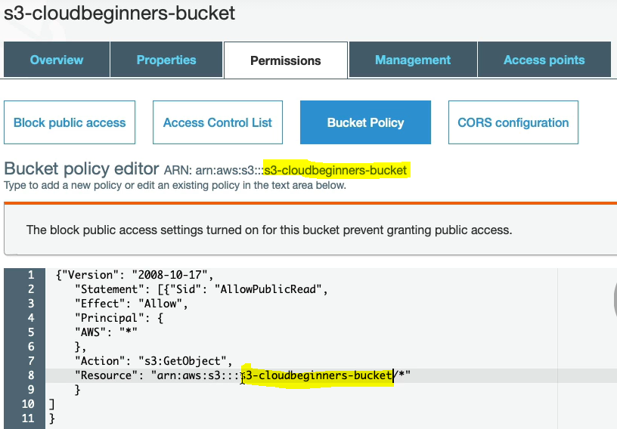

Click on save

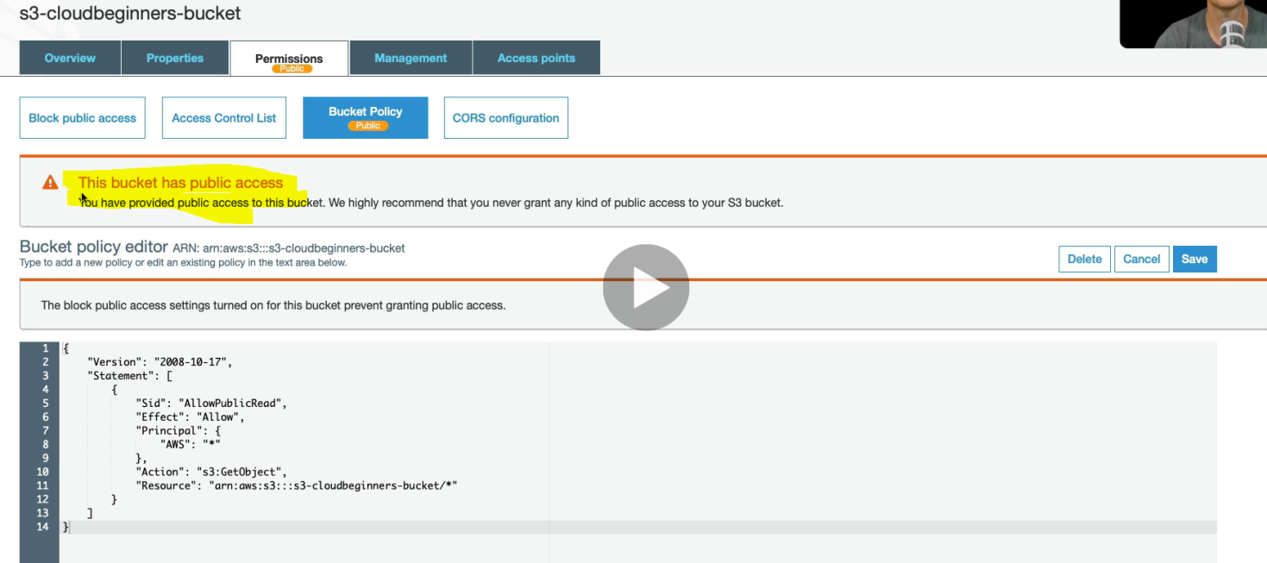

Now the bucket has public access. Now load the bucket image url once again

and here we go, we now able to access the image publicly.

**Working with S3 Object from AWS CLI:**

Let’s work on AWS S3 from AWS CLI. We will upload file into S3 bucket using CLI. So first of all we need to configure command line. And to configure run the below command on CLI.



To get the Access Key Id , following the steps>

AWS management console > Security, Identity & Compliance > IAM click

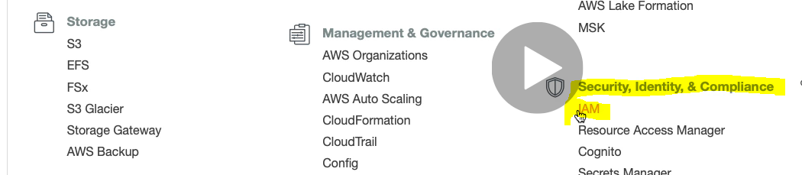

Go to user.

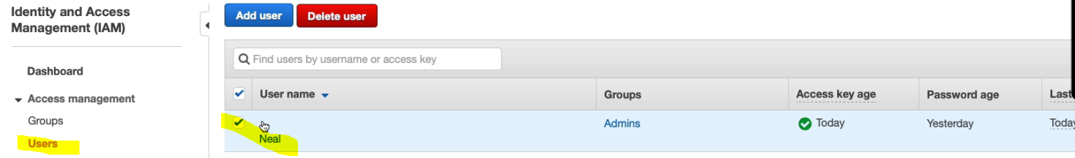

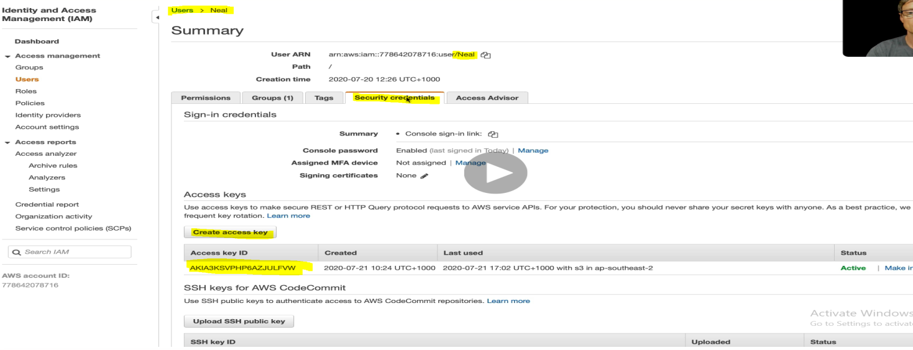

In this way we can get the Access Key ID and secret access key.

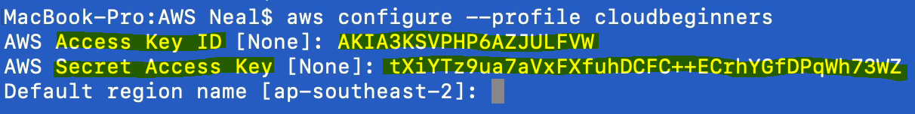

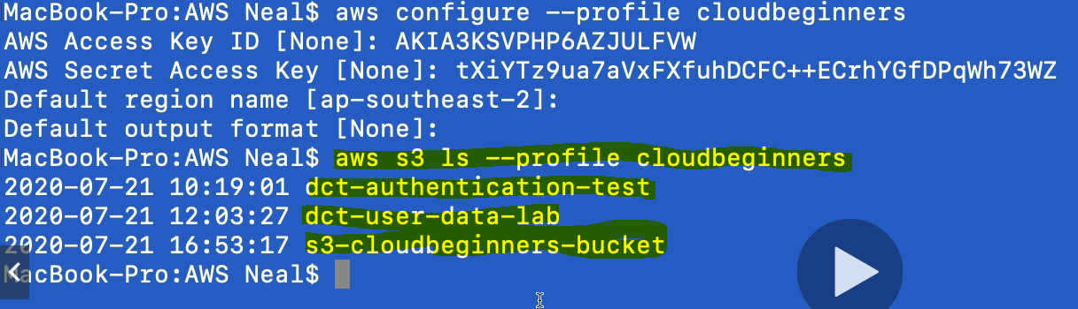

Now we have run ls command for profile and got three bucket marked in yellow.

Now let us create an object (text file) from CLI. Using nano command as shown in the screen below.



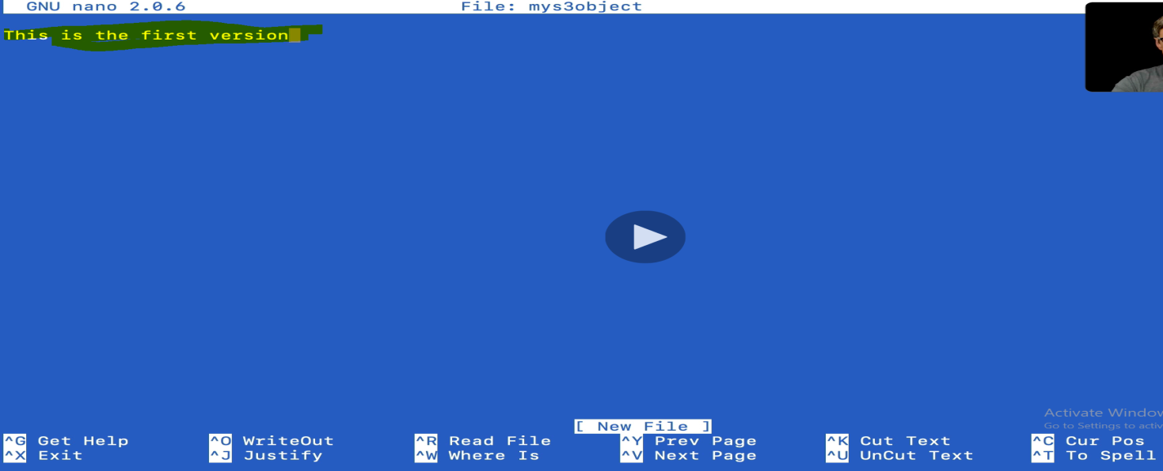

Save the file.



Here we are using cp command to copy mys3object file into bucket s3-cloudbeginners-bucket using profile

Now let’s go to the bucket and check the object got created or not.

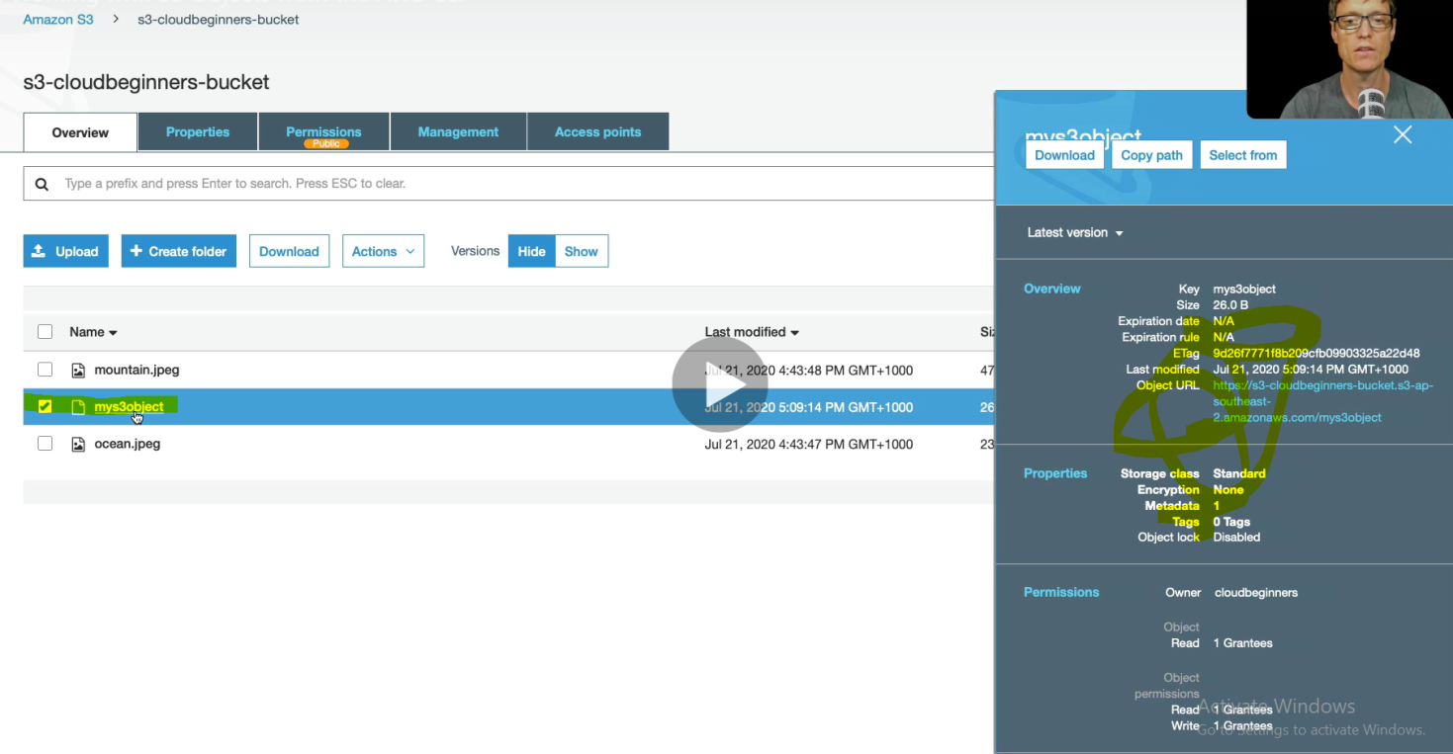

So object got created into bucket. And this would be the first version as got created first times now let’s update the version by updating file using CLI using **nano myS3Object** command

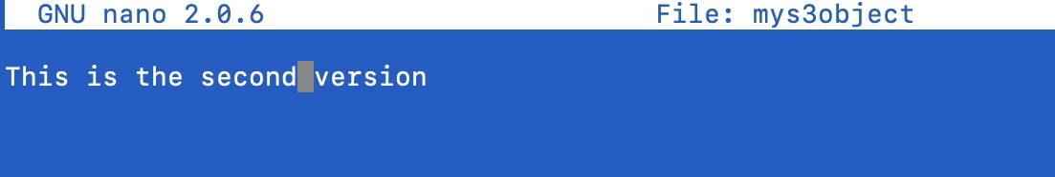

Save it and lets upload that file once again



Now let’s back to bucket history. Refresh the page before checking version history

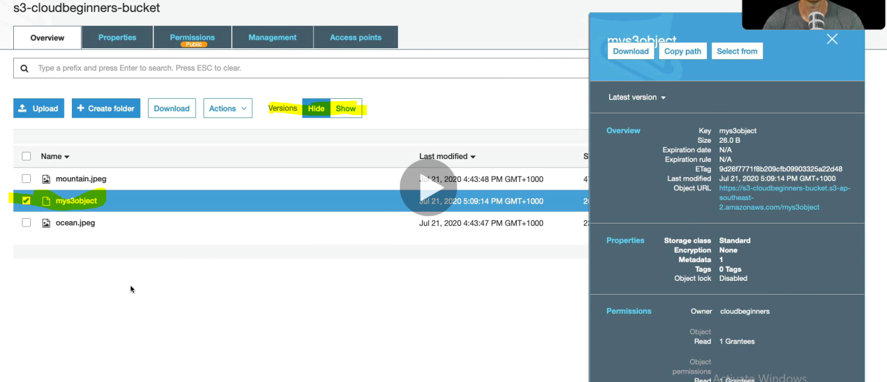

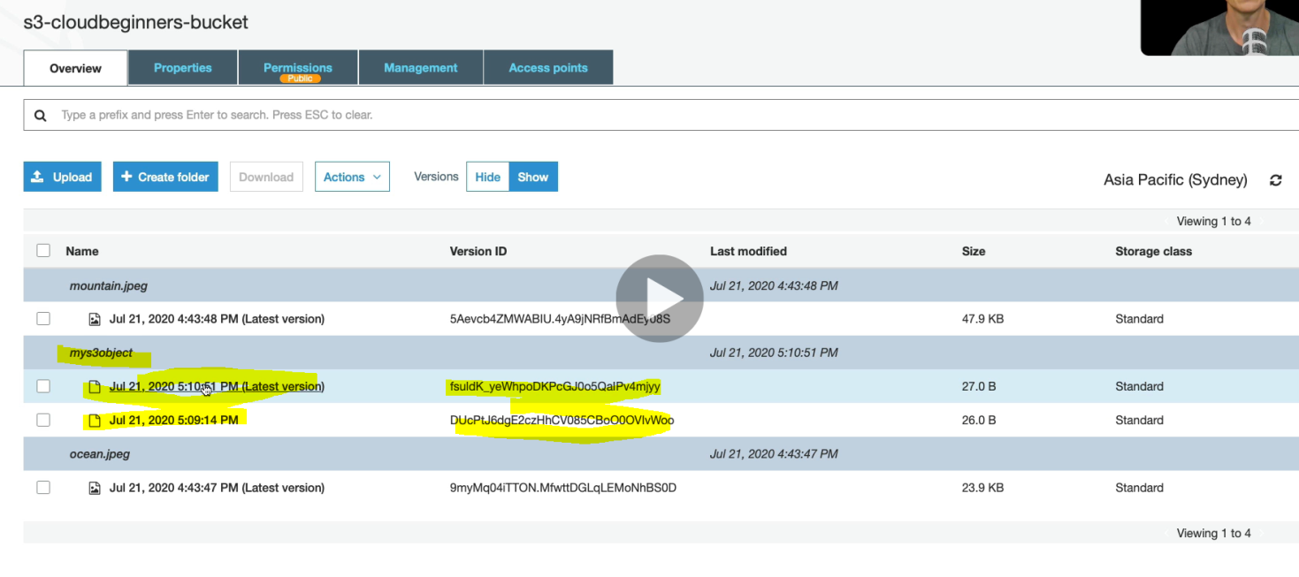We can see two different version with its version ID.

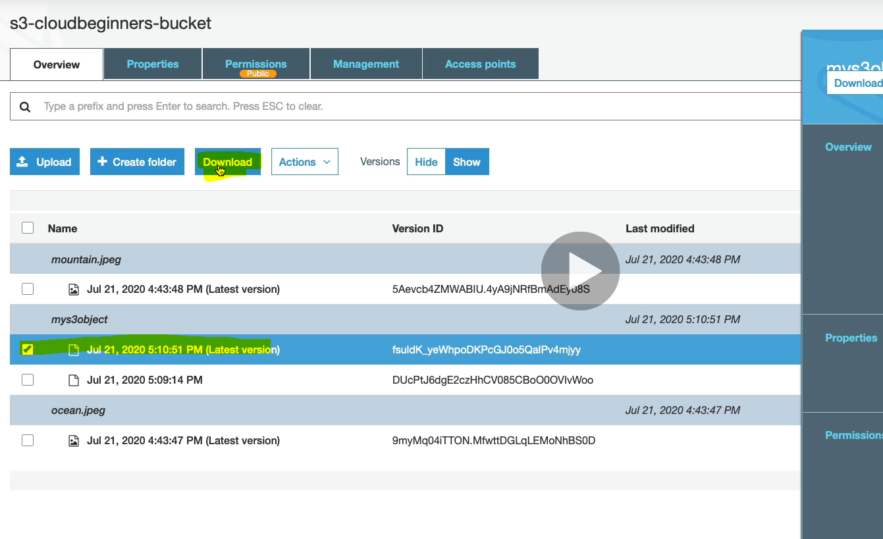

So after download we will get the object like :

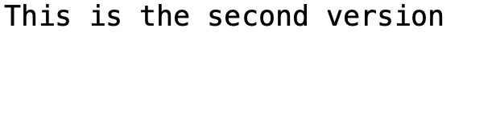

Note: If we select the object and click on delete: 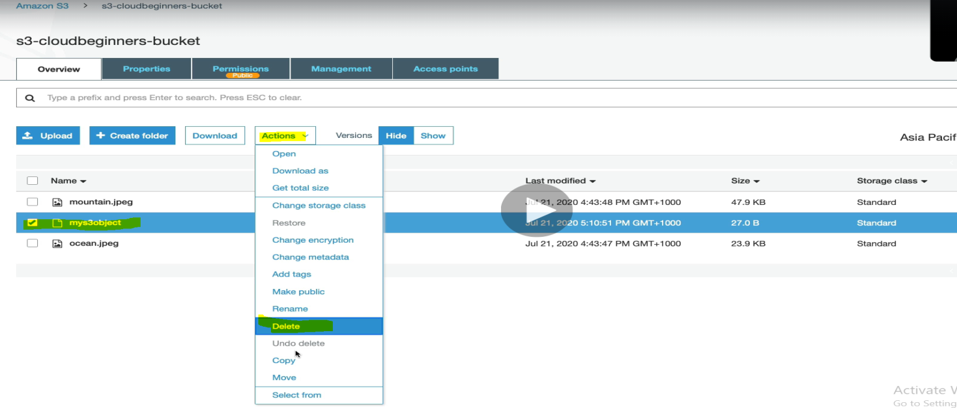 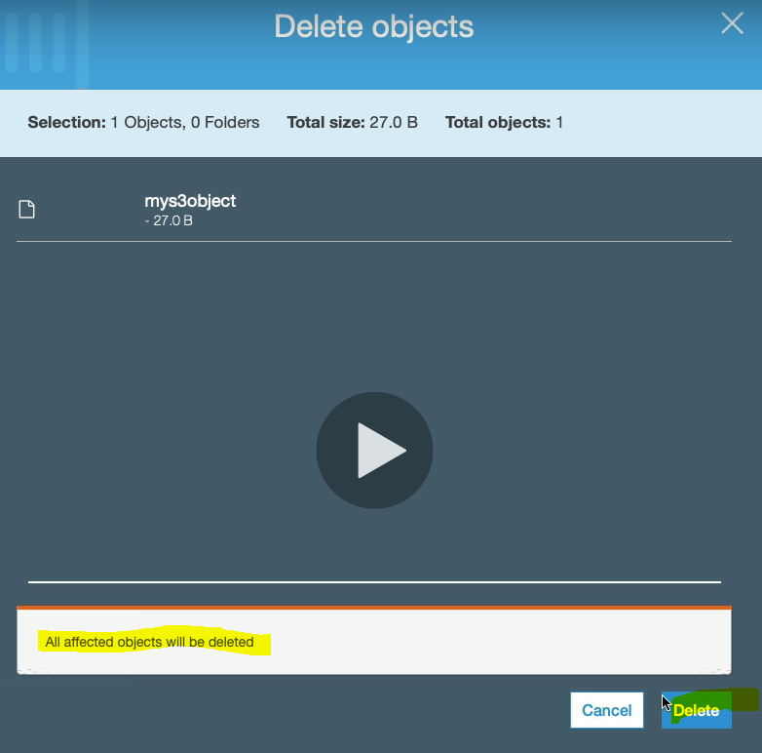

And myobject got disappeared

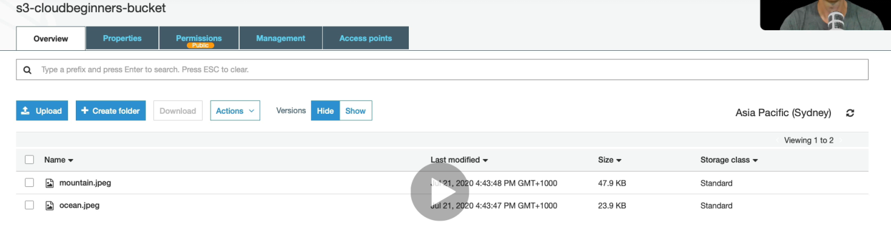

Now to retrieve the deleted object let’s go back to version and will see the delete marker, lets delete the delete market and second version objecet as shown in the image

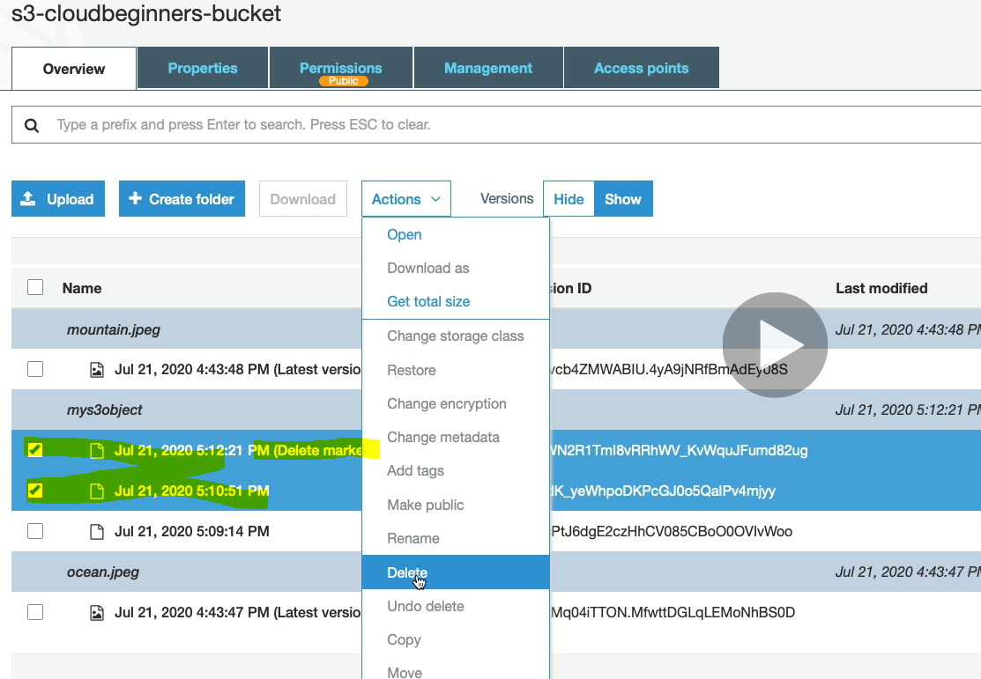

So now after deleting the original version is left. So now come back to bucket and we will see the original object in the bucket again(first version)

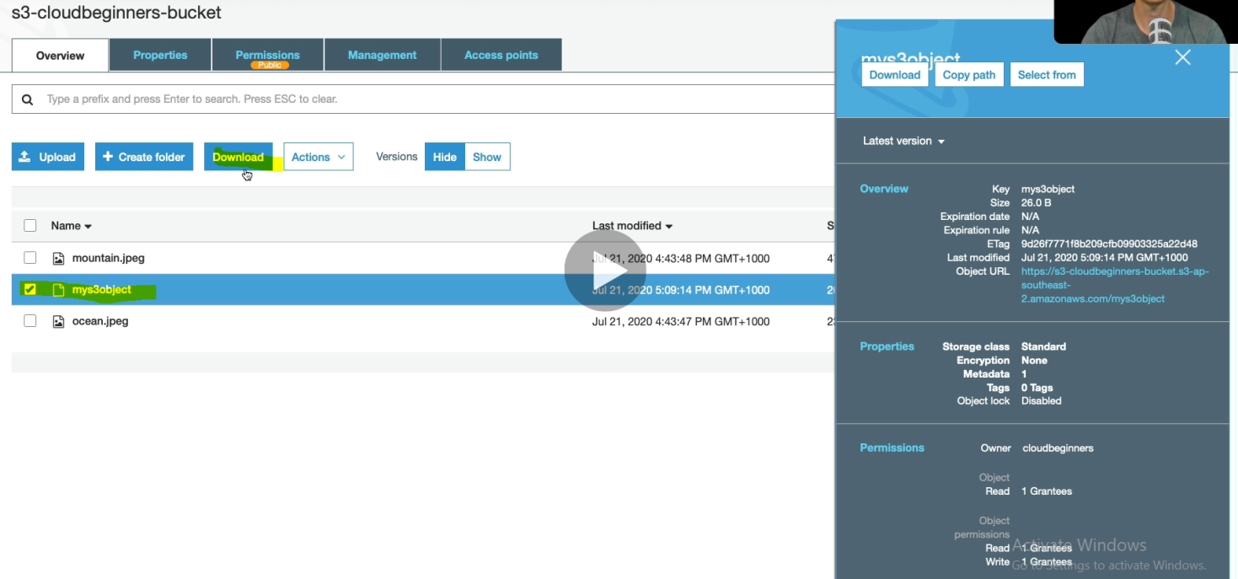

Let’s download and we will see first version object .



So this the way how the object versioning works.